

Redactor: François AMAUDRIC DU CHAFFAUT

Email: francois.amaudric-du-chaffaut@mer.gouv.fr

**Draft guide**

**Verifying fish quantities in fishing vessel holds - volumetrics method**

**INTRODUCTION**

This procedure is intended to guide inspectors in estimating the quantities of fish on board, when direct weighing or weighing by sampling is not possible.

Volumetrics is a method for measuring a space—typically a ship’s hold—to estimate the volume of fish stored, expressed in cubic metres (m³). The volume of fish can be translated in a weight after applying several factors.

It allows fisheries officers to estimate the weight of the catch on board and verify catch declarations, especially :

* When there is a suspicion of underreporting or false catch declarations.
* If the vessel identity or license status is unclear.
* To cross-check logbooks with physical evidence.

Even if not highly precise, this method reveals significant discrepancies in declared versus actual fish quantities. It can be a trigger conducting to a more extensive and precise method such as sampling, or full discharging and weighting at port.

**METHOD IMPLEMENTATION**

Ideally, two officers are involved:

* one reviews the logbooks and interviews the master for species, product types, and estimated catch; he can refer to:
  + vessel plans
  + stability book
  + hull survey certificates
* the other performs physical measurements of each fish hold.

**PROCEDURAL STEPS**

## Step 1 – Information Gathering

- Interview the captain about species, product condition, and storage method.

- Review onboard documents: fishing logbook, vessel plans, stability certificate.

## Step 2 – Measuring the hold

Use internal dimensions only: Volume (m3) = Length × Width × Height.

For irregular shapes: Triangular volume = (L × W × H) ÷ 2. *(see annex 1)*

**Step 3 – Estimate fill rate**

To obtain the fill rate of the hold and estimate the fish volume, either:

- measure the volume occupied by the fish in the hold, or

- measure the free air space in the hold and deduct it from the total volume of the hold.

## Step 4 – Apply density factor

Average density for whole fish in bulk: 1080 kg/m³

Examples (FAO and ICCAT sources):

- Marlin (MLS): 1080 kg/m³

- Bigeye tuna (BET): 1065 kg/m³

- Pacific bluefin tuna (PBF): 1070 kg/m³

- Albacore tuna (ALB): 1050 kg/m³

- Skipjack tuna (SKJ): 1030 kg/m³

- Swordfish (SWO): 1075 kg/m³

## Step 5 – Apply Processing Conversion Factor

Apply if fish is processed.

Examples:

|  |  |  |  |
| --- | --- | --- | --- |
| Species (FAO code) | Whole | Gutted | Gutted + Head off |
| Marlin (MLS) | 1.00 | 1.10 | 1.30 |
| Bigeye tuna (BET) | 1.00 | 1.13 | 1.33 |
| Pacific bluefin tuna (PBF) | 1.00 | 1.14 | 1.34 |
| Albacore tuna (ALB) | 1.00 | 1.12 | 1.31 |
| Skipjack tuna (SKJ) | 1.00 | 1.10 | 1.28 |
| Swordfish (SWO) | 1.00 | 1.10 | 1.30 |
| Sharks (CWZ) | 1.00 | 1.10 | 2.00 |
| Yellowfin tuna (YFT) | 1.00 | 1.16 | 1.36 |

## Step 6 – Apply Stacking Factor

Factors depending on stacking method:

- Loose: 0.45

- Medium (e.g. tuna): 0.51

- Tight: 0.54

## Step 7 – Compare With Onboard Records

Compare the result with the fishing logbook, captain's declarations, and landing data.

# Example Calculation

Hold: 8 × 8 × 2.5 m = 160 m³  
Fill rate: 70%  
Species: Bigeye tuna (BET), gutted  
Density: 1065 kg/m³  
Stacking factor: 0.51  
Processing factor: 1.13

Usable volume: 160 × 0.7 = 112 m³  
Gross weight = 112 × 1065 = 119,280 kg  
Stacked weight = 119,280 × 0.51 = 60,832.8 kg  
Catch weight = 60,832.8 × 1.13 = 68,741 kg ≈ 68.7 tonnes

**Annex 1. Calculating volume formulas**

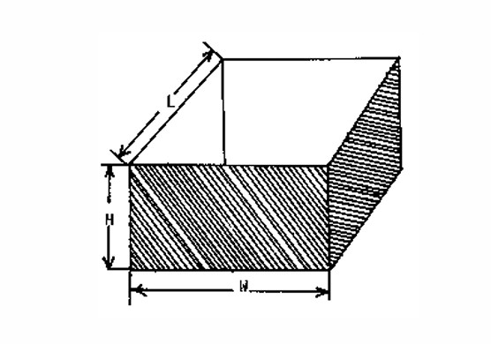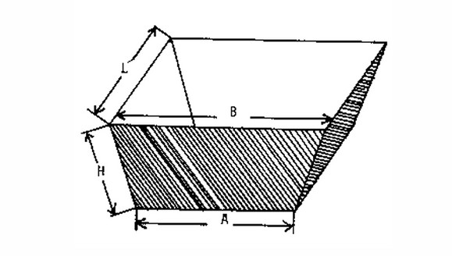

Volume = length x width x height Volume = (width A+width B) x length x height /2

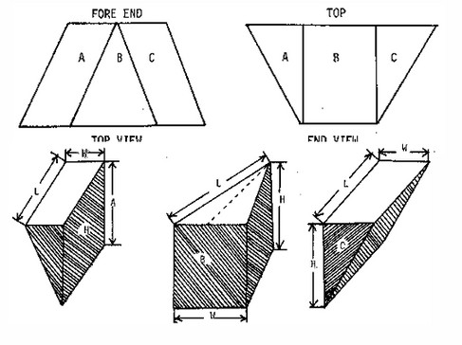

To calculate the size of these holds you need to separate them into a shape you can measure and then use the below formulas.

Total area in metre³ = VA + VB + VC

