The Commission for the Conservation and Management of
Highly Migratory Fish Stocks in the Western and Central Pacific Ocean

Scientific Committee

wcpo Bigeye Tuna (Thunnus obesus)

Stock Status and Management Advice

Contents
SC15 2019 (FISHERY INDICATORS UPDATED) 2
SC14 2018 (ASSESSMENT UPDATE CONDUCTED) 3
SC13 2017 (STOCK ASSESSMENT CONDUCTED) 12
Useful References 22
Previous Assessments 22

SC15 2019 (FISHERY INDICATORS UPDATED)

- Stock Status and trends

- SC15 noted that no stock assessment was conducted for WCPO bigeye tuna in 2019. Therefore, the stock status description from SC14 is still current. For further information on the stock status and trends from SC14, please see https://www.wcpfc.int/node/32155

- SC15 noted that the total bigeye catch in 2018 was 145,402 mt, a 13% increase from 2017 and a 1% decrease from the average 2013-2017.

- Longline catch in 2018 (71,305 mt) was a 23% increase from 2017 and a 7% increase from the 2013-2017 average. Purse seine catch in 2018 (64,119 mt) was a 10% increase from 2017 and a 4% increase from the 2013-2017 average. Pole and line catch (1,677 mt) was a 3% increase from 2017 and a 60% decrease from the average 2013-2017 catch. Catch by other gear (8,301 mt) was a 25% decrease from 2017 and 45% decrease from the average catch in 2013-2017.

- SC15 noted that under recent fishery conditions, the bigeye stock is initially projected to increase as recent estimated recruitments support adult stock biomass. Adult stock biomass is then projected to decline slightly before again increasing. Projected fishing mortality is below F_{MSY} (median F₂₀₂₀/F_{MSY} = 0.62, the risk of F₂₀₂₀ > F_{MSY} = 0%) and projected median spawning biomass is above the LRP (SB₂₀₂₀/SB_{F=0} = 0.2) (median SB₂₀₂₀/SB_{F=0} = 0.41; median SB₂₀₂₀/SB_{MSY} = 1.79. Risk that SB₂₀₂₀ < LRP = 0%). Projections are from the updated model runs of Vincent et al. (2018).

- Management advice and implications

- SC15 noted that no stock assessment has been conducted since SC14. Therefore, the advice from SC14 should be maintained, pending a new assessment or other new information. For further information on the management advice and implications from SC14, please see https://www.wcpfc.int/node/32155

- Research recommendations

- SC15 reviewed progresses for the research recommendations from SC14 for bigeye growth and noted that the following research issues need to be addressed further, after classifying these research items as short-term (preferably before SC16) and long-term (preferably before the scheduled 2023 stock assessment).
  - Develop MULTIFAN-CL functionality that can accommodate spatial variation in growth rates and movement between western and eastern Pacific to consider the appropriateness of delineating the two stocks at 150˚W (long-term).
  - Carry out further otolith age validation studies for fish in the western and central Pacific. Consider chemically marking fish at release in future tagging programs and then analyzing otoliths from recaptured marked fish (long-term). Apply other age validation methodology including radiocarbon age validation (short to long-term). SC15 noted potential issues of the spatial pattern of radiocarbon in the Pacific Ocean and its implications for mobile adult tuna.
  - Continue to develop and document protocols for daily and annual ageing by IATTC and WCPFC (short-term).
  - Continue efforts under Project 94 to collect very small bigeye caught by the Indonesian, Vietnamese, and Philippines domestic fisheries in region 7 to aid in the estimation of the size at age-1 qtr-1 parameter (L1) within the assessment model (short to long-term).
  - Compile a high confidence tagging dataset for growth analysis and develop integrated growth models incorporating the tagging data and the otolith data (short-term).
  - Conduct sensitivity analysis using alternative growth models in the stock assessment, if new growth models are developed such as an integrated growth model (short -term), a conditional age-at-length growth model (short-term), and other growth models after conducting further growth analysis listed above.
  - Undertake a genetic stock structure analysis (long-term).

SC14 2018 (ASSESSMENT UPDATE CONDUCTED)

- Stock Status and trends

- The median values of relative recent (2012-2015) spawning biomass depletion (SB_{recent}/ SB_{F=0}) and relative recent (2011-2014) fishing mortality (F_{recent}/F_{MSY}) over the uncertainty grid of 36 models (Table BET-1) were used to define stock status. The values of the upper 90th and lower 10th percentiles of the empirical distributions of relative spawning biomass and relative fishing mortality from the uncertainty grid were used to characterize the probable range of stock status.

- A description of the updated structural sensitivity grid used to characterize uncertainty in the assessment is set out in Table BET-1. Time series of total annual catch by fishing gear over the full assessment period is shown in Figure BET-1. Estimated trends in spawning biomass depletion for the 36 models in the structural uncertainty grid is shown in Figure BET-2, and juvenile and adult fishing mortality rates from the diagnostic case model is show in BET-3. Figure BET-4 displays Majuro plots summarising the results for each of the models in the structural uncertainty grid. Figures BET-5 show Kobe plots summarising the results for each of the models in the structural uncertainty grid. Table BET-2 provides a summary of reference points over the 36 models in the structural uncertainty grid.

- SC14 agreed to use the “updated new growth” model to describe the stock status of BET because SC14 considered it to be the best available scientific information. By removing results using the old growth model, the stock status becomes considerably more optimistic. However, SC14 also notes that questions remain regarding the “updated new growth” model.

- Therefore, SC14 acknowledges that further study is warranted related to the new growth model, in particular as to the cause of the difference of growth between EPO and WCPO. An inter-laboratory ageing workshop is planned for late 2018 to review ageing approaches in the WCPO and EPO and to resolve differences, if they exist.

- In addition, SC14 acknowledges that further study is warranted to refine the tagging dataset in the WCPO to assist validating age estimates of bigeye in the WCPO. SC14 further notes that adopting the new growth curve generates new broader questions related to the BET stock assessment and agreed that several aspects need to be investigated further to inform future assessments.

Table BET-1. Description of the updated structural sensitivity grid used to characterize uncertainty in the assessment.
Axis | Levels | Option
Steepness | 3 | 0.65, 0.80, 0.95
Growth | 1 | ‘Updated new growth’
Tagging over-dispersion | 2 | Default level (1), fixed (moderate) level
Size frequency weighting | 3 | Sample sizes divided by 10, 20, 50
Regional structure | 2 | 10°N regions, 20°N regions

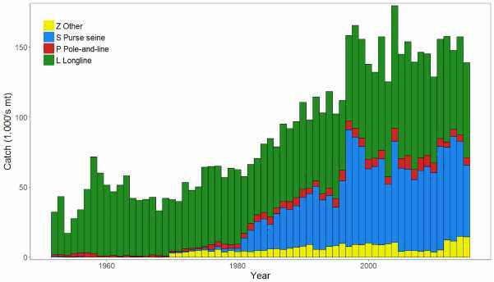
Figure BET-1. Time series of total annual catch (1000's mt) by fishing gear over the full assessment period.

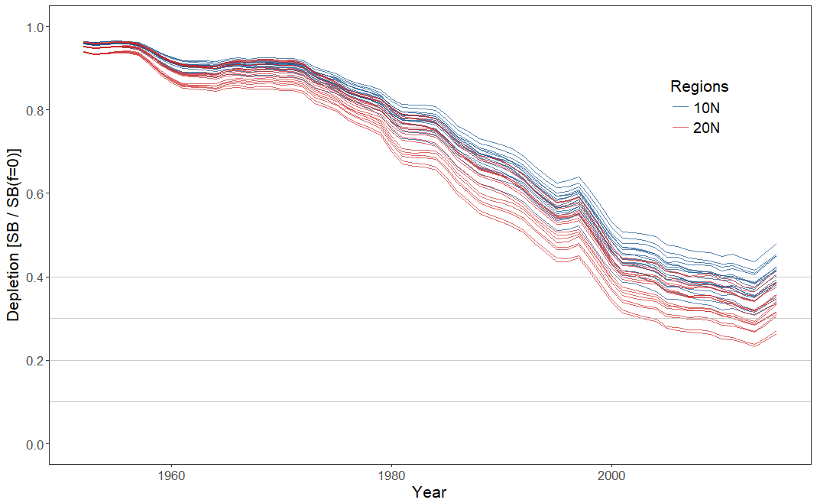
Figure BET-2. Plot showing the trajectories of spawning biomass depletion for the 36 model runs included in the structural uncertainty grid. The colours depict the models in the grid with the 10°N and 20°N spatial structures.

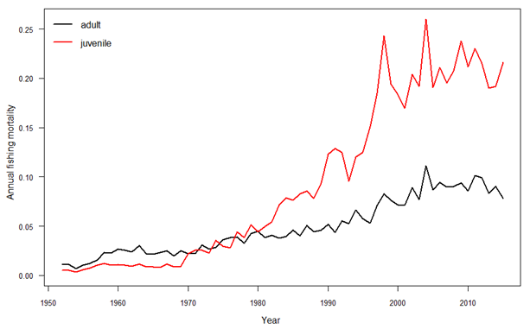
Figure BET-3. Estimated annual average juvenile and adult fishing mortality for the diagnostic case model.

SB_{recent} (2012-2015) / SB_{F=0} | SB_{latest} (2015) / SB_{F=0}
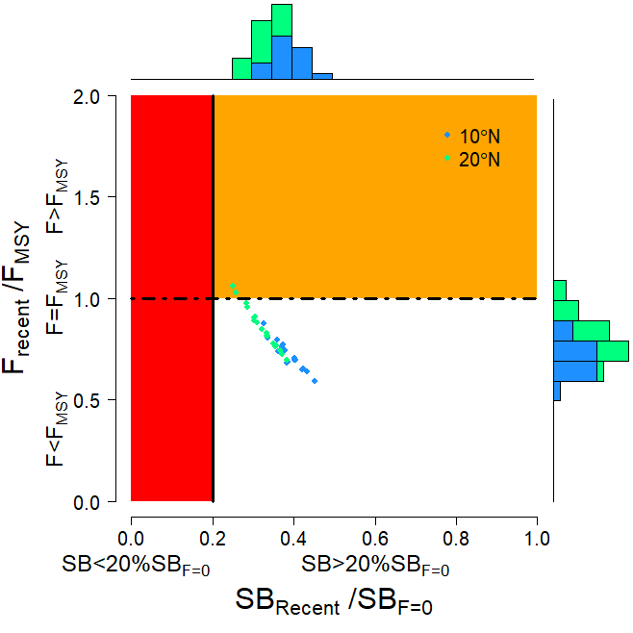 | 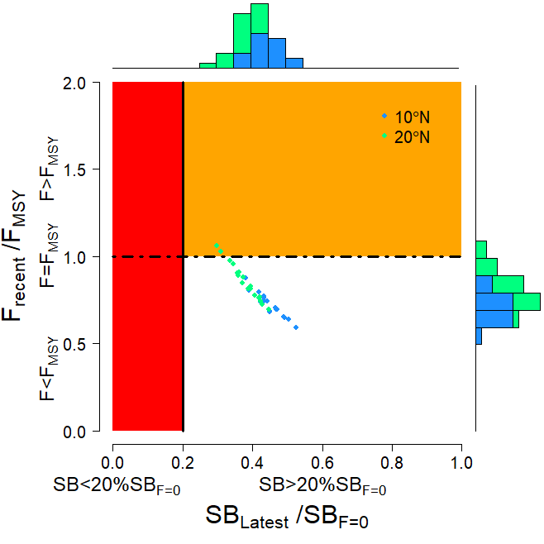
Figure BET-4. Majuro plot summarising the results for each of the models in the structural uncertainty grid. The plots represent estimates of stock status in terms of spawning biomass depletion and fishing mortality. The red zone represents spawning biomass levels lower than the agreed limit reference point, which is marked with the solid black line. The orange region is for fishing mortality greater than FMSY (FMSY is marked with the black dashed line). In the upper panel, the points represent SBrecent/SBF=0, where SBrecent is the mean SB over 2012-2015. In the lower panel, the points represent SB_{latest}/SB_{F=0}, where SB_{latest} is from 2015. In both panels the colours depict the models in the grid with the 10°N and 20°N regional structures.

SB_{recent} (2012-2015) / SB_{MSY} | SB_{latest} (2015) / SB_{MSY}
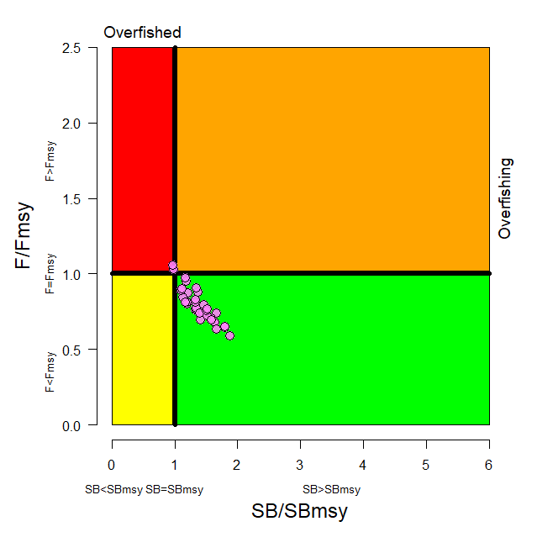 | 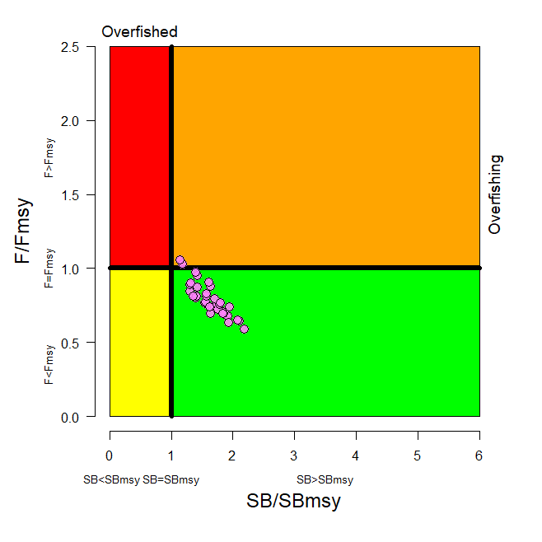
Figure BET-5. Kobe plot summarising the results for each of the models in the structural uncertainty grid. In the upper panel, the points represent SBrecent/SBMSY, where SBrecent is the mean SB over 2012-2015. In the lower panel, the points represent SB_{latest}/SB_{MSY}, where SB_{latest} is from 2015.

Table BET-2. Summary of reference points over the 36 models in the structural uncertainty grid. Note that SBrecent/SBF=0 is calculated where SBrecent is the mean SB over 2012-2015 at the request of the Scientific Committee.
 | Mean | Median | Min | 10% | 90% | Max
C_{latest} | 152,148 | 151,846 | 148,888 | 148,936 | 154,971 | 155,577
YF_{recent} | 154,180 | 153,220 | 133,120 | 141,140 | 170,720 | 172,280
f_{mult} | 1.291 | 1.301 | 0.946 | 1.075 | 1.499 | 1.690
F_{MSY} | 0.050 | 0.049 | 0.044 | 0.045 | 0.054 | 0.056
MSY | 158,551 | 159,020 | 133,520 | 143,040 | 173,880 | 180,120
F_{recent}/F_{MSY} | 0.789 | 0.768 | 0.592 | 0.667 | 0.931 | 1.058
SB₀ | 1,674,833 | 1,675,500 | 1,261,000 | 1,415,500 | 1,941,000 | 2,085,000
SB_{F=0} | 1,841,609 | 1,858,775 | 1,509,007 | 1,632,014 | 2,043,108 | 2,139,644
SB_{MSY} | 471,956 | 476,050 | 340,700 | 386,600 | 577,400 | 614,200
SB_{MSY}/SB₀ | 0.281 | 0.280 | 0.260 | 0.262 | 0.300 | 0.302
SB_{MSY}/SB_{F=0} | 0.255 | 0.255 | 0.226 | 0.235 | 0.280 | 0.287
SB_{latest}/SB₀ | 0.456 | 0.456 | 0.346 | 0.392 | 0.523 | 0.568
SB_{latest}/SB_{F=0} | 0.414 | 0.420 | 0.298 | 0.351 | 0.480 | 0.526
SB_{latest}/SB_{MSY} | 1.633 | 1.624 | 1.146 | 1.306 | 1.933 | 2.187
SB_{recent}/SB_{F=0} | 0.353 | 0.358 | 0.251 | 0.295 | 0.412 | 0.452
SB_{recent}/SB_{MSY} | 1.394 | 1.377 | 0.963 | 1.117 | 1.659 | 1.879

- SC14 noted that there has been a long-term decrease in spawning biomass from the 1950s to the present for bigeye tuna and that this is consistent with previous assessments.

- SC14 also noted that the central tendency of relative recent (2012-2015) spawning biomass depletion was median (SB_{recent}/SB_{F=0}) = 0.36 with a range of 0.30 to 0.41 (80% probability interval).

- SC14 further noted that there was 0% probability (0 out of 36 models) that the recent spawning biomass had breached the adopted LRP.

- SC14 noted that there has been a long-term increase in fishing mortality for both juvenile and adult bigeye tuna, consistent with previous assessments.

- SC14 also noted that the central tendency of relative recent fishing mortality was median (Frecent/FMSY) = 0.77 with an 80% probability interval of 0.67 to 0.93.

- SC14 further noted that there was a roughly 6% probability (2 out of 36 models) that the recent fishing mortality was above FMSY.

- SC14 also noted that, regardless of the choice of uncertainty grid, the assessment results show that the stock has been continuously declining for about 60 years since the late 1950’s, except for the recent small increase.

- SC14 also noted the continued relatively higher levels of depletion in the equatorial and western Pacific (specifically Regions 3, 4, 7 and 8) and the associated higher levels of impact, especially on juvenile bigeye tuna, in these regions due to the associated purse-seine fisheries and the ‘other’ fisheries within the western Pacific (as shown in Figures 46 and 47 of SC13-SA-WP-03).

- Table BET-3 summarises the median values of SB/SB_{F=0} and F/F_{MSY} achieved in the long term, along with the potential risk of breaching the limit reference point (LRP) and exceeding F_{MSY}, under each of the future fishing and recruitment combinations. Figure 1 presents the corresponding distributions of long term SB/SB_{F=0} and Figure 2 those for F/F_{MSY}. Potential outcomes under the 2013-15 average and CMM scenario conditions were
strongly influenced by the assumed future recruitment levels.

- Under the assumption that recent positive recruitments will continue into the future, spawning biomass relative to unfished levels is predicted to increase from recent levels under all examined future scenarios by 0-18% (SB₂₀₄₅/SB_{F=0} ranges from 0.36 to 0.42; Table BET-3, Figure BET-6). While future uncertainty in stock status increases due to stochastic future recruitment levels, the risk of future spawning biomass falling below the LRP falls to between 0 and 5%, due to the improved overall stock size. Fishing mortality falls slightly under both the status quo and optimistic scenarios, assuming recent recruitment. However, fishing mortality increases under the pessimistic scenario, but remains below F_{MSY} (30% risk of F > F_{MSY} Table BET-3, Figure BET-7).

- Under the assumption that less positive long-term recruitments are experienced in the future, spawning biomass relative to unfished levels will decline under all scenarios (SB₂₀₄₅/SB_{F=0} ranges from 0.25 to 0.30). The risk of spawning biomass falling below the LRP increases to between 17 and 32% (Table BET-3). In all fishing scenarios, fishing mortality increases relative to recent levels (by 109-138%) and is well above F_{MSY}. Risk of fishing mortality exceeding F_{MSY} ranges from 93 to 98%.

- It should be noted that even under assumption of long term recruitment levels, the risk of exceeding the LRP in the short-term ranges between 2% and 7% (2020) and 12% and 26% (2025), with only the pessimistic scenario exceeding the 20% level of risk in 2025. (Table BET-4)

Table BET-3. Including ‘2013-15 average levels’
Median values of reference point levels (adopted limit reference point (LRP) of 20% SBF=0; FMSY) and risk1 of breaching reference points from the 2017 bigeye stock assessment incorporating updated growth information, and in 2045 under the three future harvest scenarios (2013-15 average fishing levels, optimistic and pessimistic) and alternative recruitment hypotheses. ‘Updated new growth’ runs only.
Scenario |  | Scalars relative to 2013-2015 |  | Median SB₂₀₄₅/SB_{F=0} | Median SB₂₀₄₅/SB_{F=0}  v  SB₂₀₁₂₋₁₅/SB_{F=0} | Median  F₂₀₄₁₋₂₀₄₄/F_{MSY} | Median F₂₀₄₁₋₂₀₄₄/ F_{MSY} vs  F₂₀₁₁₋₁₄/ F_{MSY} | Risk
Recruitment | Fishing level | Purse seine | Longline |  |  |  |  | SB₂₀₄₅ < LRP | F>F_{MSY}
Bigeye assessment (‘recent’ levels) |  |  |  | 0.36 | - | 0.77 | - | 0% | 6%
Recent | 2013-15 avg | 1 | 1 | 0.42 | 1.18 | 0.73 | 0.95 | 0% | 11%
 | Optimistic | 1.11 | 0.98 | 0.41 | 1.15 | 0.75 | 0.98 | 0% | 13%
 | Pessimistic | 1.12 | 1.35 | 0.36 | 1.00 | 0.89 | 1.15 | 5% | 30%
Long-term | 2013-15 avg | 1 | 1 | 0.30 | 0.84 | 1.60 | 2.09 | 17% | 93%
 | Optimistic | 1.11 | 0.98 | 0.29 | 0.82 | 1.64 | 2.13 | 18% | 94%
 | Pessimistic | 1.12 | 1.35 | 0.25 | 0.70 | 1.84 | 2.38 | 32% | 98%
¹ note risk within the stock assessment is calculated as the (weighted) number of models falling below the LRP (X / 36 models). Risk under a projection scenario is the number of projections across the grid that fall below the LRP (X / 3600 (36 models x 100 projections).

Table BET-4. Median values of SB/SBF=0 and associated risk of breaching the adopted limit reference point (LRP) of 20% SBF=0 in 2020, 2025 and 2045 under the three future harvest scenarios (2013-15 average fishing levels, optimistic and pessimistic) and alternative recruitment hypotheses. ‘Updated new growth’ runs only.
Scenario |  | Scalars relative to 2013-2015 |  | Median SB₂₀₂₀/SB_{F=0} | Median SB₂₀₂₅/SB_{F=0} | Median SB₂₀₄₅/SB_{F=0} | Risk SB₂₀₂₀ < LRP | Risk SB₂₀₂₅ < LRP | Risk SB₂₀₄₅ < LRP
Recruitment | Fishing level | Purse seine | Longline
Recent | 2013-15 avg | 1 | 1 | 0.42 | 0.41 | 0.42 | 0% | 1% | 0%
 | Optimistic | 1.11 | 0.98 | 0.41 | 0.40 | 0.41 | 0% | 1% | 0%
 | Pessimistic | 1.12 | 1.35 | 0.38 | 0.35 | 0.36 | 0% | 4% | 5%
Long-term | 2013-15 avg | 1 | 1 | 0.35 | 0.30 | 0.30 | 2% | 12% | 17%
 | Optimistic | 1.11 | 0.98 | 0.35 | 0.30 | 0.29 | 2% | 13% | 18%
 | Pessimistic | 1.12 | 1.35 | 0.32 | 0.26 | 0.25 | 7% | 26% | 32%

Recent recruitments | Long-term recruitment
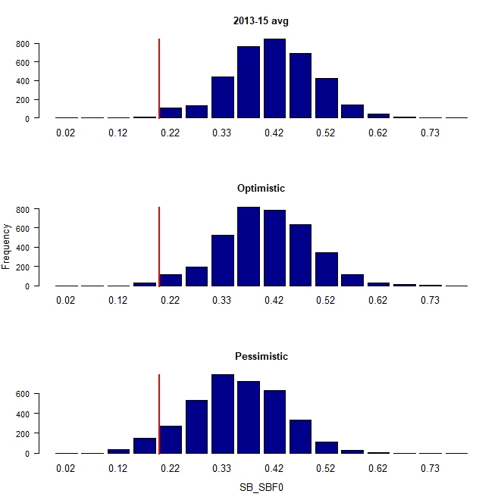 | 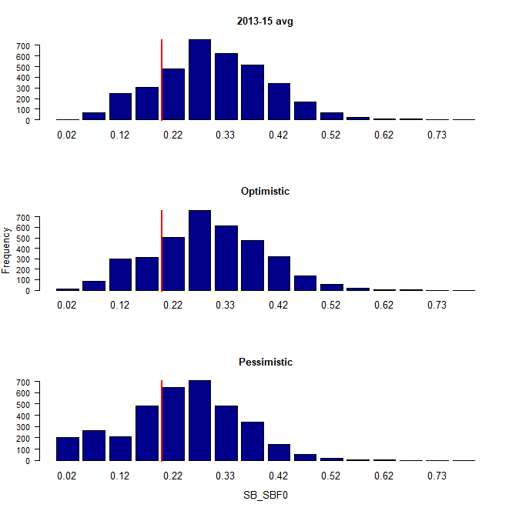
Figure BET-6. Distribution of SB2045/SBF=0 assuming recent and long term recruitment conditions (left and right columns, respectively), under the three future fishing scenarios: 2013-15 avg (2013-15 average conditions, top row); optimistic conditions (middle row); and pessimistic conditions (bottom row). Projection results from ‘updated new growth’ models (3,600 projections) only where the red line indicates the LRP.

Recent recruitments | Long-term recruitment
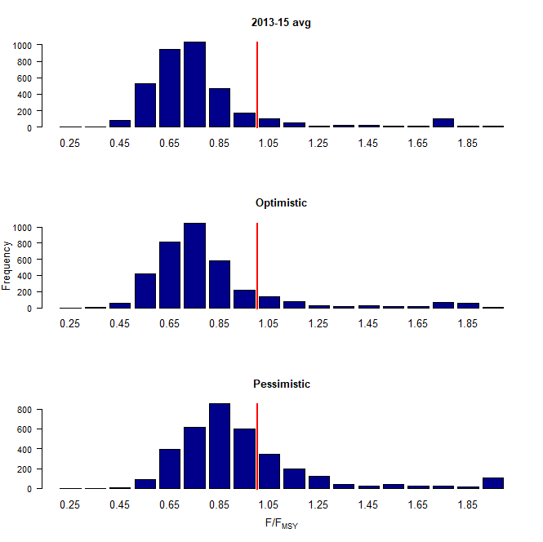 | 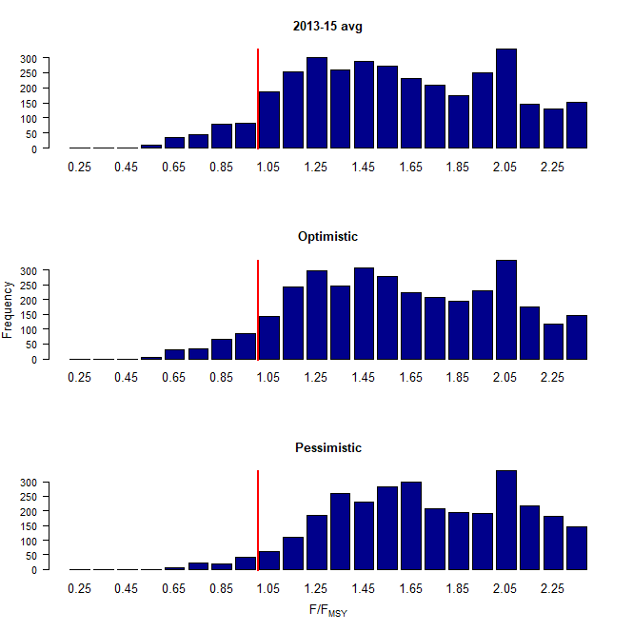
Figure BET-7. Distribution of F/F_{MSY} assuming recent and long term recruitment conditions (left and right columns, respectively), under the three future fishing scenarios: 2013-15 avg (2013-15 average conditions, top row); optimistic conditions (middle row); and pessimistic conditions (bottom row). Projection results from ‘updated new growth’ models (3,600 projections) only.

Recent recruitments | Long-term recruitment
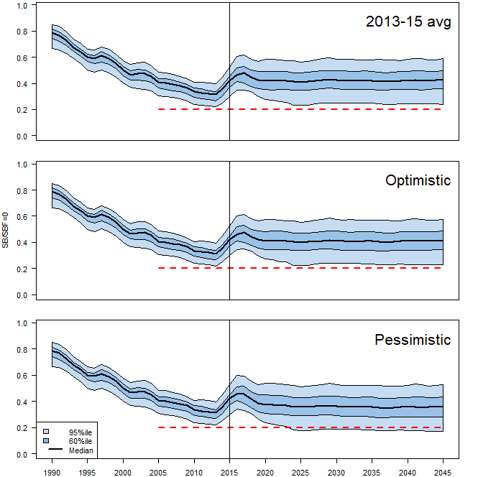 | 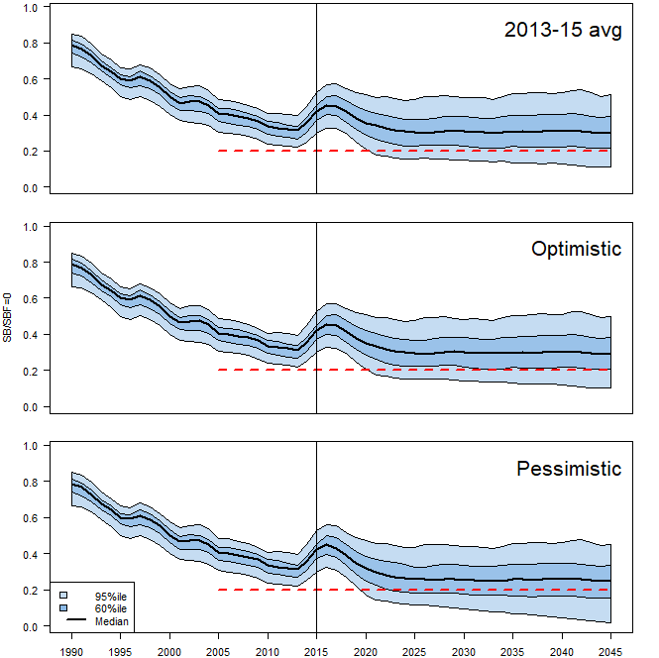
Figure BET-8. Time series of WCPO bigeye tuna spawning biomass (SB/SBF=0) from the uncertainty grid of assessment model runs for the period 1990 to 2015 (the vertical line at 2015 represents the last year of the assessment), and stochastic projection results for the period 2016 to 2045 under the three future fishing scenarios (“2013-15 avg”, “Optimistic” and “Pessimistic”; rows). During the projection period (2016-2045) levels of recruitment variability are assumed to match those over the “recent” time period (2005-2014; left panel) or the time period used to estimate the stock-recruitment relationship (1962-2014; right panel). The red dashed line represents the agreed limit reference point.

- Management advice and implications

- SC14 noted that the preliminary estimate of total catch of WCPO bigeye tuna for 2017 was 126,929t, a 17% decrease from 2016 and a 19% decrease from the average 2012-2016. Longline catch in 2017 (58,164t) was an 8% decrease from 2016 and a 19% decrease from the 2012-2016 average. Purse seine catch in 2017 (56,194t) was a 12% decrease from 2016 and a 13% decrease from the 2012-2016 average. Pole and line catch (1,411t) was a 65% decrease from 2016 and a 70% decrease from the average 2012-2016 catch. Catch by other gear (11,160t) was a 48% decrease from 2016 and 28% decrease from the average catch in 2012-2016.

- Based on the uncertainty grid adopted by SC14, the WCPO bigeye tuna spawning biomass is above the biomass LRP and recent F is very likely below FMSY. The stock is not experiencing overfishing (94% probability F<F_{MSY}) and it is not in an overfished condition (0% probability SB/SB_{F=0}<LRP).

- Although SC14 considers that the updated assessment is consistent with the previous assessment, SC14 also advises that the amount of uncertainty in the stock status results for the 2018 assessment update is lower than for the previous assessment due to the exclusion of old information on bigeye tuna growth.

- SC14 noted that levels of fishing mortality and depletion differ among regions, and that fishery impact was higher in the tropical region (Regions 3, 4, 7 and 8 in the stock assessment model), with particularly high fishing mortality on juvenile bigeye tuna in these regions. SC14 therefore recommends that WCPFC15 could continue to consider measures to reduce fishing mortality from fisheries that take juveniles, with the goal to increase bigeye fishery yields and reduce any further impacts on the spawning biomass for this stock in the tropical regions.

- SC14 noted that according to CMM-17-01 bigeye tuna SB/SB_{F=0} is to be maintained above the 2012-2015 level (SB_{recent}/SB_{F=0} = 0.36; Table BET-3) pending the agreement on a TRP. SC14 also noted that the projection results based on scenarios estimating CMM2017-01 indicated a high level of uncertainty on the levels of spawning stock biomass relative to the LRP and the objective of CMM-2017-01 in 2045. Under the scenario assuming long-term average recruitment continues into the future there was a high risk (add value) of breaching the LRPs and a zero probability of achieving the objective of CMM-2017-01, while under the scenario which assumes higher more recent recruitments continues into the future there was a low risk (add value) of breaching the LRPs and a 100% probability of achieving the objective of CMM-2017-01.

- However, SC14 also noted that the projections assume that longline catches would be maintained regardless of the decrease in biomass. This may result in unlikely high levels of effort. Therefore, the catch estimates under the long-term recruitment scenario, especially in the longer term projections, are more uncertain.

- Based on these results, SC14 recommends that WCPFC15 takes note of the results of the projections in relation achieving CMM-2017-01 and as a precautionary approach that the fishing mortality on bigeye tuna stock should not be increased from the recent average (2011-2014) level to maintain spawning biomass at or above the 2012-2015 average, until the Commission can articulate the management objectives and agree on an appropriate target reference point (TRP) for BET, although one CCM considers that SC14 could provide more options for the commission to consider.

- Research Recommendations

- SC14 noted that the acceptance of the new growth model for BET raises a number of issues in relation to patterns of growth and stock structure of BET across the Pacific Ocean and recommended that the following research issues need to be addressed:

- Two different growth models separated at 150˚W effectively means that Pacific BET should be assessed as a two-stock resource between the WCPO and EPO. However, catch information indicates that the fishing grounds near 150˚W are a core area of BET catch, thus influencing the assessments of both the WCPFC and IATTC. Also, tagging information suggests movement of BET between the WCPO and EPO. Therefore, the appropriateness off delineating the two stocks at 150˚W needs to be investigated.
- The new growth analysis suggests area variant growth across the Pacific. While the level of variation is seen to be relatively small within the WCPO (and possibly within the margins of observation error), there is a suggestion of substantial change in growth around the boundary between the WCPO and the EPO (c.f. Figure 14 in SA-WP-01). The reasons for this suggested change in growth remains unknown, but SC14 noted the utility of collecting more information from the regions either side of this boundary to inform a greater understanding of possible changes in growth around this area. While the incorporation of area-variant growth within the assessment model would also help explore this issue, SC14 noted the difficulty of this task.
- SC11 concluded that the stock status of WCPO BET from the Pan-Pacific assessment and the WCPO-only assessment were similar when the growth models were similar in the EPO and WCPO. This conclusion needs to be revisited in light of the different growth between EPO and WCPO by adopting the new growth.

- The following additional research activities were also recommended by SC14 in order to improve the understanding of the age and growth of BET across the Pacific:

- A WCPO growth model based on size composition and tagging data, as well as the use of additional modeling approaches (e.g., length-conditional), should also be evaluated.
- Collaboration with the IATTC to analyze bigeye growth from otolith and tagging data collected across the entire Pacific, to better characterize the apparent regional difference in growth between the WCPO and EPO, and possible environmental determinants of such differences.
- Analyzing the same otoliths by different laboratories, to build confidence in ageing estimates and to estimate ageing error.
- Continued development of a high-confidence tagging dataset for growth analysis, with particular focus on larger bigeye tuna and events with reliable measurements at release. Such data would assist with the validation of the age estimates of large bigeye in the WCPO and could potentially be incorporated directly into the assessment model as an additional data set. However, a reliable measurement of both length at release and recapture are necessary to accurately estimate incremental growth.
- Collect otoliths of very small bigeye that are captured by the Indonesian, Vietnamese, and Philippines domestic fisheries in region 7 and estimate age through daily ring counts to aid in the estimation of the size at age-1 qtr⁻¹ parameter (L1) within the assessment model.

SC13 2017 (STOCK ASSESSMENT CONDUCTED)

- Stock status and trends

- The median values of relative recent (2012-2015) spawning biomass (SBrecent/ SBF=0) and relative recent fishing mortality (Frecent/FMSY) over the uncertainty grid were used to measure the central tendency of stock status. The values of the upper 90th and lower 10th percentiles of the empirical distributions of relative spawning biomass and relative fishing mortality from the uncertainty grid were used to characterize the probable range of stock status.

- A description of the updated structural sensitivity grid used to characterize uncertainty in the assessment was set out in Table BET-1. Time series of total annual catch by fishing gear for the diagnostic case model over the full assessment period is shown in Figure BET-1. Estimated annual average recruitment, spawning potential, juvenile and adult fishing mortality and fishing depletion for the diagnostic case model are shown in Figures BET-2 – BET-5. Figures BET-6 and BET-7 display Majuro plots summarising the results for each of the models in the structural uncertainty grid. Figures BET-8 and BET-9 show Kobe plots summarising the results for each of the models in the structural uncertainty grid. Figure BET-10 provides estimated time-series (or “dynamic”) Majuro and Kobe plots from the bigeye ‘diagnostic case’ model run. Figure BET-11 provides estimates of reduction in spawning potential due to fishing by region, and over all regions attributed to various fishery groups (gear-types) for the diagnostic case model. Table BET-2 provides a summary of reference points over the 72 models in the structural uncertainty grid.

Table BET-1. Description of the updated structural sensitivity grid used to characterize uncertainty in the assessment.
Axis | Levels | Option
Steepness | 3 | 0.65, 0.80, 0.95
Growth | 2 | ‘Old growth’, ‘New growth’
Tagging over-dispersion | 2 | Default level (1), fixed (moderate) level
Size frequency weighting | 3 | Sample sizes divided by 10, 20, 50
Regional structure | 2 | 2017 regions, 2014 regions

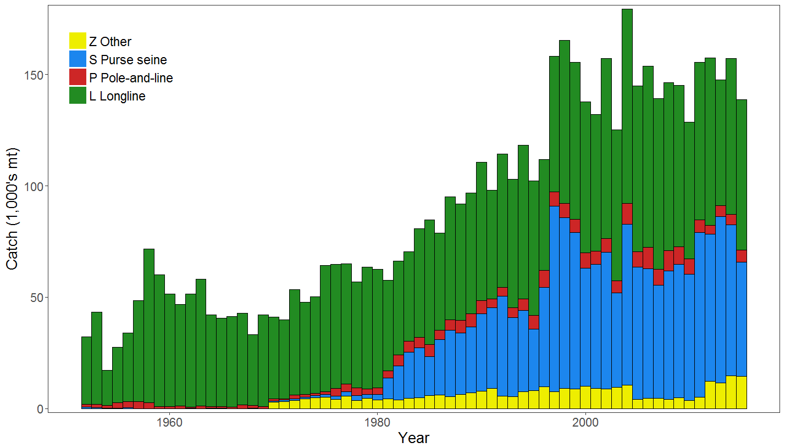
Figure BET-1. Time series of total annual catch (1000's mt) by fishing gear for the diagnostic case model over the full assessment period.

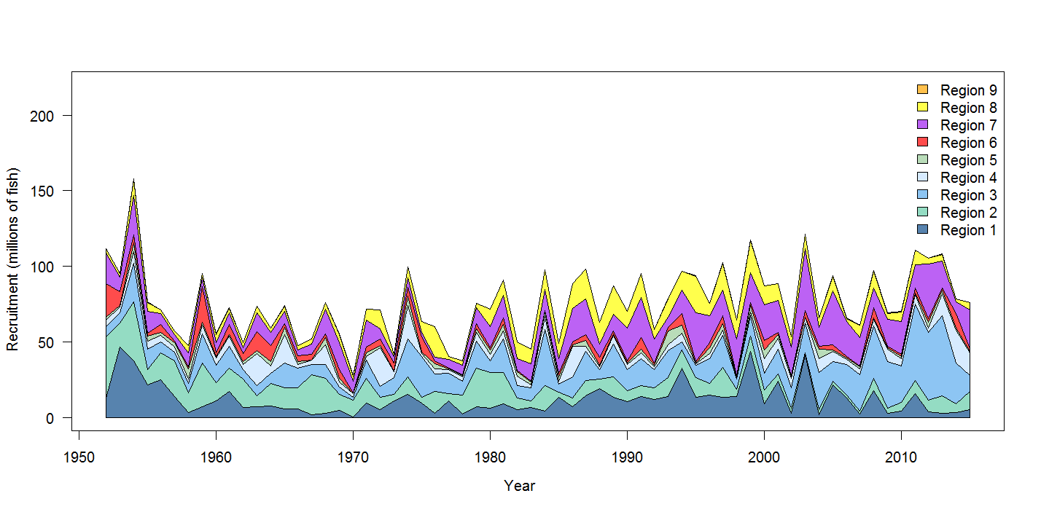
Figure BET-2. Estimated annual average recruitment by model region for the diagnostic case model, showing the relative sizes among regions.

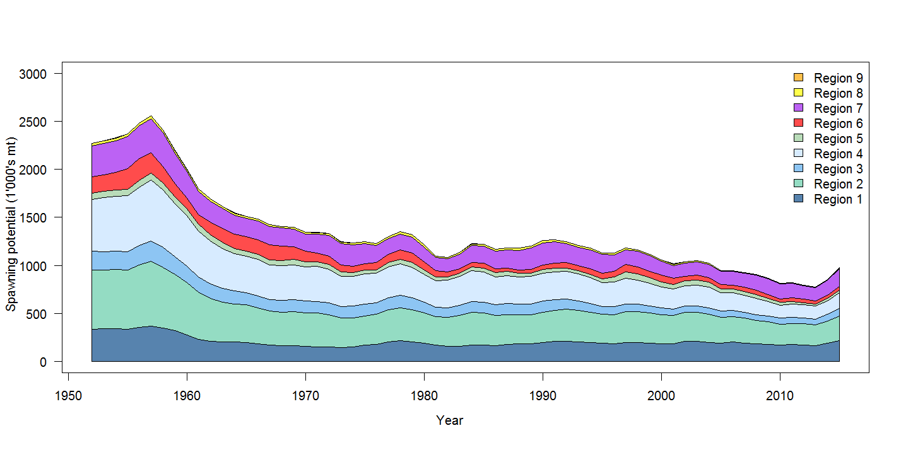
Figure BET-3. Estimated annual average spawning potential by model region for diagnostic case model, showing the relative sizes among regions

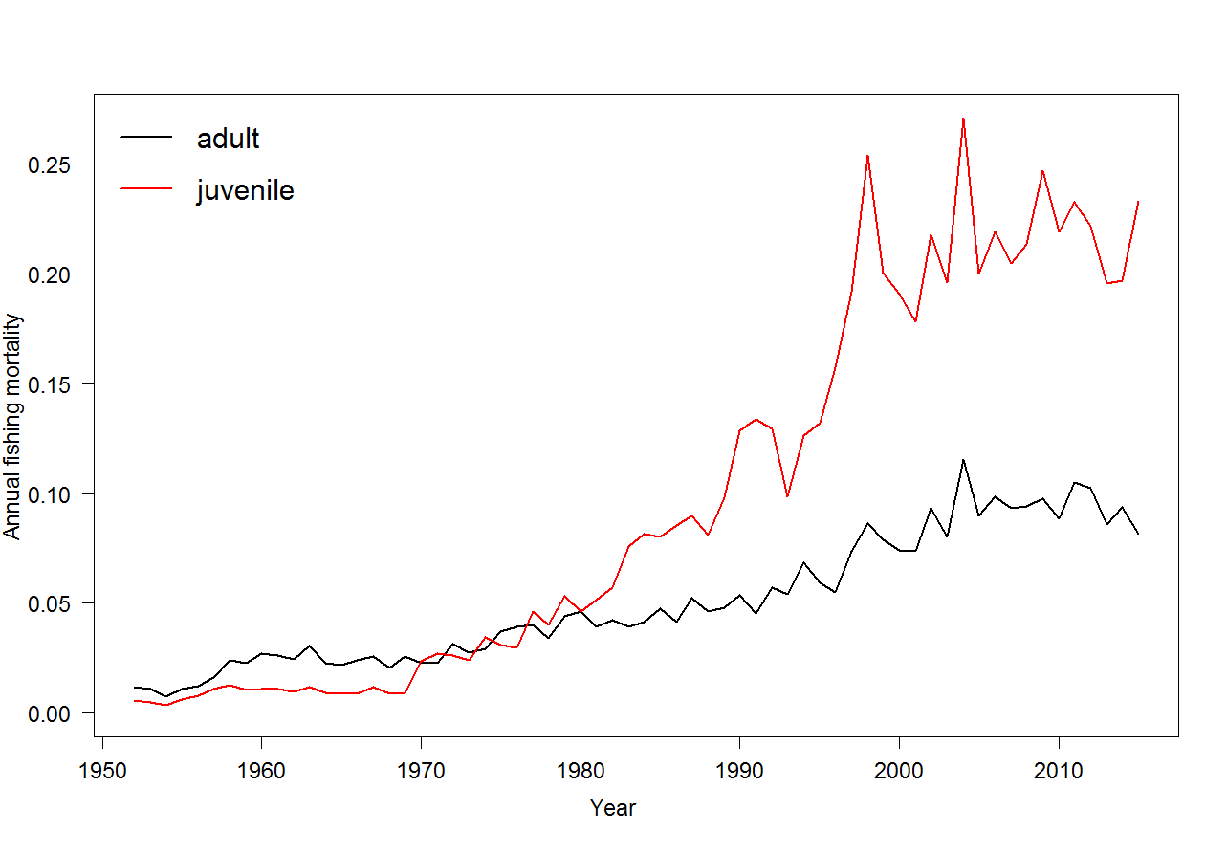
Figure BET-4. Estimated annual average juvenile and adult fishing mortality for the diagnostic case model.

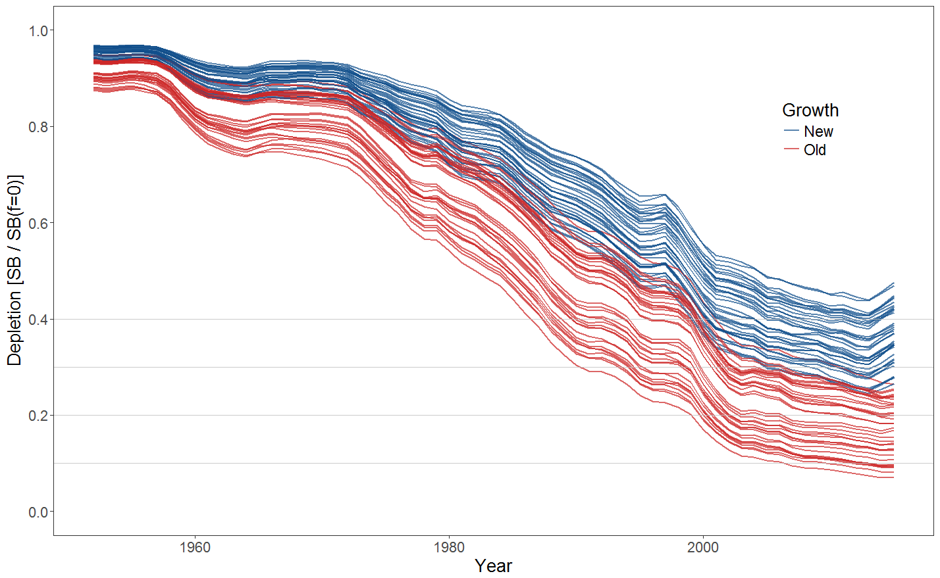
Figure BET-5. Plot showing the trajectories of fishing depletion (of spawning potential) for the 72 model runs included in the structural uncertainty grid. The colours depict the models in the grid with the new and old growth functions.

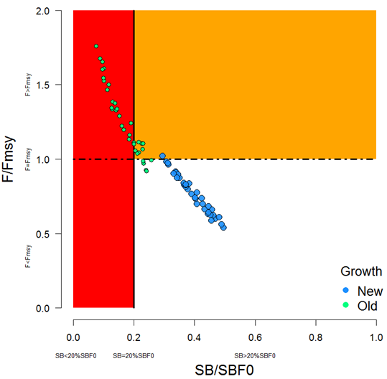 | 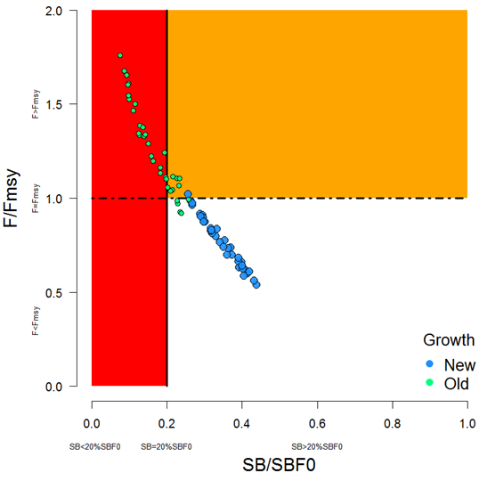
Figure BET-6. Majuro plot summarising the results for each of the models in the structural uncertainty grid. The plots represent estimates of stock status in terms of spawning potential depletion and fishing mortality. The red zone represents spawning potential levels lower than the agreed limit reference point which is marked with the solid black line. The orange region is for fishing mortality greater than F_{MSY} (F_{MSY} is marked with the black dashed line). The points represent SB_{latest}/SB_{F=0} (labelled as SB/SB_{F=0} above), and the colours depict the models in the grid with the new and old growth functions with the size of the points representing the decision of the SC to weight the new growth models three times higher than the old growth models. | Figure BET-7. Majuro plot summarising the results for each of the models in the structural uncertainty grid. The plots represent estimates of stock status in terms of spawning potential depletion and fishing mortality. The red zone represents spawning potential levels lower than the agreed limit reference point which is marked with the solid black line. The orange region is for fishing mortality greater than F_{MSY} (F_{MSY} is marked with the black dashed line). The points represent SB_{recent}/SB_{F=0} (labelled as SB/SB_{F=0} above), where SB_{recent} is the mean SB over 2012-2015 instead of 2011-2014 (used in the stock assessment report), at the request of the Scientific Committee. The colours depict the models in the grid with the new and old growth functions with the size of the points representing the decision of the SC to weight the new growth models three times higher than the old growth models.

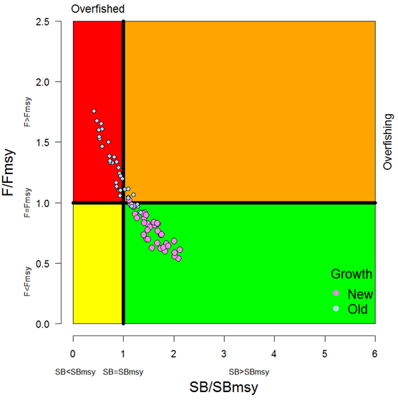 | 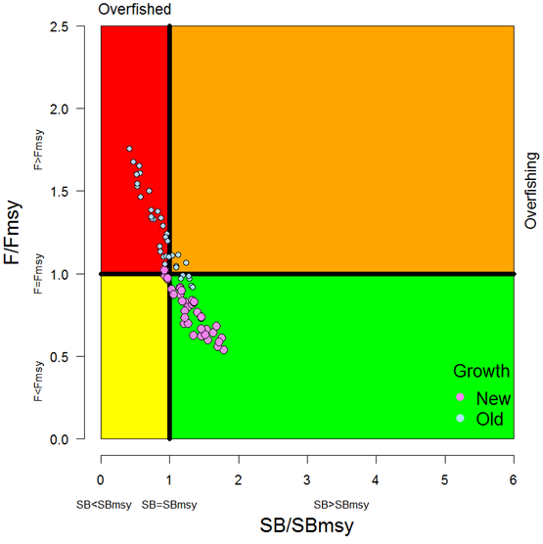
Figure BET8. Kobe plot summarising the results for each of the models in the structural uncertainty grid. The points represent SB_{latest} /SB_{MSY} , with the colours depicting the models in the grid with the new and old growth functions, and the size of the points representing the decision of the SC to weight the new growth models three times higher than the old growth models. | Figure BET-9. Kobe plot summarising the results for each of the models in the structural uncertainty grid. The points represent SB_{recent}/SB_{MSY}, with the colours depicting the models in the grid with the new and old growth functions, and the size of the points representing the decision of the SC to weight the new growth models three times higher than the old growth models.
Figure BET-10. Estimated time-series (or “dynamic”) Majuro and Kobe plots from the bigeye ‘diagnostic case’ model run.

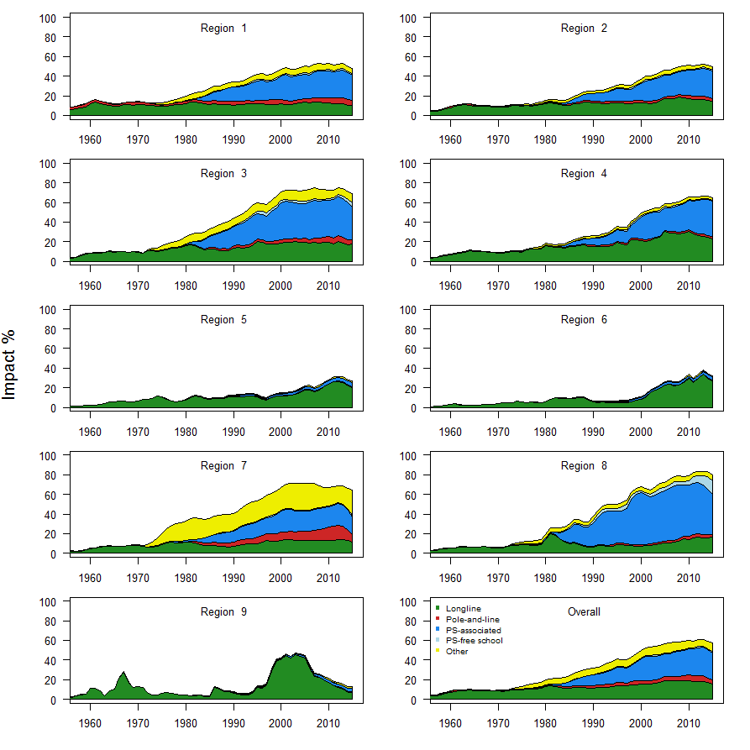
Figure BET-11. Estimates of reduction in spawning potential due to fishing by region, and over all regions (lower right panel), attributed to various fishery groups (gear-types) for the diagnostic case model.

Table BET-2. Summary of reference points over the 72 models in the structural uncertainty grid where the models using the new growth function are given three times the weighting of the models using the old growth function. Note that SB_{recent}/SB_{F=0} is calculated where SB_{recent} is the mean SB over 2012-2015 instead of 2011-2014 (used in the stock assessment report), at the request of the Scientific Committee.
 | Mean | Median | Min | 10% | 90% | Max
C_{latest} | 149,178 | 153,137 | 130,903 | 131,597 | 156,113 | 157,725
MSY | 156,765 | 158,040 | 124,120 | 137,644 | 180,656 | 204,040
Y_{Frecent} | 150,382 | 148,920 | 118,000 | 133,400 | 168,656 | 187,240
F_{mult} | 1.21 | 1.20 | 0.57 | 0.76 | 1.63 | 1.85
F_{MSY} | 0.05 | 0.05 | 0.04 | 0.04 | 0.05 | 0.06
F_{recent}/F_{MSY} | 0.89 | 0.83 | 0.54 | 0.61 | 1.32 | 1.76
SB_{MSY} | 457,162 | 454,100 | 219,500 | 285,530 | 598,210 | 710,000
SB₀ | 1,730,410 | 1,763,000 | 1,009,000 | 1,279,300 | 2,148,200 | 2,509,000
SB_{MSY}/SB₀ | 0.26 | 0.26 | 0.22 | 0.24 | 0.29 | 0.29
SB_{F=0} | 1,915,184 | 1,953,841 | 1,317,336 | 1,584,593 | 2,170,899 | 2,460,411
SB_{MSY}/SB_{F=0} | 0.24 | 0.24 | 0.17 | 0.18 | 0.27 | 0.29
SB_{latest} /SB₀ | 0.37 | 0.40 | 0.11 | 0.19 | 0.49 | 0.53
SB_{latest} /SB_{F=0} | 0.34 | 0.37 | 0.08 | 0.15 | 0.46 | 0.49
SB_{latest} /SB_{MSY} | 1.42 | 1.45 | 0.42 | 0.86 | 1.97 | 2.12
SB_{recent}/SB_{F=0} | 0.30 | 0.32 | 0.08 | 0.15 | 0.41 | 0.44
SB_{recent}/SB_{MSY} | 1.21 | 1.23 | 0.32 | 0.63 | 1.66 | 1.86

- SC13 noted that the central tendency of relative recent spawning biomass under the selected new and old growth curve model weightings was median (SB_{recent}/SB_{F=0}) = 0.32 with a probable range of 0.15 to 0.41 (80% probability interval). This suggested that there was likely a buffer between recent spawning biomass and the LRP but that there was also some probability that recent spawning biomass was below the LRP.

- SC13 also noted that there was a roughly 16% probability (23 out of 144 model weight units) that the recent spawning biomass had breached the adopted LRP with Prob((SB_{recent}/SB_{F=0}) < 0.2) = 0.16. This suggested that there was a high probability (roughly 5 out of 6) that recent bigeye tuna spawning biomass had not breached the adopted spawning biomass limit reference point of 0.2*SB_{F=0}.

- SC13 noted that the central tendency of relative recent fishing mortality under the selected new and old growth curve model weightings was median(F_{recent}/F_{MSY}) = 0.83 with an 80% probability interval of 0.61 to 1.31. While this suggested that there was likely a buffer between recent fishing mortality and F_{MSY}, it also showed that there was some probability that recent fishing mortality was above F_{MSY}.

- SC13 also noted that there was a roughly 23% probability (33 out of 144 model weight units as described in para. 6) that the recent fishing mortality was above F_{MSY} with Prob((F_{recent}/F_{MSY}) > 1) = 0.23. While this suggested that recent fishing mortality was likely below F_{MSY}, there was also a moderate probability (~ 1 out of 4) that recent fishing mortality has exceeded F_{MSY}.

- SC13 noted that the best available information on the stock status of WCPO bigeye tuna has changed in two ways from the previous assessment under the selected weighting of the 2017 assessment uncertainty grid. First, the stock status condition is more positive with a higher central tendency for SB_{recent}/SB_{F=0} in the 2017 assessment (median(SB_{recent}/SB_{F=0}) = 0.32) in comparison to the 2014 assessment ( (SB_{current}/SB_{F=0}) = 0.20) and a lower ratio of relative recent F in the 2017 assessment ( median(F_{recent}/F_{MSY}) = 0.83 ) in comparison to the 2014 assessment ( F_{current}/F_{MSY} = 1.57 ). Second, there is much greater uncertainty in the stock status of bigeye tuna in 2017 due to the fuller technical treatment of structural uncertainty through the use of the model uncertainty grid.

- SC13 noted that the positive changes for bigeye tuna stock status in the 2017 assessment are primarily due to three factors: the inclusion of the new growth curve information, the inclusion of the new regional assessment structure, and the estimated increases in recruitment in recent years. In terms of the cause of the recent increases in recruitment, SC13 commented that it was unclear whether the recent improvement was due to positive oceanographic conditions, effective management measures to conserve spawning biomass, some combination of both, or other factors. SC13 also noted the recent recruitment improvements for yellowfin and skipjack tunas. SC13 also noted recent recruitment improvements for bigeye tuna in the Eastern Pacific Ocean.

- SC13 also noted that, regardless of the choice of uncertainty grid, the assessment results show that the stock has been continuously declining for about 60 years since the late 1950’s, except for the recent small increase suggested in the new growth curve model grid.

- SC13 also noted the continued higher levels of depletion in the equatorial and western Pacific (specifically Regions 3, 4, 7 and 8 of the stock assessment) and the associated higher levels of impact, especially on juvenile bigeye tuna, in these regions due to the associated purse-seine fisheries and the ‘other’ fisheries within the western Pacific (as shown in Figures 35 and 46 of SC13-SA-WP-05).

- SC13 noted that there has been a long-term increase in fishing mortality for both juvenile and adult bigeye tuna, consistent with previous assessments.

- SC13 noted that there has been a long-term decrease in spawning biomass from the 1950s to the present for bigeye tuna and that this is consistent with previous assessments.

- Management advice and implications

- Based on the uncertainty grid adopted by SC13, the WCPO bigeye tuna spawning biomass is likely above the biomass LRP and recent F is likely below F_{MSY}, and therefore noting the level of uncertainties in the current assessment it appears that the stock is not experiencing overfishing (77% probability) and it appears that the stock is not in an overfished condition (84% probability).

- Although SC13 considers that the new assessment is a significant improvement in relation to the previous one, SC13 advises that the amount of uncertainty in the stock status results for the 2017 assessment is higher than for the previous assessment due to the inclusion of new information on bigeye tuna growth and regional structures.

- SC13 also noted that levels of fishing mortality and depletion differ between regions, and that fishery impact was higher in the tropical region (Regions 3, 4, 7 and 8 in the stock assessment model), with particularly high fishing mortality on juvenile bigeye tuna in these regions. SC13 therefore recommends that WCPFC14 could continue to consider measures to reduce fishing mortality from fisheries that take juveniles, with the goal to increase bigeye fishery yields and reduce any further impacts on the spawning potential for this stock in the tropical regions.

- Based on those results, SC13 recommends as a precautionary approach that the fishing mortality on bigeye tuna stock should not be increased from current level to maintain current or increased spawning biomass until the Commission can agree on an appropriate target reference point (TRP).

- Research Recommendations

- SC13 recognized that future work is required to improve the assessment and to reduce uncertainty. Future research should concentrate on the two axes (e.g. growth, regional structure) of uncertainty which are the most influential. The growth analysis should continue with the emphasis on providing length at age estimates for larger fish between 130 and 180 cm FL. Additional research is also required for the regional structure uncertainty to consider options in addition to the structures used in the 2014 and 2017 assessments, for example, by using statistical approaches (e.g. tree models).

- In addition, SC13 considers that the model ensemble or weighting will be increasingly important as SC moves to uncertainty grid approaches in stock assessments and requests the Scientific Services Provider to study those methods further.

- SC13 requested that SPC undertake projections of potential changes in spawning biomass in the future under current levels of fishing mortality. This would be similar to the projections delivered in SC13-SA-IP-22, but would be based on the weighted uncertainty grid as described above.

Useful References

SC15- SA-WP-01 A compendium of fisheries indicators for tuna stocks. https://www.wcpfc.int/node/42927

SC15- SA-WP-02 Project 94: Workshop on yellowfin and bigeye age and growth. https://www.wcpfc.int/node/42928

SC15- SA-IP-19 Report of the Workshop on Age and Growth of Bigeye and Yellowfin Tunas in the Pacific Ocean. https://www.wcpfc.int/node/43329

SC14-SA-WP-01 Update on age and growth of bigeye tuna in the WCPO WCPFC Project 81 Rev 1. https://www.wcpfc.int/node/31012

SC14-SA-WP-03 Incorporation of updated growth information within the 2017 WCPO bigeye stock assessment grid, and examination of the sensitivity of estimates to alternative model spatial structures. https://www.wcpfc.int/node/31047

SC13-SA-WP-01 Project 35: Age, growth and maturity of bigeye tuna in the western and central Pacific Ocean. https://www.wcpfc.int/node/29514

SC13-SA-WP-05 Stock assessment of bigeye tuna in the western and central Pacific Ocean Rev 1 (23 July 2017). https://www.wcpfc.int/node/29518

SC13-SA-IP-06 Background analyses for the 2017 stock assessments of bigeye and yellowfin tuna in the western and central Pacific Ocean. https://www.wcpfc.int/node/29530

SC8-SA-WP-01 Independent (Peer) Review of 2011 WCPO Bigeye Tuna Assessment. https://wcpfc.int/node/3131

Previous Assessments

SC10-SA-WP-00 Minor revisions to the bigeye, skipjack and yellowfin assessment reports (25 July). https://wcpfc.int/node/19146

SC10-SA-WP-01 Stock assessment of bigeye tuna in the western and central Pacific Ocean Rev 1 (25 July 2014). https://wcpfc.int/node/18975

SC7-SA-WP-02 Stock assessment of bigeye tuna in the western and central Pacific Ocean. https://wcpfc.int/node/2785

SC6-SA-WP-04 Stock assessment of bigeye tuna in the western and central Pacific Ocean. https://wcpfc.int/node/2467

SC5-SA-WP-04 Stock assessment of bigeye tuna in the western and central Pacific Ocean. https://wcpfc.int/node/2157

SC4-SA-WP-01 Stock assessment of bigeye tuna in the western and central Pacific Ocean, including an analysis of management options. https://wcpfc.int/node/1219

SC4-SA-WP-02 A preliminary stock assessment of bigeye tuna in the western and central Pacific Ocean using stock synthesis 3 (SS3); A comparison with MULTIFAN-CL. https://wcpfc.int/node/1220

SC2-SA-WP-02 Stock assessment of bigeye tuna in the western and central Pacific Ocean, including an analysis of management options. https://wcpfc.int/node/1747

SC1-SA-WP-02 Stock assessment of bigeye tuna in the Western and Central Pacific Ocean. https://wcpfc.int/node/1883

