Bigeye Tuna (Thunnus obesus)
Stock Status & Trends plus Management Advice and Implications

Contents
SC13 2017 (STOCK ASSESSMENT CONDUCTED) 1
Useful References 13
Previous Assessments 13

SC13 2017 (STOCK ASSESSMENT CONDUCTED)

- Stock status and trends

- The median values of relative recent (2012-2015) spawning biomass (SBrecent/ SBF=0) and relative recent fishing mortality (Frecent/FMSY) over the uncertainty grid were used to measure the central tendency of stock status. The values of the upper 90th and lower 10th percentiles of the empirical distributions of relative spawning biomass and relative fishing mortality from the uncertainty grid were used to characterize the probable range of stock status.
- A description of the updated structural sensitivity grid used to characterize uncertainty in the assessment was set out in Table BET-1. Time series of total annual catch by fishing gear for the diagnostic case model over the full assessment period is shown in Figure BET-1. Estimated annual average recruitment, spawning potential, juvenile and adult fishing mortality and fishing depletion for the diagnostic case model are shown in Figures BET-2 – BET-5. Figures BET-6 and BET-7 display Majuro plots summarising the results for each of the models in the structural uncertainty grid. Figures BET-8 and BET-9 show Kobe plots summarising the results for each of the models in the structural uncertainty grid. Figure BET-10 provides estimated time-series (or “dynamic”) Majuro and Kobe plots from the bigeye ‘diagnostic case’ model run. Figure BET-11 provides estimates of reduction in spawning potential due to fishing by region, and over all regions attributed to various fishery groups (gear-types) for the diagnostic case model. Table BET-2 provides a summary of reference points over the 72 models in the structural uncertainty grid.

Table BET-1. Description of the updated structural sensitivity grid used to characterize uncertainty in the assessment.
Axis | Levels | Option
Steepness | 3 | 0.65, 0.80, 0.95
Growth | 2 | ‘Old growth’, ‘New growth’
Tagging over-dispersion | 2 | Default level (1), fixed (moderate) level
Size frequency weighting | 3 | Sample sizes divided by 10, 20, 50
Regional structure | 2 | 2017 regions, 2014 regions

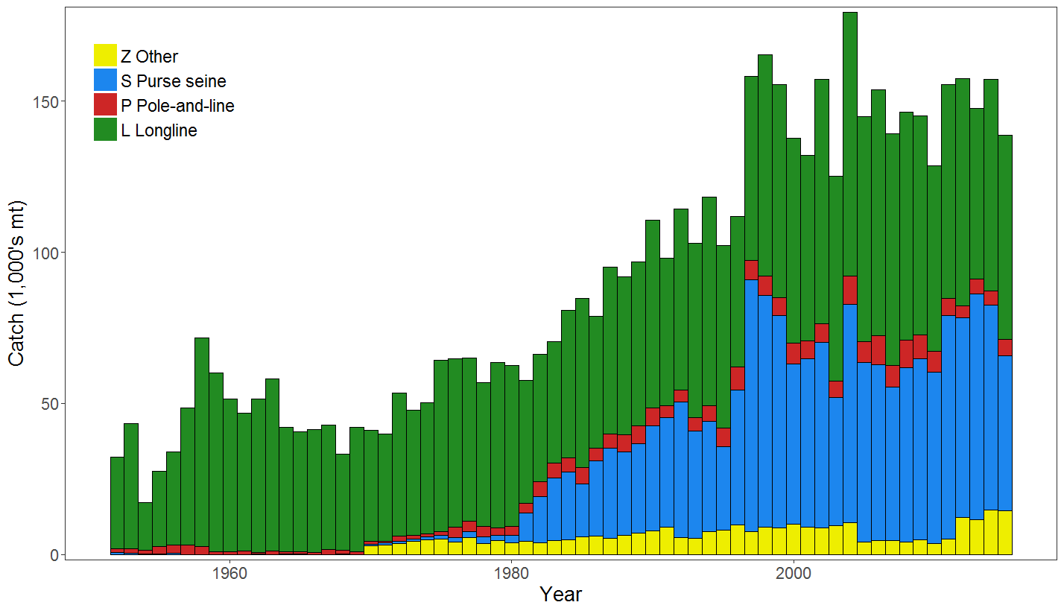
Figure BET-1. Time series of total annual catch (1000's mt) by fishing gear for the diagnostic case model over the full assessment period.

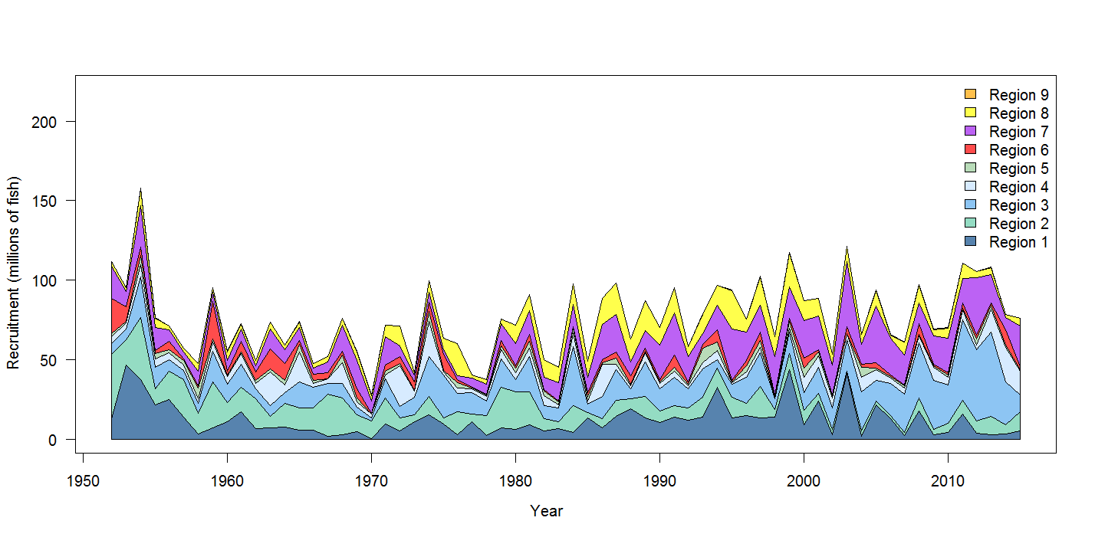
Figure BET-2. Estimated annual average recruitment by model region for the diagnostic case model, showing the relative sizes among regions.

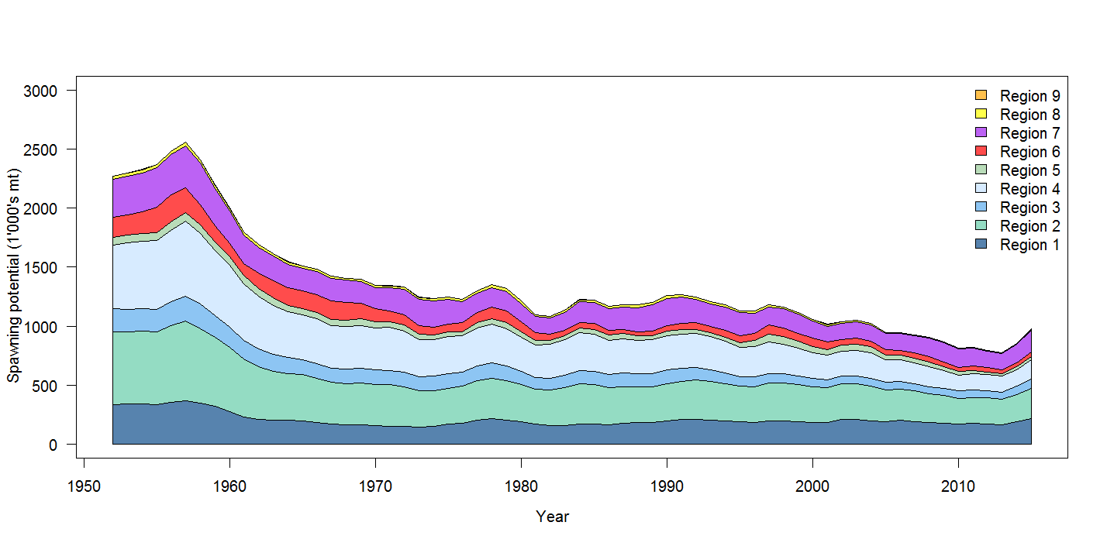
Figure BET-3. Estimated annual average spawning potential by model region for diagnostic case model, showing the relative sizes among regions

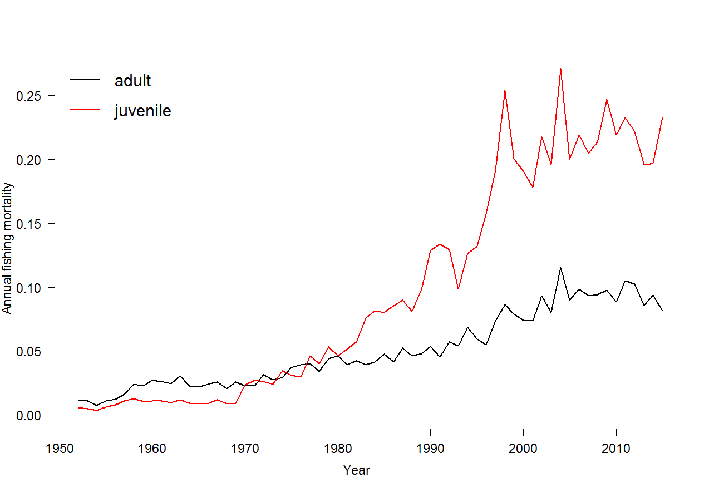
Figure BET-4. Estimated annual average juvenile and adult fishing mortality for the diagnostic case model.

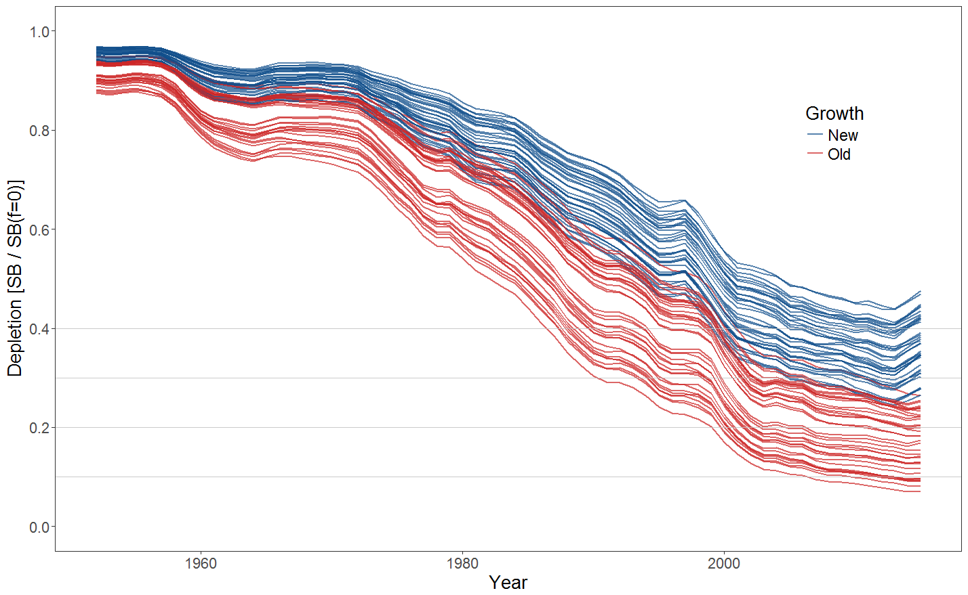
Figure BET-5. Plot showing the trajectories of fishing depletion (of spawning potential) for the 72 model runs included in the structural uncertainty grid. The colours depict the models in the grid with the new and old growth functions.

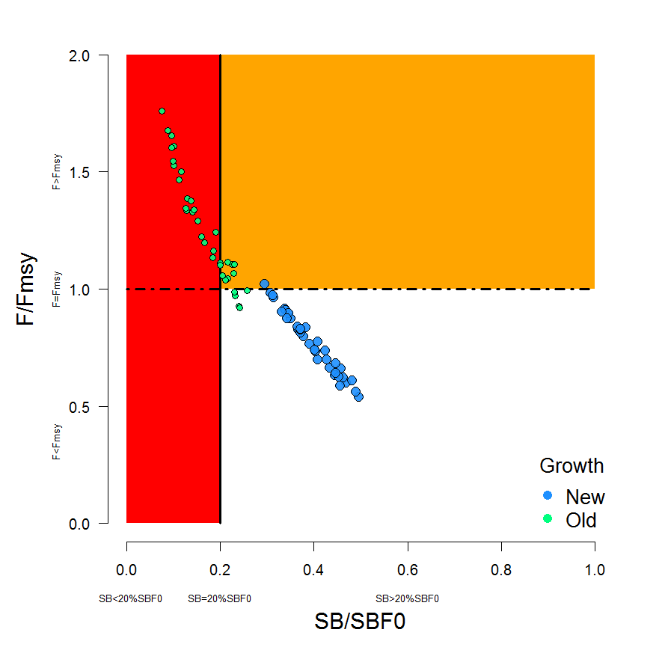
Figure BET-6. Majuro plot summarising the results for each of the models in the structural uncertainty grid. The plots represent estimates of stock status in terms of spawning potential depletion and fishing mortality. The red zone represents spawning potential levels lower than the agreed limit reference point which is marked with the solid black line. The orange region is for fishing mortality greater than F_{MSY} (F_{MSY} is marked with the black dashed line). The points represent SB_{latest}/SB_{F=0} (labelled as SB/SB_{F=0} above), and the colours depict the models in the grid with the new and old growth functions with the size of the points representing the decision of the SC to weight the new growth models three times higher than the old growth models.

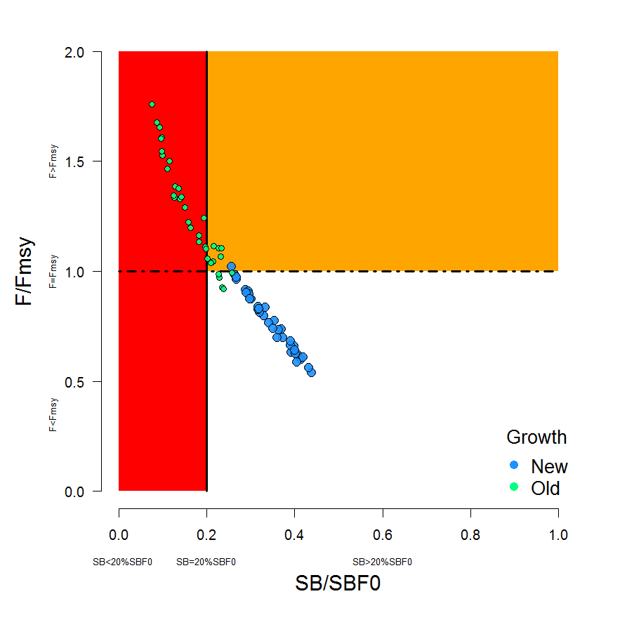
Figure BET-7. Majuro plot summarising the results for each of the models in the structural uncertainty grid. The plots represent estimates of stock status in terms of spawning potential depletion and fishing mortality. The red zone represents spawning potential levels lower than the agreed limit reference point which is marked with the solid black line. The orange region is for fishing mortality greater than F_{MSY} (F_{MSY} is marked with the black dashed line). The points represent SB_{recent}/SB_{F=0} (labelled as SB/SB_{F=0} above), where SB_{recent} is the mean SB over 2012-2015 instead of 2011-2014 (used in the stock assessment report), at the request of the Scientific Committee. The colours depict the models in the grid with the new and old growth functions with the size of the points representing the decision of the SC to weight the new growth models three times higher than the old growth models.

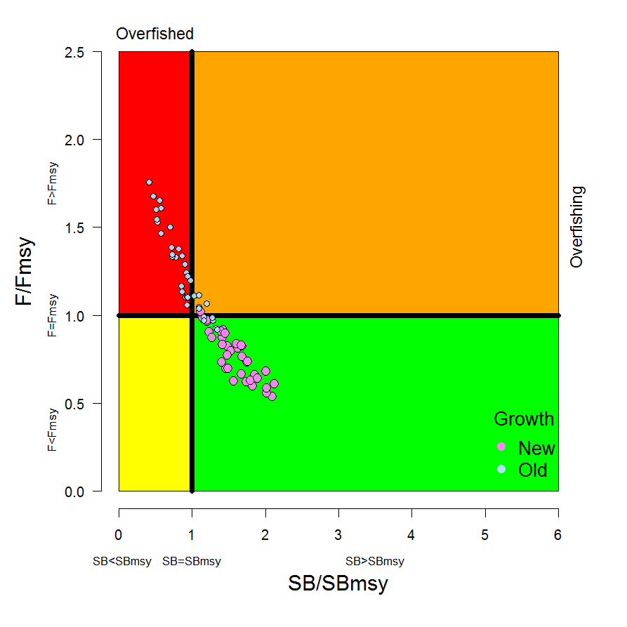
Figure BET8. Kobe plot summarising the results for each of the models in the structural uncertainty grid. The points represent SB_{latest} /SB_{MSY} , with the colours depicting the models in the grid with the new and old growth functions, and the size of the points representing the decision of the SC to weight the new growth models three times higher than the old growth models.

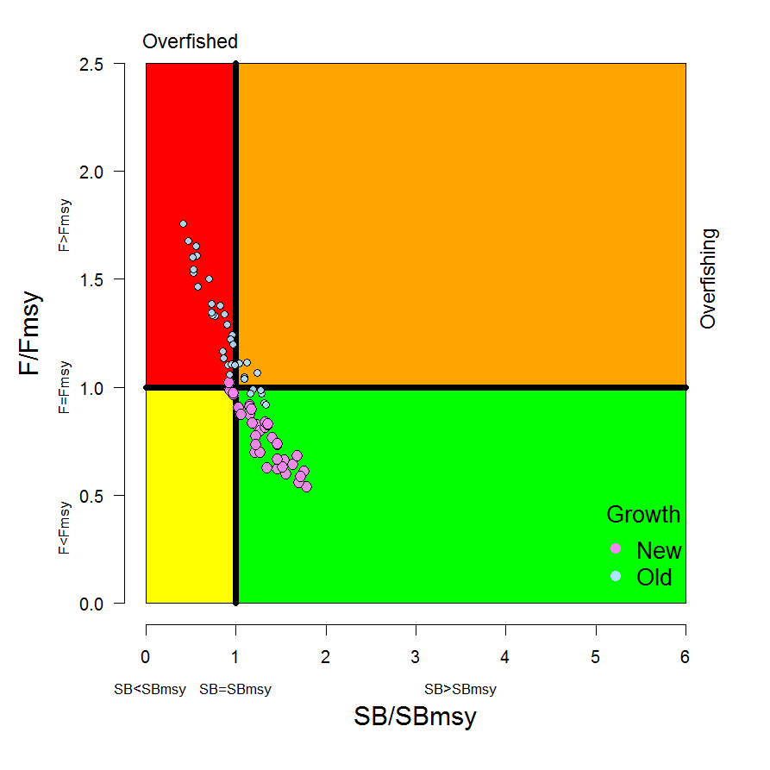
Figure BET-9. Kobe plot summarising the results for each of the models in the structural uncertainty grid. The points represent SB_{recent}/SB_{MSY}, with the colours depicting the models in the grid with the new and old growth functions, and the size of the points representing the decision of the SC to weight the new growth models three times higher than the old growth models.

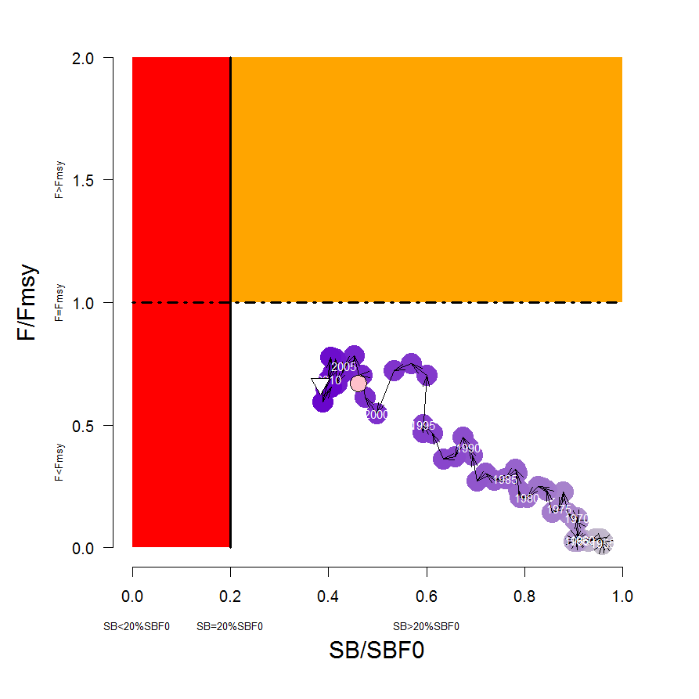
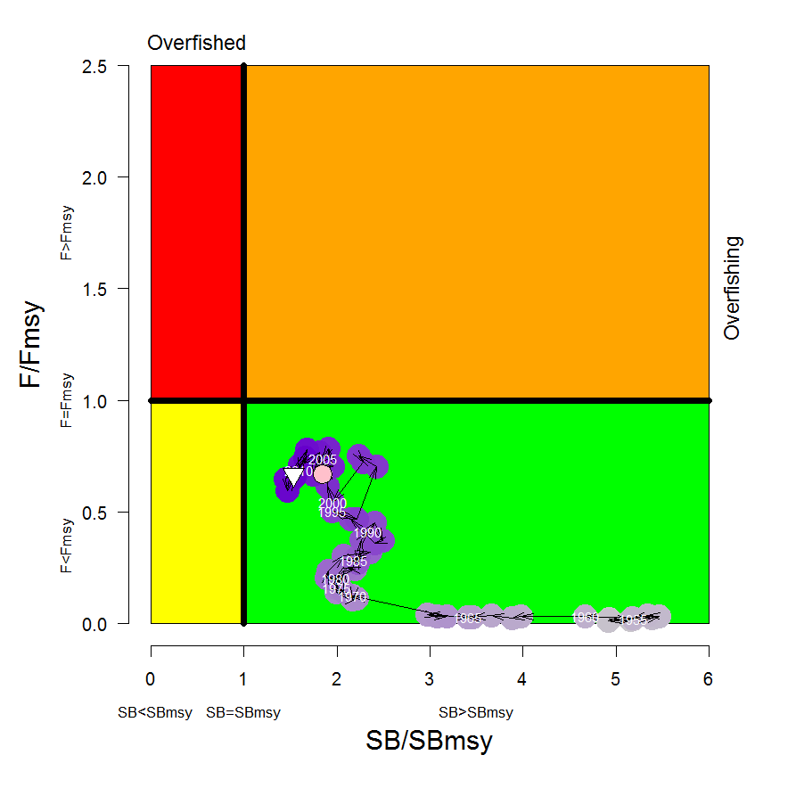
Figure BET-10. Estimated time-series (or “dynamic”) Majuro and Kobe plots from the bigeye ‘diagnostic case’ model run.
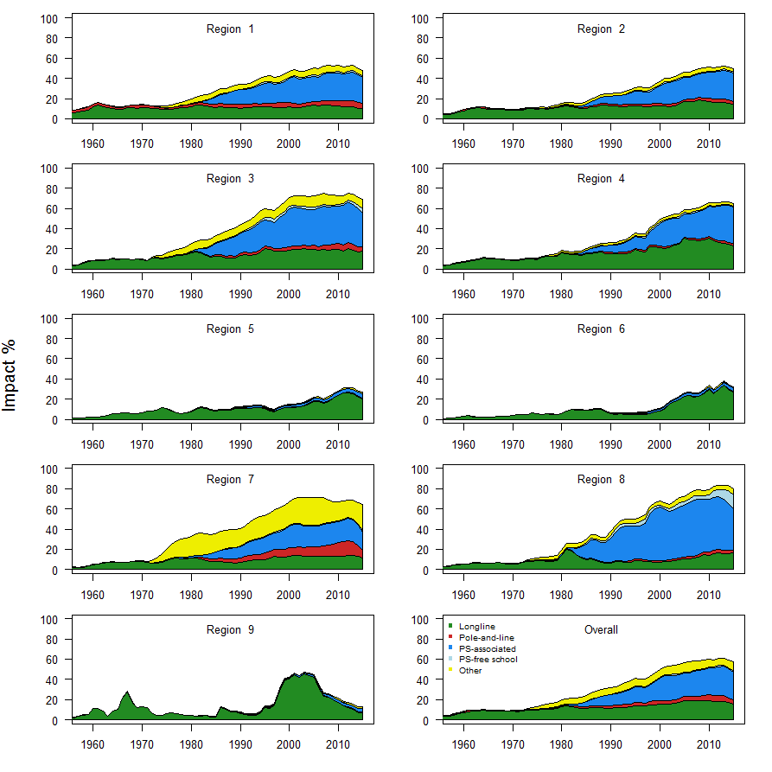
Figure BET-11. Estimates of reduction in spawning potential due to fishing by region, and over all regions (lower right panel), attributed to various fishery groups (gear-types) for the diagnostic case model.

Table BET-2. Summary of reference points over the 72 models in the structural uncertainty grid where the models using the new growth function are given three times the weighting of the models using the old growth function. Note that SB_{recent}/SB_{F=0} is calculated where SB_{recent} is the mean SB over 2012-2015 instead of 2011-2014 (used in the stock assessment report), at the request of the Scientific Committee.
 | Mean | Median | Min | 10% | 90% | Max
C_{latest} | 149,178 | 153,137 | 130,903 | 131,597 | 156,113 | 157,725
MSY | 156,765 | 158,040 | 124,120 | 137,644 | 180,656 | 204,040
Y_{Frecent} | 150,382 | 148,920 | 118,000 | 133,400 | 168,656 | 187,240
F_{mult} | 1.21 | 1.20 | 0.57 | 0.76 | 1.63 | 1.85
F_{MSY} | 0.05 | 0.05 | 0.04 | 0.04 | 0.05 | 0.06
F_{recent}/F_{MSY} | 0.89 | 0.83 | 0.54 | 0.61 | 1.32 | 1.76
SB_{MSY} | 457,162 | 454,100 | 219,500 | 285,530 | 598,210 | 710,000
SB₀ | 1,730,410 | 1,763,000 | 1,009,000 | 1,279,300 | 2,148,200 | 2,509,000
SB_{MSY}/SB₀ | 0.26 | 0.26 | 0.22 | 0.24 | 0.29 | 0.29
SB_{F=0} | 1,915,184 | 1,953,841 | 1,317,336 | 1,584,593 | 2,170,899 | 2,460,411
SB_{MSY}/SB_{F=0} | 0.24 | 0.24 | 0.17 | 0.18 | 0.27 | 0.29
SB_{latest} /SB₀ | 0.37 | 0.40 | 0.11 | 0.19 | 0.49 | 0.53
SB_{latest} /SB_{F=0} | 0.34 | 0.37 | 0.08 | 0.15 | 0.46 | 0.49
SB_{latest} /SB_{MSY} | 1.42 | 1.45 | 0.42 | 0.86 | 1.97 | 2.12
SB_{recent}/SB_{F=0} | 0.30 | 0.32 | 0.08 | 0.15 | 0.41 | 0.44
SB_{recent}/SB_{MSY} | 1.21 | 1.23 | 0.32 | 0.63 | 1.66 | 1.86

- SC13 noted that the central tendency of relative recent spawning biomass under the selected new and old growth curve model weightings was median (SB_{recent}/SB_{F=0}) = 0.32 with a probable range of 0.15 to 0.41 (80% probability interval). This suggested that there was likely a buffer between recent spawning biomass and the LRP but that there was also some probability that recent spawning biomass was below the LRP.

- SC13 also noted that there was a roughly 16% probability (23 out of 144 model weight units) that the recent spawning biomass had breached the adopted LRP with Prob((SB_{recent}/SB_{F=0}) < 0.2) = 0.16. This suggested that there was a high probability (roughly 5 out of 6) that recent bigeye tuna spawning biomass had not breached the adopted spawning biomass limit reference point of 0.2*SB_{F=0}.

- SC13 noted that the central tendency of relative recent fishing mortality under the selected new and old growth curve model weightings was median(F_{recent}/F_{MSY}) = 0.83 with an 80% probability interval of 0.61 to 1.31. While this suggested that there was likely a buffer between recent fishing mortality and F_{MSY}, it also showed that there was some probability that recent fishing mortality was above F_{MSY}.

- SC13 also noted that there was a roughly 23% probability (33 out of 144 model weight units as described in para. 6) that the recent fishing mortality was above F_{MSY} with Prob((F_{recent}/F_{MSY}) > 1) = 0.23. While this suggested that recent fishing mortality was likely below F_{MSY}, there was also a moderate probability (~ 1 out of 4) that recent fishing mortality has exceeded F_{MSY}.

- SC13 noted that the best available information on the stock status of WCPO bigeye tuna has changed in two ways from the previous assessment under the selected weighting of the 2017 assessment uncertainty grid. First, the stock status condition is more positive with a higher central tendency for SB_{recent}/SB_{F=0} in the 2017 assessment (median(SB_{recent}/SB_{F=0}) = 0.32) in comparison to the 2014 assessment ( (SB_{current}/SB_{F=0}) = 0.20) and a lower ratio of relative recent F in the 2017 assessment ( median(F_{recent}/F_{MSY}) = 0.83 ) in comparison to the 2014 assessment ( F_{current}/F_{MSY} = 1.57 ). Second, there is much greater uncertainty in the stock status of bigeye tuna in 2017 due to the fuller technical treatment of structural uncertainty through the use of the model uncertainty grid.

- SC13 noted that the positive changes for bigeye tuna stock status in the 2017 assessment are primarily due to three factors: the inclusion of the new growth curve information, the inclusion of the new regional assessment structure, and the estimated increases in recruitment in recent years. In terms of the cause of the recent increases in recruitment, SC13 commented that it was unclear whether the recent improvement was due to positive oceanographic conditions, effective management measures to conserve spawning biomass, some combination of both, or other factors. SC13 also noted the recent recruitment improvements for yellowfin and skipjack tunas. SC13 also noted recent recruitment improvements for bigeye tuna in the Eastern Pacific Ocean.

- SC13 also noted that, regardless of the choice of uncertainty grid, the assessment results show that the stock has been continuously declining for about 60 years since the late 1950’s, except for the recent small increase suggested in the new growth curve model grid.

- SC13 also noted the continued higher levels of depletion in the equatorial and western Pacific (specifically Regions 3, 4, 7 and 8 of the stock assessment) and the associated higher levels of impact, especially on juvenile bigeye tuna, in these regions due to the associated purse-seine fisheries and the ‘other’ fisheries within the western Pacific (as shown in Figures 35 and 46 of SC13-SA-WP-05).

- SC13 noted that there has been a long-term increase in fishing mortality for both juvenile and adult bigeye tuna, consistent with previous assessments.

- SC13 noted that there has been a long-term decrease in spawning biomass from the 1950s to the present for bigeye tuna and that this is consistent with previous assessments.

- Management advice and implications

- Based on the uncertainty grid adopted by SC13, the WCPO bigeye tuna spawning biomass is likely above the biomass LRP and recent F is likely below F_{MSY}, and therefore noting the level of uncertainties in the current assessment it appears that the stock is not experiencing overfishing (77% probability) and it appears that the stock is not in an overfished condition (84% probability).

- Although SC13 considers that the new assessment is a significant improvement in relation to the previous one, SC13 advises that the amount of uncertainty in the stock status results for the 2017 assessment is higher than for the previous assessment due to the inclusion of new information on bigeye tuna growth and regional structures.

- SC13 also noted that levels of fishing mortality and depletion differ between regions, and that fishery impact was higher in the tropical region (Regions 3, 4, 7 and 8 in the stock assessment model), with particularly high fishing mortality on juvenile bigeye tuna in these regions. SC13 therefore recommends that WCPFC14 could continue to consider measures to reduce fishing mortality from fisheries that take juveniles, with the goal to increase bigeye fishery yields and reduce any further impacts on the spawning potential for this stock in the tropical regions.

- Based on those results, SC13 recommends as a precautionary approach that the fishing mortality on bigeye tuna stock should not be increased from current level to maintain current or increased spawning biomass until the Commission can agree on an appropriate target reference point (TRP).

Research Recommendations

- SC13 recognized that future work is required to improve the assessment and to reduce uncertainty. Future research should concentrate on the two axes (e.g. growth, regional structure) of uncertainty which are the most influential. The growth analysis should continue with the emphasis on providing length at age estimates for larger fish between 130 and 180 cm FL. Additional research is also required for the regional structure uncertainty to consider options in addition to the structures used in the 2014 and 2017 assessments, for example, by using statistical approaches (e.g. tree models).

- In addition, SC13 considers that the model ensemble or weighting will be increasingly important as SC moves to uncertainty grid approaches in stock assessments and requests the Scientific Services Provider to study those methods further.

- SC13 requested that SPC undertake projections of potential changes in spawning biomass in the future under current levels of fishing mortality. This would be similar to the projections delivered in SC13-SA-IP-22, but would be based on the weighted uncertainty grid as described above.

Useful References

SC13-SA-WP-01 Project 35: Age, growth and maturity of bigeye tuna in the western and central Pacific Ocean. https://www.wcpfc.int/node/29514

SC13-SA-WP-05 Stock assessment of bigeye tuna in the western and central Pacific Ocean Rev 1 (23 July 2017). https://www.wcpfc.int/node/29518

SC13-SA-IP-06 Background analyses for the 2017 stock assessments of bigeye and yellowfin tuna in the western and central Pacific Ocean. https://www.wcpfc.int/node/29530

SC8-SA-WP-01 Independent (Peer) Review of 2011 WCPO Bigeye Tuna Assessment. https://wcpfc.int/node/3131

Previous Assessments

SC10-SA-WP-00 Minor revisions to the bigeye, skipjack and yellowfin assessment reports (25 July). https://wcpfc.int/node/19146

SC10-SA-WP-01 Stock assessment of bigeye tuna in the western and central Pacific Ocean Rev 1 (25 July 2014). https://wcpfc.int/node/18975

SC7-SA-WP-02 Stock assessment of bigeye tuna in the western and central Pacific Ocean. https://wcpfc.int/node/2785

SC6-SA-WP-04 Stock assessment of bigeye tuna in the western and central Pacific Ocean. https://wcpfc.int/node/2467

SC5-SA-WP-04 Stock assessment of bigeye tuna in the western and central Pacific Ocean. https://wcpfc.int/node/2157

SC4-SA-WP-01 Stock assessment of bigeye tuna in the western and central Pacific Ocean, including an analysis of management options. https://wcpfc.int/node/1219

SC4-SA-WP-02 A preliminary stock assessment of bigeye tuna in the western and central Pacific Ocean using stock synthesis 3 (SS3); A comparison with MULTIFAN-CL. https://wcpfc.int/node/1220

SC2-SA-WP-02 Stock assessment of bigeye tuna in the western and central Pacific Ocean, including an analysis of management options. https://wcpfc.int/node/1747

SC1-SA-WP-02 Stock assessment of bigeye tuna in the Western and Central Pacific Ocean. https://wcpfc.int/node/1883

