The Commission for the Conservation and Management of
Highly Migratory Fish Stocks in the Western and Central Pacific Ocean

Scientific Committee

WCPO Yellowfin Tuna (Thunnus albacares)

Stock Status and Management Advice

Contents
SC16 2020 (STOCK ASSESSMENT CONDUCTED) 2
SC15 2019 (FISHERY INDICATORS UPDATED) 12
SC14 2018 (FISHERY INDICATORS UPDATED) 13
SC13 2017 (STOCK ASSESSMENT CONDUCTED) 14
References 24

SC16 2020 (STOCK ASSESSMENT CONDUCTED)

- Stock Status and trends

- The median values of relative recent (2015-2018) spawning biomass depletion (SB_{recent}/ SB_{F=0}) and relative recent (2014-2017) fishing mortality (F_{recent}/F_{MSY}) over the uncertainty grid of 72 models (Table YFT-1) were used to define stock status. The values of the upper 90thand lower 10thpercentiles of the empirical distributions of relative spawning biomass and relative fishing mortality from the uncertainty grid were used to characterize the probable range of stock status.

- A description of the updated structural sensitivity grid used to characterize uncertainty in the assessment is illustrated in Table YFT-1. The spatial structure used in the 2020 stock assessment is shown in Figure YFT-1. Time series of total annual catch by fishing gear over the full assessment period is shown in Figure YFT-2. The time series of total annual catch by fishing gear and assessment region is shown in Figure YFT-3. Estimated annual average recruitment, spawning potential, and total biomass by model region is shown in Figure YFT-4. Estimated trends in spawning biomass depletion for the 72 models in the structural uncertainty grid is shown in Figure YFT-5, and juvenile and adult fishing mortality rates from the diagnostic model is shown in Figure YFT-6. Estimates of the reduction in spawning potential due to fishing by region are shown in Figure YFT-7. Time-dynamic percentiles of depletion (SB_{t}/SB_{t,F=0}) for the 72 models are shown in Figure YFT-8. A Majuro and Kobe plot summarising the results for each of the 72 models in the structural uncertainty grid are shown in Figures YFT-9 and 10, respectively. Projections are illustrated in Figure YFT-11. Table YFT-2 provides a summary of reference points over the 72 models in the structural uncertainty grid.

- The most influential axis of uncertainty with respect to estimated stock status was growth. The most pessimistic model estimates occurred with models that assumed growth estimated from the modal progression information in the size composition data. The most optimistic stock status estimates were obtained from models that used the growth curve estimated externally from otolith data. Models where growth was estimated by the conditional age-at-length data resulted in estimates that were in between the other two, but were more consistent with the otolith growth curve models. Further research is required to develop alternative growth estimates at the regional spatial scale and develop model diagnostics and objective criteria for model inclusion.

Table YFT-1. Description of the updated structural sensitivity grid used to characterize uncertainty in the assessment, where * denotes the level assumed in the diagnostic model. Equal weighting was given to all axis values.
Axis | Value 1 | Value 2 | Value 3 | Value 4
Growth | Conditional Age-at-length* | Modal (Size Composition) | Otolith
Steepness | 0.65 | 0.8 * | 0.95
Size Scalar | 20 | 60 * | 200 | 500
Mixing Period | 1 Quarter | 2 Quarters *

Table YFT-2. Summary of reference points over the 72 models in the structural uncertainty grid. Note that “recent” is the average over the period 2015-2018 for SB and 2014-2017 for fishing mortality, while “latest” is 2018. The values of the upper 90th and lower 10th percentiles of the empirical distributions are also shown. F_{mult} is the multiplier of recent (2014-2017) fishing mortality required to attain MSY.
 | Mean | Median | Minimum | 10th percentile | 90th percentile | Maximum
C_{latest} | 709,389 | 711,072 | 700,358 | 702,279 | 712,761 | 714,073
Y_{Frecent} | 779,872 | 784,200 | 661,600 | 707,720 | 877,040 | 908,000
f_{mult} | 2.87 | 2.80 | 1.70 | 2.12 | 3.72 | 4.29
F_{MSY} | 0.11 | 0.10 | 0.08 | 0.09 | 0.12 | 0.15
MSY | 1,090,706 | 1,091,200 | 791,600 | 874,200 | 1,283,920 | 1,344,400
F_{recent}/F_{MSY} | 0.37 | 0.36 | 0.23 | 0.27 | 0.47 | 0.59
SB_{F=0} | 3,641,228 | 3,603,980 | 2,893,274 | 3,231,353 | 4,050,429 | 4,394,277
SB_{MSY} | 860,326 | 858,700 | 349,100 | 590,090 | 1,114,400 | 1,322,000
SB_{MSY}/SB_{F=0} | 0.23 | 0.24 | 0.12 | 0.18 | 0.28 | 0.30
SB _{latest}/SB_{F=0} | 0.54 | 0.54 | 0.40 | 0.47 | 0.60 | 0.66
SB _{latest}/SB_{MSY} | 2.43 | 2.28 | 1.47 | 1.67 | 3.29 | 4.89
SB _{recent}/SB_{F=0} | 0.58 | 0.58 | 0.42 | 0.51 | 0.64 | 0.68
SB _{recent}/SB_{MSY} | 2.59 | 2.43 | 1.54 | 1.77 | 3.57 | 5.27

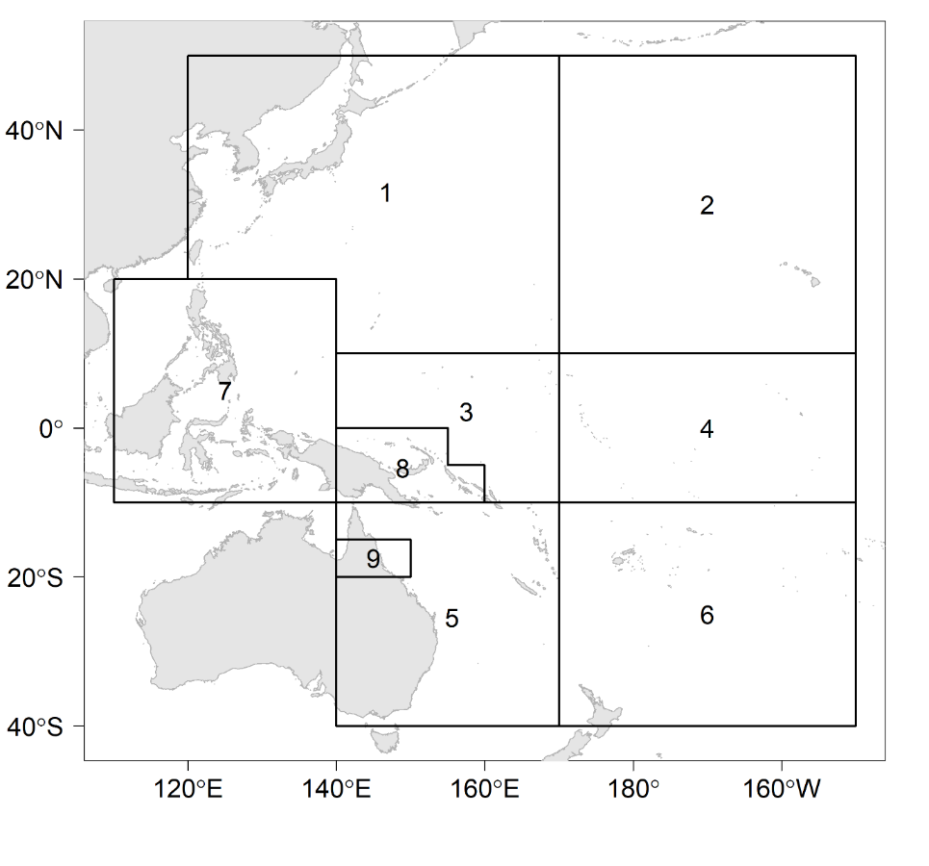
Figure YFT-1. The geographical area covered by the stock assessment and the boundaries for the 9 regions when using the “10N regional structure”.

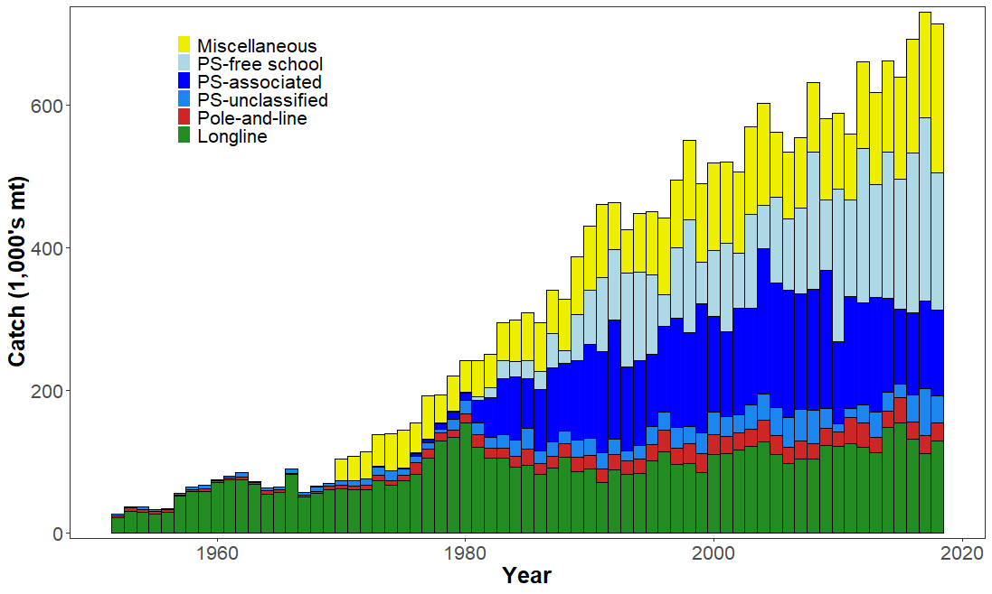
Figure YFT-2.Time series of total annual catch (1000s mt) by fishing gear over the full assessment region and time period. The different colours denote longline (green), pole-and-line (red), purse seine unclassified (blue), purse seine-associated (dark blue), purse seine-unassociated (light blue), miscellaneous (yellow).

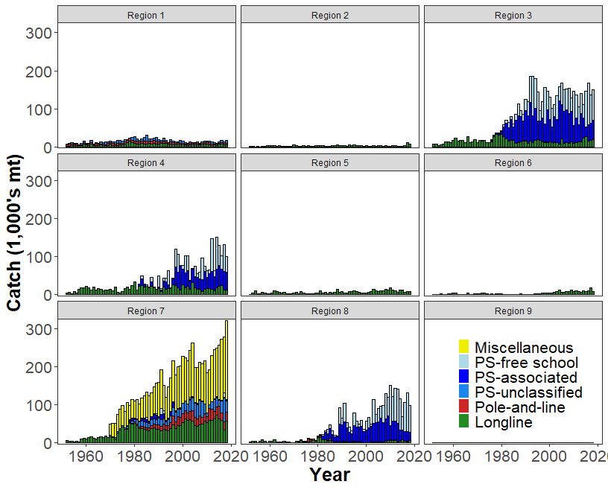
Figure YFT-3. Time series of total annual catch (1000s mt) by fishing gear and assessment region over the full assessment period. The different colours denote longline (green), pole-and-line (red), purse seine unclassified (blue), purse seine-associated (dark blue), purse seine-unassociated (light blue), miscellaneous (yellow).
(a) Recruitment
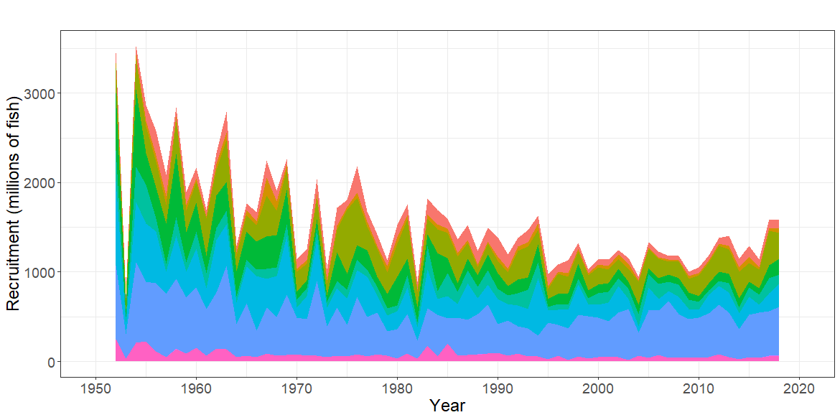
(b) Spawning Potential
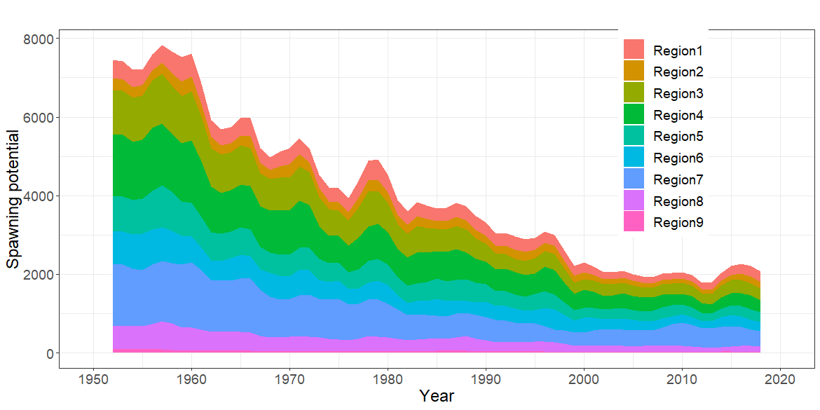
(c) Total Biomass
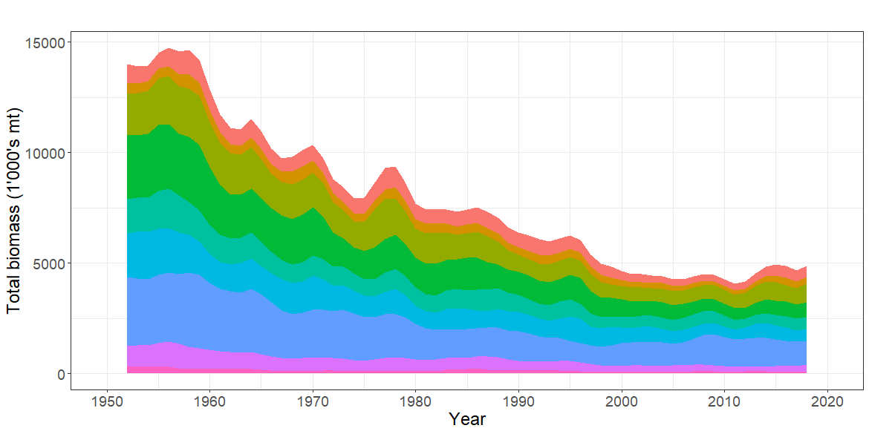

Figure YFT-4. Estimated annual average, (a) recruitment (b) spawning potential (c) total biomass by model region for the diagnostic model, showing the relative sizes among regions.

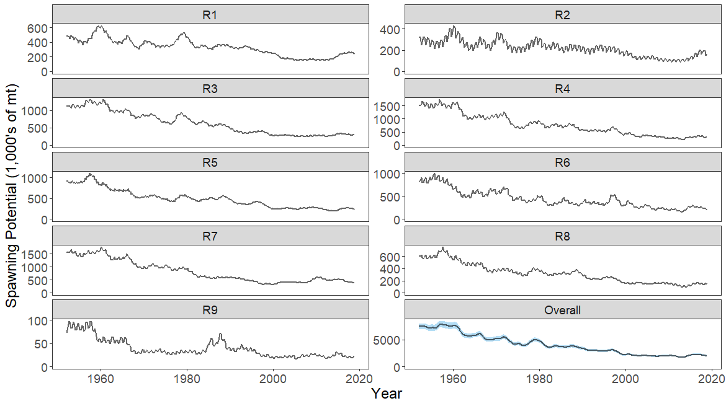
Figure YFT-5. The temporal trend in estimated spawning potential by model region for the diagnosticmodel, where the blue shaded region for the overall spawning potential shows the estimated 95% confidence interval based on statistical uncertainty estimated for the diagnostic model. Note that the y-axis scale among panels are not consistent.
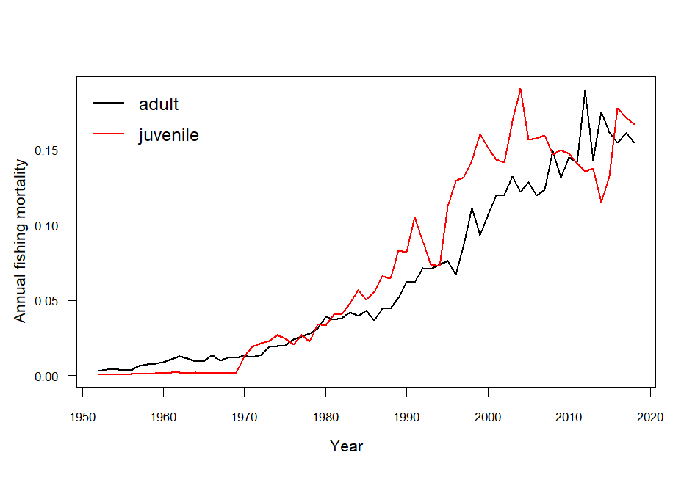
Figure YFT-6. Estimated annual average juvenile and adult fishing mortality for the diagnostic model.
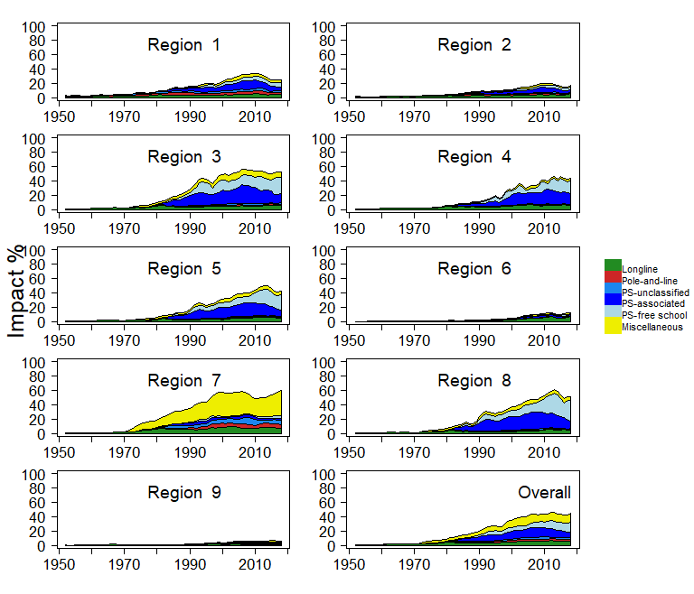
Figure YFT-7. Estimates of reduction in spawning potential due to fishing by region (Fishery Impact =(1-SB_{t}/SB_{t;F=0}) * 100%) and over all regions (lower right panel), attributed to various fishery groups for the diagnostic model.

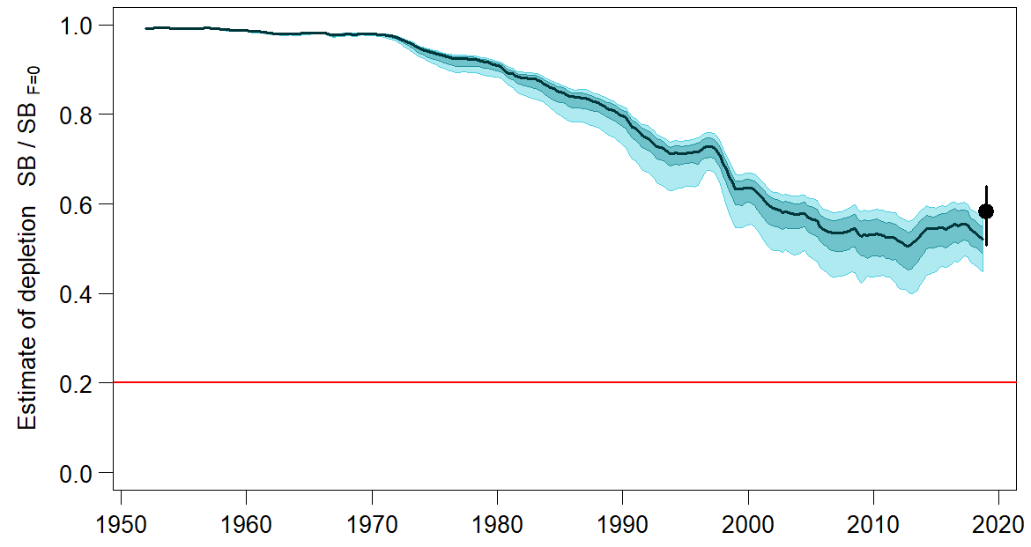

Figure YFT-8. Plot showing the trajectories of fishing depletion of spawning potential for the models in the structural uncertainty grid for the median, 50% quantile, and 80% quantile of instantaneous depletion across the structural uncertainty grid and the point and error bars is the median and 10th and 90th percentile of estimates of SB_{recent}/SB_{F=0}.

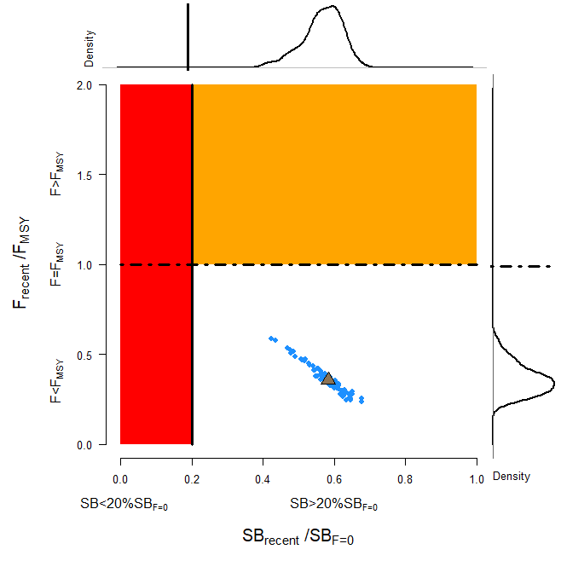
Figure YFT-9. Majuro plot representing stock status in terms of recent spawning potential depletion (2015–2018) and fishing mortality. The plots summarize the results for each of the models in the structural uncertainty grid with marginal distributions for spawning potential depletion and fishing mortality, where the brown triangle is the median of the structural uncertainty grid.

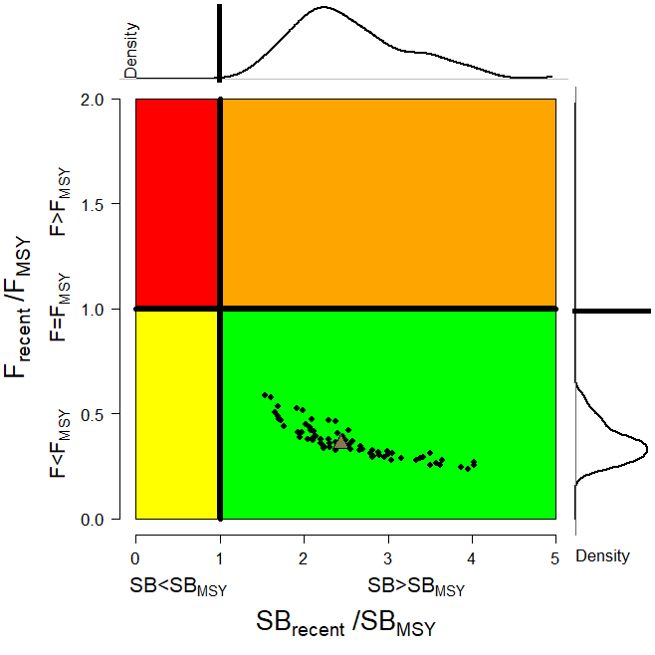
Figure YFT-10. Kobe plot for the recent spawning potential (2015–2018) summarizing the results for each of the models in the structural uncertainty grid. The plots represent estimates of stock status in terms of spawning biomass depletion and fishing mortality relative to MSY quantities and marginal distributions of each are presented with the median of the structural uncertainty grid displayed as a brown triangle.
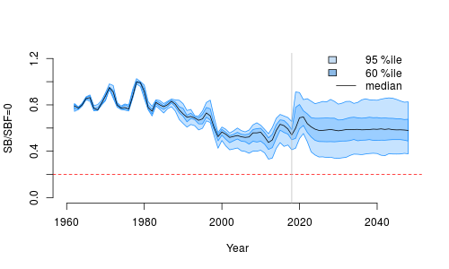
Figure YFT-11.Time series of yellowfin tuna spawning biomass (SB_{t}/SB_{t,F=0}, where SB_{t,F=0} is the average SB from t-10 to t-1) from the uncertainty grid of assessment models for the period 2000 to 2018, and stochastic projection results for the period 2019 to 2048 assuming 2016-2018 average catches in longline and other fisheries and 2018 effort in purse seine fisheries continue. Vertical gray line at 2018 represents the last year of the assessment. During the projection period (2019-2048) levels of recruitment variability are assumed to match those over the time period used to estimate the stock-recruitment relationship (1962-2017). The red horizontal dashed line represents the agreed limit reference point.

- SC16 noted that there has been a long-term decrease in spawning biomass from the 1970s for yellowfin tuna but that the depletion rates have been relatively stable over the last decade.

- SC16 also noted that the median value of relative recent (2015-2018) spawning biomass depletion (SB₂₀₁₅₋₂₀₁₈/SB_{F=0}) was 0.58 with a 10th to 90th percentile interval of 0.51 to 0.64.

- SC16 further noted that there was 0% probability (0 out of 72 models) that the recent (2015-2018) spawning biomass had breached the adopted LRP.

- SC16 noted that there has been a long-term increase in fishing mortality for both juvenile and adult yellowfin tuna which is consistent with previous assessments, but since 2010 there has been no directional trend.

- SC16 noted that the median of relative recent fishing mortality (F₂₀₁₄₋₂₀₁₇/F_{MSY}) was 0.36 with a 10thto 90thpercentile interval of 0.27 to 0.47.

- SC16 further noted that there was 0% probability (0 out of 72 models) that the recent (2014-2017) fishing mortality was above F_{MSY}.

- SC16 noted the results of stochastic projections (Figure YFT-11) from the 2020 assessment which indicated the potential stock consequences of ﬁshing at “status quo” conditions (2016–2018 average longline and other fishery catch and 2018 purse seine effort levels) and long-term recruitment scenario using the uncertainty framework approach endorsed by SC. Projections indicate that median SB₂₀₂₅/SB_{F=0} = 0.58; median SB₂₀₃₅/SB_{F=0} = 0.59 and median SB₂₀₄₅/SB_{F=0} = 0.58. The risk that SB₂₀₄₈/SB_{F=0} is less than the Limit Reference Point is 0%.

- Management advice and implications

- SC16 noted that the preliminary estimate of total catch of WCPO yellowfin tuna for 2019 was 669,362 t, a 5% decrease from 2018 and a 1% increase from the average 2014-2018. Purse seine catch in 2019 (364,571 t) was a 4% decrease from 2018 and an 8% decrease from the 2014-2018 average. Longline catch in 2019 (104,440 t) was a 7% increase from 2018 and a 9% increase from the 2014-2018 average. Pole and line catch (37,563 t) was a 43% increase from 2018 and a 40% increase from the average 2014-2018 catch. Catch by other gear totalled 162,788 t and was an 18% decrease from 2018 and a 16% increase from the average catch in 2014-2018.

- SC16 noted that the median catch in the last year of the assessment (2018) was 711,072 mt which was less than the median MSY (1,091,200 mt).

- Based on the uncertainty grid adopted by SC16, the WCPO yellowfin tuna spawning biomass is above the biomass LRP and recent F is below F_{MSY}. The stock is not experiencing overfishing (100% probability F<F_{MSY}) and is not in an overfished condition (0%probability SB/SB_{F=0}<LRP). Additionally, stochastic projections predict there to be no risk of breaching the LRP (0% probability SB₂₀₄₈/SB_{F=0}<LRP).

- SC16 also noted that levels of fishing mortality and depletion differ between regions, and that fishery impact was highest in the tropical region (Regions 3, 4, 7 and 8 in the stock assessment model), mainly due to the purse seine fisheries in the equatorial Pacific and the “other” fisheries within the Western Pacific. There is also evidence that the overall stock status is buffered with biomass kept at a more elevated level overall by low exploitation in the temperate regions (1, 2, 5, 6, and 9). SC16 therefore re-iterates that WCPFC17 could consider measures to reduce fishing mortality from fisheries that take juveniles, with the goal to increase fishery yields and reduce any further impacts on the spawning potential for this stock in the tropical regions.

- SC16 noted that the 2020 stock assessment results indicate the stock is currently exploited at relatively low levels (median F/F_{MSY} = 0.36, 10th to 90th percentile interval 0.27-0.47). Nevertheless, SC16 recommends that the Commission notes that further increases in YFT fishing mortality would likely affect other stocks/species which are currently moderately exploited due to the multispecies/gears interactions in WCPFC fisheries taking YFT.

- SC16 also noted that although the structural uncertainty grid presents a positive indication of stock status, the high level of unresolved conflict amongst the data inputs used in the assessment suggests additional caution may be appropriate when interpreting assessment outcomes to guide management decisions.

- Based on those results, SC16 recommends as a precautionary approach that the fishing mortality on yellowfin tuna stock should not be increased from the level that maintains spawning biomass at 2012-2015 levels until the Commission can agree on an appropriate target reference point.

SC15 2019 (FISHERY INDICATORS UPDATED)

- Stock status and trends

- SC15 noted that no stock assessment was conducted for WCPO yellowfin tuna in 2019. Therefore, the stock status description from SC13 is still current. For further information on the stock status and trends from SC13, please see https://www.wcpfc.int/node/29904

- SC15 noted that the total yellowfin catch in 2018 was 666,971 mt (the second highest catch on record), a 2% decrease from 2017 and a 9% increase from the average 2013-2017.

- Purse seine catch in 2018 (374,062 mt) was a 22% decrease from 2017 and a 1% increase from the 2013-2017 average. Longline catch in 2018 (94,509 mt) was an 11% increase from 2017 and a 4% increase from the 2013-2017 average. Pole and line catch (12,201 mt) was a 1% decrease from 2017 and a 48% decrease from the average 2013-2017 catch. Catch by other gear (186,199 mt) was a 79% increase from 2017 and 51% increase from the average catch in 2013-2017.

- SC15 noted that under recent fishery conditions, the yellowfin stock is initially projected to increase as recent estimated recruitments support adult stock biomass. Adult stock biomass is then projected to decline slightly before again increasing. Projected fishing mortality is below F_{MSY} (median F₂₀₂₀/F_{MSY} = 0.74, the risk of F₂₀₂₀ > F_{MSY} = 3%) and projected median spawning biomass is above the LRP (SB₂₀₂₀/SB_{F=0} = 0.2) (median SB₂₀₂₀/SB_{F=0} = 0.32; median SB₂₀₂₀/SB_{MSY} = 1.33. Risk that SB₂₀₂₀ < LRP = 8%).

- Management advice and implications

- SC15 noted that no stock assessment has been conducted since SC13. Therefore, the advice from SC13 should be maintained, pending a new assessment or other new information. For further information on the management advice and implications from SC13, please see https://www.wcpfc.int/node/29904

- Research Recommendations

- SC15 encouraged the continuation of project 82 on yellowfin tuna age and growth for the next stock assessment.

- SC15 noted that the following research issues need to be addressed for yellowfin tuna after classifying these research items as short-term (preferably before SC16) and long-term (preferably before the scheduled 2023 stock assessment).
        - Carry out further otolith age validation studies for yellowfin in the western and central Pacific such as applying radiocarbon age validation (short to long-term).
        - Compile a high confidence tagging dataset for growth analysis and develop an integrated growth model incorporating the tagging data and the otolith data (short-term).
        - Continue to develop and document protocols for daily and annual ageing by IATTC and WCPFC (short-term).

SC14 2018 (FISHERY INDICATORS UPDATED)

- Stock Status and trends

- SC14 noted that no stock assessment was conducted for WCPO yellowfin tuna in 2018. Therefore, the stock status description from SC13 is still current. For further information on the stock status and trends from SC13, please see below.

- SC14 noted that the total yellowfin catch in 2017 was a record 670,890 mt, a 4% increase from 2016 and a 12% increase from the average 2012-2016.

- Purse seine catch in 2017 (472,279mt) was a 22% increase from 2016 and a 33% increase from the 2012-2016 average. Longline catch in 2017 (83,399mt) was a 6% decrease from 2016 and a 9% decrease from the 2012-2016 average. Pole and line catch (12,219mt) was a 48% decrease from 2016 and a 56% decrease from the average 2012-2016 catch. Catch by other gear (102,993mt) was a 28% decrease from 2016 and 17% decrease from the average catch in 2012-2016.

- SC14 noted that under recent fishery conditions, the yellowfin stock was initially projected to increase as recent estimated relatively high recruitments support adult stock biomass, then decline slightly. Median F₂₀₁₉/F_{MSY} = 0.63; median SB₂₀₁₉/SB_{F=0} = 0.37; median SB₂₀₁₉/SB_{MSY} = 1.51. Risk that SB₂₀₁₉ < LRP = 6%.

- Management advice and implications

- SC14 noted that no stock assessment has been conducted since SC13. Therefore, the advice from SC13 should be maintained to achieve the objectives set in CMM-2017-01, pending a new assessment or other new information. For further information on the management advice and implications from SC13, please see below.

- Research Recommendations

- SC14 reviewed the work on age and growth of yellowfin tuna presented in SA-WP-13 and noted that the final results of this projected will be presented to SC15. SC14 encouraged analysis of the same otoliths by different laboratories, to build confidence in ageing estimates through inter laboratory daily-annual age workshop.

SC13 2017 (STOCK ASSESSMENT CONDUCTED)

- SC13 endorsed the 2017 WCPO yellowfin tuna stock assessment as the most advanced and comprehensive assessment yet conducted for this species.

- SC13 also endorsed the use of the assessment model uncertainty grid to characterize stock status and management advice and implications.

- SC13 reached consensus on the weighting of assessment models in the uncertainty grid for yellowfin tuna. The consensus weighting considered all options within five axes of uncertainty for steepness, tagging dispersion, tag mixing, size frequency (with two levels), and regional structure to be equally likely. The resulting uncertainty grid was used to characterize stock status, to summarize reference points as provided in the assessment document SC13-SA-WP-06, and to calculate the probability of breaching the adopted spawning biomass limit reference point (0.2*SB_{F=0}) and the probability of F_{recent} being greater than F_{MSY}.

- Stock status and trends

- The median values of relative recent spawning biomass (2012-2015) (SB_{recent}/SB_{F=0}) and relative recent fishing mortality (F_{recent}/F_{MSY}) over the uncertainty grid were used to measure the central tendency of stock status. The values of the upper 90th and lower 10th percentiles of the empirical distributions of relative spawning biomass and relative fishing mortality from the uncertainty grid were used to characterize the probable range of stock status.

- Descriptions of the updated structural sensitivity grid used to characterize uncertainty in the assessment are provided in Table YFT-1. Catch trend data is presented in Figure YFT-1. Estimated annual average recruitment, biomass, fishing mortality and depletion are shown in Figures YFT-2 – YFT-5. Majuro plots summarizing the results for each of the models in the structural uncertainty grid retained for management advice are represented in Figures YFT-6 and YFT-7. Figure YFT-8 and YFT-9 present Kobe plots summarizing the results for each of the models in the structural uncertainty grid. Figure YFT-10 provides estimated time-series (or “dynamic”) Majuro and Kobe plots from the yellowfin ‘diagnostic case’ model run. Figure YFT-11 shows estimates of reduction in spawning potential due to fishing by region, and over all regions attributed to various fishery groups (gear-types) for the diagnostic case model. Table YFT-2 provides a summary of reference points over the 48 models in the structural uncertainty grid (based on the SC decision to include size frequency weighting levels 20 and 50 only).

Table YFT-1: Description of the updated structural sensitivity grid used to characterize uncertainty in the assessment
Axis | Levels | Option
Steepness | 3 | 0.65, 0.80, 0.95
Tagging overdispersion | 2 | Default level (1), fixed (moderate) level
Tag mixing | 2 | 1 or 2 quarters
Size frequency weighting | 3 | Sample sizes divided by 10, 20, 50
Regional structure | 2 | 2017 regions, 2014 regions

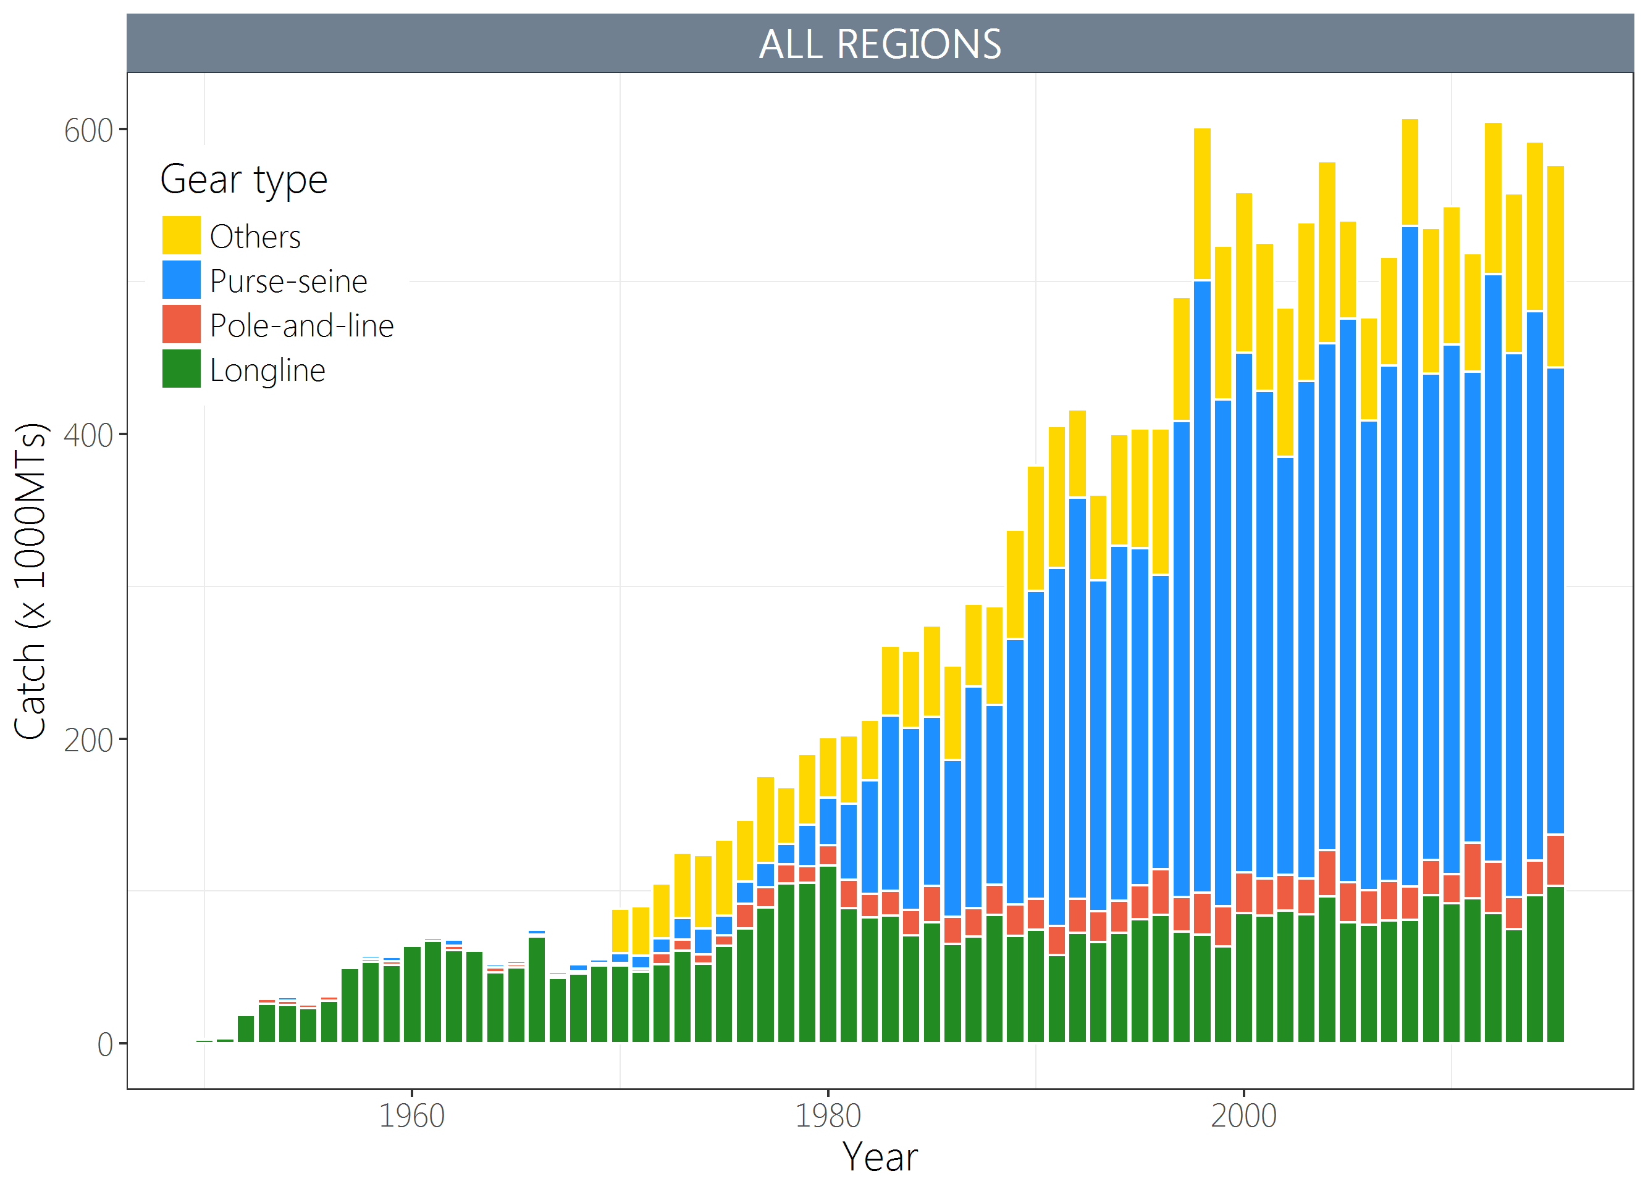
Figure YFT-1. Time series of total annual catch (1000's mt) by fishing gear for the diagnostic case model over the full assessment period.

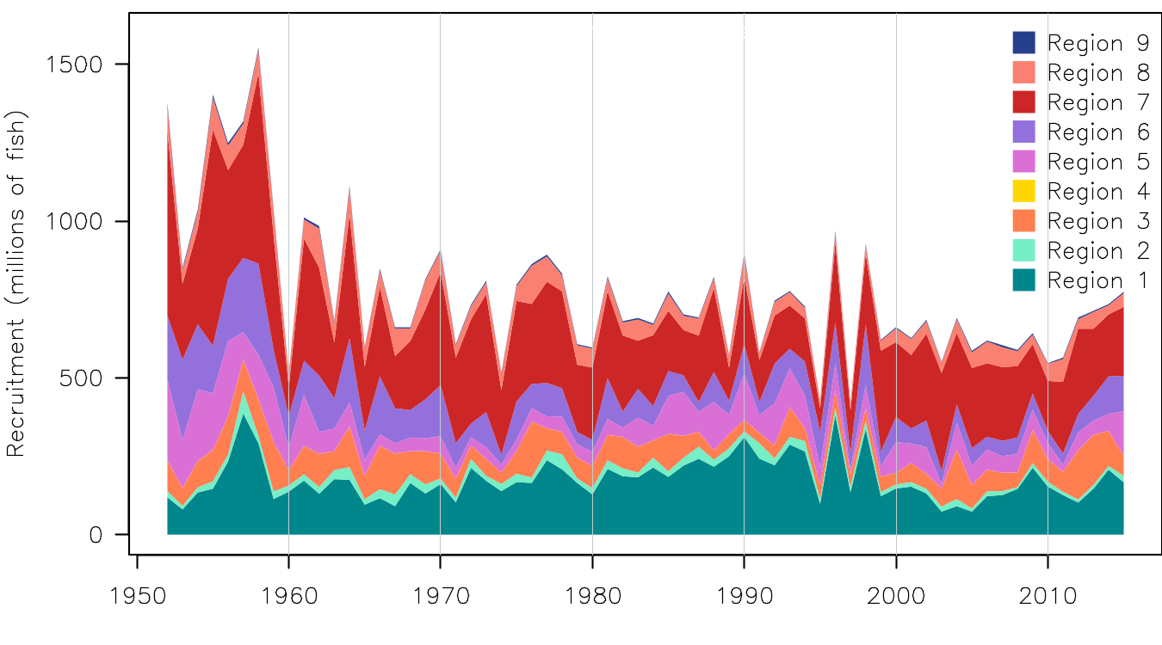
Figure YFT-2. Estimated annual average recruitment by model region for the diagnostic case model, showing the relative sizes among regions.

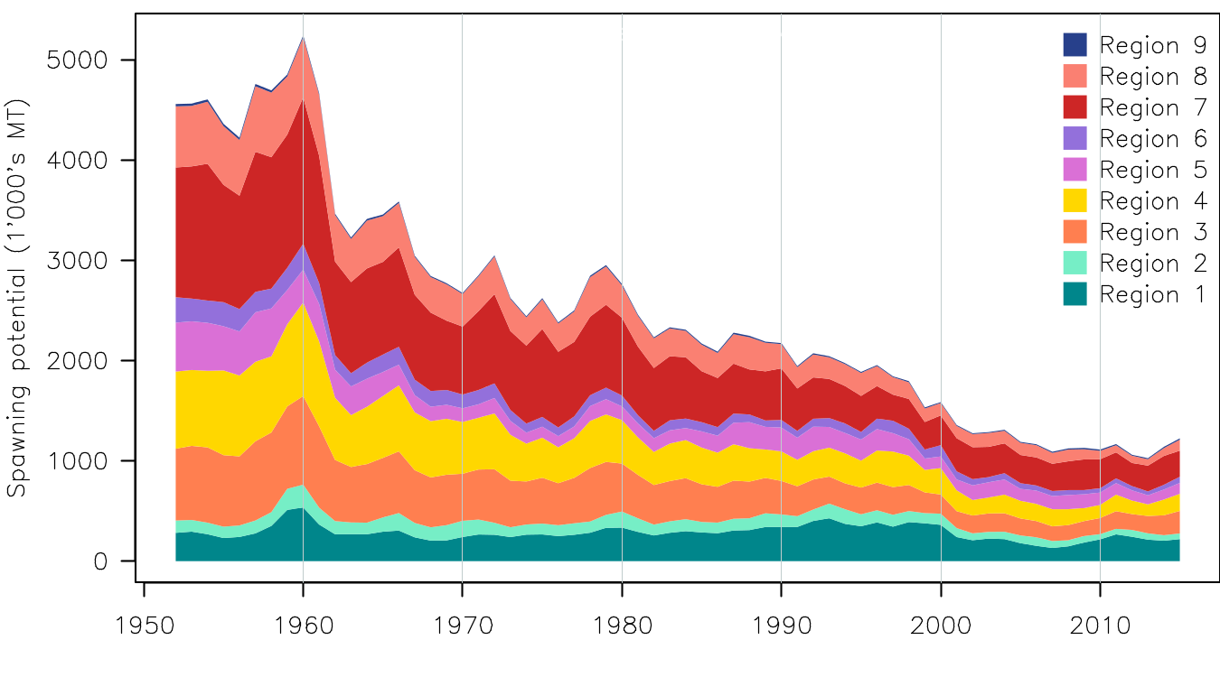
Figure YFT-3. Estimated annual average spawning potential by model region for the diagnostic case model, showing the relative sizes among regions.
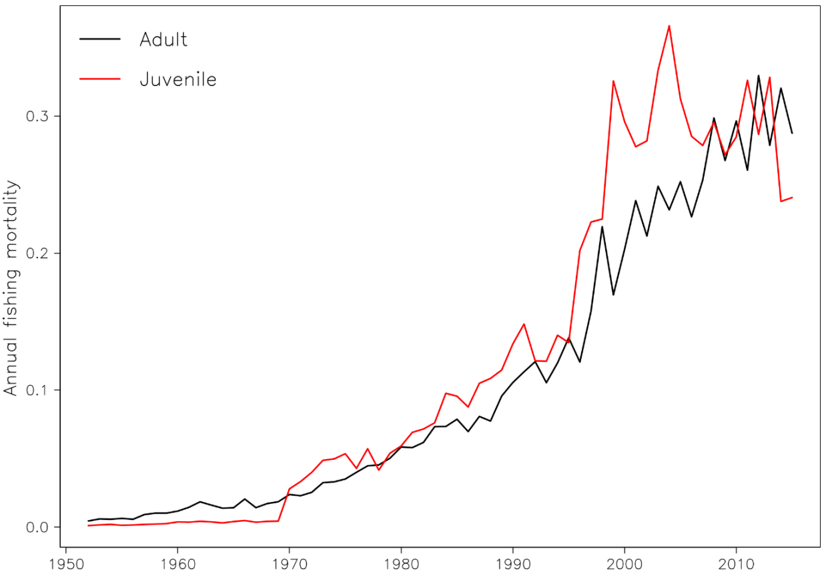
Figure YFT-4. Estimated annual average juvenile and adult fishing mortality for the diagnostic case model.

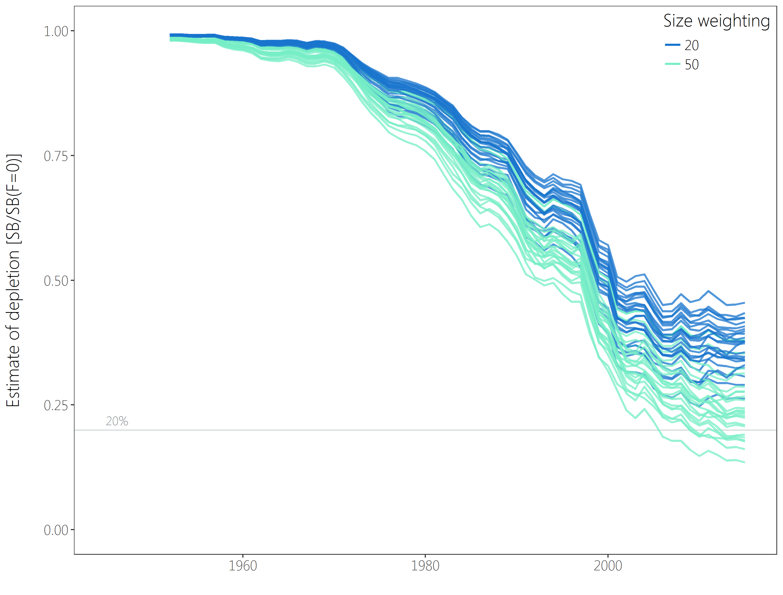
Figure YFT-5：Plot showing the trajectories of fishing depletion (of spawning potential) for the 48 model runs retained for the structural uncertainty grid used for management advice. The colours depict the models in the grid with the size composition weighting using divisors of 20 and 50.
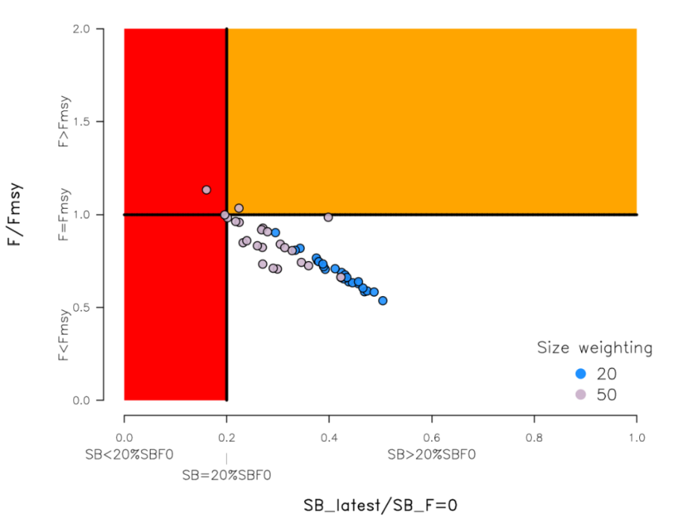
Figure YFT-6. Majuro plot summarising the results for each of the models in the structural uncertainty grid retained for management advice. The plots represent estimates of stock status in terms of spawning potential depletion and fishing mortality. The red zone represents spawning potential levels lower than the agreed limit reference point which is marked with the solid black line. The orange region is for fishing mortality greater than F_{MSY} (F_{MSY} is marked with the black horizontal line). The points represent SB_{latest}/SB_{F=0}, and the colours depict the models in the grid with the size composition weighting using divisors of 20 and 50.

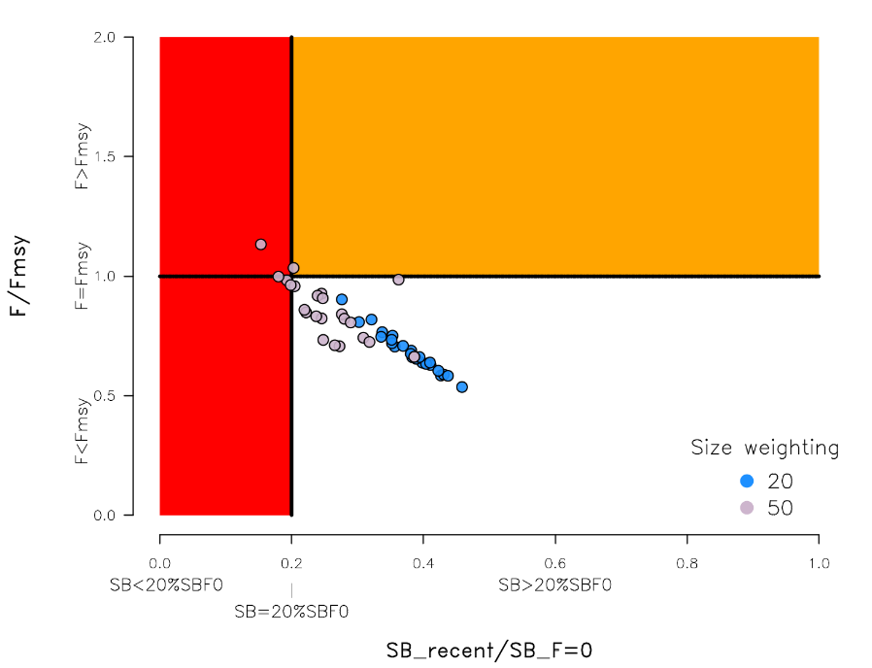
Figure YFT-7: Majuro plot summarising the results for each of the models in the structural uncertainty grid retained for management advice. The plots represent estimates of stock status in terms of spawning potential depletion and fishing mortality. The red zone represents spawning potential levels lower than the agreed limit reference point which is marked with the solid black line. The orange region is for fishing mortality greater than F_{MSY} (F_{MSY} is marked with the black horizontal line). The points represent SB_{recent}/SB_{F=0}, and the colours depict the models in the grid with the size composition weighting using divisors of 20 and 50.

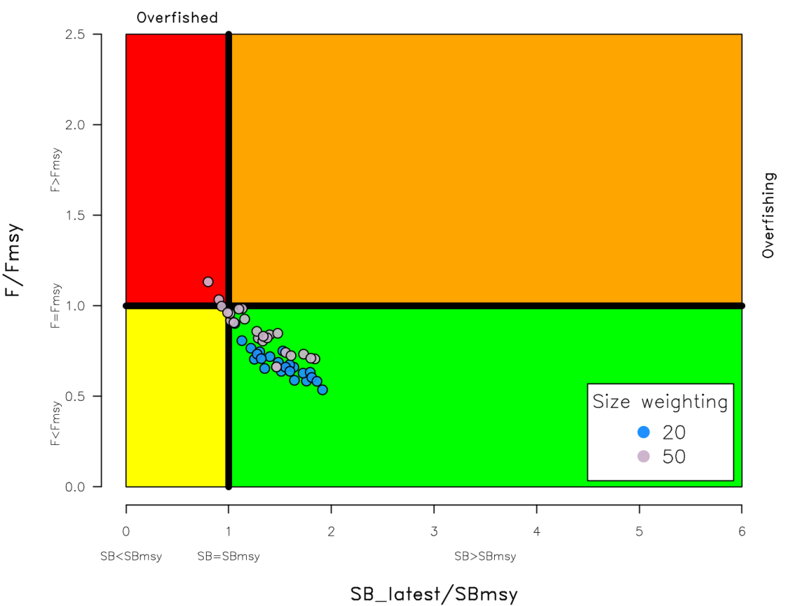
Figure YFT-8. Kobe plot summarising the results for each of the models in the structural uncertainty grid. The points represent SB_{latest}/SB_{MSY}, the colours depict the models in the grid with the size composition weighting using divisors of 20 and 50.

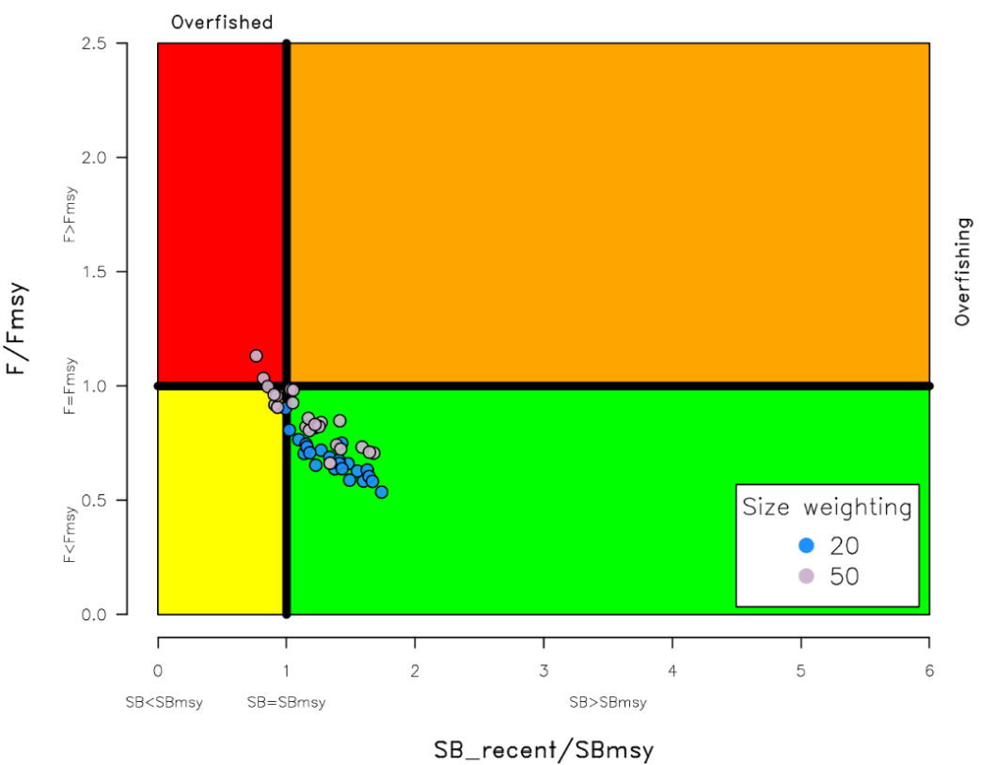
Figure YFT-9. Kobe plot summarising the results for each of the models in the structural uncertainty grid. The points represent SB_{recent}/SB_{MSY}, the colours depict the models in the grid with the size composition weighting using divisors of 20 and 50.

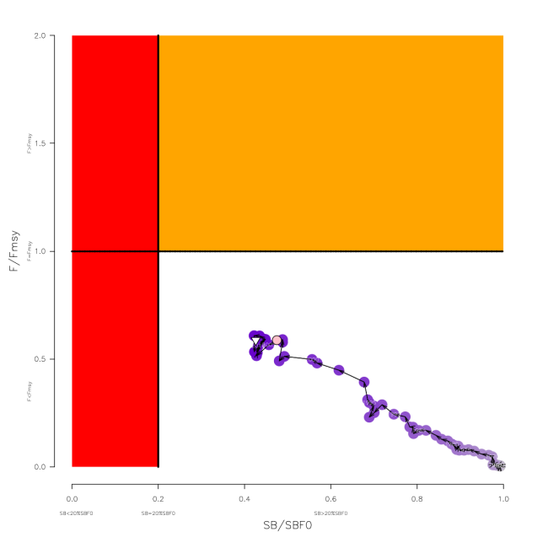
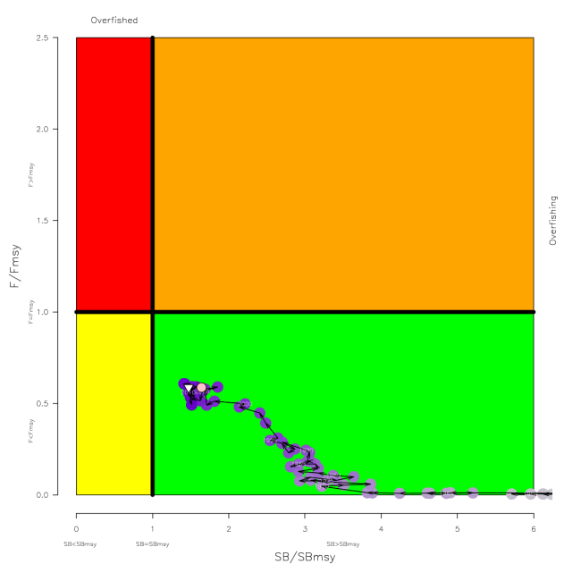
Figure YFT-10. Estimated time-series (or “dynamic”) Majuro and Kobe plots from the yellowfin ‘diagnostic case’ model run.

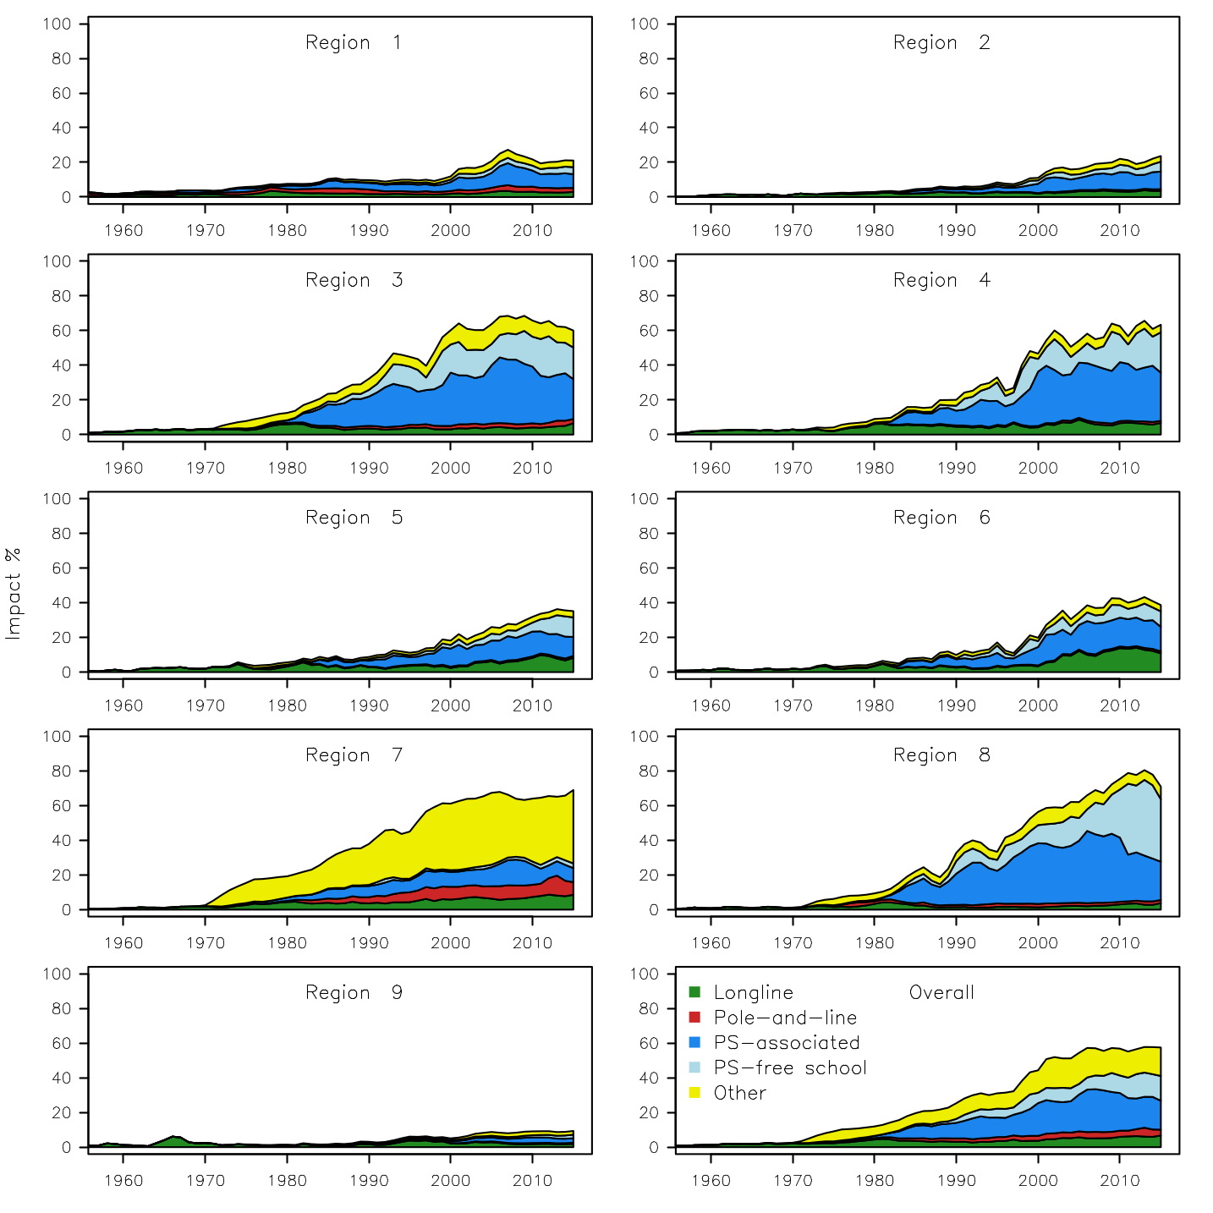
Figure YFT-11. Estimates of reduction in spawning potential due to fishing by region, and over all regions (lower right panel), attributed to various fishery groups (gear-types) for the diagnostic case model.

Table YFT-2. Summary of reference points over the 48 models in the structural uncertainty grid retained for management advice using divisors of 20 and 50 for the weighting on the size composition data. Note that SB_{recent}/SB_{F=0} is calculated where SB_{recent} is the mean SB over 2012-2015 instead of 2011-2014 (used in the stock assessment report), at the request of the Scientific Committee.
 | Mean | Median | Min | 10% | 90% | Max
C_{latest} | 611,982 | 612,592 | 606,762 | 607,517 | 614,237 | 614,801
MSY | 670,658 | 670,800 | 539,200 | 601,480 | 735,280 | 795,200
Y_{Frecent} | 646,075 | 643,400 | 534,400 | 586,120 | 717,880 | 739,600
F_{mult} | 1.34 | 1.36 | 0.88 | 1.03 | 1.61 | 1.86
F_{MSY} | 0.12 | 0.12 | 0.07 | 0.10 | 0.14 | 0.16
F_{recent}/F_{MSY} | 0.77 | 0.74 | 0.54 | 0.62 | 0.97 | 1.13
SB_{MSY} | 544,762 | 581,400 | 186,800 | 253,320 | 786,260 | 946,800
SB₀ | 2,199,750 | 2,290,000 | 1,197,000 | 1,366,600 | 2,784,500 | 3,256,000
SB_{MSY}/SB₀ | 0.24 | 0.24 | 0.15 | 0.18 | 0.28 | 0.34
SB_{F=0} | 2,083,477 | 2,178,220 | 1,193,336 | 1,351,946 | 2,643,390 | 2,845,244
SB_{MSY}/SB_{F=0} | 0.25 | 0.26 | 0.16 | 0.19 | 0.30 | 0.35
SB_{latest} /SB₀ | 0.33 | 0.34 | 0.18 | 0.23 | 0.42 | 0.45
SB_{latest} /SB_{F=0} | 0.35 | 0.37 | 0.16 | 0.22 | 0.46 | 0.50
SB_{latest} /SB_{MSY} | 1.40 | 1.39 | 0.80 | 1.02 | 1.80 | 1.91
SB_{recent}/SB_{F=0} | 0.32 | 0.33 | 0.15 | 0.20 | 0.41 | 0.46
SB_{recent}/SB_{MSY} | 1.40 | 1.41 | 0.81 | 1.05 | 1.71 | 1.93

- SC13 noted that the central tendency of relative recent spawning biomass was median (SB_{recent}/SB_{F=0}) = 0.33 with a probable range of 0.20 to 0.41 (80% probable range), and there was a roughly 8% probability (4 out of 48 models) that the recent spawning biomass had breached the adopted LRP with Prob((SB_{recent}/SB_{F=0})<0.2) = 0.08. The median estimate (0.33) is below that estimated from the 2014 assessment grid ((SB_{current}/SB_{F=0}) = 0.41, see SC10-SA-WP-04), noting the differences in grid uncertainty axes used in that assessment.

- SC13 noted that the central tendency of relative recent fishing mortality was median (F_{recent}/F_{MSY}) = 0.74 with an 80% probability interval of 0.62 to 0.97, and there was a roughly 4% probability (2 out of 48 models) that the recent fishing mortality was above F_{MSY} with Prob((F_{recent}/F_{MSY})>1) = 0.04. The median estimate (0.74) is also comparable to that estimated from the 2014 assessment grid (F_{current}/F_{MSY} = 0.76, see SC10-SA-WP-04)

- SC13 noted that the assessment results show that the stock has been continuously declining for about 50 years since the late 1960’s.

- SC13 also noted that levels of fishing mortality and depletion differ between regions, and that fishery impact was highest in the tropical region (Regions 3, 4, 7 and 8 in the stock assessment model), mainly due to the purse seine fisheries in the equatorial Pacific and the “other” fisheries within the Western Pacific (as shown in Figure 44 of SC13-SA-WP-06).

- Management advice and implications

- Based on the uncertainty grid adopted by SC13 the spawning biomass is highly likely above the biomass LRP and recent F is highly likely below F_{MSY}, and therefore noting the level of uncertainties in the current assessment it appears that the stock is not experiencing overfishing 96% probability) and it appears that the stock is not in an overfished condition (92% probability).

- Based on the diagnostic case, both juvenile and adult fishing mortality show a steady increase since the 1970s. Adult fishing mortality has increased continuously over most of the time series, while juvenile fishing mortality has stabilized since the late 1990s at a level similar to that now estimated for adult yellowfin.

- SC13 reiterates its previous advice from SC10 that WCPFC could consider measures to reduce fishing mortality from fisheries that take juveniles, with the goal to increase to maximum fishery yields and reduce any further impacts on the spawning potential for this stock in the tropical regions.

- SC13 also reiterates its previous advice from SC10 that measures should be implemented to maintain current spawning biomass levels until the Commission can agree on an appropriate target reference point (TRP).

Research Recommendations

- SC13 recognized that reviewing yellowfin growth through a study of yellowfin otoliths collected from the WCPO and incorporating this into future assessments should be encouraged.

References

SC16-SA-WP-02 Age and growth of yellowfin and bigeye tuna in the western and central Pacific Ocean from otoliths https://www.wcpfc.int/node/46609

SC16-SA-WP-04 Stock assessment of yellowfin tuna in the western and central Pacific Ocean (31July) - Rev.03 https://www.wcpfc.int/node/46611

SC16-SA-IP-06 Background analyses for the 2020 stock assessments of bigeye and yellowfin tuna https://www.wcpfc.int/node/46620

SC15- SA-WP-01 A compendium of fisheries indicators for tuna stocks. https://www.wcpfc.int/node/42927

SC15- SA-WP-02 Project 94: Workshop on yellowfin and bigeye age and growth. https://www.wcpfc.int/node/42928

SC15- SA-WP-03 Progress on yellowfin tuna age and growth in the WCPO (Project 82). https://www.wcpfc.int/node/42929

SC15- SA-IP-19 Report of the Workshop on Age and Growth of Bigeye and Yellowfin Tunas in the Pacific Ocean. https://www.wcpfc.int/node/43329

SC14-SA-WP-02 A compendium of fisheries indicators for tuna stocks. https://www.wcpfc.int/node/30987

SC14-SA-WP-13 Progress on yellowfin tuna age and growth in the WCPO WCPFC Project 82. https://www.wcpfc.int/node/31097

SC13-SA-WP-06 Stock assessment of yellowfin tuna in the western and central Pacific Ocean Rev 1 (26 July 2017). https://www.wcpfc.int/node/29519

SC10-SA-WP-04 Stock assessment of yellowfin tuna in the western and central Pacific Ocean Rev 1 (25 July 2014) https://wcpfc.int/node/18997

SC7-SA-WP-03 Stock assessment of yellowfin tuna in the western and central Pacific Ocean (Rev.1 - 03August2011). https://wcpfc.int/node/2786

SC5-SA-WP-03 Stock assessment of yellowfin tuna in the western and central Pacific Ocean. https://wcpfc.int/node/2175

SC3-SA-WP-01 Stock assessment of yellowfin tuna in the western and central Pacific Ocean, including an analysis of management options. https://wcpfc.int/node/1649

SC2-SA-WP-01 Stock assessment of yellowfin tuna in the western and central Pacific Ocean, including an analysis of management options. https://wcpfc.int/node/1746

SC1-SA-WP-01 Stock assessment of yellowfin tuna in the Western and Central Pacific Ocean. https://wcpfc.int/node/1881

