Yellowfin Tuna (Thunnus albacares)
Stock Status & Trends plus Management Advice and Implications

Contents
SC14 2018 (INDICATOR ANALYSIS) 1
SC13 2017 (STOCK ASSESSMENT CONDUCTED) 3
Useful References 14
Previous Assessments 14

SC14 2018 (INDICATOR ANALYSIS)

Stock Status and trends

SC14 noted that no stock assessment was conducted for WCPO yellowfin tuna in 2018. Therefore, the stock status description from SC13 is still current. For further information on the stock status and trends from SC13, please see below.

SC14 noted that the total yellowfin catch in 2017 was a record 670,890 mt, a 4% increase from 2016 and a 12% increase from the average 2012-2016.

Purse seine catch in 2017 (472,279mt) was a 22% increase from 2016 and a 33% increase from the 2012-2016 average. Longline catch in 2017 (83,399mt) was a 6% decrease from 2016 and a 9% decrease from the 2012-2016 average. Pole and line catch (12,219mt) was a 48% decrease from 2016 and a 56% decrease from the average 2012-2016 catch. Catch by other gear (102,993mt) was a 28% decrease from 2016 and 17% decrease from the average catch in 2012-2016.

SC14 noted that under recent fishery conditions, the yellowfin stock was initially projected to increase as recent estimated relatively high recruitments support adult stock biomass, then decline slightly. Median F₂₀₁₉/F_{MSY} = 0.63; median SB₂₀₁₉/SB_{F=0} = 0.37; median SB₂₀₁₉/SB_{MSY} = 1.51. Risk that SB₂₀₁₉ < LRP = 6%.

Management advice and implications

SC14 noted that no stock assessment has been conducted since SC13. Therefore, the advice from SC13 should be maintained to achieve the objectives set in CMM-2017-01, pending a new assessment or other new information. For further information on the management advice and implications from SC13, please see below.

Research Recommendations

SC14 reviewed the work on age and growth of yellowfin tuna presented in SA-WP-13 and noted that the final results of this projected will be presented to SC15. SC14 encouraged analysis of the same otoliths by different laboratories, to build confidence in ageing estimates through inter laboratory daily-annual age workshop.

SC13 2017 (STOCK ASSESSMENT CONDUCTED)

- SC13 endorsed the 2017 WCPO yellowfin tuna stock assessment as the most advanced and comprehensive assessment yet conducted for this species.
- SC13 also endorsed the use of the assessment model uncertainty grid to characterize stock status and management advice and implications.

- SC13 reached consensus on the weighting of assessment models in the uncertainty grid for yellowfin tuna. The consensus weighting considered all options within five axes of uncertainty for steepness, tagging dispersion, tag mixing, size frequency (with two levels), and regional structure to be equally likely. The resulting uncertainty grid was used to characterize stock status, to summarize reference points as provided in the assessment document SC13-SA-WP-06, and to calculate the probability of breaching the adopted spawning biomass limit reference point (0.2*SB_{F=0}) and the probability of F_{recent} being greater than F_{MSY}.

- Stock status and trends

- The median values of relative recent spawning biomass (2012-2015) (SB_{recent}/SB_{F=0}) and relative recent fishing mortality (F_{recent}/F_{MSY}) over the uncertainty grid were used to measure the central tendency of stock status. The values of the upper 90th and lower 10th percentiles of the empirical distributions of relative spawning biomass and relative fishing mortality from the uncertainty grid were used to characterize the probable range of stock status.

- Descriptions of the updated structural sensitivity grid used to characterize uncertainty in the assessment are provided in Table YFT-1. Catch trend data is presented in Figure YFT-1. Estimated annual average recruitment, biomass, fishing mortality and depletion are shown in Figures YFT-2 – YFT-5. Majuro plots summarizing the results for each of the models in the structural uncertainty grid retained for management advice are represented in Figures YFT-6 and YFT-7. Figure YFT-8 and YFT-9 present Kobe plots summarizing the results for each of the models in the structural uncertainty grid. Figure YFT-10 provides estimated time-series (or “dynamic”) Majuro and Kobe plots from the yellowfin ‘diagnostic case’ model run. Figure YFT-11 shows estimates of reduction in spawning potential due to fishing by region, and over all regions attributed to various fishery groups (gear-types) for the diagnostic case model. Table YFT-2 provides a summary of reference points over the 48 models in the structural uncertainty grid (based on the SC decision to include size frequency weighting levels 20 and 50 only).

Table YFT-1: Description of the updated structural sensitivity grid used to characterize uncertainty in the assessment
Axis | Levels | Option
Steepness | 3 | 0.65, 0.80, 0.95
Tagging overdispersion | 2 | Default level (1), fixed (moderate) level
Tag mixing | 2 | 1 or 2 quarters
Size frequency weighting | 3 | Sample sizes divided by 10, 20, 50
Regional structure | 2 | 2017 regions, 2014 regions

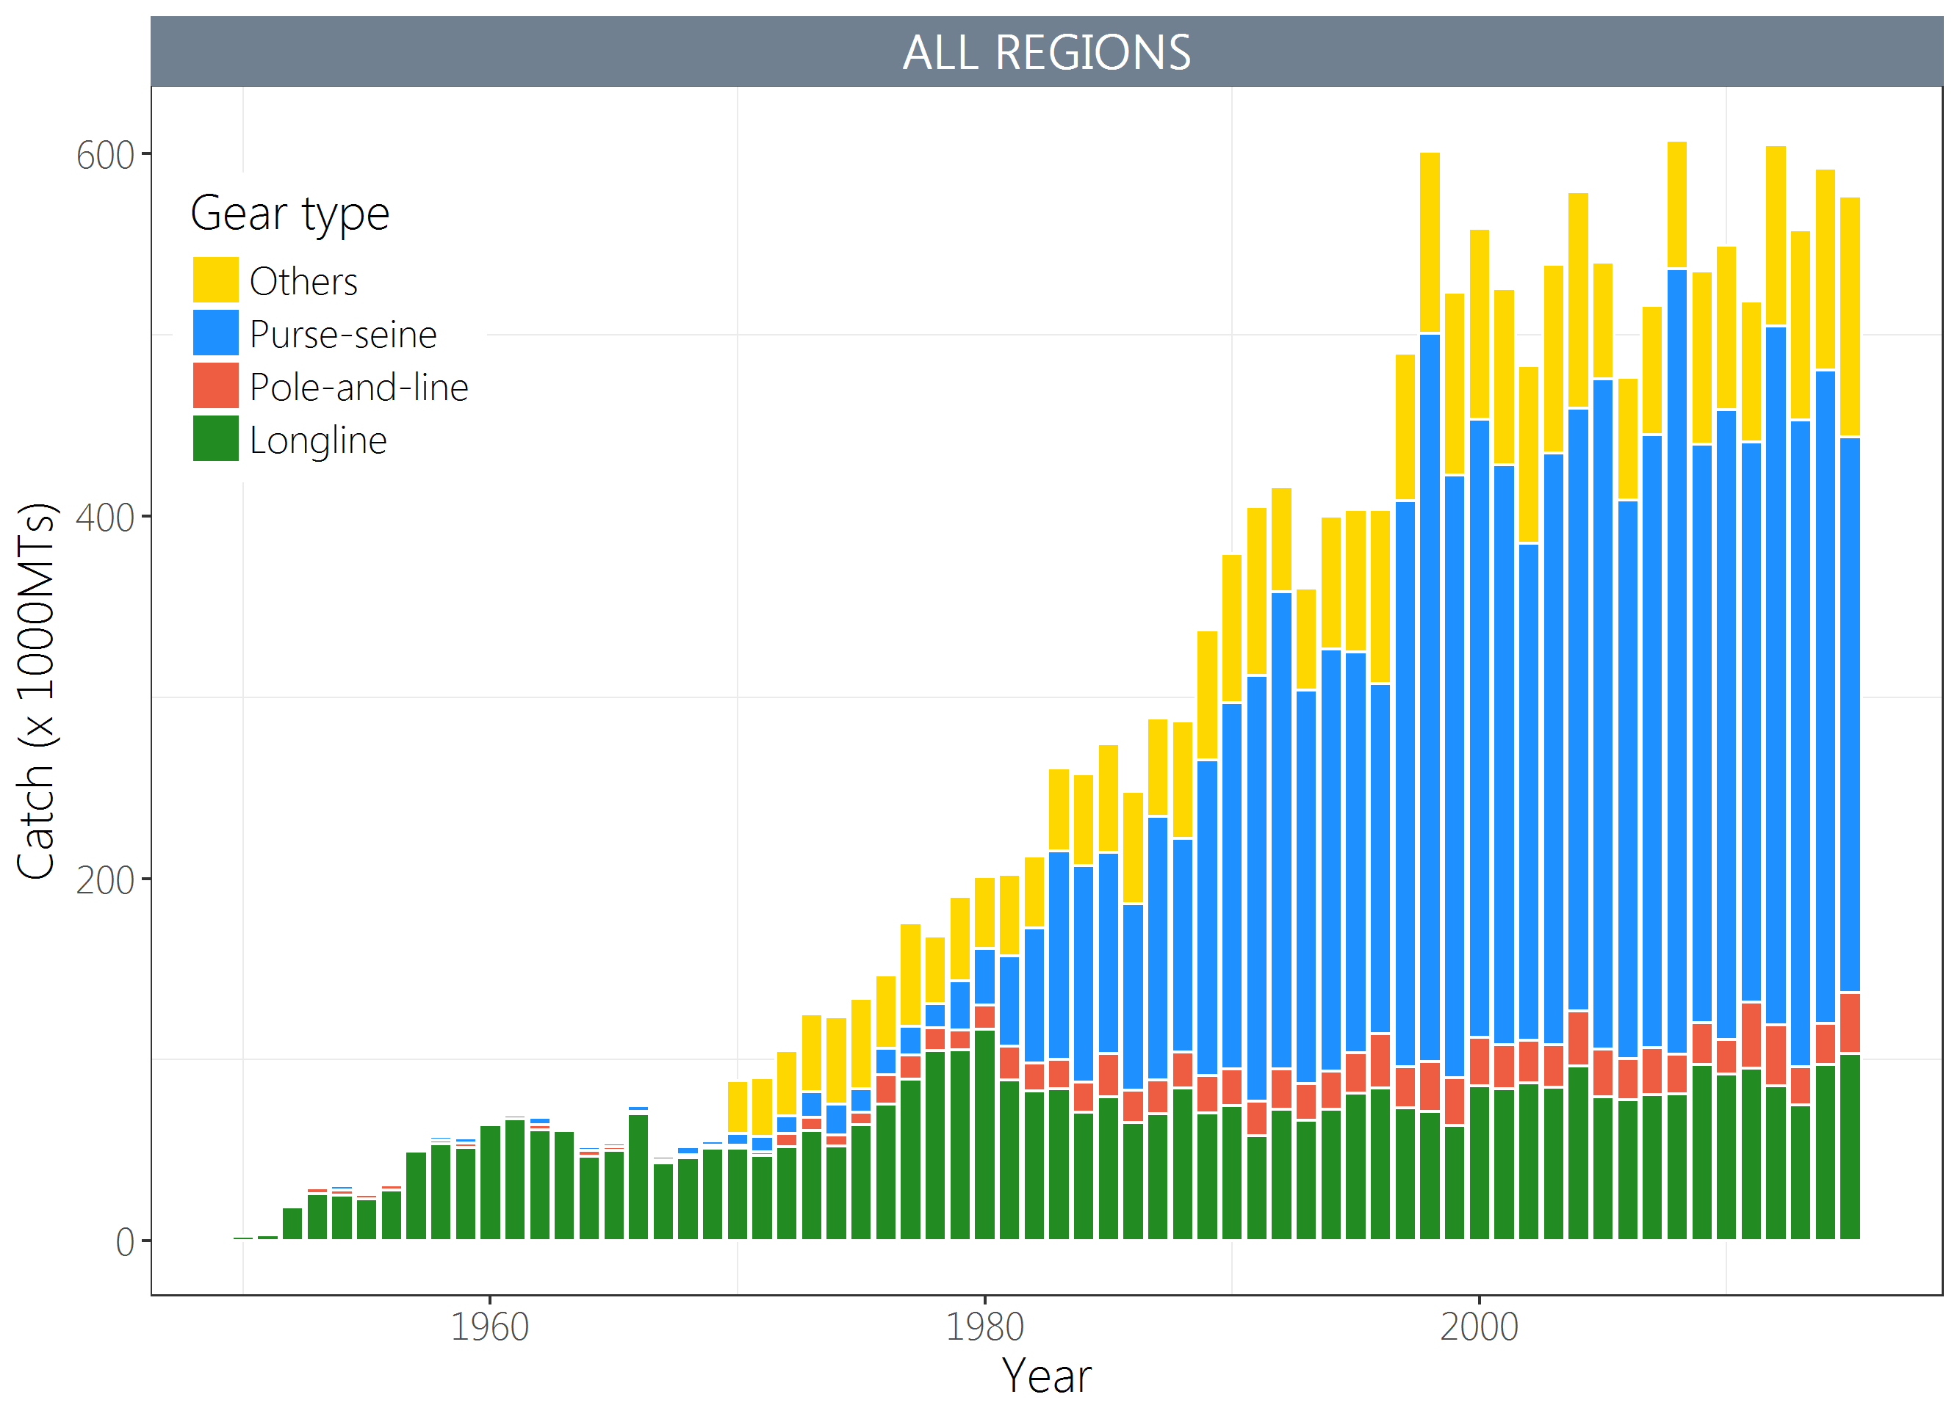
Figure YFT-1. Time series of total annual catch (1000's mt) by fishing gear for the diagnostic case model over the full assessment period.

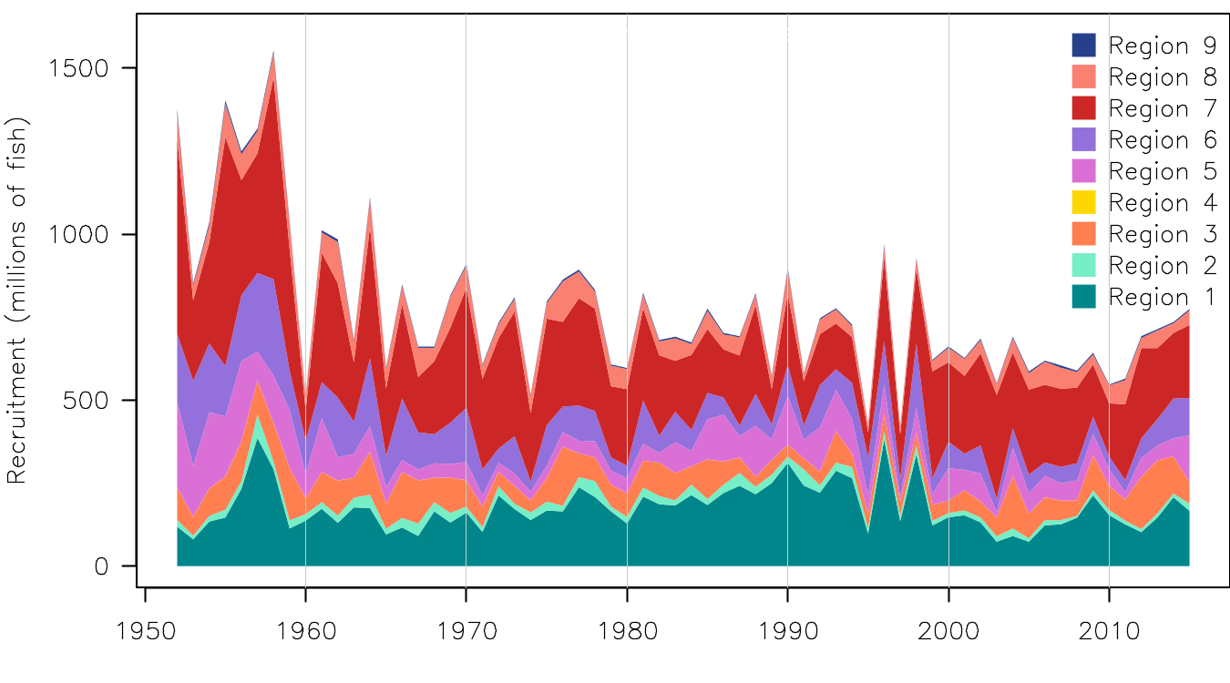
Figure YFT-2. Estimated annual average recruitment by model region for the diagnostic case model, showing the relative sizes among regions.

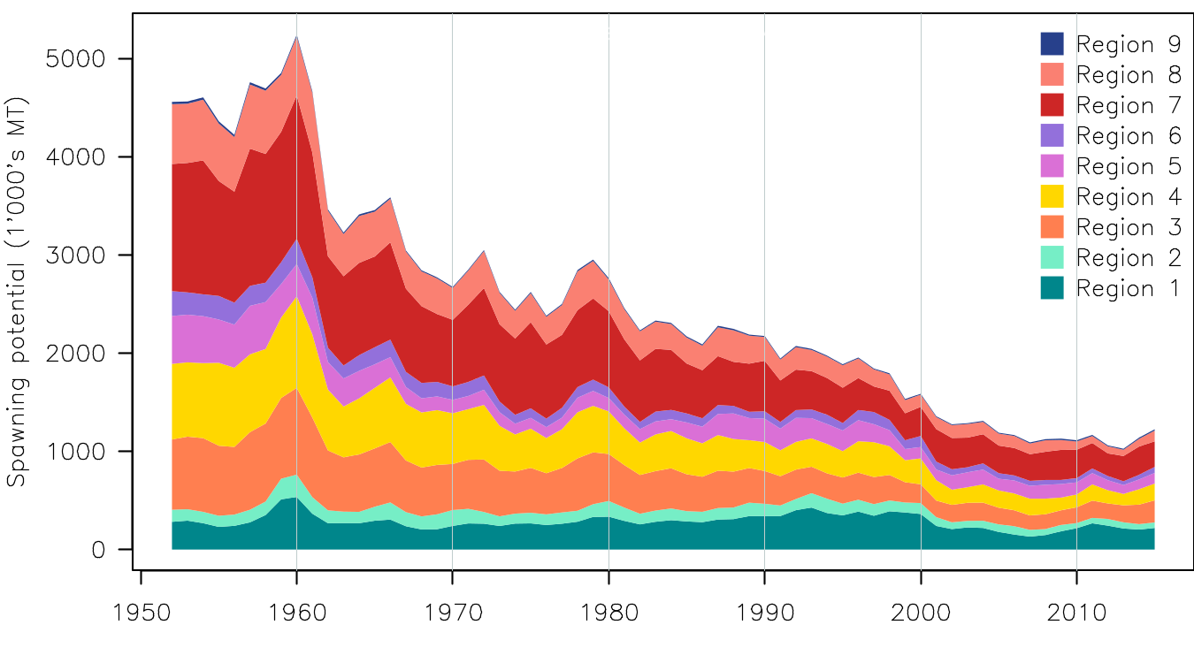
Figure YFT-3. Estimated annual average spawning potential by model region for the diagnostic case model, showing the relative sizes among regions.
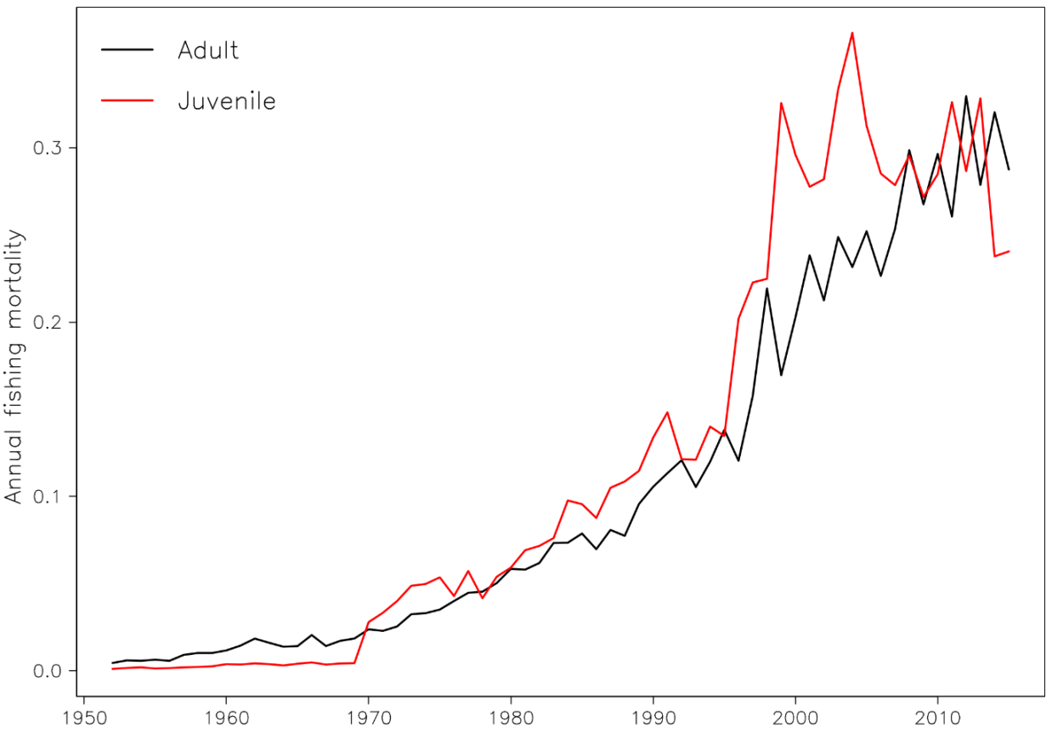
Figure YFT-4. Estimated annual average juvenile and adult fishing mortality for the diagnostic case model.

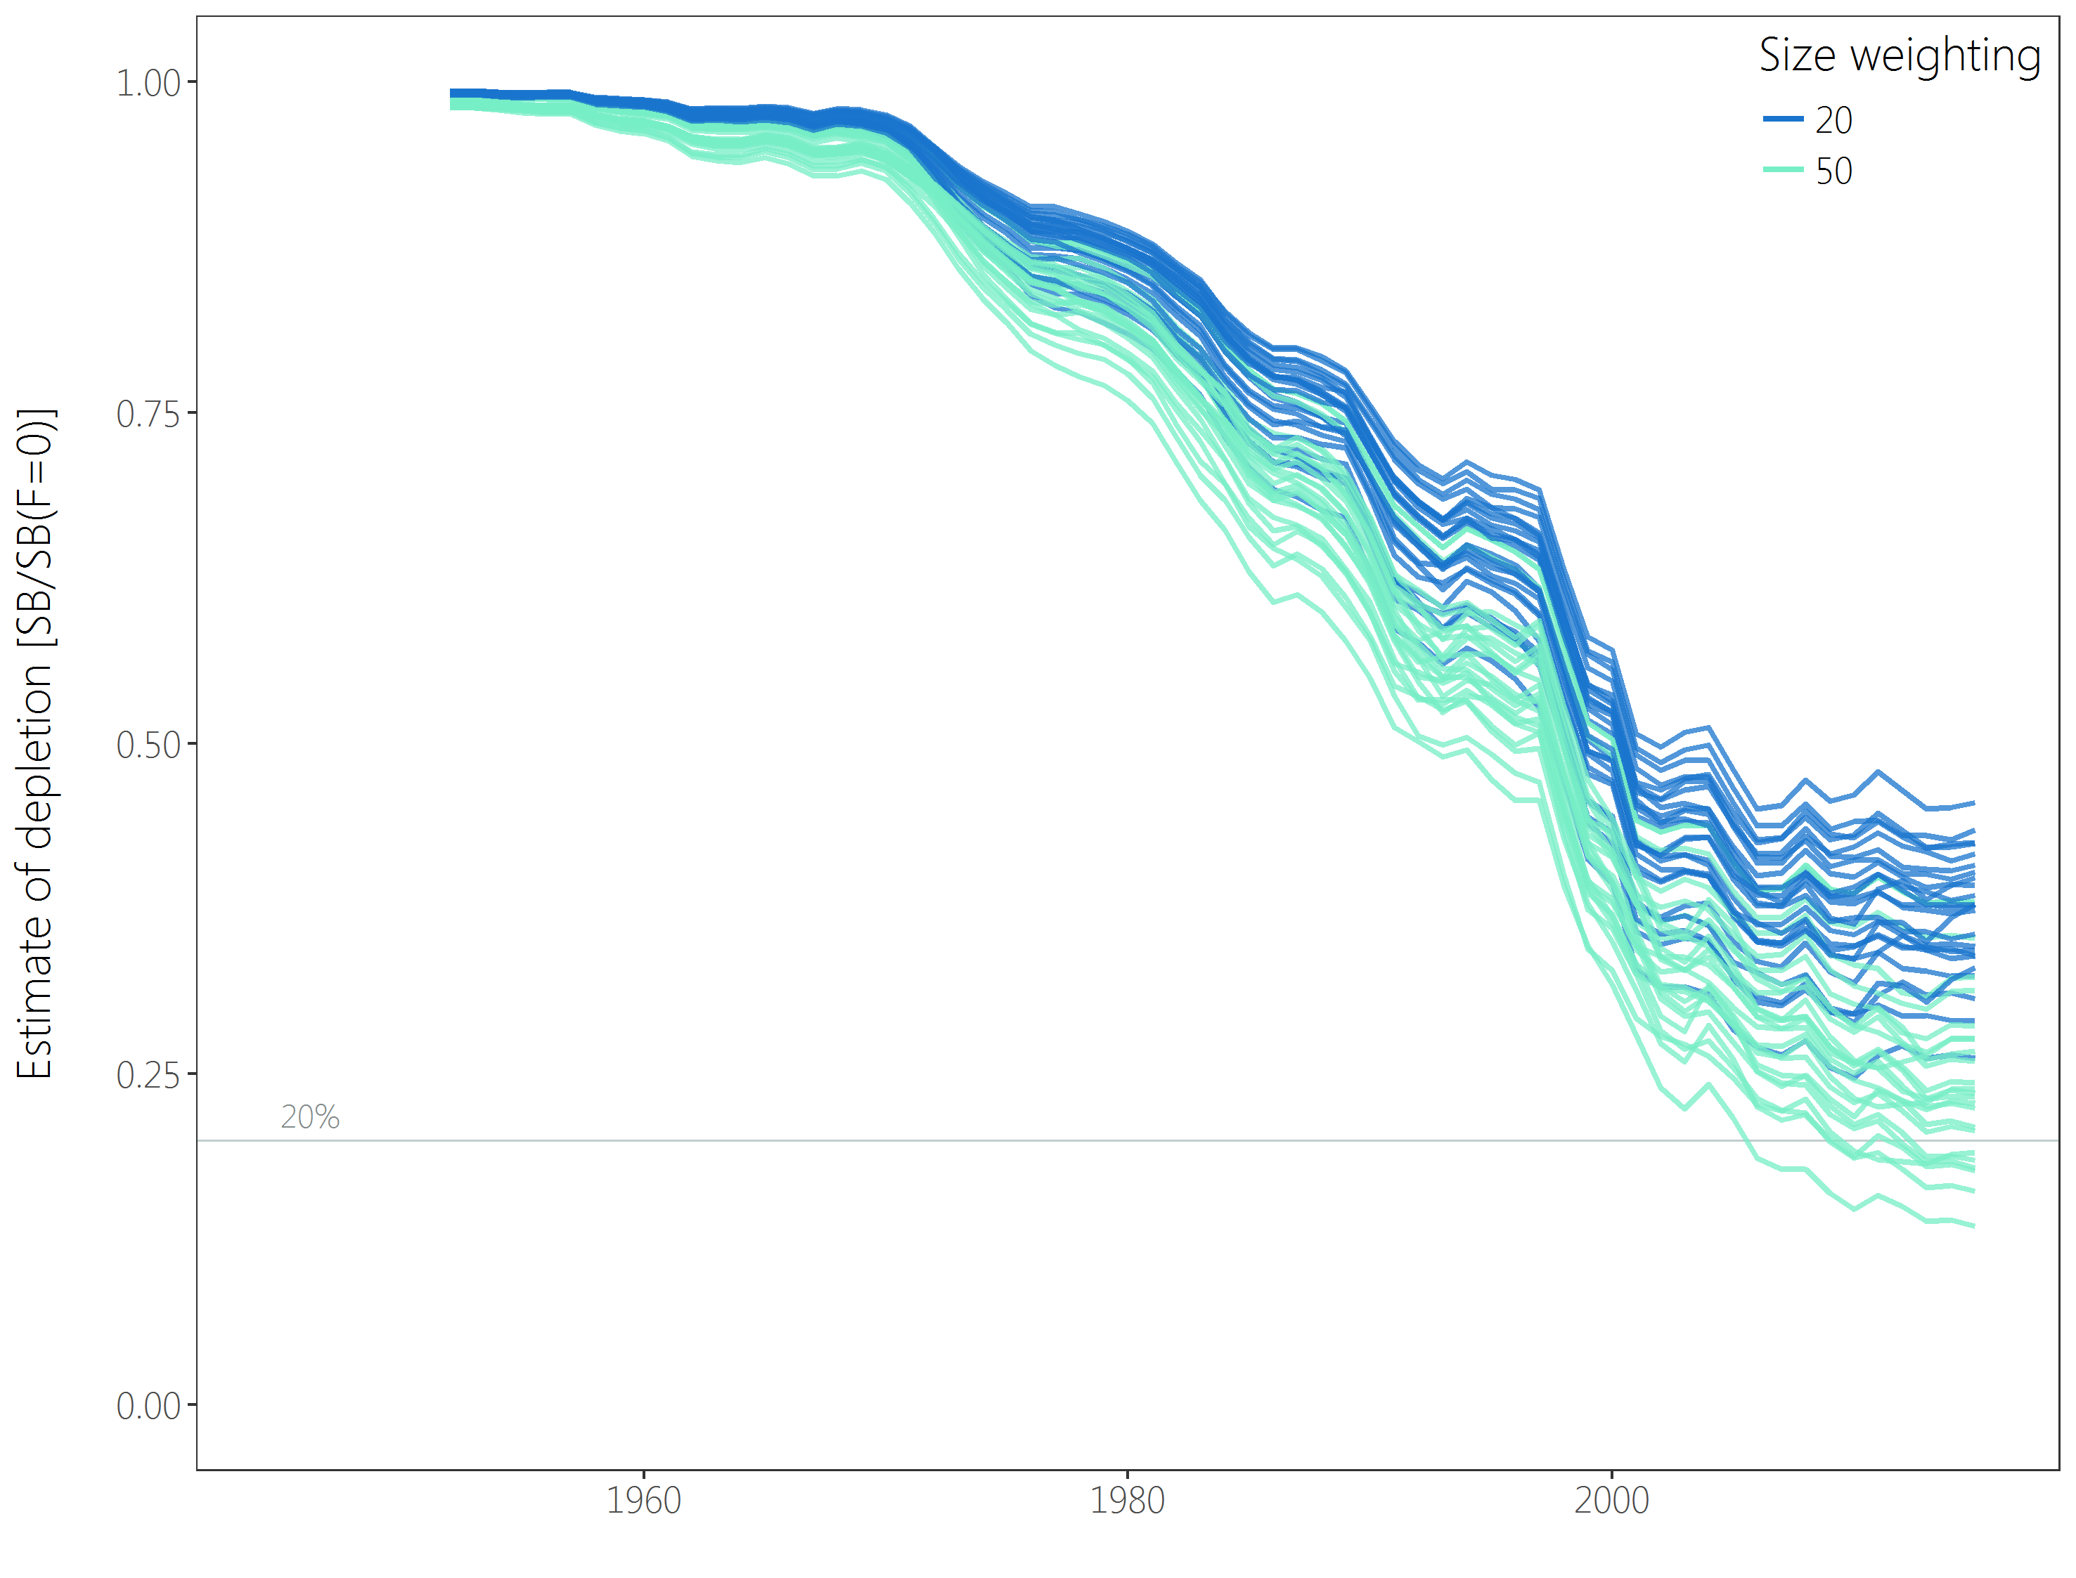
Figure YFT-5：Plot showing the trajectories of fishing depletion (of spawning potential) for the 48 model runs retained for the structural uncertainty grid used for management advice. The colours depict the models in the grid with the size composition weighting using divisors of 20 and 50.
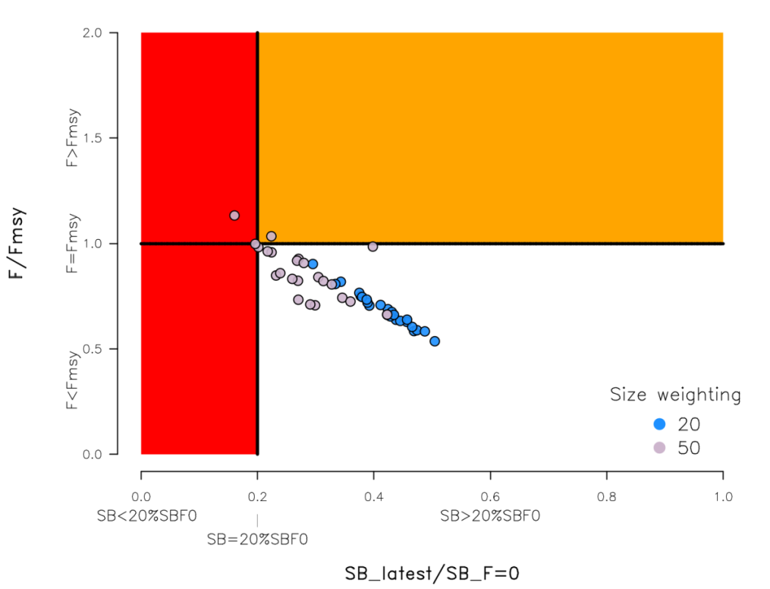
Figure YFT-6. Majuro plot summarising the results for each of the models in the structural uncertainty grid retained for management advice. The plots represent estimates of stock status in terms of spawning potential depletion and fishing mortality. The red zone represents spawning potential levels lower than the agreed limit reference point which is marked with the solid black line. The orange region is for fishing mortality greater than F_{MSY} (F_{MSY} is marked with the black horizontal line). The points represent SB_{latest}/SB_{F=0}, and the colours depict the models in the grid with the size composition weighting using divisors of 20 and 50.
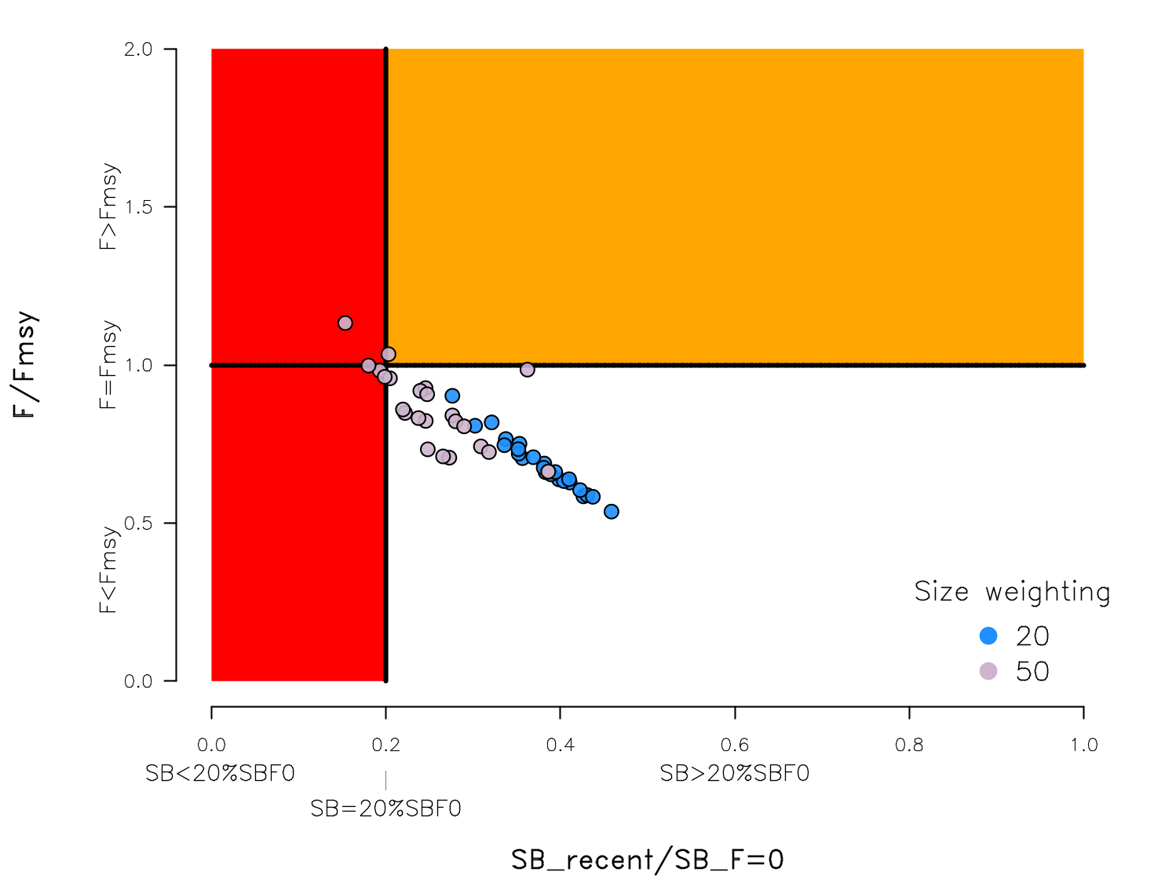
Figure YFT-7: Majuro plot summarising the results for each of the models in the structural uncertainty grid retained for management advice. The plots represent estimates of stock status in terms of spawning potential depletion and fishing mortality. The red zone represents spawning potential levels lower than the agreed limit reference point which is marked with the solid black line. The orange region is for fishing mortality greater than F_{MSY} (F_{MSY} is marked with the black horizontal line). The points represent SB_{recent}/SB_{F=0}, and the colours depict the models in the grid with the size composition weighting using divisors of 20 and 50.

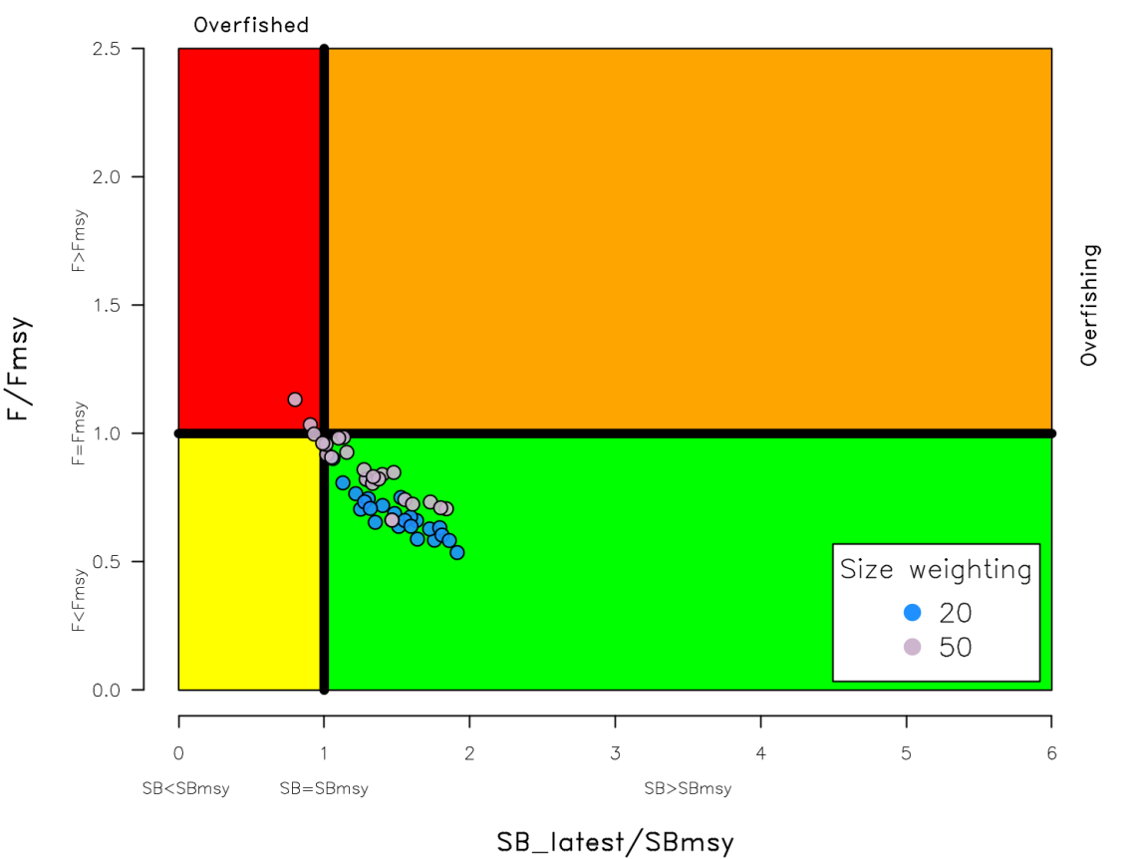
Figure YFT-8. Kobe plot summarising the results for each of the models in the structural uncertainty grid. The points represent SB_{latest}/SB_{MSY}, the colours depict the models in the grid with the size composition weighting using divisors of 20 and 50.
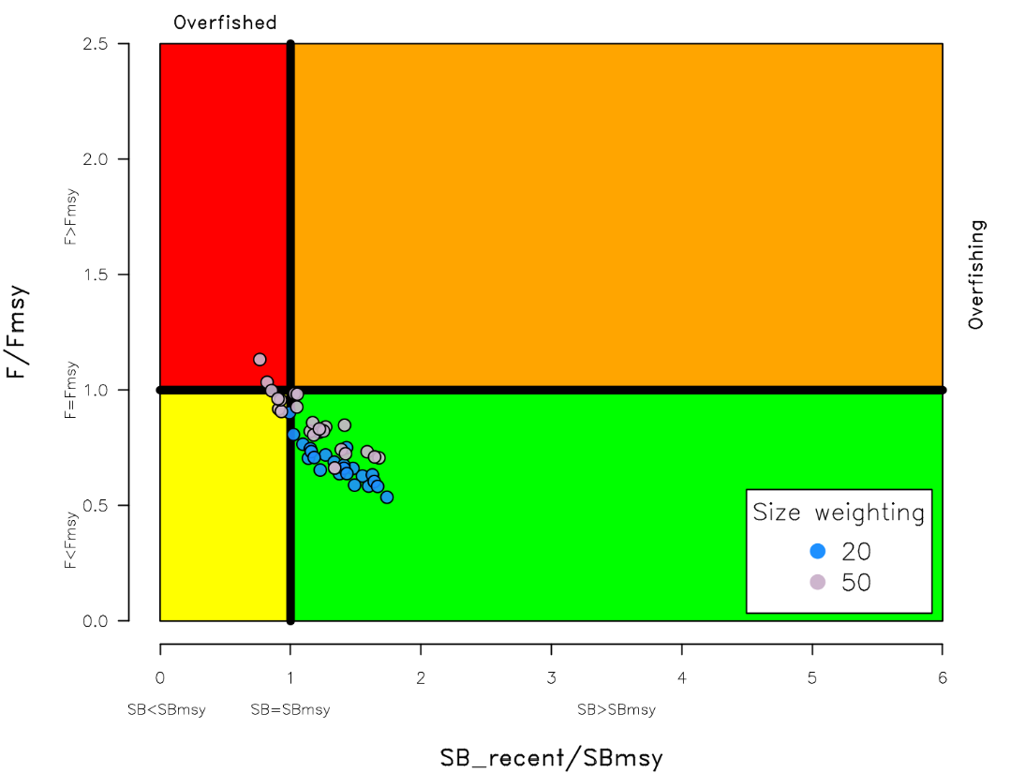
Figure YFT-9. Kobe plot summarising the results for each of the models in the structural uncertainty grid. The points represent SB_{recent}/SB_{MSY}, the colours depict the models in the grid with the size composition weighting using divisors of 20 and 50.

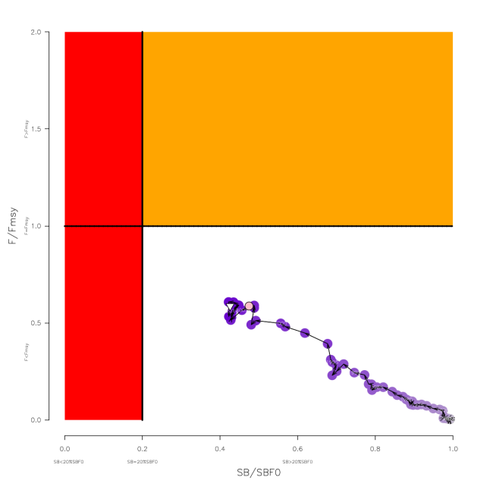
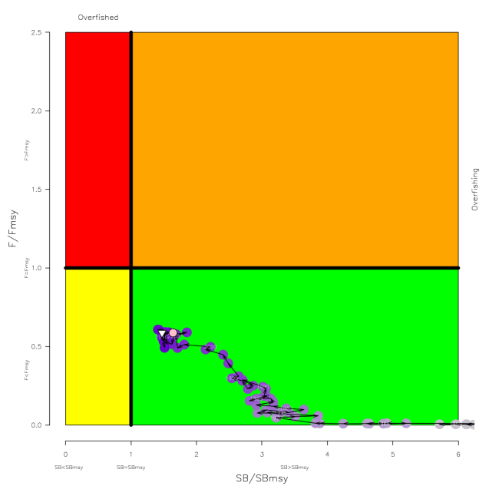
Figure YFT-10. Estimated time-series (or “dynamic”) Majuro and Kobe plots from the yellowfin ‘diagnostic case’ model run.

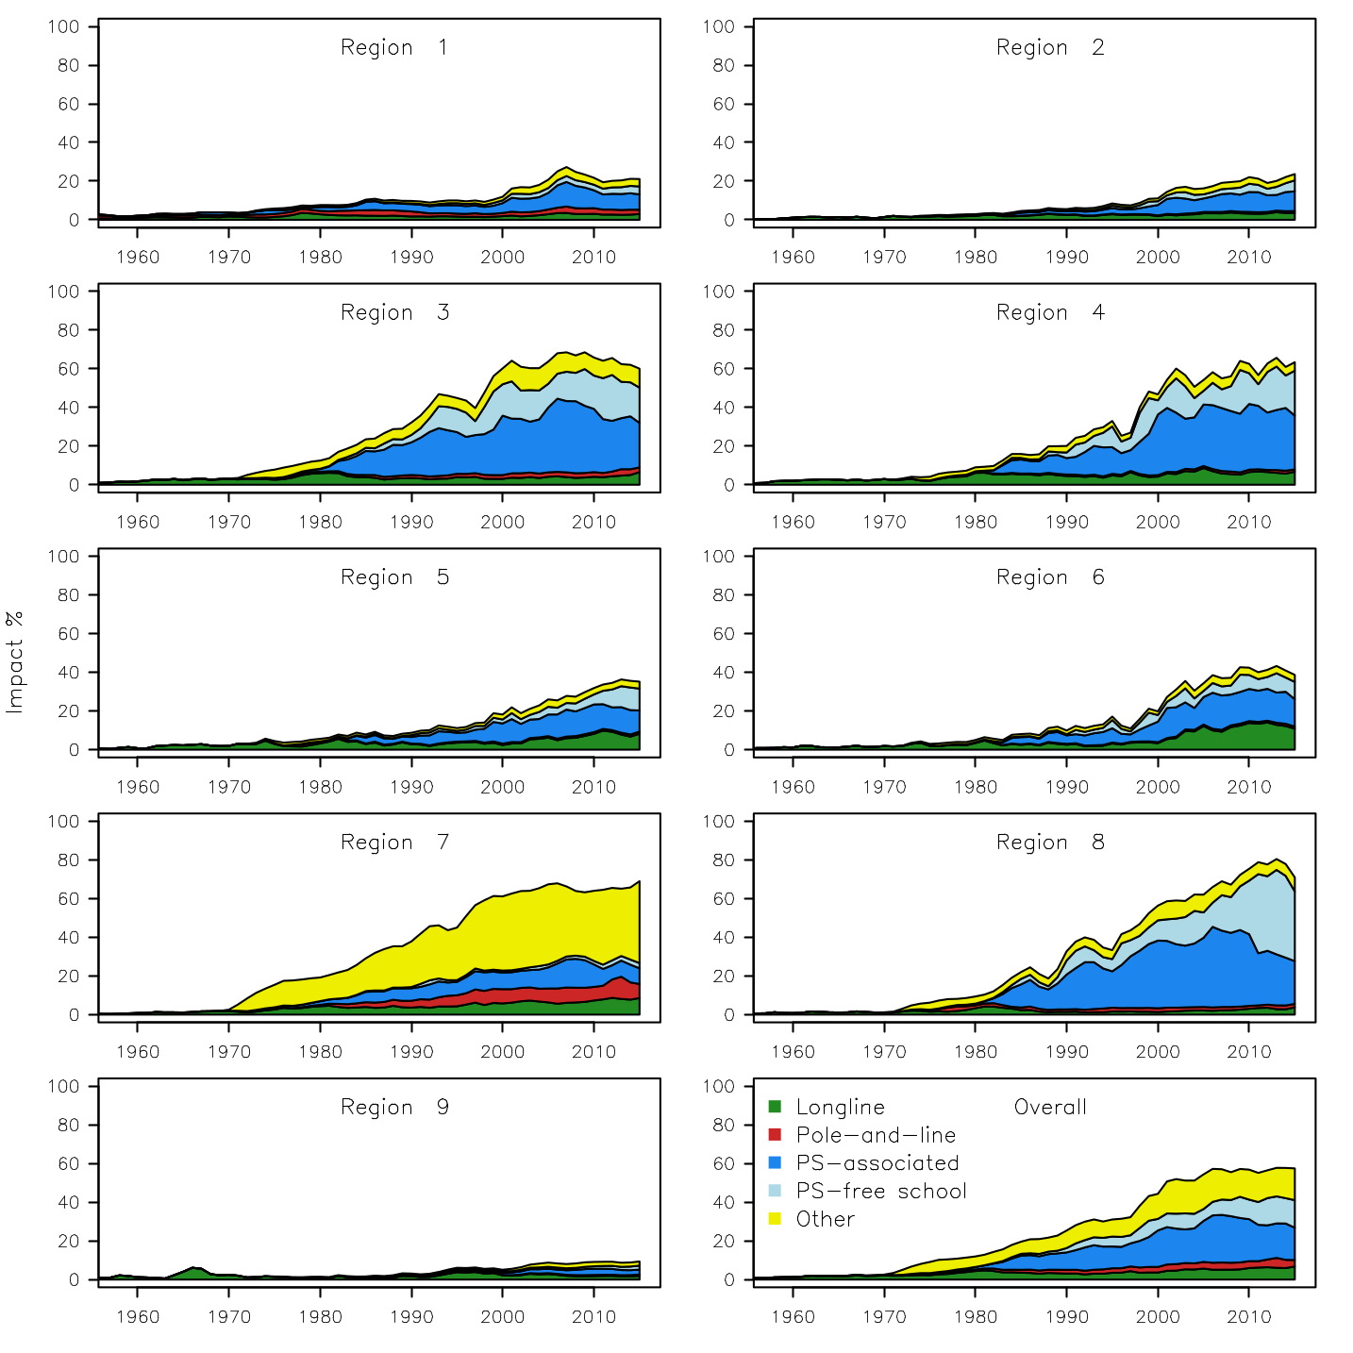
Figure YFT-11. Estimates of reduction in spawning potential due to fishing by region, and over all regions (lower right panel), attributed to various fishery groups (gear-types) for the diagnostic case model.

Table YFT-2. Summary of reference points over the 48 models in the structural uncertainty grid retained for management advice using divisors of 20 and 50 for the weighting on the size composition data. Note that SB_{recent}/SB_{F=0} is calculated where SB_{recent} is the mean SB over 2012-2015 instead of 2011-2014 (used in the stock assessment report), at the request of the Scientific Committee.
 | Mean | Median | Min | 10% | 90% | Max
C_{latest} | 611,982 | 612,592 | 606,762 | 607,517 | 614,237 | 614,801
MSY | 670,658 | 670,800 | 539,200 | 601,480 | 735,280 | 795,200
Y_{Frecent} | 646,075 | 643,400 | 534,400 | 586,120 | 717,880 | 739,600
F_{mult} | 1.34 | 1.36 | 0.88 | 1.03 | 1.61 | 1.86
F_{MSY} | 0.12 | 0.12 | 0.07 | 0.10 | 0.14 | 0.16
F_{recent}/F_{MSY} | 0.77 | 0.74 | 0.54 | 0.62 | 0.97 | 1.13
SB_{MSY} | 544,762 | 581,400 | 186,800 | 253,320 | 786,260 | 946,800
SB₀ | 2,199,750 | 2,290,000 | 1,197,000 | 1,366,600 | 2,784,500 | 3,256,000
SB_{MSY}/SB₀ | 0.24 | 0.24 | 0.15 | 0.18 | 0.28 | 0.34
SB_{F=0} | 2,083,477 | 2,178,220 | 1,193,336 | 1,351,946 | 2,643,390 | 2,845,244
SB_{MSY}/SB_{F=0} | 0.25 | 0.26 | 0.16 | 0.19 | 0.30 | 0.35
SB_{latest} /SB₀ | 0.33 | 0.34 | 0.18 | 0.23 | 0.42 | 0.45
SB_{latest} /SB_{F=0} | 0.35 | 0.37 | 0.16 | 0.22 | 0.46 | 0.50
SB_{latest} /SB_{MSY} | 1.40 | 1.39 | 0.80 | 1.02 | 1.80 | 1.91
SB_{recent}/SB_{F=0} | 0.32 | 0.33 | 0.15 | 0.20 | 0.41 | 0.46
SB_{recent}/SB_{MSY} | 1.40 | 1.41 | 0.81 | 1.05 | 1.71 | 1.93

- SC13 noted that the central tendency of relative recent spawning biomass was median (SB_{recent}/SB_{F=0}) = 0.33 with a probable range of 0.20 to 0.41 (80% probable range), and there was a roughly 8% probability (4 out of 48 models) that the recent spawning biomass had breached the adopted LRP with Prob((SB_{recent}/SB_{F=0})<0.2) = 0.08. The median estimate (0.33) is below that estimated from the 2014 assessment grid ((SB_{current}/SB_{F=0}) = 0.41, see SC10-SA-WP-04), noting the differences in grid uncertainty axes used in that assessment.

- SC13 noted that the central tendency of relative recent fishing mortality was median (F_{recent}/F_{MSY}) = 0.74 with an 80% probability interval of 0.62 to 0.97, and there was a roughly 4% probability (2 out of 48 models) that the recent fishing mortality was above F_{MSY} with Prob((F_{recent}/F_{MSY})>1) = 0.04. The median estimate (0.74) is also comparable to that estimated from the 2014 assessment grid (F_{current}/F_{MSY} = 0.76, see SC10-SA-WP-04)

- SC13 noted that the assessment results show that the stock has been continuously declining for about 50 years since the late 1960’s.

- SC13 also noted that levels of fishing mortality and depletion differ between regions, and that fishery impact was highest in the tropical region (Regions 3, 4, 7 and 8 in the stock assessment model), mainly due to the purse seine fisheries in the equatorial Pacific and the “other” fisheries within the Western Pacific (as shown in Figure 44 of SC13-SA-WP-06).

- Management advice and implications

- Based on the uncertainty grid adopted by SC13 the spawning biomass is highly likely above the biomass LRP and recent F is highly likely below F_{MSY}, and therefore noting the level of uncertainties in the current assessment it appears that the stock is not experiencing overfishing 96% probability) and it appears that the stock is not in an overfished condition (92% probability).

- Based on the diagnostic case, both juvenile and adult fishing mortality show a steady increase since the 1970s. Adult fishing mortality has increased continuously over most of the time series, while juvenile fishing mortality has stabilized since the late 1990s at a level similar to that now estimated for adult yellowfin.

- SC13 reiterates its previous advice from SC10 that WCPFC could consider measures to reduce fishing mortality from fisheries that take juveniles, with the goal to increase to maximum fishery yields and reduce any further impacts on the spawning potential for this stock in the tropical regions.

- SC13 also reiterates its previous advice from SC10 that measures should be implemented to maintain current spawning biomass levels until the Commission can agree on an appropriate target reference point (TRP).

Research Recommendations

- SC13 recognized that reviewing yellowfin growth through a study of yellowfin otoliths collected from the WCPO and incorporating this into future assessments should be encouraged.

Useful References

SC14-SA-WP-02 A compendium of fisheries indicators for tuna stocks. https://www.wcpfc.int/node/30987

SC14-SA-WP-13 Progress on yellowfin tuna age and growth in the WCPO WCPFC Project 82. https://www.wcpfc.int/node/31097

SC13-SA-WP-06 Stock assessment of yellowfin tuna in the western and central Pacific Ocean Rev 1 (26 July 2017). https://www.wcpfc.int/node/29519

SC13-SA-IP-06 Background analyses for the 2017 stock assessments of bigeye and yellowfin tuna in the western and central Pacific Ocean. https://www.wcpfc.int/node/29530

Previous Assessments

SC10-SA-WP-04 Stock assessment of yellowfin tuna in the western and central Pacific Ocean Rev 1 (25 July 2014) https://wcpfc.int/node/18997

SC7-SA-WP-03 Stock assessment of yellowfin tuna in the western and central Pacific Ocean (Rev.1 - 03August2011). https://wcpfc.int/node/2786

SC5-SA-WP-03 Stock assessment of yellowfin tuna in the western and central Pacific Ocean. https://wcpfc.int/node/2175

SC3-SA-WP-01 Stock assessment of yellowfin tuna in the western and central Pacific Ocean, including an analysis of management options. https://wcpfc.int/node/1649

SC2-SA-WP-01 Stock assessment of yellowfin tuna in the western and central Pacific Ocean, including an analysis of management options. https://wcpfc.int/node/1746

SC1-SA-WP-01 Stock assessment of yellowfin tuna in the Western and Central Pacific Ocean. https://wcpfc.int/node/1881

