Skipjack Tuna (Katsuwonas pelamis)
Stock Status & Trends plus Management Advice and Implications

Contents
SC13 2017 1
SC12 2016 (STOCK ASSESSMENT CONDUCTED) 2
Useful References 9
Previous Assessments 10

SC13 2017

- Stock status and trends

- SC13 noted that no stock assessment was conducted for WCPO skipjack tuna in 2017. Therefore, the stock status description from SC12 is still current. For further information on the stock status and trends from SC12, please see https://www.wcpfc.int/node/27769

- SC13 noted that the total catch in 2016 (1,816,762 mt) was comparable to that in 2015 and a 2% increase over 2011-2015. (see SC13-SA-WP-02)
- Purse seine catch (1,408,110 mt) was comparable to both 2015 and the 2011-2015 average. Pole and line catch (151,441 mt) was a 1% decrease from 2015 and an 11% decrease from 2011-2015 average. Catches by other fisheries (251,470 mt) were 2% higher than in 2015 and 26% higher than 2011-2015 average.

- SC13 noted that under recent fishery conditions (2016 catch level for LL and other fisheries and effort level for purse seine), the skipjack stock was initially projected to decrease for a short period and then to increase as recent relatively high recruitments move through the stock. Median F₂₀₁₈/F_{MSY} = 0.37; median SB₂₀₁₈/SB_{F=0} = 0.47.

- FFA members noted that skipjack tagging activities should be prioritized for the future stock assessment purpose as the pole and line fisheries which provided a major abundance index continues to shrink geographically.

- Management advice and implications

- SC13 noted that no stock assessment has been conducted since SC12. Therefore, the advice from SC12 should be maintained, pending a new assessment or other new information. For further information on the management advice and implications from SC12, please see https://www.wcpfc.int/node/27769

SC12 2016 (STOCK ASSESSMENT CONDUCTED)

- Stock status and trends

- S. McKechnie presented SC12-SA-WP-04 (stock assessment of skipjack tuna in the western and central Pacific Ocean) that assessed the stock of skipjack tuna in the WCPO up to the end of 2015. New developments to the assessment include addressing the recommendations of the previous assessment (2014), exploration of uncertainties in the assessment model, particularly in response to the inclusion of additional years of data, and to improve diagnostic weakness of previous assessments. Other key papers were presented to document: 1) methods of estimating standardized catch per unit effort indices, 2) construction of the tagging data input file, 3) revisions and summaries of fisheries definitions, and the guidance of the Pre-assessment workshop.
- SC12 noted that the skipjack catch in 2015 was 1,827,750 mt, was a 9% decrease over 2014 and a 3% increase over the average for 2010-14.
- Purse seine skipjack catch in 2015 was 13% lower than that in 2014 and effort 21% lower.
- The SC12 was unable to reach consensus on the description of stock status based on the 2016 stock assessment.
- SC12 notes that the majority of member countries agreed on the following description of WCPO skipjack tuna status and trends.
Majority view of stock status and trends
- A majority of SC12 CCMs selected the reference case model as the base case to represent the stock status of skipjack tuna (column “Ref Case” in Table SKJ2). To characterize uncertainty, those CCMs chose the structural uncertainty grid. Summaries of important model quantities for these models are shown in Table SKJ2.

Table SKJ1. Description of the structural sensitivity grid used to characterise uncertainty in the assessment. The reference case option is denoted in bold face.
Axis | Levels | Option
Steepness | 3 | 0.65, 0.80, or 0.95
Mixing period | 2 | 1 quarter mixing, 2 quarters mixing
Length composition weighting | 3 | Sample sizes divided by 10, 20, or 50
Tagging overdispersion | 3 | Default level, Estimated, or Fixed (moderate) level

Table SKJ2: Estimates of management quantities for the selected stock assessment models. For the purpose of this assessment, “recent” is the average over the period 2011–2014 and “latest” is 2015. The column “Ref Case” shows summaries for the reference case and the remaining columns are the quantiles of the structural uncertainty grid, e.g. 5% and 50% are the 5% quantile and the median (50% quantile), respectively. Option 1 in the text recommends basing management advice on the reference case model and considering the uncertainty represented by the 5% and 95% quantile columns. Option 2 recommends basing management advice on the range of model runs in the structural uncertainty grid, as represented by the 5% and 95% quantile columns.
Quantity | Ref Case | 50% | 5% | 25% | 75% | 95%
$$C_{latest}$$ | 1,679,528 | 1,679,444 | 1,678,646 | 1,679,170 | 1,679,497 | 1,679,592
$$MSY$$ | 1,891,600 | 1,875,600 | 1,618,060 | 1,785,400 | 1,976,700 | 2,199,880
$${Y_{F}}_{recent}$$ | 1,594,800 | 1,607,000 | 1,486,660 | 1,533,200 | 1,755,200 | 1,808,860
$$f_{mult}$$ | 2.23 | 2.07 | 1.57 | 1.85 | 2.29 | 2.62
$$F_{MSY}$$ | 0.24 | 0.24 | 0.21 | 0.22 | 0.26 | 0.28
$${F_{recent}/F}_{MSY}$$ | 0.45 | 0.48 | 0.38 | 0.44 | 0.54 | 0.64
$${SB}_{MSY}$$ | 1,626,000 | 1,628,000 | 1,258,700 | 1,425,750 | 1,852,750 | 2,166,100
$${SB}_{0}$$ | 6,764,000 | 6,359,500 | 5,214,050 | 5,853,750 | 7,095,250 | 8,340,450
$${SB}_{F=0}$$ | 7,221,135 | 6,876,526 | 5,778,079 | 6,408,578 | 7,425,353 | 8,555,240
$${{SB}_{latest}/SB}_{0}$$ | 0.62 | 0.55 | 0.43 | 0.49 | 0.59 | 0.71
$${{SB}_{latest}/SB}_{F=0}$$ | 0.58 | 0.51 | 0.39 | 0.47 | 0.57 | 0.67
$${{SB}_{latest}/SB}_{MSY}$$ | 2.56 | 2.15 | 1.6 | 1.81 | 2.43 | 3.08
$${{SB}_{recent}/SB}_{F=0}$$ | 0.52 | 0.49 | 0.4 | 0.46 | 0.52 | 0.57
$${{SB}_{recent}/SB}_{MSY}$$ | 2.31 | 2.04 | 1.58 | 1.82 | 2.32 | 2.65

- Trends in estimated recruitment, spawning biomass, fishing mortality and depletion are shown in Figures SKJ 1-4.
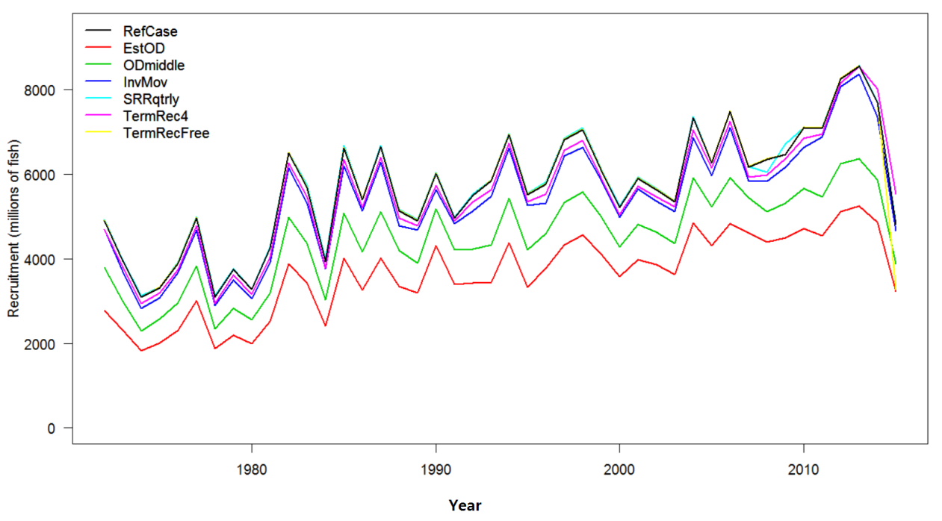
Figure SKJ1: Estimated annual recruitment (millions of fish) for the WCPO obtained from the reference case model and six additional runs.
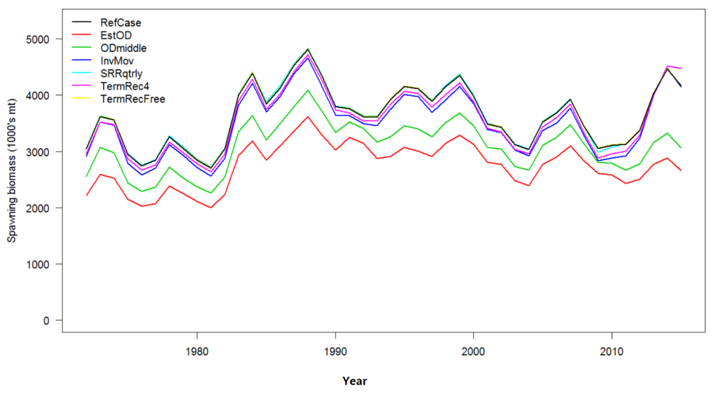
Figure SKJ2: Estimated annual average spawning potential for the WCPO obtained from the reference case model and six additional runs.
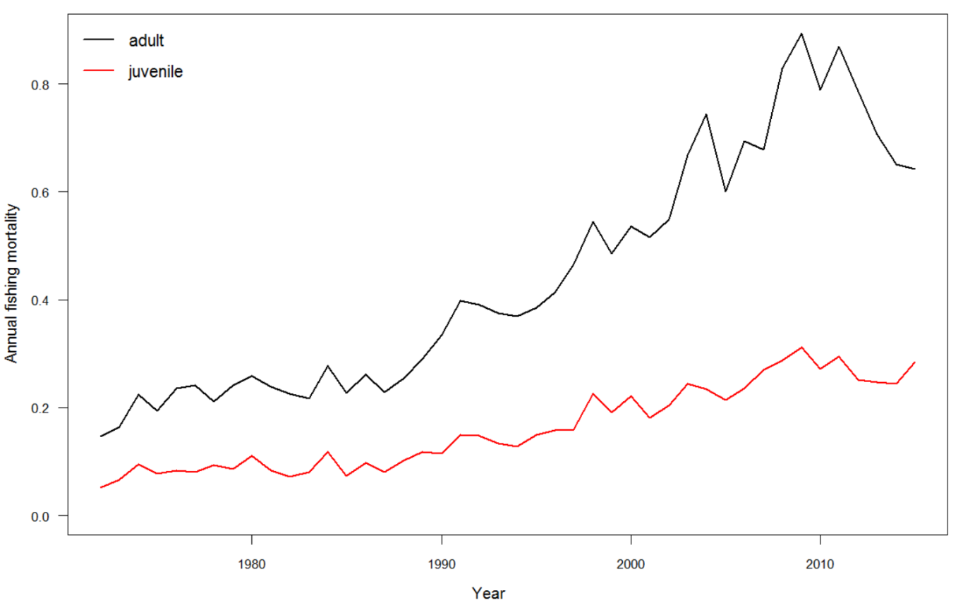
Figure SKJ3: Estimated annual average juvenile and adult fishing mortality for the WCPO obtained from the reference case model.
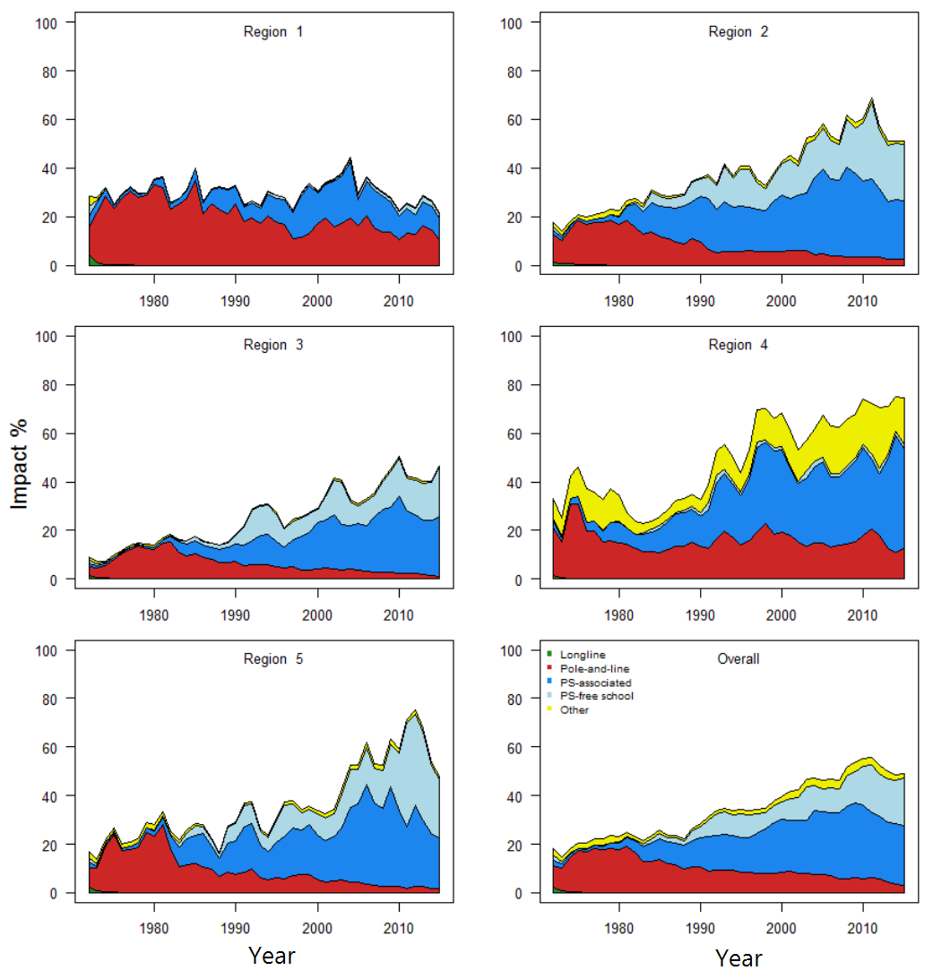
Figure SKJ4: Estimates of reduction in spawning potential due to fishing (fishery impact = 1-SB_{t}/SB_{t,F=0}) by region and for the WCPO attributed to various fishery groups for the reference case model.
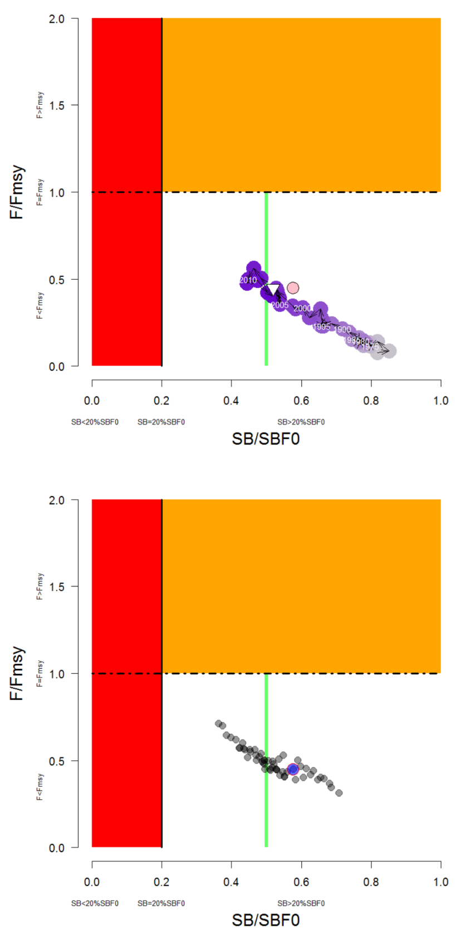
Figure SKJ5: Temporal trend for the reference case model (top) and the structural uncertainty grid (bottom panel) in stock status relative to SB_{F=0} (x-axis) and F_{MSY} (y-axis). The red zone represents spawning potential levels lower than the agreed LRP, which is marked with the solid black line (0.2SB_{F=0}). The orange region is for fishing mortality greater than F_{MSY} (F=F_{MSY}; marked with the black dashed line). The green line indicates the interim target reference point 50%SBF=0.
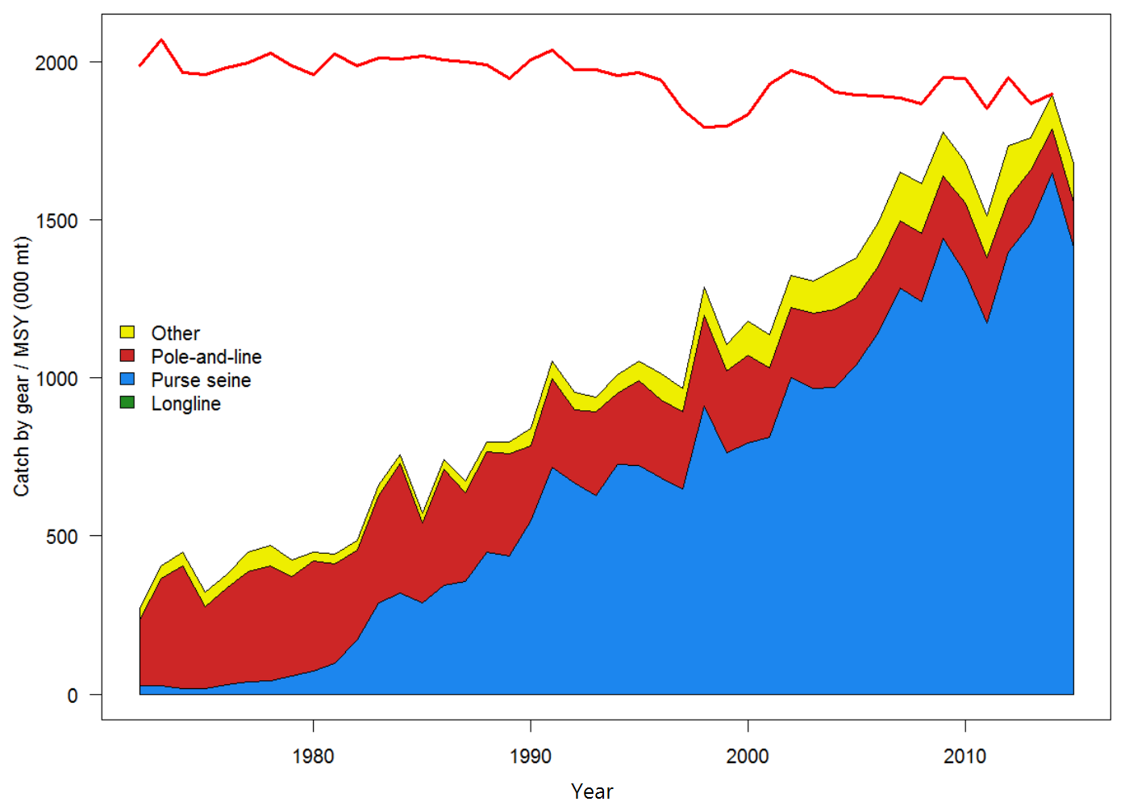
Figure SKJ6: History of annual estimates of MSY compared with catches of three major fisheries for the reference case model.
- Dynamics of most model quantities are relatively consistent with the results of the 2014 stock assessment, although there has been a period of several subsequent years with high recruitments and increased spawning biomass.
- Fishing mortality of all age-classes is estimated to have increased significantly since the beginning of industrial tuna fishing, but fishing mortality still remains below the level that would result in the MSY (F_{recent}/F_{MSY} = 0.45 for the reference case), and is estimated to have decreased moderately in the last several years. Across the reference case and the structural uncertainty grid F_{recent}/F_{MSY} varied between 0.38 (5% quantile) to 0.64 (95% quantile). This indicates that overfishing is not occurring for the WCPO skipjack tuna stock (Figure SKJ 5).
- The estimated MSY of 1,891,600 mt is moderately higher than the 2014 estimate due to the adoption of an annual, rather than quarterly, stock-recruitment relationship. Recent catches are lower than, but approaching, this MSY value (Figure SKJ 6).
- The latest (2015) estimate of spawning biomass is well above both the level that will support MSY (SBlatest/SBMSY = 2.56, for the reference case model) and the adopted LRP of 0.2 SBF=0 (SBlatest/SBF=0 = 0.58, for the reference case model), and SBlatest/SBF=0 was relatively close to the adopted interim target reference point (0.5 SBF=0) for all models explored in the assessment (structural uncertainty grid: median = 0.51, 5% and 95% quantiles = 0.39 and 0.67).
Alternative view of stock status and trends
- China, Japan and Chinese Taipei considered it is not possible to select a base-case model from various sensitivity models in the 2016 assessment, given the advice from the Scientific Service Provider that a suite of the sensitivity models were plausible. Therefore, these members considered that it would be more appropriate to provide advice to WCPFC13 on skipjack stock status based on the range of uncertainty expressed by the alternative model runs in the sensitivity analysis rather than based on the single base case model (represented by the 5% and 95% quantiles of the structural sensitivity grid presented in Table SKJ2).
- The estimated MSY of the WCPO skipjack stock ranges from 1,618,060 mt (5% quantile) to 2,199,880 mt (95% quantile) across the alternative skipjack stock assessment models represented in the sensitivity grid. These CCMs also noted that some alternative models indicate that the 2015 biomass is below the adopted TRP of 0.5SBF=0.

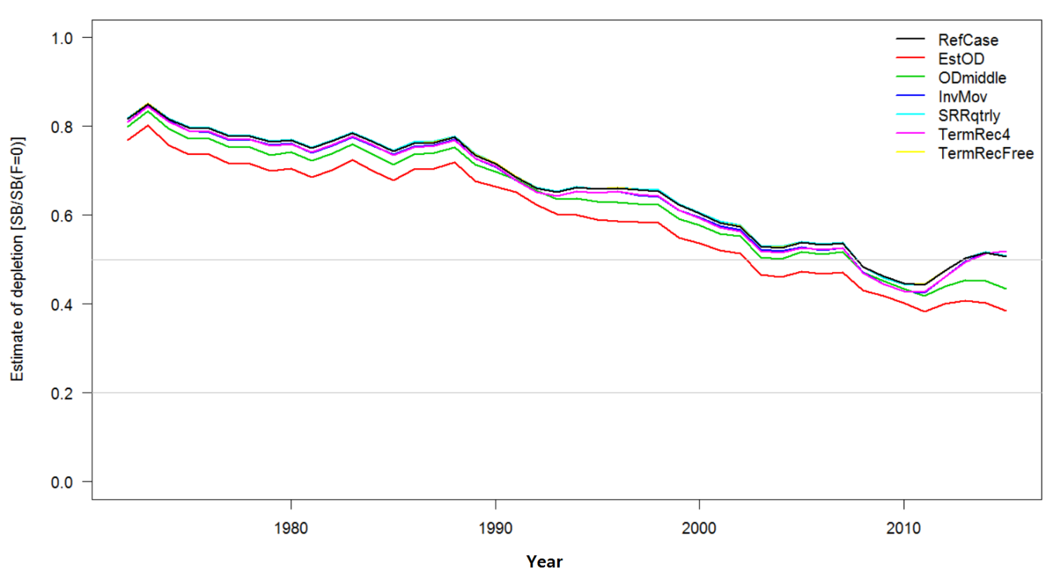
Figure SKJ 7. Estimated fisheries depletion SB/SBF=0, for each of the sensitivity models.

Management advice and implications
- SC12 noted that the skipjack assessment continues to show that the stock is currently moderately exploited and fishing mortality level is sustainable. The recent catches are fluctuating around and some models also indicate that the stock is currently under the TRP.
- SC12 noted that fishing is having a significant impact on stock size and can be expected to affect catch rates. The stock distribution is also influenced by changes in oceanographic conditions associated with El Niño and La Niña events, which impact on catch rates and stock size. Additional purse-seine effort will yield only modest gains in long-term skipjack tuna catches and may result in a corresponding increase in fishing mortality for bigeye and yellowfin tunas. The management of total effort in the WCPO should recognize this.
- SC12 noted that skipjack spawning biomass is now around the adopted TRP and SC12 recommends that the Commission take action to keep the spawning biomass near the TRP and also advocates for the adoption of harvest control rules based on the information provided.
- In order to maintain the quality of stock assessments for this important stock, SC12 recommends 1) continued work on developing an index of abundance based on purse seine data; 2) regular large scale tagging cruises and complementary tagging work continue to be undertaken in a way that provides the best possible data for stock assessment purposes.
- SC12 also notes that the current method of calculating the TRP is based on the most recent 10 years of recruitment information. However, the information on spawning potential, SB₂₀₁₅, which is used to evaluate current stock status relative to the TRP can change very rapidly for skipjack which mature at age 1 and this rapid maturation may provide an optimistic status evaluation when recruitment is estimated have an increasing trend but is estimated with substantial uncertainty, as is currently observed in the case of skipjack which does not have a fishery-independent index of recruitment strength.
- There is ongoing concern by at least one CCM that high catches in the equatorial region may be causing a range contraction of WCPO skipjack tuna, thus reducing skipjack tuna availability to fisheries conducted at higher latitudes than the Pacific equatorial region. SC12 reiterates the advice of SC11 whereby there is no demonstrated statistical evidence for SKJ range contraction. As a result, SC12 recommends that ongoing research on range contraction of skipjack tuna be continued in the framework of Project 67.

Useful References

SC13-SA-WP-02 A compendium of fisheries indicators for tuna stocks. https://www.wcpfc.int/node/29515

SC13-SA-WP-07 Impacts of Recent High Catches of Skipjack on Fisheries on the Margins of the WCPFC Convention Area Rev 1 (21 July 2017) https://www.wcpfc.int/node/29520

SC12-SA-WP-04 Stock assessment of skipjack tuna in the western and central Pacific Ocean. https://www.wcpfc.int/node/27490

SC12-SA-WP-04a Additional analyses to support the 2016 stock assessment of skipjack tuna in the western and central Pacific Ocean. https://www.wcpfc.int/node/28559

SC12-SA-IP-05 Construction of tagging data input files for the 2016 skip jack tuna stock assessment in the western and central Pacific Ocean. https://www.wcpfc.int/node/27489

SC12-SA-IP-06 Summary of fisheries structures for the 2016 stock assessment of skipjack tuna in the western and central Pacific Ocean. https://www.wcpfc.int/node/27486

Previous Assessments

SC10-SA-WP-05 Stock assessment of skipjack tuna in the western and central Pacific Ocean. (Rev 1 25 July 2014) https://wcpfc.int/node/18998

SC7-SA-WP-04 Stock assessment of skipjack tuna in the western and central Pacific Ocean (Rev.1 - 04August2011). https://wcpfc.int/node/2787

SC6-SA-WP-10 Stock Assessment of skipjack tuna in the western and central Pacific Ocean. Rev.1. https://wcpfc.int/node/2468

SC4-SA-WP-04 Stock assessment of skipjack tuna in the western and central Pacific Ocean. https://wcpfc.int/node/2008

SC1-SA-WP-04 Stock assessment of skipjack tuna in the western and central Pacific Ocean. https://wcpfc.int/node/1887

