The Commission for the Conservation and Management of
Highly Migratory Fish Stocks in the Western and Central Pacific Ocean

Scientific Committee

South Pacific Albacore Tuna (Thunnus alalunga)

Stock Status And Management Advice

Contents
SC15 2019 (FISHERY INDICATORS UPDATED) 2
SC14 2018 (STOCK ASSESSMENT CONDUCTED) 3
SC13 2017 (FISHERY INDICATORS UPDATED) 9
Useful References 11
Previous Assessments 11

SC15 2019 (FISHERY INDICATORS UPDATED)

- Stock status and trends

- SC15 noted that no stock assessments were conducted for South Pacific albacore in 2019. Therefore, the stock status descriptions from SC14 are still current for South Pacific albacore. For further information on the stock status and trends from SC14, please see https://www.wcpfc.int/node/32155. Updated information on fishery trends and indicators were compiled for and reviewed by SC15.

- SC15 noted that the total provisional Pacific Ocean catch south of the equator in 2018, updated since the paper was submitted, was 80,820 mt, a 13% decrease from 2017 and a 2% decrease from the average 2013-2017. Longline catch in 2018 (77,776 mt) was a 14% decrease from 2017 and an 8% decrease from the 2013-2017 average.

- The average stock status in 2016 (the last year of the assessment) across the 72 model runs was SB_{latest}/SB_{F=0} = 0.52, below the interim target reference point (SB_{latest}/SB_{F=0} = 0.56) established by the WCPFC in 2018. The probability of being below the TRP in 2016 is 63%. The stock is not overfished nor is overfishing occurring.

- SC15 noted projections from the 2018 assessment which apply to the WCPFC Convention Area. The historical status and projections have a greater uncertainty in spawning stock depletion than observed for bigeye and yellowfin tuna because South Pacific albacore has a different grid which incorporates natural mortality and growth, and this gives a wider spread of uncertainty. SC15 noted that under recent fishery conditions of assuming that the 2018 catch remains constant, the albacore stock is initially projected to increase as recent estimated relatively high recruitments support adult stock biomass, then decline as future recruitment is sampled from the long-term historical estimates The projections indicate that median F₂₀₂₀/F_{MSY} = 0.24; median SB₂₀₂₀/SB_{F=0} = 0.43; and median SB₂₀₂₀/SB_{MSY} = 3.2. The risk that SB₂₀₂₀/SB_{F=0} < LRP = 0%, SB₂₀₂₀ < SB_{MSY} = 0% and F₂₀₂₀ > F_{MSY} = 0%.

- The stock biomass is expected to decline from the 2016 level of 0.52 to 0.39 by 2035. The risk of the stock biomass breaching the LRP in 2035 is expected to be 23%. The longline-vulnerable biomass (the longline CPUE proxy) is expected to decrease by 36% relative to 2013 levels.

- Management advice and implications

- Given the stock assessment in 2018 and SC15 projections, SC15 advises that WCPFC develop comprehensive binding South Pacific albacore management measures which will result in the stock reaching the TRP within the 20-year time horizon. SC15 advises WCPFC16 may consider establishing a CMM to further reduce total catch or effort in order to reverse the projected decline in the vulnerable biomass.

- SC15 notes that the 2018 South Pacific albacore stock assessment pertained to the WCPFC Convention Area. The South Pacific albacore catch in the eastern Pacific Ocean has recently increased and the scheduled 2021 South Pacific albacore assessment may pertain to the entire south Pacific stock in order to incorporate all population dynamics. WCPFC and IATTC compatible measures would be more easily implemented should an entire south Pacific assessment be conducted.

- Research recommendation

- SC15 noted that the assumed future recruitment can have a large impact on the projection result. It was recommended that research be undertaken to quantify autocorrelation behavior of recruitment to be included in the future projection.

SC14 2018 (STOCK ASSESSMENT CONDUCTED)

- SC14 accepted as SC14-SA-WP-05 as providing the best available scientific information for the purpose of stock assessment determination.

- Stock status and trends

- The median, 10 percentile and 90 percentile values of recent (2013-2016) spawning biomass ratio (SBrecent/ SBF=0) and recent fishing mortality in relation to FMSY (Frecent/FMSY) over the structural uncertainty grid were used to characterize uncertainty and describe the stock status.

- A description of the structural sensitivity grid used to characterize uncertainty in the assessment is set out in Table SPA-1. The regional structure used within the assessment is presented in Figure SPA-1, and the time series of total annual catch by fishing gear for the diagnostic case model over the full assessment period is shown in Figure SPA-2 for the total assessment region, and Figure SPA-3 by model region. Estimated annual average recruitment, spawning potential, juvenile and adult fishing mortality and fishing depletion for the diagnostic case model are shown in Figures SPA-4 – SPA-7. Figure SPA-8 displays Majuro plots summarising the results for each of the models in the structural uncertainty grid, while Figure SPA-9 shows equivalent Kobe plots for SBrecent and SBlatest across the structural uncertainty grid. Figure SPA-10 provides estimates of reduction in spawning potential due to fishing by region, and over all regions attributed to various fishery groups (gear-types) for the diagnostic case model. Table SPA-2 provides a summary of reference points over the 72 models in the structural uncertainty grid. Figure SPA-11 presents the history of the annual estimates of MSY for the diagnostic case model, compared with annual catch by the main gear types. Finally, Figure SPA-12 presents the estimated time-series (or ‘dynamic’) Kobe plots for four example models from the assessment (one from each of the combinations of growth types, and natural mortality M set to 0.3 or 0.4)

- SC14 noted that the median level of spawning biomass depletion from the uncertainty grid was SBrecent/SBF=0 = 0.52 with a probable range of 0.37 to 0.63 (80% probability interval). There were no individual models where (SBrecent/SBF=0) < 0.2 which indicated that the probability that recent spawning biomass was below the LRP was zero. SC14 noted that the grid median Frecent/FMSY was 0.20, with a range of 0.08 to 0.41 (80% probability interval) and that no values of Frecent/FMSY in the grid exceeded 1.

- SC14 also noted that there was a 0% probability (0 out of 72 models) that the recent fishing mortality had exceeded FMSY.

- SC14 noted that the structural uncertainty grid for the south Pacific albacore had changed since the 2015 assessment, with the 2018 assessment examining additional axes of uncertainty including assumptions on growth and CPUE standardization approach. As a consequence, the uncertainty identified is higher than in previous assessments.

- SC14 also noted that the assessment results show that while the stock depletion (SB/SBF=0) has exhibited a long-term decline (Figure SPA-7) the stock is not in an overfished state and overfishing is not taking place.

b. Management Advice and implications

- SC14 noted that the preliminary estimate of total catch of south Pacific albacore (within the WCPFC Convention Area south of the equator) for 2017 was 75,707mt, which was a 33% increase from 2016 and a 13% increase over 2012-2016. (see SC14-SA-WP-02).

- Preliminary catch for longliners in 2017 (72,785mt) was 34% higher compared with 2016 and a 14% increase over 2012-2016. Preliminary other gear (primarily troll) catch in 2017 (2,896t) was 17% higher compared with 2016 but a 1% decrease over 2012-2016. (see SC14-SA-WP-02).

- Based on the uncertainty grid adopted by SC14, the South Pacific albacore tuna spawning biomass is very likely to be above the biomass LRP and recent F is very likely below FMSY, and therefore the stock is not experiencing overfishing (100% probability F < FMSY) and is not in an overfished condition (100% probability SBrecent > LRP).

- SC14 recalled its previous advice from SC11, SC12, and SC13 that longline fishing mortality and longline catch be reduced to avoid decline in the vulnerable biomass so that economically viable catch rates can be maintained, especially for longline catch of adult albacore. SC14 recommends that this advice be taken into consideration when the TRP for South Pacific albacore is discussed at WCPFC15.

Table SPA-1. Description of the structural sensitivity grid used to characterize uncertainty in the 2018 south Pacific albacore assessment. Levels used within the diagnostic case are starred.
Axis | Levels | Option
Steepness | 3 | 0.65, 0.80*, 0.95
Natural mortality | 2 | 0.3*, 0.4
Growth | 2 | Estimated* (K, L∞) or fixed (Chen-Wells)
Size frequency weighting | 3 | Sample sizes divided by 20, 50* or 80
CPUE | 2 | Geostatistical*, Traditional

Table SPA-2. Summary of reference points over all the 72 individual models in the structural uncertainty grid.
 | Mean | Median | Min | 10% | 90% | Max
Clatest | 61719 | 61635 | 60669 | 60833 | 62704 | 63180
MSY | 100074 | 98080 | 65040 | 70856 | 130220 | 162000
YFrecentt | 71579 | 71780 | 56680 | 62480 | 80432 | 89000
fmult | 6.2 | 4.96 | 1.89 | 2.44 | 12.05 | 17.18
FMSY | 0.07 | 0.07 | 0.05 | 0.05 | 0.09 | 0.1
Frecent/FMSY | 0.23 | 0.2 | 0.06 | 0.08 | 0.41 | 0.53
SBMSY | 71407 | 68650 | 26760 | 39872 | 100773 | 134000
SB0 | 443794 | 439800 | 308800 | 353870 | 510530 | 696200
SBMSY/SB0 | 0.16 | 0.17 | 0.07 | 0.1 | 0.21 | 0.23
SBF=0 | 469004 | 462633 | 380092 | 407792 | 534040 | 620000
SBMSY/SBF=0 | 0.15 | 0.15 | 0.06 | 0.09 | 0.2 | 0.22
SBlatest/SB0 | 0.55 | 0.56 | 0.33 | 0.42 | 0.69 | 0.74
SBlatest/SBF=0 | 0.53 | 0.52 | 0.3 | 0.37 | 0.69 | 0.77
SBlatest/SBMSY | 4 | 3.42 | 1.45 | 1.96 | 7.07 | 10.74
SBrecent/SBF=0 | 0.51 | 0.52 | 0.32 | 0.37 | 0.63 | 0.72
SBrecent/SBMSY | 3.88 | 3.3 | 1.58 | 1.96 | 6.56 | 9.67

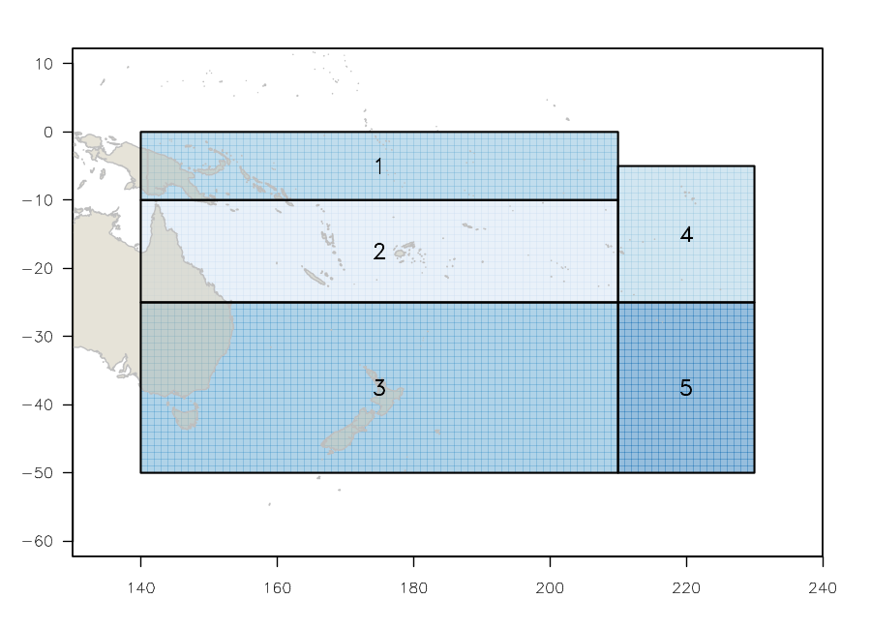 | 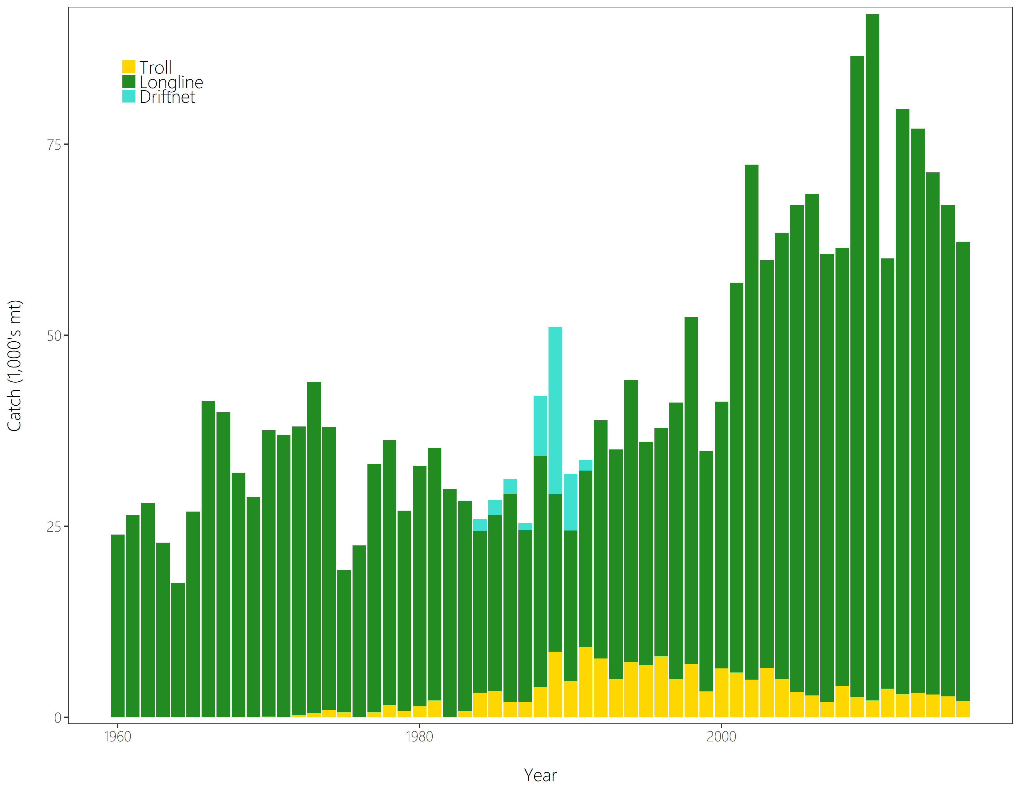
Figure SPA- 1. The geographical area covered by the stock assessment and the boundaries for the 5 regions under the “updated 2018 regional structure". | Figure SPA- 2. Time series of total annual catch (1000’s mt) by fishing gear for the diagnostic case model over the full assessment period. The different colours refer to longline (green), troll (yellow) and driftnet (turquoise). Note that the catch by longline gear has been converted into catch-in-weight from catch-in-numbers.

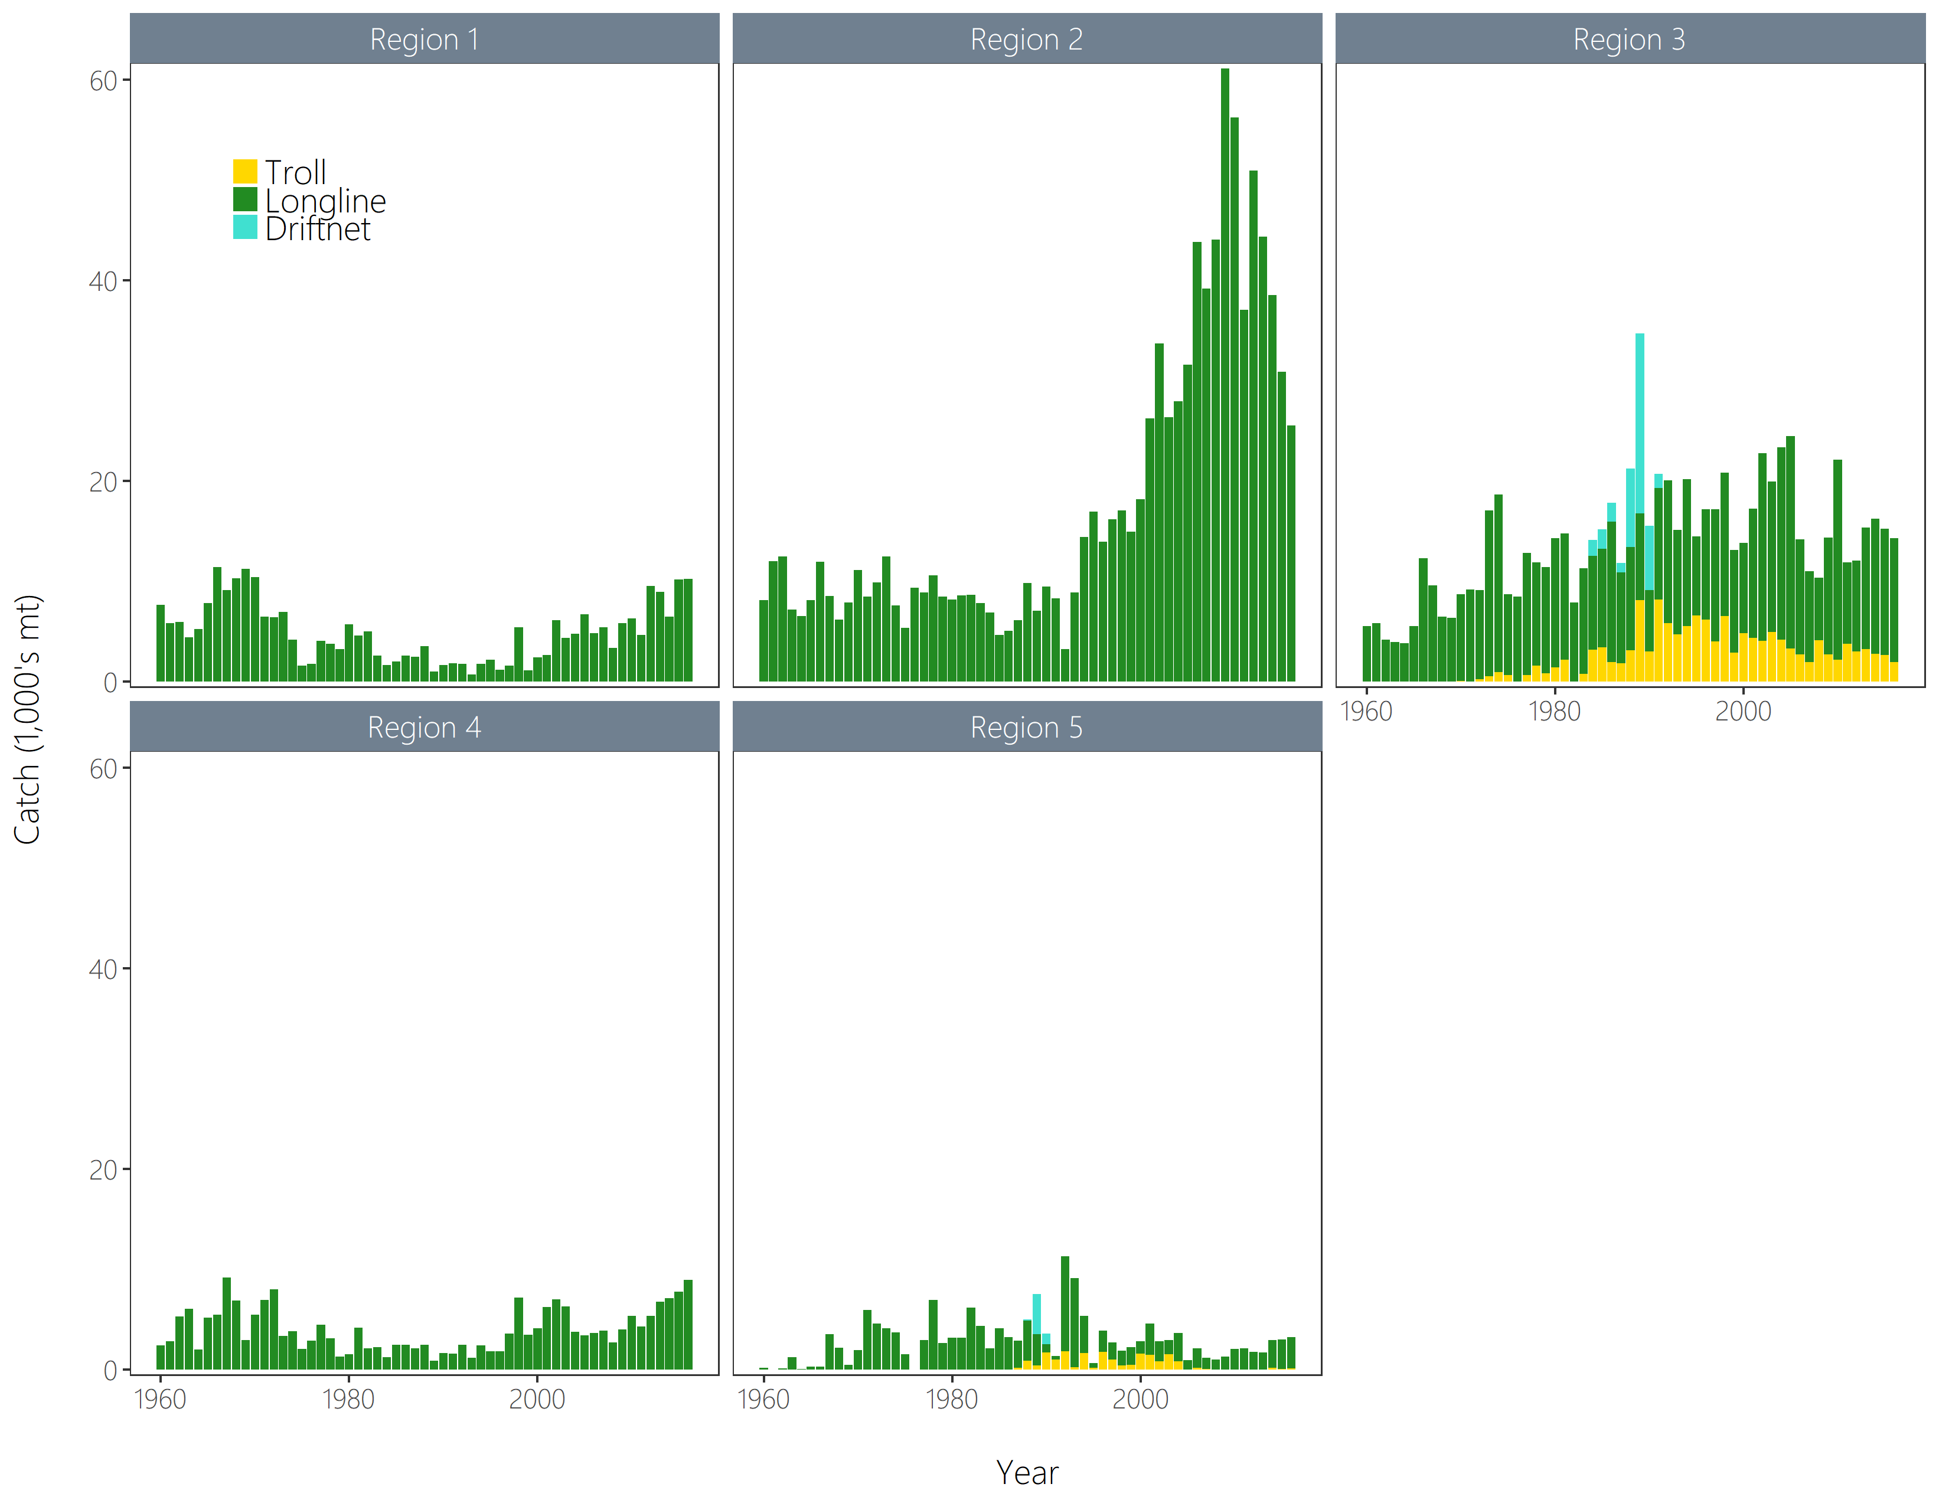 | 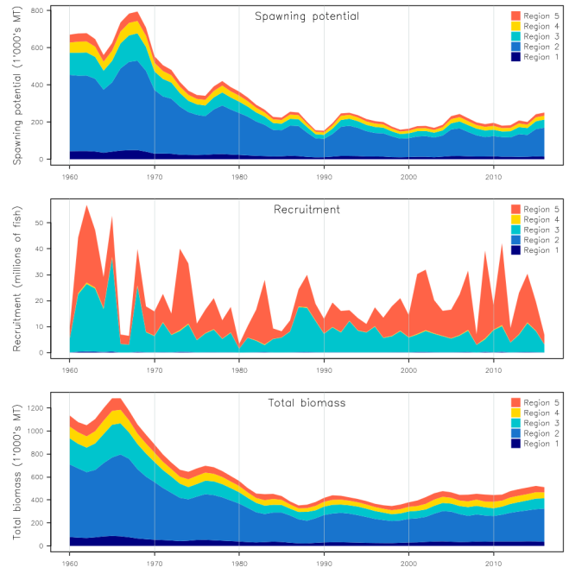
Figure SPA-3. Time series of total annual catch (1000’s mt) by fishing gear and assessment region from the diagnostic case model over the full assessment period. The different colours denote longline (green), driftnet (turquoise) and troll (yellow). | Figure SPA-4. Estimated annual average recruitment, spawning potential and total biomass by model region for the diagnostic case model, showing the relative sizes among regions.

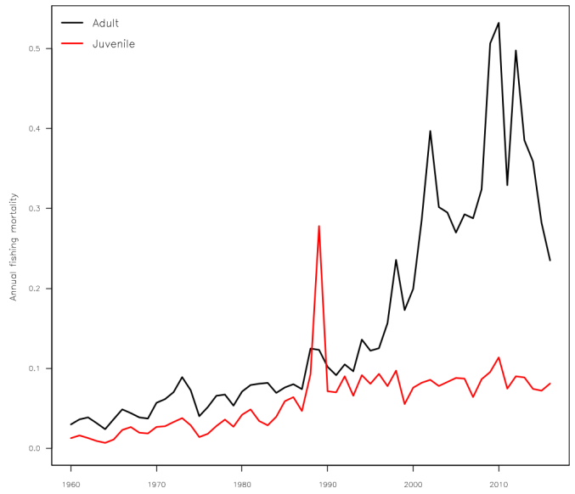 | 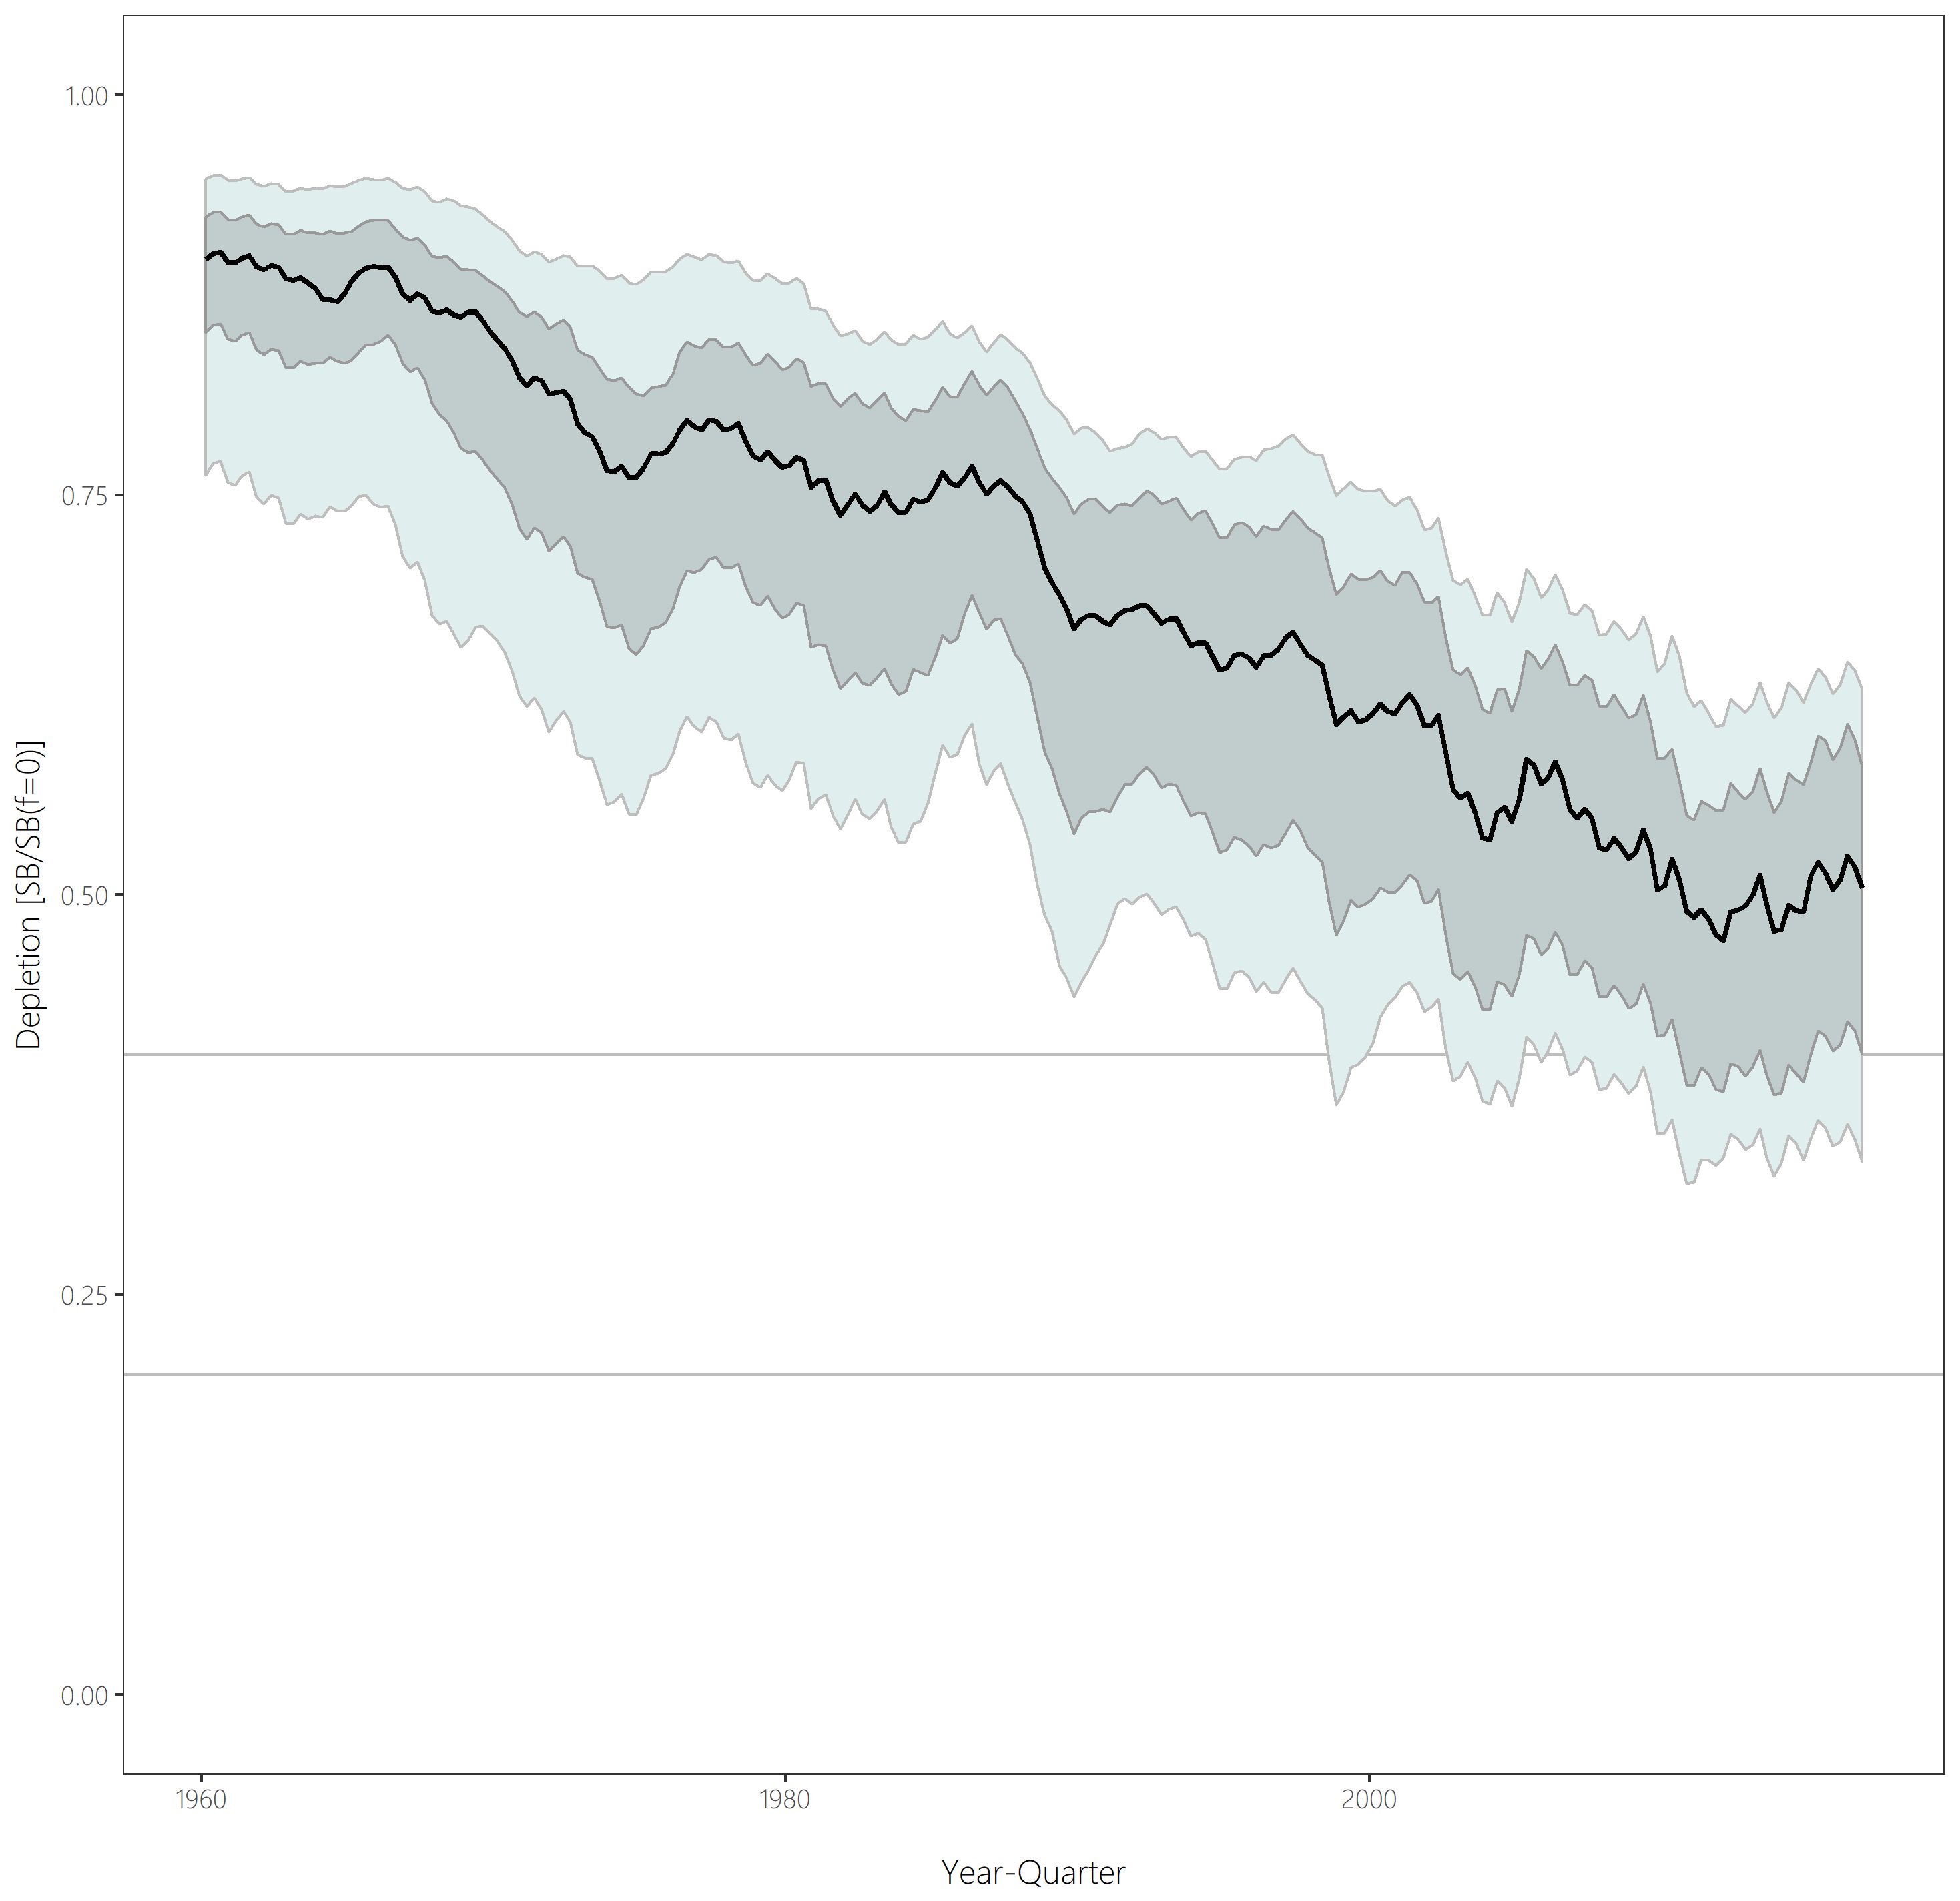
Figure SPA-5. Estimated annual average juvenile and adult fishing mortality for the diagnostic case model. | Figure SPA-6. Distribution of time series depletion estimates across the structural uncertainty grid. Black line represents the grid median trajectory, dark grey region represents the 50%ile range, light grey the 90%ile range.

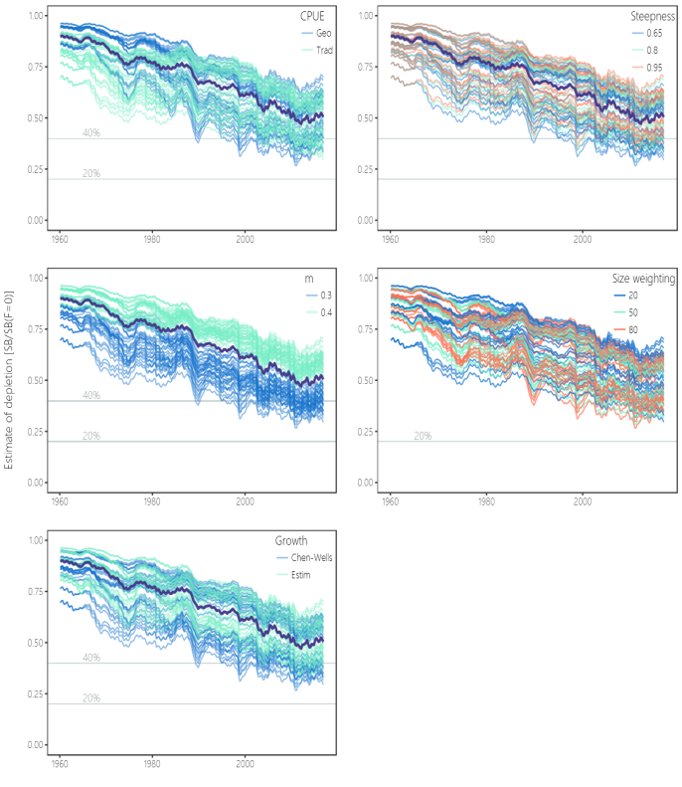 | 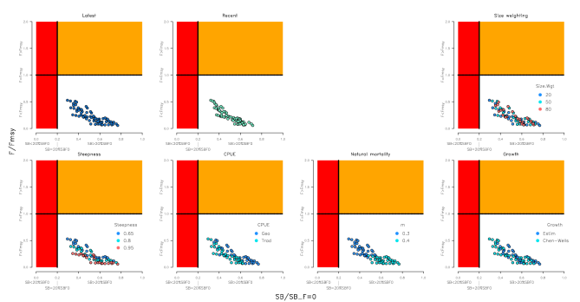
Figure SPA-7. Plots showing the trajectories of fishing depletion (of spawning potential) for the model runs included in the structural uncertainty grid. The five panels show the models separated on the basis of the five axes used in the grid, with the colour denoting the level within the axes for each model. | Figure SPA-8. Majuro plots summarising the results for each of the models in the structural uncertainty grid under the SBlatest/SBF=0 and the SBrecent/SBF=0 reference points (top left) and each axis of uncertainty.

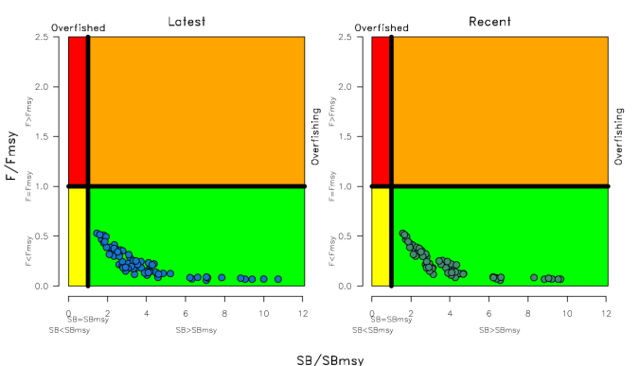 | 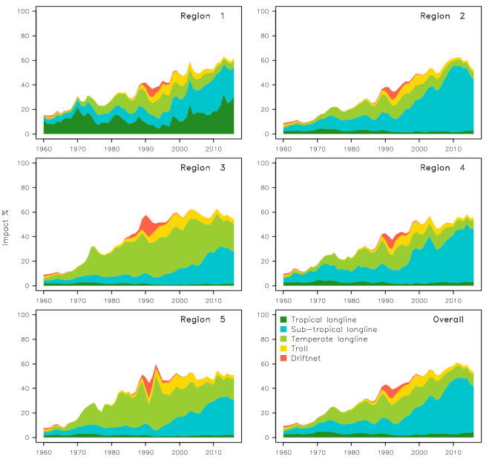
Figure SPA-9. Kobe plots summarising the results for each of the models in the structural uncertainty grid under the SBlatest/SBF=0 and the SBrecent/SBF=0 reference points. | Figure SPA-10. Estimates of reduction in spawning potential due to fishing (fishery impact = 1-SB latest/SB F=0) by region, and over all regions (lower right panel), attributed to various fishery groups for the diagnostic case model.

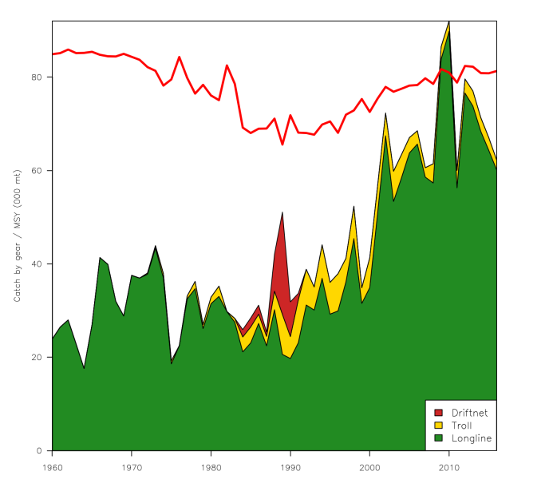 | 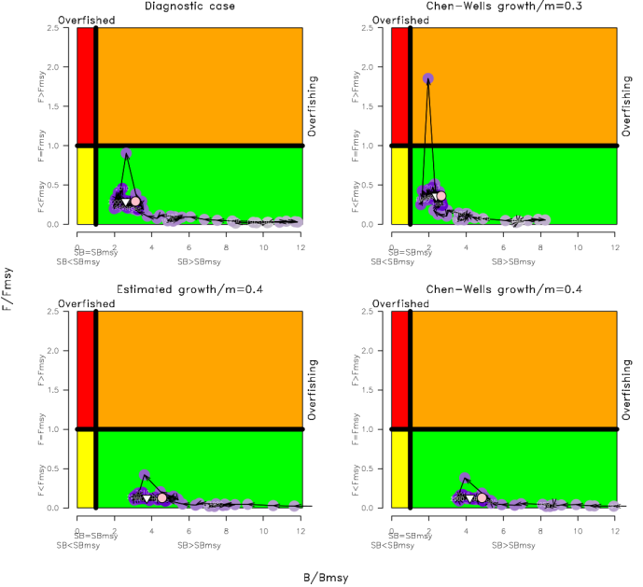
Figure SPA-11. History of the annual estimates of MSY (red line) for the diagnostic case model compared with annual catch by the main gear types. | Figure SPA-12. Estimated time-series (or ‘dynamic’) Kobe plots for four example models from the assessment (one from each of the combinations of growth types, and natural mortality M set to 0.3 or 0.4).

SC13 2017 (FISHERY INDICATORS UPDATED)

- Stock status and trends

- SC13 noted that no stock assessment was conducted for South Pacific albacore tuna in 2017. Therefore, the stock status description from SC11 is still current. For further information on the stock status and trends from SC11, please see http://www.wcpfc.int/node/26922

- SC13 considered an update of trends in South Pacific albacore fisheries (SC13-SA-WP-08) and noted that there had been reductions in longline effort in the WCPF Convention Area south of 10^{ᴼ}S through 2014-2016 (declining from about 300 million hooks in 2013 to around 254 million in 2015, and 200 million hooks in 2016 – with the 2016 value being provisional) and that effort distributions vary a little and show an area of highly concentrated fishing effort. SC13 noted an issue of transhipment that needs to be clarified at TCC13. Status quo projections were calculated, assuming current southern longline and troll fishery effort would continue into the future at levels equal to those seen in 2015 (Figure SPA-1). If 2015 fishing effort levels continue into the future, the stock is predicted to continue to decline on average, falling to SB_{current}/SB_{F=0} = 0.35 in 2033 with a 7% predicted probability of being below the LRP. Overall vulnerable biomass (a CPUE proxy) in longline fisheries is estimated to decrease by 7% from 2013-2033.
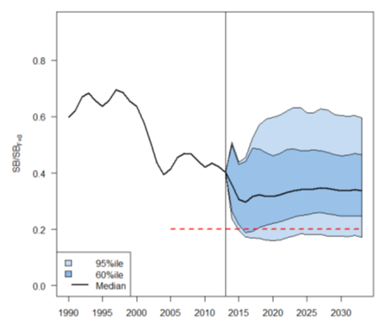
Figure SPA-1. Stochastic projections of adult stock status under 2014 longline and troll effort levels. The limit reference point (20% SB_{F=0}) is indicated by the horizontal dashed red line. Note: from 1960 up to 2013 inclusive the line represents the median across the 9 assessment model runs (structural uncertainty only); uncertainty after 2013 represents both structural uncertainty and stochastic recruitment (1800 simulation runs).

- Management advice and implications

- SC13 noted that no stock assessment was conducted for South Pacific albacore tuna in 2017. Therefore, the advice from SC11 should be maintained. For further information on the stock status and trends from SC11, please see https://www.wcpfc.int/node/26922

- SC13 noted that the preliminary estimate of total catch of south Pacific albacore (within the WCPF Convention Area south of the equator) for 2016 was 58,033 mt which was an 8% decrease from 2015 and a 13% decrease over 2011-2015. (see SC13-SA-WP-02).

- Preliminary longline catch in 2016 (55,635 mt) was 8% lower compared with 2015 and a 13% decrease over 2011-2015. Preliminary troll catch in 2016 (2,372 mt) was 17% lower compared with 2015 and a 24% decrease over 2011-2015. (see SC13- SA-WP-02).

- SC13 considered an update of trends in South Pacific albacore fisheries (SC13-SA-WP-08) and noted that there had been reductions in longline effort in the WCPF Convention Area south of 10ᴼS through 2014-2016 (by approximately 15%) and that effort distributions vary a little and show an area of highly concentrated fishing effort. SC13 noted an issue of transhipment that needs to be clarified at TCC13. Status quo projections were calculated, assuming current southern longline and troll fishery effort would continue into the future at levels equal to those seen in 2015 (Figure SPA-1). If 2015 fishing effort levels continue into the future, the stock is predicted to continue to decline on average, falling to SB_{current}/SB_{F=0} = 0.35 in 2033 with a 7% predicted probability of being below the LRP. Overall vulnerable biomass (a CPUE proxy) in longline fisheries is estimated to decrease by 7% from 2013-2033.

- Pending a new assessment in 2018, SC13 recalls its previous advice from SC11 and SC12 that longline fishing mortality and longline catch be reduced to avoid further decline in the vulnerable biomass so that economically viable catch rates can be maintained, especially for longline catches of adult albacore. SC13 recommends that this advice be taken into consideration when the TRP for South Pacific albacore is discussed at WCPFC14.

Useful References

SC15- SA-WP-01 A compendium of fisheries indicators for tuna stocks. https://www.wcpfc.int/node/42927

SC15- SA-WP-08 Trends in the South Pacific Albacore Longline and Troll Fisheries. https://www.wcpfc.int/node/42934

SC14-SA-WP-05 Stock assessment of South Pacific albacore tuna Rev 2.
https://www.wcpfc.int/node/31182

SC14-SA-WP-02 A compendium of fisheries indicators for tuna stocks. https://www.wcpfc.int/node/30987

SC14-SA-IP-07 Background Analysis for the 2018 stock assessment of South Pacific albacore tuna. https://www.wcpfc.int/node/31260

SC14-SA-IP-08 Trends in the South Pacific Albacore Longline and Troll Fisheries Rev 2. https://www.wcpfc.int/node/30986
And associated excel files
https://www.wcpfc.int/node/30988
https://www.wcpfc.int/node/30989

SC13-WCPFC13-03 Biological and Economic Consequences of Alternative Trajectories to Achieve a Candidate South Pacific Albacore Target Reference Point; Pilling G [1]., M. Skirtun [2], C. Reid [2] and J. Hampton [1] – ([1] SPC-OFP & [2] FFA).
https://www.wcpfc.int/node/29429

SC13-WCPFC13-04 Performance Indicators and Monitoring Strategies for Skipjack and South Pacific Albacore Commensurate with Candidate Management Objectives for the Tropical Purse Seine and Southern Longline Fisheries; Scott R., G. Pilling and J. Hampton (SPC-OFP).
https://www.wcpfc.int/node/29430

SC13-MI-WP-01 Implications of a range of Target Reference Points for the south Pacific albacore stock; FFA.
https://www.wcpfc.int/node/29544

SC13-MI-WP-02 Performance indicators and monitoring strategies for South Pacific Albacore compatible with candidate management objectives for the Southern Longline Fishery; Scott R., G. Pilling and J. Hampton. (SPC-OFP).
https://www.wcpfc.int/node/29545

SC7-SA-WP-05 Regional study of South Pacific albacore population biology: Year 3 – Biological sampling and analysis. https://wcpfc.int/node/2788

Previous Assessments

SC11-SA-WP-06 Stock assessment for south Pacific albacore tuna. Rev 1 (4 August 2015). Harley, S. J[1], N. Davies[2], L Tremblay-Boyer[1], John Hampton[1], and S McKechnie [1] ([1] SPC-OFP & [2] Te Takina Ltd).
https://www.wcpfc.int/node/21776

SC8-SA-WP-04 Stock Assessment of Albacore in the south Pacific Ocean Rev 1 (29 July 2012) https://wcpfc.int/node/3233

SC7-SA-WP-06 Stock assessment of albacore tuna in the South Pacific Ocean. https://wcpfc.int/node/2813

SC5-SA-WP-06 Stock assessment of albacore tuna in the south Pacific Ocean. https://wcpfc.int/node/2177

SC4-SA-WP-08 Stock assessment of Albacore tuna in the south Pacific Ocean. https://wcpfc.int/node/1225

SC2-SA-WP-04 An update of the stock assessment for South Pacific albacore tuna, including an investigation of the sensitivity to key biological parameters included in the model. https://wcpfc.int/node/1749

SC1-SA-WP-03 Stock assessment of albacore tuna in the South Pacific Ocean. https://wcpfc.int/node/1885

