**South Pacific Albacore Tuna (*Thunnus alalonga*)**

**Stock Status &Trends plus Management Advice and Implications**

Contents

SC13 2017 1

SC12 2016 3

SC11 2015 (STOCK ASSESSMENT CONDUCTED) 5

Useful References 13

Previous Assessments 13

# SC13 2017

**4.1.4.2 Provision of scientific information**

**a. Status and trends**

322. SC13 noted that no stock assessment was conducted for South Pacific albacore tuna in 2017. Therefore, the stock status description from SC11 is still current.

323. SC13 noted that the preliminary estimate of total catch of south Pacific albacore (within the WCPF Convention Area south of the equator) for 2016 was 58,033t which was an 8% decrease from 2015 and a 13% decrease over 2011-2015 (see SC13-SA-WP-02).

324. Preliminary longline catch in 2016 (55,635t) was 8% lower compared with 2015 and a 13% decrease over 2011-2015. Preliminary troll catch in 2016 (2,372t) was 17% lower compared with 2015 and a 24% decrease over 2011-2015 (see SC13-SA-WP-02).

**325. SC13 considered an update of trends in South Pacific albacore fisheries (SC13-WCPFC-2017/SA-WP-08) and noted that there had been reductions in longline effort in the WCPF Convention south of 10oS through the 2014-2016 (59,225 to 52,951 – with the 2016 value being provisional) and that effort distributions vary a little and show an area of highly concentrated fishing effort. SC13 noted an issue of transhipment that needs to be clarified at TCC13. Status quo projections were calculated, assuming current southern longline and troll fishery effort would continue into the future at levels equal to those seen in 2015 (Figure SPA1). [If 2015 fishing effort levels continue into the future, the stock is predicted to continue to decline on average, falling to SBcurrent/SBF=0 = 0.35 in 2033 with a 7% predicted probability of being below the LRP. Overall vulnerable biomass (a CPUE proxy) in longline fisheries is estimated to decrease by 7% from 2013-2033.**

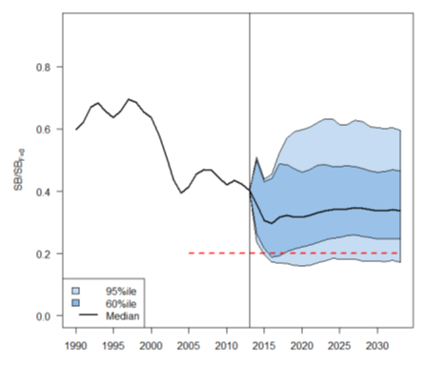

Figure SPA-1. Stochastic projections of adult stock status under 2014 longline and troll effort levels. The limit reference point (20% SBF=0) is indicated by horizontal dashed red line. Note: from 1960 up to 2013 inclusive the line represents the median across the 9 assessment model runs (structural uncertainty only); uncertainty after 2013 represents both structural uncertainty and stochastic recruitment (1800 simulation runs).

**b. Management advice and implications**

326. Pending a new assessment in 2018, SC13 recalls its previous advice from SC11 and SC12 that longline fishing mortality and longline catch be reduced to avoid further decline in the vulnerable biomass so that economically viable catch rates can be maintained, especially for longline catches of adult albacore. SC13 recommends that this advice be taken into consideration when the TRP for South Pacific albacore is discussed at WCPFC14.

**327. SC13 noted that no stock assessment was conducted for South Pacific albacore tuna in 2017. Therefore, the stock status description from SC11 is still current.**

**328. SC13 noted that the preliminary estimate of total catch of south Pacific albacore (within the WCPF Convention Area south of the equator) for 2016 was 58,033t which was an 8% decrease from 2015 and a 13% decrease over 2011-2015. (see SC13-WCPFC-2017/SA-WP-02).**

**329. Preliminary longline catch in 2016 (55,635t) was 8% lower compared with 2015 and a 13% decrease over 2011-2015. Preliminary troll catch in 2016 (2,372t) was 17% lower compared with 2015 and a 24% decrease over 2011-2015. (see SC13-WCPFC-2017/SA-WP-02).**

**330. SC13 considered an update of trends in South Pacific albacore fisheries (SC13-WCPFC-2017/SA-WP-08) and noted that there had been reductions in longline effort in the WCPF Convention south of 10o South through the 2014-2016 (-SPC to do: longline effort in the WCPF Convention south of 10o South through the 2013-2015 (by approximately 15%) and that effort distributions vary a little and show an area of highly concentrated fishing effort. SC13 noted an issue of transhipment that needs to be clarified at TCC13. Status quo projections were calculated, assuming current southern longline and troll fishery effort would continue into the future at levels equal to those seen in 2015 (Figure SPA1). If 2015 fishing effort levels continue into the future, the stock is predicted to continue to decline on average, falling to SBcurrent/SBF=0 = 0.35 in 2033 with a 7% predicted probability of being below the LRP. Overall vulnerable biomass (a CPUE proxy) in longline fisheries is estimated to decrease by 7% from 2013-2033.**

331. The EU noted that according to the last assessment the value of SBmsy was below the adopted LRP, which questioned the biological relevance of this LRP for this species.

**332. Pending a new assessment in 2018, SC13 recalls its previous advice from SC11 and SC12 that longline fishing mortality and longline catch be reduced to avoid further decline in the vulnerable biomass so that economically viable catch rates can be maintained, especially for longline catches of adult albacore. SC13 recommends that this advice be taken into consideration when the TRP for South Pacific albacore is discussed at WCPFC14.**

# SC12 2016

**4.1.4.2 Provision of scientific information**

332. During the recommendation session, CCMs discussed whether they would include some language about the projections and the risk of breaching the LRP, and whether economic conditions should be included. It was noted that declining trends were evident in the economic conditions. Some CCMs commented that there had been some concerns about accuracy of the nominal CPUE, with one CCM commenting that its fleet did not have declining catch rates.

**Stock status and trends**

**333. SC12 noted that no stock assessment was conducted for South Pacific albacore tuna in 2016. Therefore, the stock status description from SC11 is still current.**

**334. SC12 noted that the total south Pacific albacore catch in 2015 was 68,594 mt, 16% lower than both the catch in 2014 and the average catch for 2010-14.**

**335. Longline south Pacific albacore catch in 2015 was 17% lower than that in 2014, while troll catch in 2015 was 16% higher than that in 2014.**

**336. SC12 considered an update of trends in South Pacific albacore fisheries (SC12-SA-WP-06) and noted that there had been some small reductions in southern longline effort in 2014 compared to 2013, but 2015 effort levels are currently considered uncertain. Status quo projections were calculated, assuming current southern longline and troll fishery effort would continue into the future at levels equal to those seen in 2014 (based on the information available to SPC as at 2nd June 2016). Potential future spawning biomass levels relative to unfished levels were examined, and the probability that the south Pacific albacore stock may fall below the biomass Limit Reference Point was calculated.**

**337. If 2014 fishing effort levels continue into the future, the stock is predicted to continue to decline on average, falling to a projected spawning biomass depletion of SB2033/SBF=0 = 0.32 in 2033. The risk of falling below the LRP was estimated to be 19%. Furthermore, the CPUE was estimated to decline by 14% from 2013 levels.**

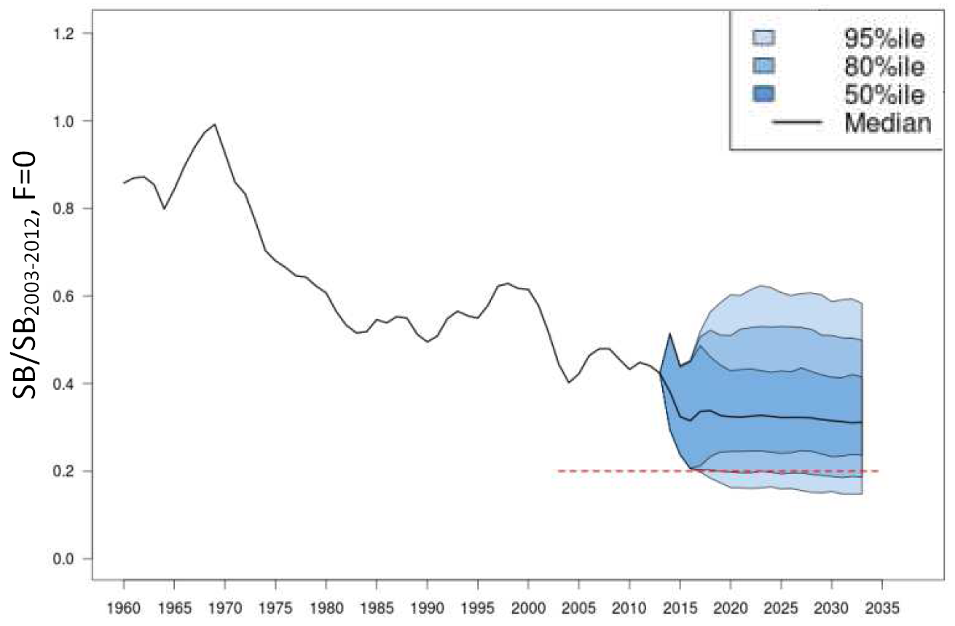

Figure SPA1 (Figure 10 from SC12-SA-WP-06). Stochastic projections of adult stock status under 2014 longline and troll effort levels. The limit reference point (20% SBF=0) is indicated by the horizontal dashed red line. Note that from 1960 up to 2013 inclusive the line represents the median across the 9 assessment model runs (structural uncertainty only); uncertainty after 2013 represents both structural uncertainty and stochastic recruitment.

**Management advice and implications**

**338. SC12 noted that no management advice has been provided since SC11. Therefore, the advice from SC11 should be maintained, that longline fishing mortality and longline catch be reduced to avoid further decline in the vulnerable biomass so that economically viable catch rates can be maintained. SC12 also noted that the results of the indicator analyses supported the stock status results for South Pacific albacore that were obtained from the 2015 assessment.**

**339. Based on the indicator analysis, SC12 also advised that there is a 19% chance that the south Pacific albacore stock will fall below the Limit Reference Point by 2033 if 2014 fishing effort levels continue, and that overall decreases in vulnerable biomass (a proxy for longline CPUE) of 14% would also be likely to occur.**

**340. SC12 recommends that the Commission note the information presented on economic conditions in the south Pacific longline fishery. Information in SC12-ST-WP-04 indicated that declining catch rates are contributing to declines in economic conditions that are likely to undermine profitability in the fishery.**

341. FFA members noted that this is impacting the viability of their fishing fleets and noted that this reinforces the need for management.

# SC11 2015 (STOCK ASSESSMENT CONDUCTED)

**4.1.4.2 Provision of scientific information**

***a. Status and trends***

1. **There have been significant improvements to the 2015 stock assessment including: improvements to the MULTIFAN-CL modelling framework, a regional disaggregated framework, access to operational data for construction of CPUE indices and regional weights, age-length data to improve growth estimation, and additional tagging data. Further, the regional structure of the model was changed to cover the southern Convention area and be better aligned with the other tuna assessments. This will enable better consideration of the multispecies impacts of management measures. Natural mortality was set at 0.3 in the reference case for consistency with the value used in the assessments performed in other RFMOs.**
2. **SC11 selected the reference case model as the base case to represent the stock status of south Pacific albacore tuna. To characterize uncertainty SC11 chose all the grid model runs except for those relating to the alternative regional weight hypothesis. This gave a total of 18 model runs and we report the 5%, median and 95% values on the base case estimate in this stock status summary. Details of the base case and axes of uncertainty for the grid are provided in Table SP-ALB1.**

**Table SP-ALB1:** Description of the structural sensitivity grid used to characterize uncertainty in the assessment. The base case option is denoted in bold face.

|  |  |  |
| --- | --- | --- |
| Name | Description | One-off change model name(s) |
| Natural mortality | 0.25, **0.30**, and 0.40 per year | Low_M and High_M |
| Length data weighting | **Standard weighting** or down-weighted | SZ_dwnwht |
| Steepness | 0.65, **0.80**, and 0.95 | h_0.65 and h_0.95 |

1. **Time trends in estimated recruitment, spawning biomass, fishing mortality and fishery impacts are shown in Figures SP-ALB 1–5.**
2. **The estimated maximum sustainable yield (MSY) of 76,800 mt is lower than in the 2012 assessment (2012 MSY = 99,085 mt). Aside from general improvements to the stock assessment this was also influenced by 1) exclusion of catches from outside the southern part of the WCPFC Convention area; and 2) a reduction in the assumed value of natural mortality. Based on the range of MSY estimates (range: 62,260‐129,814 mt), current catch is likely at or slightly less than the MSY.**
3. **Fishing mortality has generally been increasing through time, with Fcurrent (2009-12 average) is estimated to be 0.39 times the fishing mortality that will support the *MSY*. Across the grid Fcurrent/FMSY ranged from 0.13‐0.62. This indicates that overfishing is not occurring, but fishing mortality on adults is approaching the assumed level of natural mortality (Table SP-ALB2 and Figure SP-ALB5).**
4. **The fishery impact by sub-tropical longline fisheries has increased continuously since 2000 (Figure SP-ALB6).**
5. **The latest (2013) estimates of spawning biomass are above both the level that will support the MSY (SBlatest/SBMSY = 2.86 for the base case and range 1.74—7.03 across the grid) and the adopted LRP of 0.2SBF=0 (SBlatest/SBF=0 = 0.40 for the base case and range 0.30-0.60 across the grid). It is important to note that SBMSY is lower than the limit reference point (0.14 SBF=0) due to the combination of the selectivity of the fisheries and maturity of the species.**
6. **For the first time SC considered an index of economic conditions in the south Pacific albacore fishery (MI-WP-03). This index, which integrates fish prices, catch rates, and fishing prices, estimates a strong declining trend in economic conditions, reaching an historical low in 2013. While there was a slight recovery in 2014, conditions are still well below the average primarily due to high fishing costs and continued low catch rates. Domestic vessels from some longline fleets have reduced their fishing effort (i.e., tied up for periods of time) in response to these conditions.**

**Table SP-ALB2:** Estimates of management quantities for base case and grid of 18 models (see Table SP-ALB1 for details). For the purpose of this assessment, “current” is the average over the period 2009–2012 and “latest” is 2013.

|  |  |  |  |  |
| --- | --- | --- | --- | --- |
|  | Base case | 5% | Grid Median | 95% |
| $MSY$ (mt) | 76,800 | 62,260 | 84,980 | 129,814 |
| $$C_{latest}/MSY$$ | 1.00 | 0.60 | 0.91 | 1.23 |
| $$F_{current}/F_{MSY}$$ | 0.39 | 0.13 | 0.34 | 0.62 |
| $$B_{0}$$ | 711,400 | 638,465 | 806,900 | 1,024,500 |
| $$B_{current}$$ | 456,984 | 365,962 | 509,653 | 783,308 |
| $${SB}_{0}$$ | 396,500 | 368,925 | 438,700 | 502,275 |
| $${SB}_{MSY}$$ | 57,430 | 35,762 | 59,180 | 90,778 |
| $${SB}_{F=0}$$ | 408,361 | 392,358 | 442,163 | 486,146 |
| $${SB}_{latest}$$ | 164,451 | 131,456 | 190,467 | 272,696 |
| $${SB}_{latest}/{SB}_{MSY}$$ | 2.86 | 1.74 | 3.20 | 7.03 |
| $${SB}_{latest}/{SB}_{F=0}$$ | 0.40 | 0.30 | 0.44 | 0.60 |

**Table SP-ALB3:** Comparisona of selected south Pacific albacore tuna reference points from the 2009, 2011, 2012, and 2015 assessments. These represent the value used to provide management advice. Note that the time window for assessment and reference point calculation changes for Fcurrent/FMSY and SBlatest/SBF=0 and that prior to the 2015 assessment, the south Pacific albacore assessments covered the entire south Pacific Ocean rather than the convention area south of the equator used in 2015.

|  |  |  |  |  |
| --- | --- | --- | --- | --- |
| Management quantity | 2015 | 2012b | 2011 | 2009c |
| MSY(mt) | 76,800[1] | 99,085 | 85,130 | 97,610 |
| Fcurrent/FMSY | 0.39 | 0.21 | 0.26 | 0.25 |
| SBlatest/SBF=0 | 0.40 | 0.58 | 0.60 | 0.68 |

a 2015 assessment was conducted for WCPF CA and 2011/2012 stock assessment was for the whole South Pacific.

b The median of the grid was used to provide management advice instead of a single model run

c Only SBcurrent is available

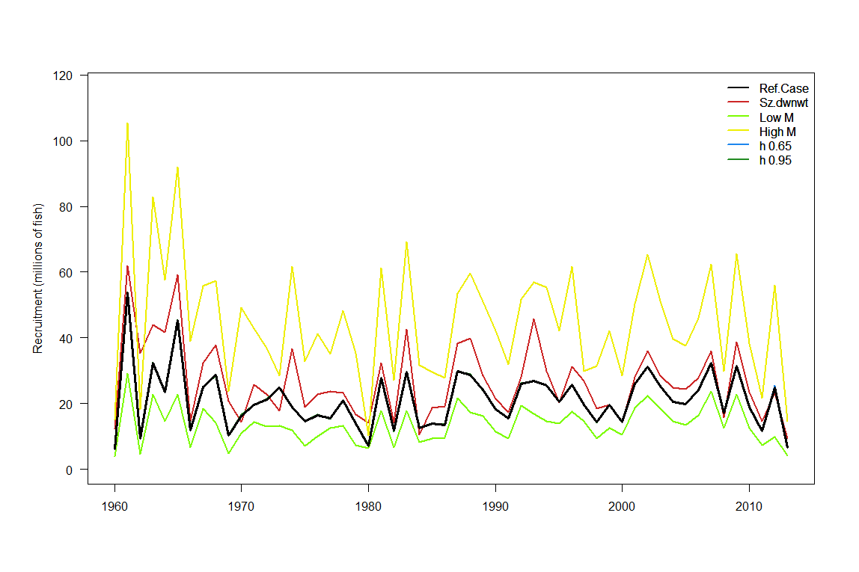

**Figure SP-ALB1:** Estimated annual recruitment (millions of fish) for the base case model and one-change sensitivity analyses (a subset of runs from the grid). See Table SP-ALB1 for a description of these sensitivity analyses. The model runs with alternative steepness values give the same recruitment estimates.

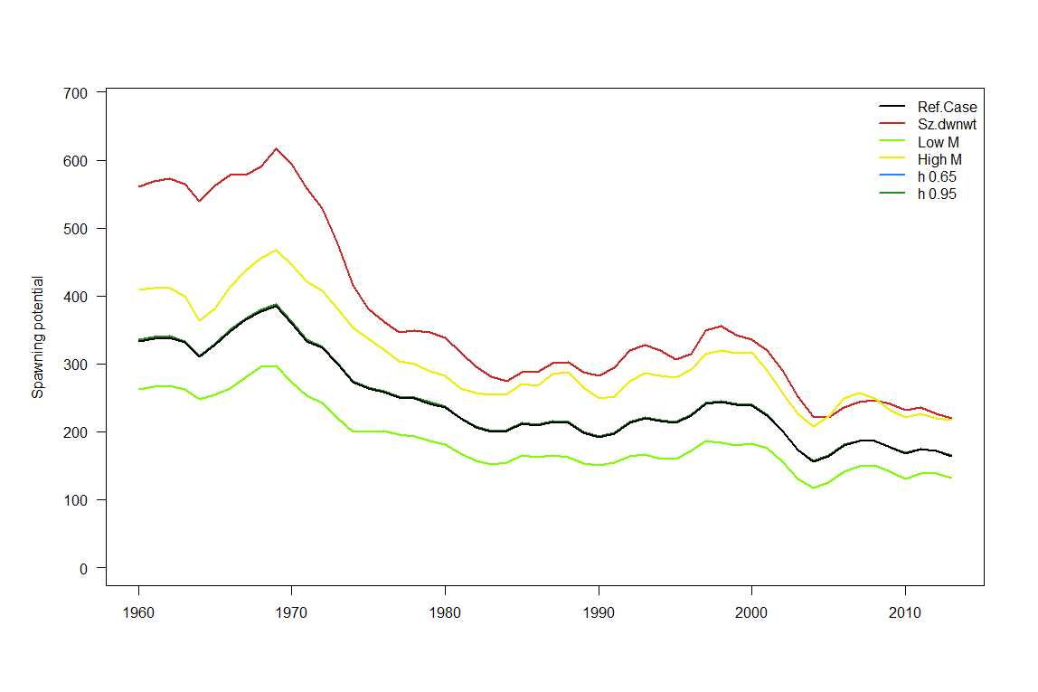

**Figure SP-ALB2:** Estimated annual average spawning potential for the base case model and one-change sensitivity analyses (a subset of runs from the grid). The model runs with alternative steepness values give the same spawning potential estimates.

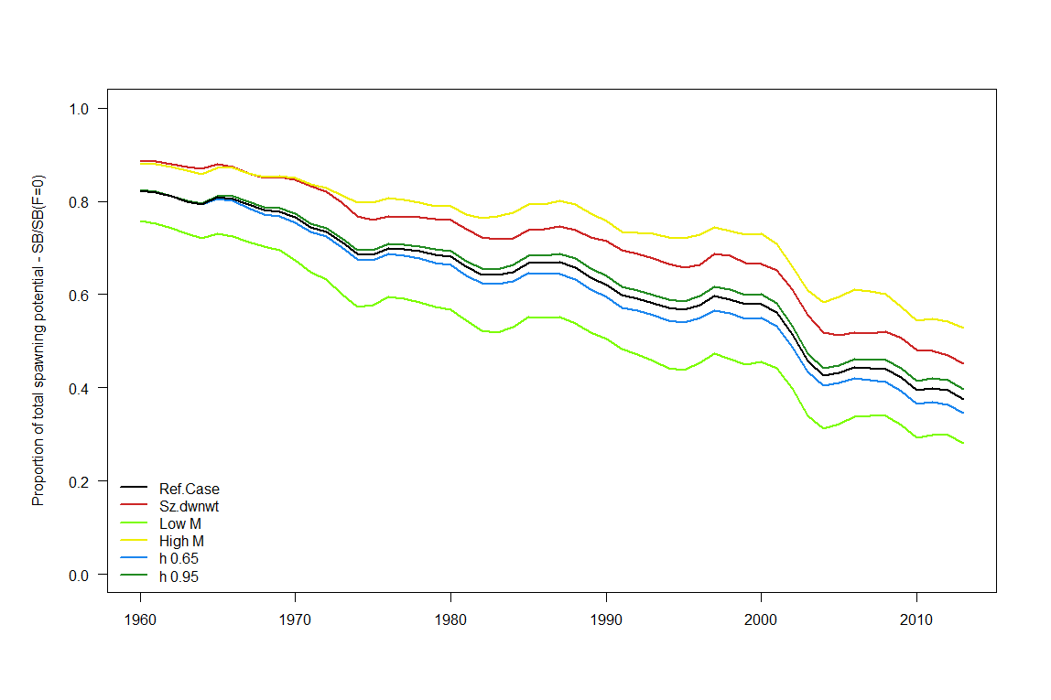

**Figure SP-ALB3:** Estimated annual average spawning depletion for the base case model and one-change sensitivity analyses (a subset of runs from the grid).

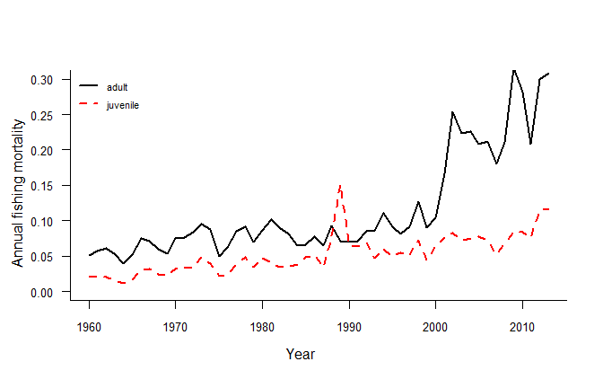

**Figure SP-ALB4:** Estimated annual average juvenile and adult fishing mortality for the base case model.

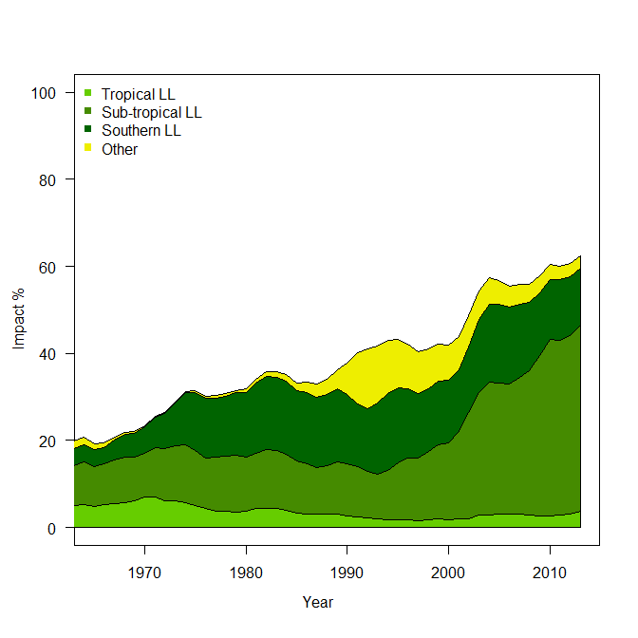

**Figure SP-ALB5:** Estimates of reduction in spawning potential due to fishing (fishery impact = 1-SBt/SBt,F=0) to different fishery groups for the base case model.

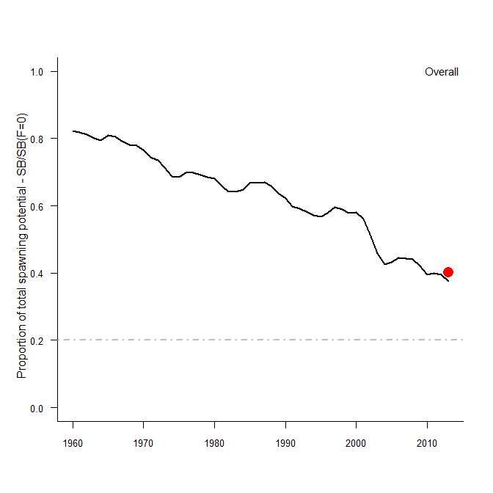

**Figure SP-ALB6:** Ratio of exploited to unexploited spawning potential, SBlatest/SBF=0, for the reference case. The current WCPFC limit reference point of 20%SBF=0 is provided for reference as the grey dashed line and the red circle represents the level of spawning potential depletion based on the agreed method of calculating SBF=0 over the last ten years of the model (excluding the last year).

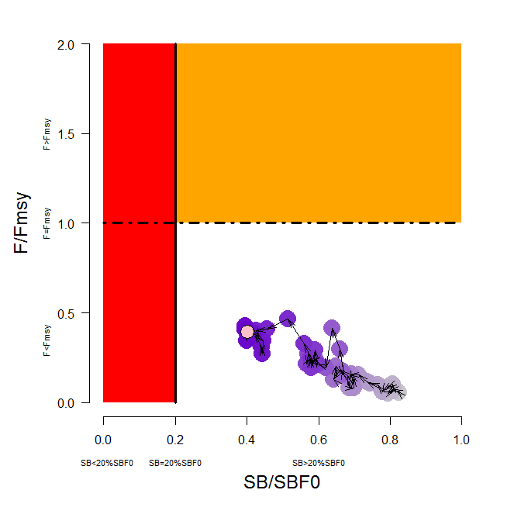

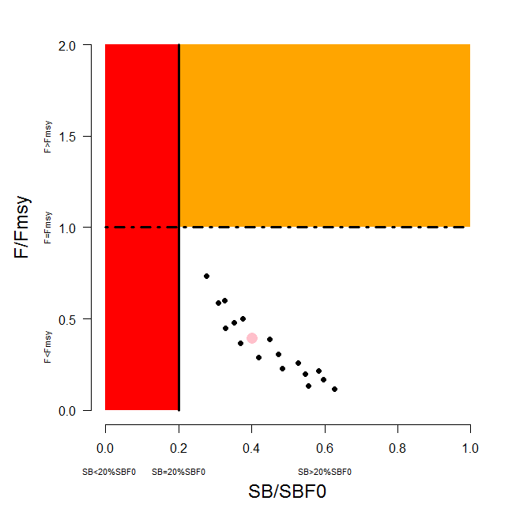

**Figure SP-ALB7:** Temporal trend for the base case model (top) and terminal condition for the base case and other sensitivity runs (bottom) in stock status relative to SBF=0 (x-axis) and FMSY (y-axis). The red zone represents spawning potential levels lower than the agreed LRP which is marked with the solid black line (0.2SBF=0). The orange region is for fishing mortality greater than FMSY (F=FMSY; marked with the black dashed line). The pink circle (top panel) is SB2012/SBF=0 (where SBF=0 was the average over the period 2002-2011). The bottom panel includes the base case (pink circle) and 18 models from the grid.

***b. Management advice and implications***

1. **The South Pacific albacore spawning stock is currently above both the level that will support the MSY and the adopted spawning biomass limit reference point, and overfishing is not occurring (F less than Fmsy).**
2. **While overfishing is not occurring, further increases in effort will yield little or no increase in long-term catches and result in further reduced catch rates.**
3. **Decline in abundance of albacore is a key driver in the reduced economic conditions experienced by many PICT domestic longline fleets. Further, reductions in prices are also impacting some distant water fleets.**
4. **For several years, SC has noted that any increases in catch or effort in sub-tropical longline fisheries are likely to lead to declines in catch rates in some regions (10oS-30oS), especially for longline catches of adult albacore, with associated impacts on vessel profitability.**
5. **Despite the fact that the stock is not overfished and overfishing is not occurring, SC11 reiterates the advice of SC10 recommending that longline fishing mortality and longline catch be reduced to avoid further decline in the vulnerable biomass so that economically viable catch rates can be maintained.**

# Useful References

SC11-SA-WP-06 Stock assessment for south Pacific albacore tuna. Rev 1 (4 August 2015). Harley, S. J[1], N. Davies[2], L Tremblay-Boyer[1], John Hampton[1], and S McKechnie [1] ([1] SPC-OFP & [2] Te Takina Ltd).

<https://www.wcpfc.int/node/21776>

SC13-SA-WP-02 A compendium of fisheries indicators for tuna stocks; Pilling G., R. Scott, P. Williams, S. Brouwer and J. Hampton (SPC-OFP)

<https://www.wcpfc.int/node/29515>

SC13-SA-WP-08 Trends in the South Pacific Albacore Longline and Troll Fisheries; Brouwer S., G. Pilling, P. Williams (SPC-OFP) and the WCPFC Secretariat.

<https://www.wcpfc.int/node/29521>

and associated excel files

<https://www.wcpfc.int/node/29632>

<https://www.wcpfc.int/node/29633>

SC13-WCPFC13-03 Biological and Economic Consequences of Alternative Trajectories to Achieve a Candidate South Pacific Albacore Target Reference Point; Pilling G [1]., M. Skirtun [2], C. Reid [2] and J. Hampton [1] – ([1] SPC-OFP & [2] FFA).

<https://www.wcpfc.int/node/29429>

SC13-WCPFC13-04 Performance Indicators and Monitoring Strategies for Skipjack and South Pacific Albacore Commensurate with Candidate Management Objectives for the Tropical Purse Seine and Southern Longline Fisheries; Scott R., G. Pilling and J. Hampton (SPC-OFP).

<https://www.wcpfc.int/node/29430>

SC13-MI-WP-01 Implications of a range of Target Reference Points for the south Pacific albacore stock; FFA.

<https://www.wcpfc.int/node/29544>

SC13-MI-WP-02 Performance indicators and monitoring strategies for South Pacific Albacore compatible with candidate management objectives for the Southern Longline Fishery; Scott R., G. Pilling and J. Hampton. (SPC-OFP).

<https://www.wcpfc.int/node/29545>

SC7-SA-WP-05 Regional study of South Pacific albacore population biology: Year 3 – Biological sampling and analysis. <https://wcpfc.int/node/2788>

# Previous Assessments

SC8-SA-WP-04 Stock Assessment of Albacore in the south Pacific Ocean Rev 1 (29 July 2012) <https://wcpfc.int/node/3233>

SC7-SA-WP-06 Stock assessment of albacore tuna in the South Pacific Ocean. <https://wcpfc.int/node/2813>

SC5-SA-WP-06 Stock assessment of albacore tuna in the south Pacific Ocean. <https://wcpfc.int/node/2177>

SC4-SA-WP-08 Stock assessment of Albacore tuna in the south Pacific Ocean. <https://wcpfc.int/node/1225>

SC2-SA-WP-04 An update of the stock assessment for South Pacific albacore tuna, including an investigation of the sensitivity to key biological parameters included in the model. <https://wcpfc.int/node/1749>

SC1-SA-WP-03 Stock assessment of albacore tuna in the South Pacific Ocean. <https://wcpfc.int/node/1885>

1. This is the reference case, not the grid median, as per 2012.