South Pacific Albacore Tuna (Thunnus alalonga)
Stock Status &Trends plus Management Advice and Implications

Contents
SC14 2018 (STOCK ASSESSMENT CONDUCTED) 1
Useful References 16
Previous Assessments 16

SC14 2018 (STOCK ASSESSMENT CONDUCTED)

Stock Status

The median, 10 percentile and 90 percentile values of recent (2013-2016) spawning biomass ratio (SB_{recent}/ SB_{F=0}) and recent fishing mortality in relation to F_{MSY} (F_{recent}/F_{MSY}) over the structural uncertainty grid were used to characterize uncertainty and describe the stock status.

A description of the structural sensitivity grid used to characterize uncertainty in the assessment is set out in Table SPA-1. The regional structure used within the assessment is presented in Figure SPA-1, and the time series of total annual catch by fishing gear for the diagnostic case model over the full assessment period is shown in Figure SPA-2 for the total assessment region, and Figure SPA-3 by model region. Estimated annual average recruitment, spawning potential, juvenile and adult fishing mortality and fishing depletion for the diagnostic case model are shown in Figures SPA-3 – SPA-7. Figure SPA-8 displays Majuro plots summarising the results for each of the models in the structural uncertainty grid, while Figure SPA-9 shows equivalent Kobe plots for SB_{recent} and SB_{latest} across the structural uncertainty grid. Figure SPA-10 provides estimates of reduction in spawning potential due to fishing by region, and over all regions attributed to various fishery groups (gear-types) for the diagnostic case model. Table SPA-2 provides a summary of reference points over the 72 models in the structural uncertainty grid. Figure SPA-11 presents the history of the annual estimates of MSY for the diagnostic case model, compared with annual catch by the main gear types. Finally, Figure SPA-12 presents the estimated time-series (or ‘dynamic’) Kobe plots for four example models from the assessment (one from each of the combinations of growth types, and natural mortality M set to 0.3 or 0.4).

SC14 noted that the median level of spawning biomass depletion from the uncertainty grid was SBrecent/SBF=0 = 0.52 with a probable range of 0.37 to 0.63 (80% probability interval). There were no individual models where (SBrecent/SBF=0) < 0.2 which indicated that the probability that recent spawning biomass was below the LRP was zero.SC14 noted that the grid median Frecent/FMSY was 0.20, with a range of 0.08 to 0.41 (80% probability interval) and that no values of Frecent/FMSY in the grid exceeded 1.

SC14 also noted that there was a 0% probability (0 out of 72 models) that the recent fishing mortality had exceeded FMSY.

SC14 noted that the structural uncertainty grid for the south Pacific albacore had changed since the 2015 assessment, with the 2018 assessment examining additional axes of uncertainty including assumptions on growth and CPUE standardization approach. As a consequence, the uncertainty identified is higher than in previous assessments.

SC14 also noted that the assessment results show that while the stock depletion (SB/SBF=0) has exhibited a long-term decline (Figure SPA-7) the stock is not in an overfished state and overfishing is not taking place.

Management Advice

SC14 noted that the preliminary estimate of total catch of south Pacific albacore (within the WCPFC Convention Area south of the equator) for 2017 was 75,707mt, which was a 33% increase from 2016 and a 13% increase over 2012-2016. (see SC14-WCPFC-2018/SA-WP-02).

Preliminary catch for longliners in 2017 (72,785mt) was 34% higher compared with 2016 and a 14% increase over 2012-2016. Preliminary other gear (primarily troll) catch in 2017 (2,896t) was 17% higher compared with 2016 but a 1% decrease over 2012-2016. (see SC14-WCPFC-2018/SA-WP-02).

Based on the uncertainty grid adopted by SC14, the WCPO albacore tuna spawning biomass is very likely to be above the biomass LRP and recent F is very likely below FMSY, and therefore the stock is not experiencing overfishing (100% probability F < F_{MSY}) and is not in an overfished condition (100% probability SB_{recent} > LRP).

SC14 recalled its previous advice from SC11, SC12, and SC13 that longline fishing mortality and longline catch be reduced to avoid decline in the vulnerable biomass so that economically viable catch rates can be maintained, especially for longline catch of adult albacore. SC14 recommends that this advice be taken into consideration when the TRP for South Pacific albacore is discussed at WCPFC15.

Table SPA-1. Description of the structural sensitivity grid used to characterize uncertainty in the 2018 south Pacific albacore assessment. Levels used within the diagnostic case are starred.
Axis | Levels | Option
Steepness | 3 | 0.65, 0.80*, 0.95
Natural mortality | 2 | 0.3*, 0.4
Growth | 2 | Estimated* (K, L∞) or fixed (Chen-Wells)
Size frequency weighting | 3 | Sample sizes divided by 20, 50* or 80
CPUE | 2 | Geostatistical*, Traditional

Table SPA-2. Summary of reference points over all the 72 individual models in the structural uncertainty grid.
 | Mean | Median | Min | 10% | 90% | Max
C_{latest} | 61719 | 61635 | 60669 | 60833 | 62704 | 63180
MSY | 100074 | 98080 | 65040 | 70856 | 130220 | 162000
YF_{recentt} | 71579 | 71780 | 56680 | 62480 | 80432 | 89000
fmult | 6.2 | 4.96 | 1.89 | 2.44 | 12.05 | 17.18
F_{MSY} | 0.07 | 0.07 | 0.05 | 0.05 | 0.09 | 0.1
F_{recent}/F_{MSY} | 0.23 | 0.2 | 0.06 | 0.08 | 0.41 | 0.53
SB_{MSY} | 71407 | 68650 | 26760 | 39872 | 100773 | 134000
SB₀ | 443794 | 439800 | 308800 | 353870 | 510530 | 696200
SB_{MSY}/SB₀ | 0.16 | 0.17 | 0.07 | 0.1 | 0.21 | 0.23
SB_{F=0} | 469004 | 462633 | 380092 | 407792 | 534040 | 620000
SB_{MSY}/SB_{F=0} | 0.15 | 0.15 | 0.06 | 0.09 | 0.2 | 0.22
SB_{latest}/SB₀ | 0.55 | 0.56 | 0.33 | 0.42 | 0.69 | 0.74
SB_{latest}/SB_{F=0} | 0.53 | 0.52 | 0.3 | 0.37 | 0.69 | 0.77
SB_{latest}/SB_{MSY} | 4 | 3.42 | 1.45 | 1.96 | 7.07 | 10.74
SB_{recent}/SB_{F=0} | 0.51 | 0.52 | 0.32 | 0.37 | 0.63 | 0.72
SB_{recent}/SB_{MSY} | 3.88 | 3.3 | 1.58 | 1.96 | 6.56 | 9.67

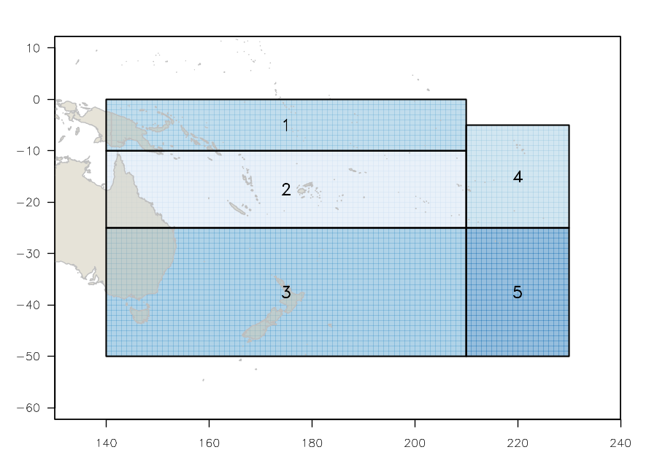
Figure SPA- 1 The geographical area covered by the stock assessment and the boundaries for the 5 regions under the updated \ 2018 regional structure".
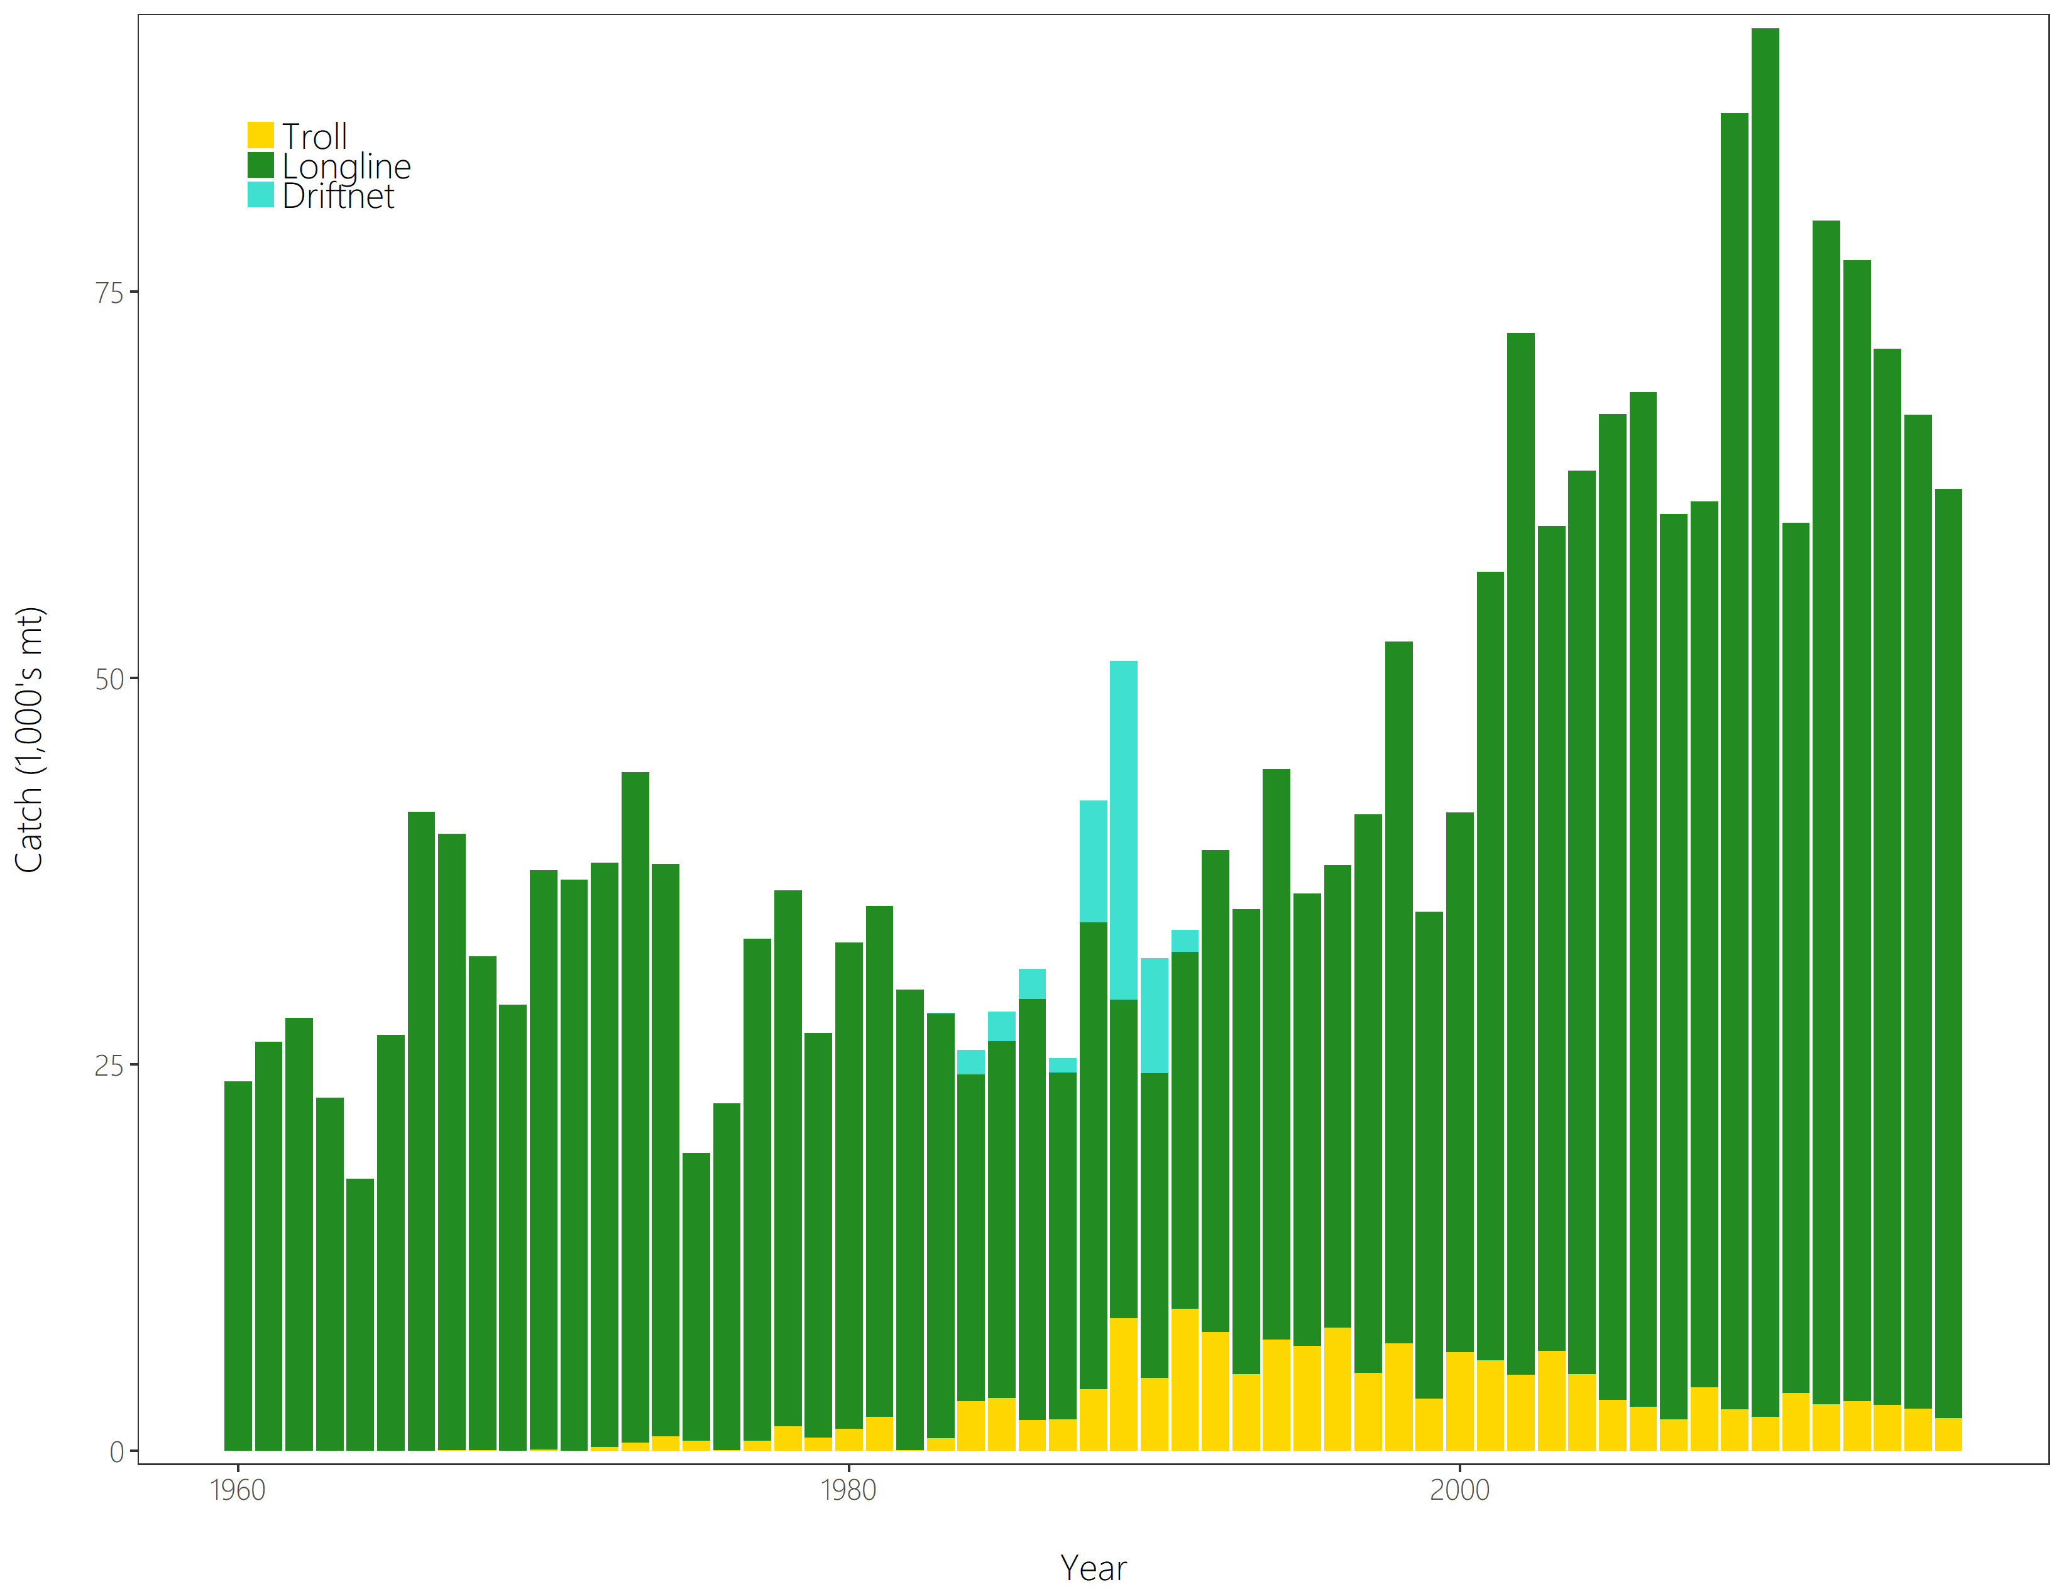
Figure SPA- 2 Time series of total annual catch (1000’s mt) by fishing gear for the diagnostic case model over the full assessment period. The different colours refer to longline (green), troll (yellow) and driftnet (turquoise). Note that the catch by longline gear has been converted into catch-in-weight from catch-in-numbers.
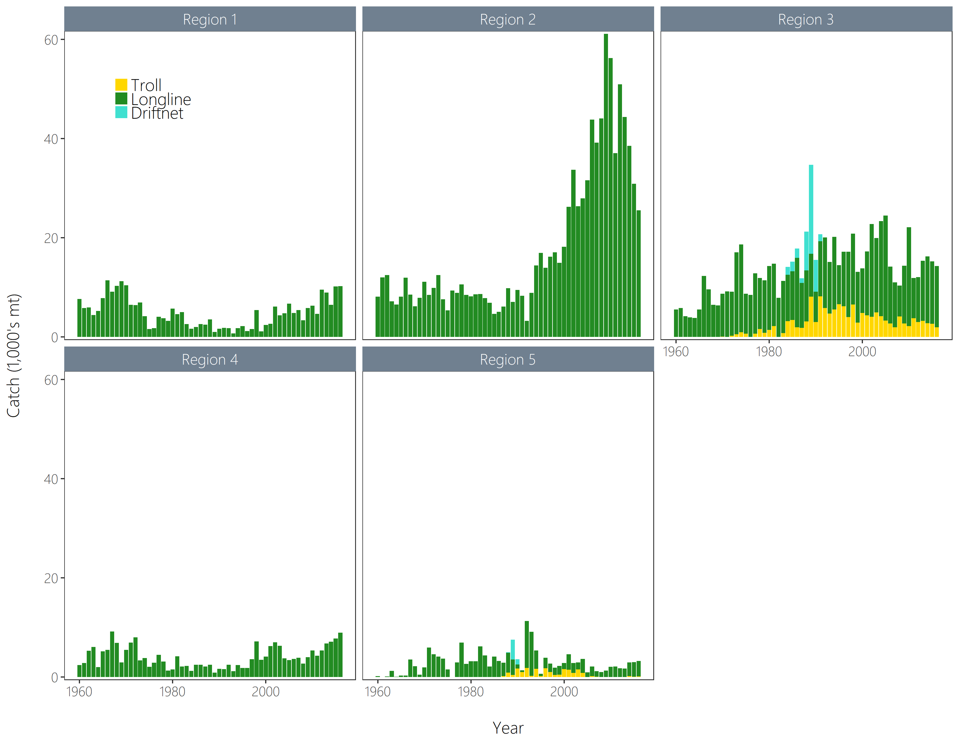
Figure SPA-3 Time series of total annual catch (1000’s mt) by fishing gear and assessment region from the diagnostic case model over the full assessment period. The different colours denote longline (green), driftnet (turquoise) and troll (yellow).

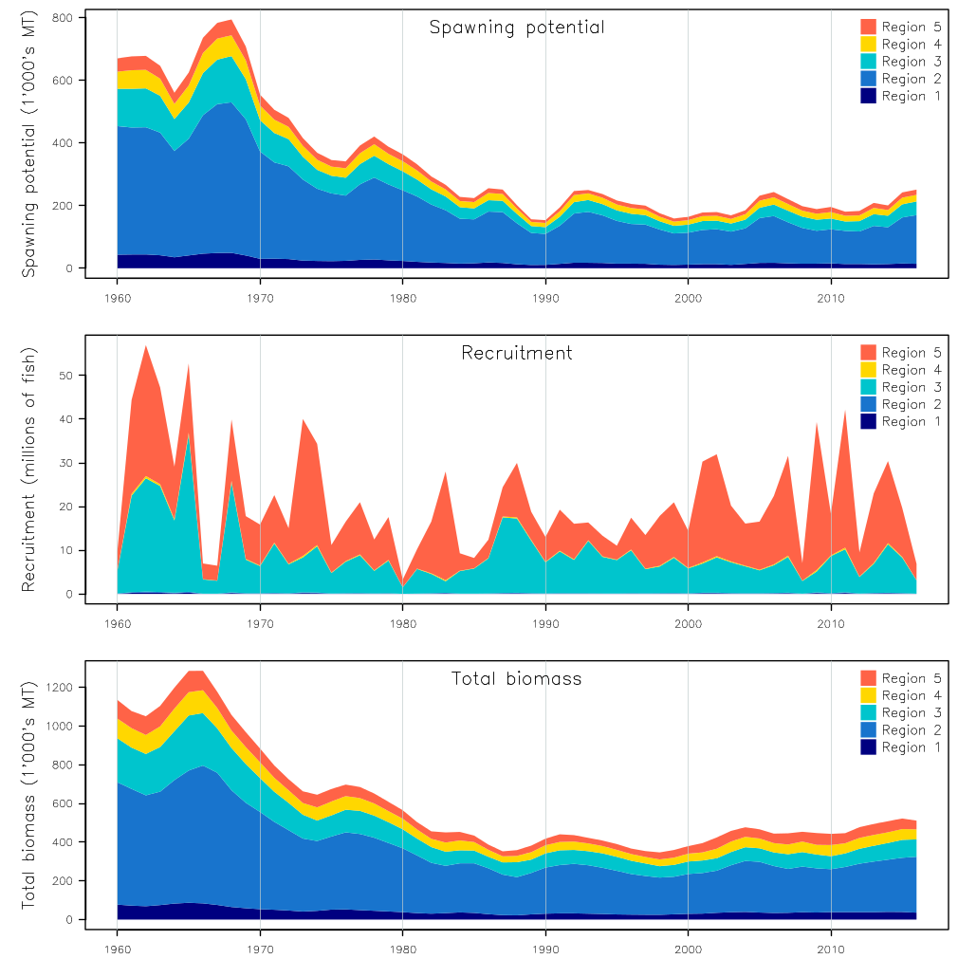
Figure SPA-4 Estimated annual average recruitment, spawning potential and total biomass by model region for the diagnostic case model, showing the relative sizes among regions.

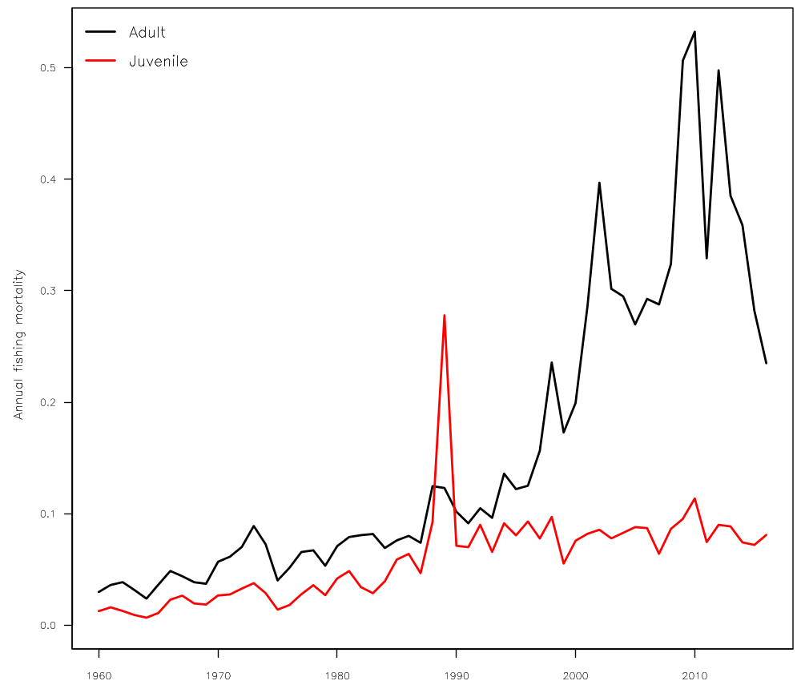
Figure SPA-5 Estimated annual average juvenile and adult fishing mortality for the diagnostic case model.

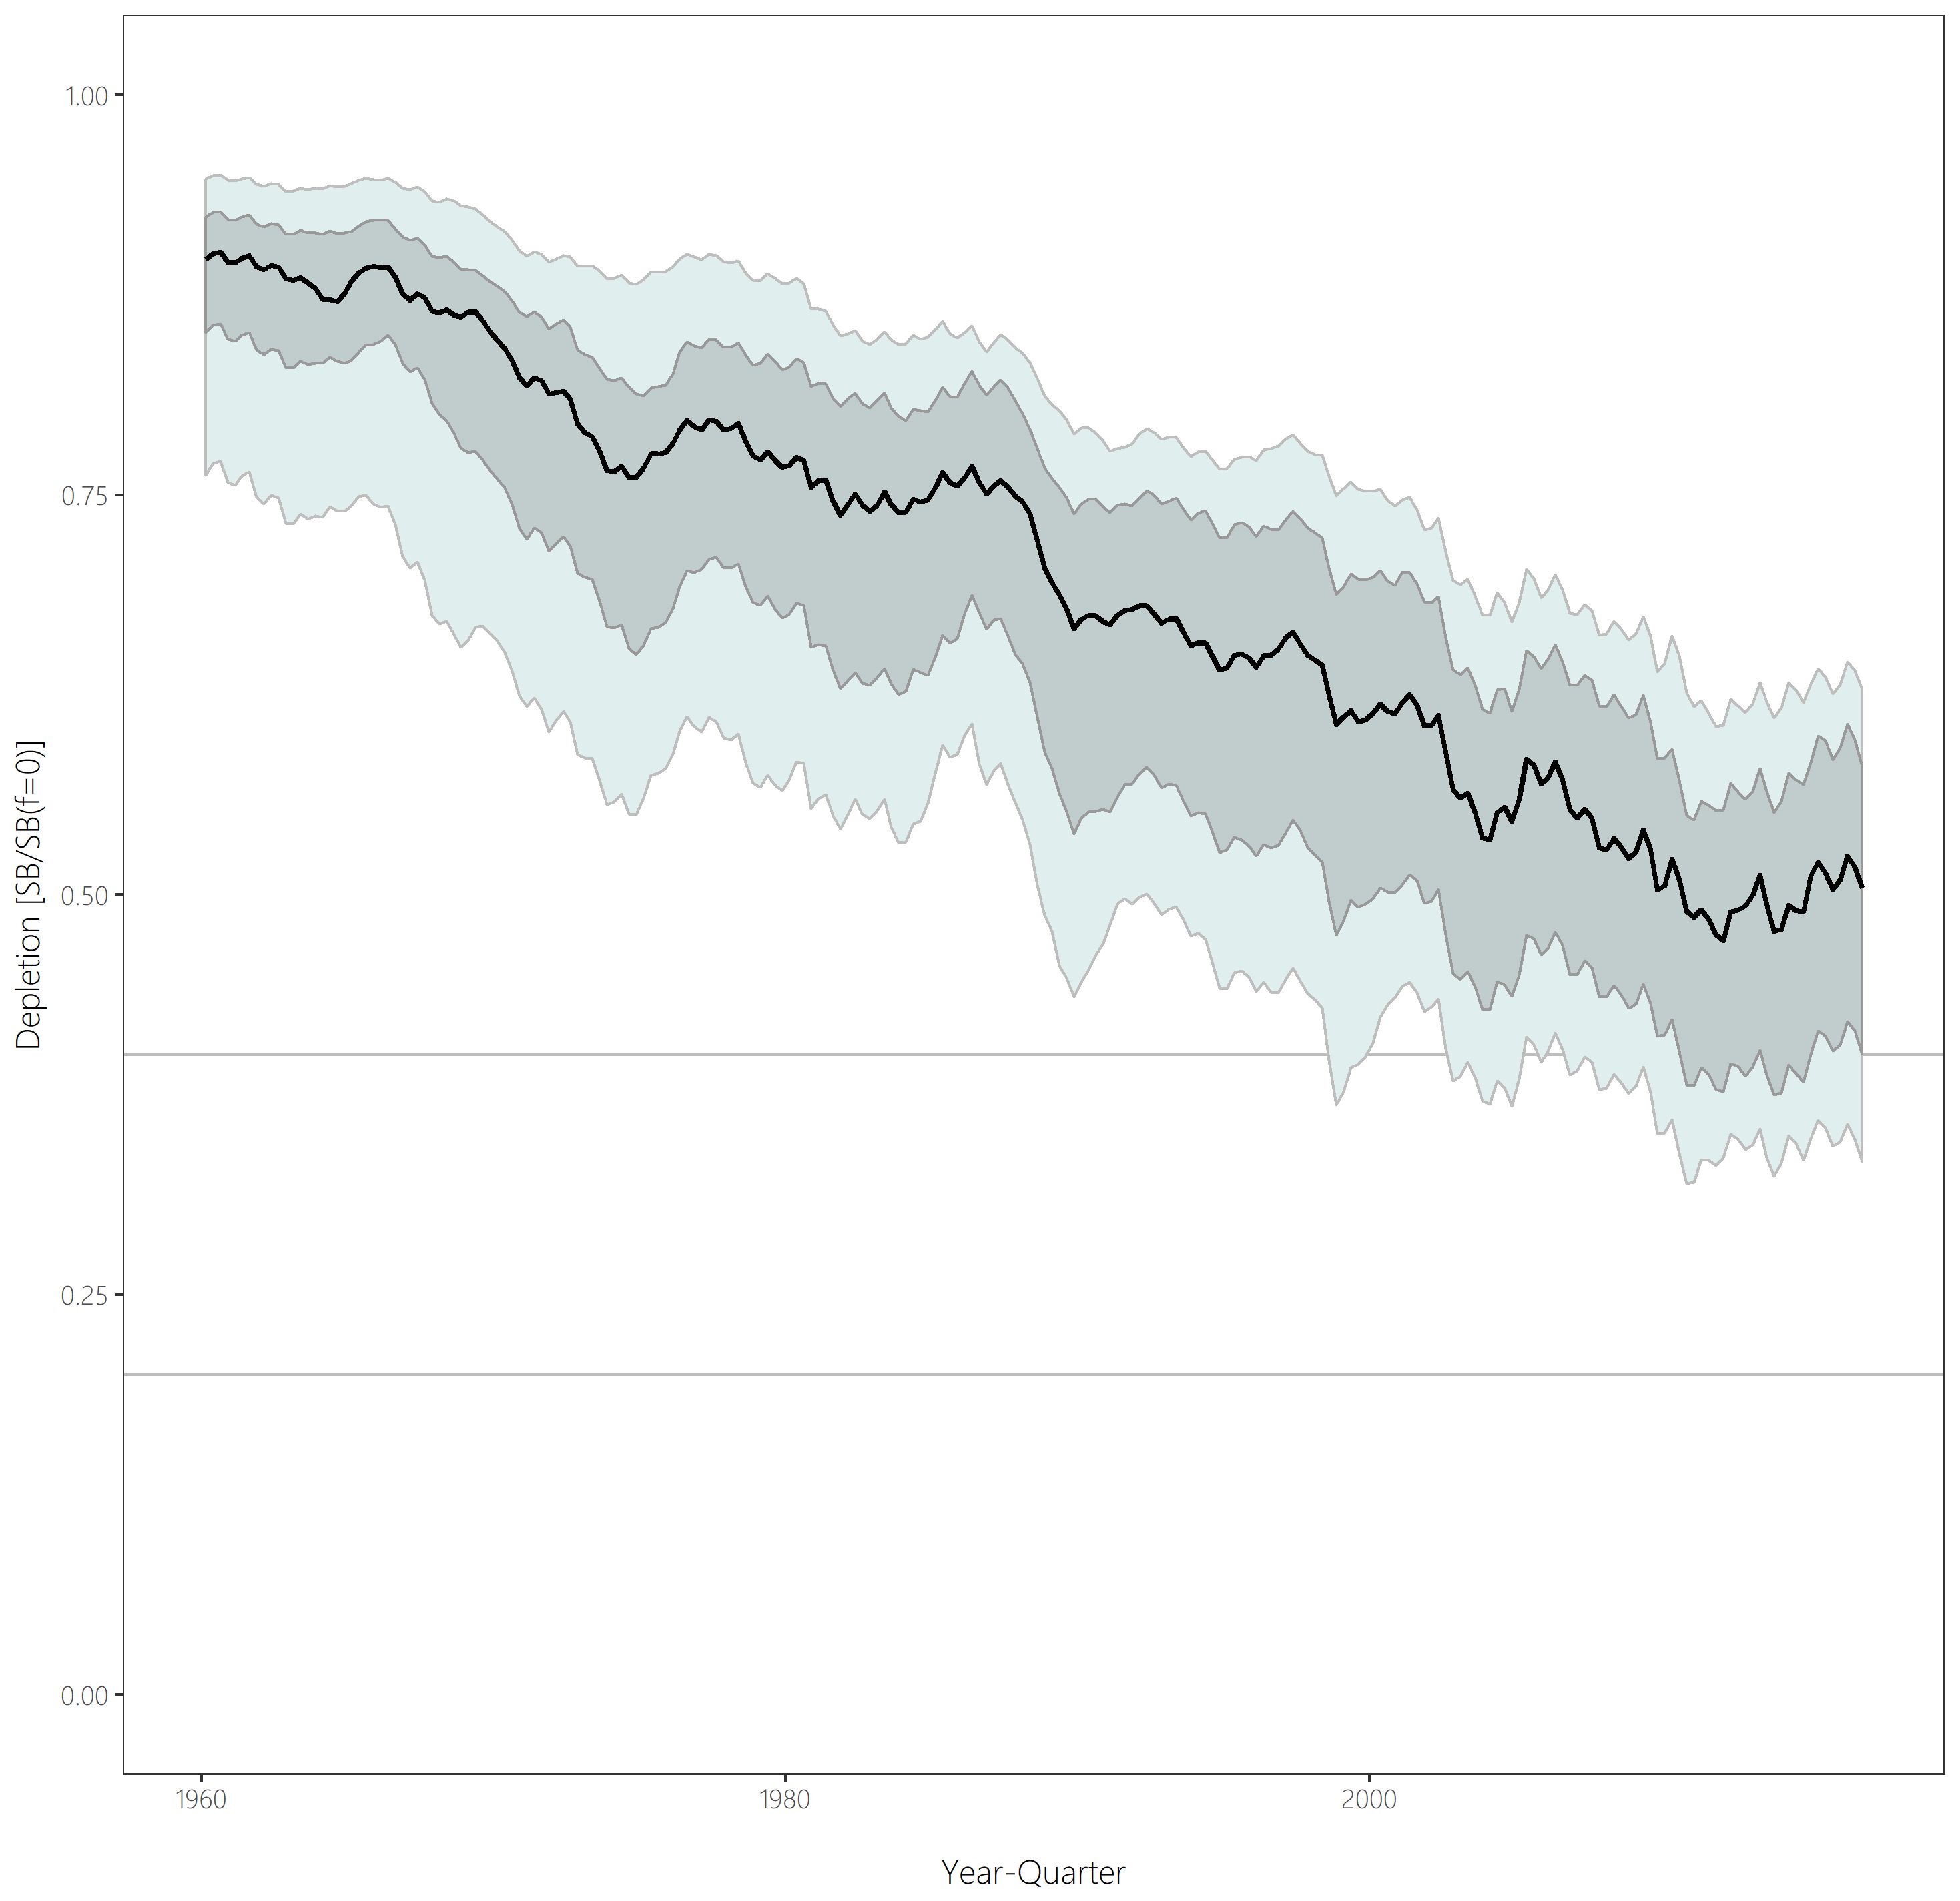
Figure SPA-6 Distribution of time series depletion estimates across the structural uncertainty grid. Black line represents the grid median trajectory, dark grey region represents the 50%ile range, light grey the 90%ile range.
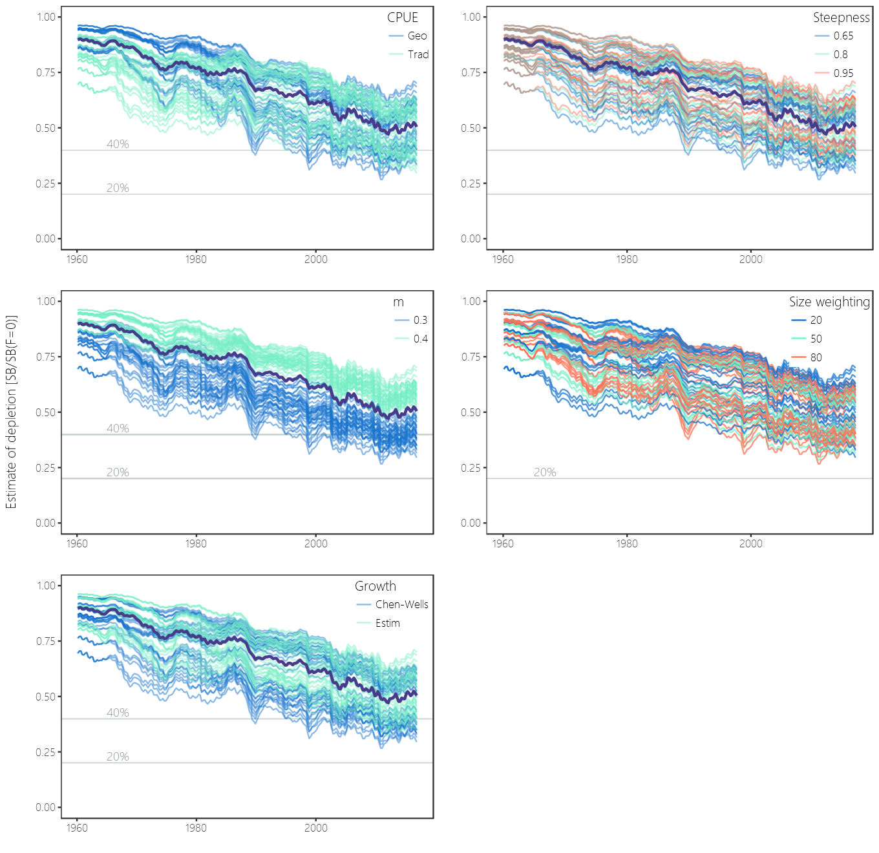
Figure SPA- 7 Plots showing the trajectories of fishing depletion (of spawning potential) for the model runs included in the structural uncertainty grid. The five panels show the models separated on the basis of the five axes used in the grid, with the colour denoting the level within the axes for each model.

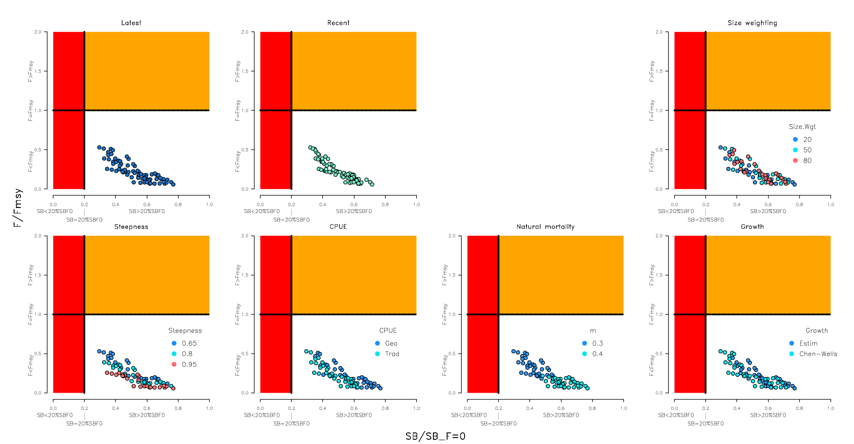
Figure SPA-8 Majuro plots summarising the results for each of the models in the structural uncertainty grid under the SB latest=SB F =0 and the SB recent=SB F =0 reference points (top left) and each axis of uncertainty.

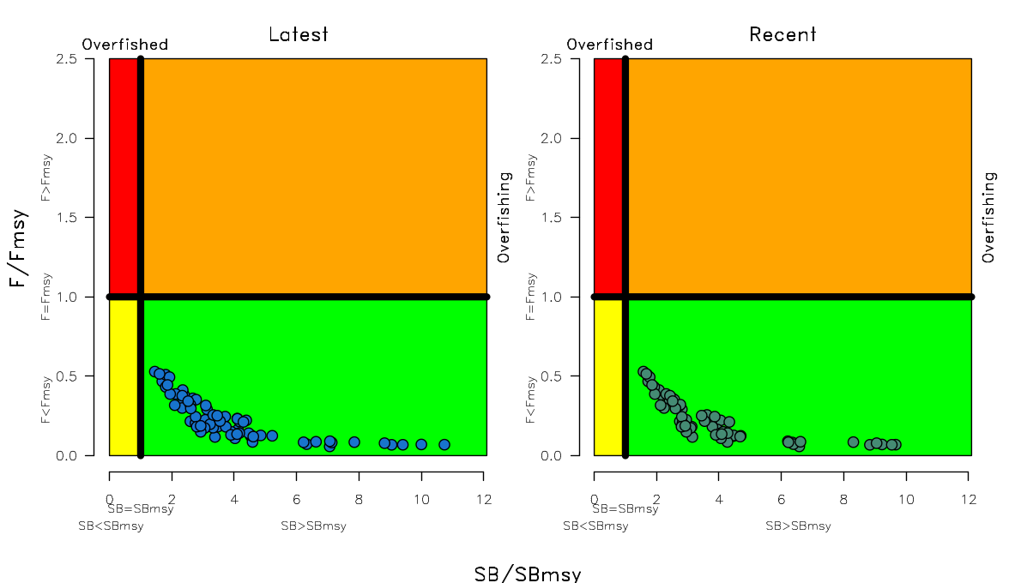
Figure SPA-8 Kobe plots summarising the results for each of the models in the structural uncertainty grid under the SB latest=SB F =0 and the SB recent=SB F =0 reference points.

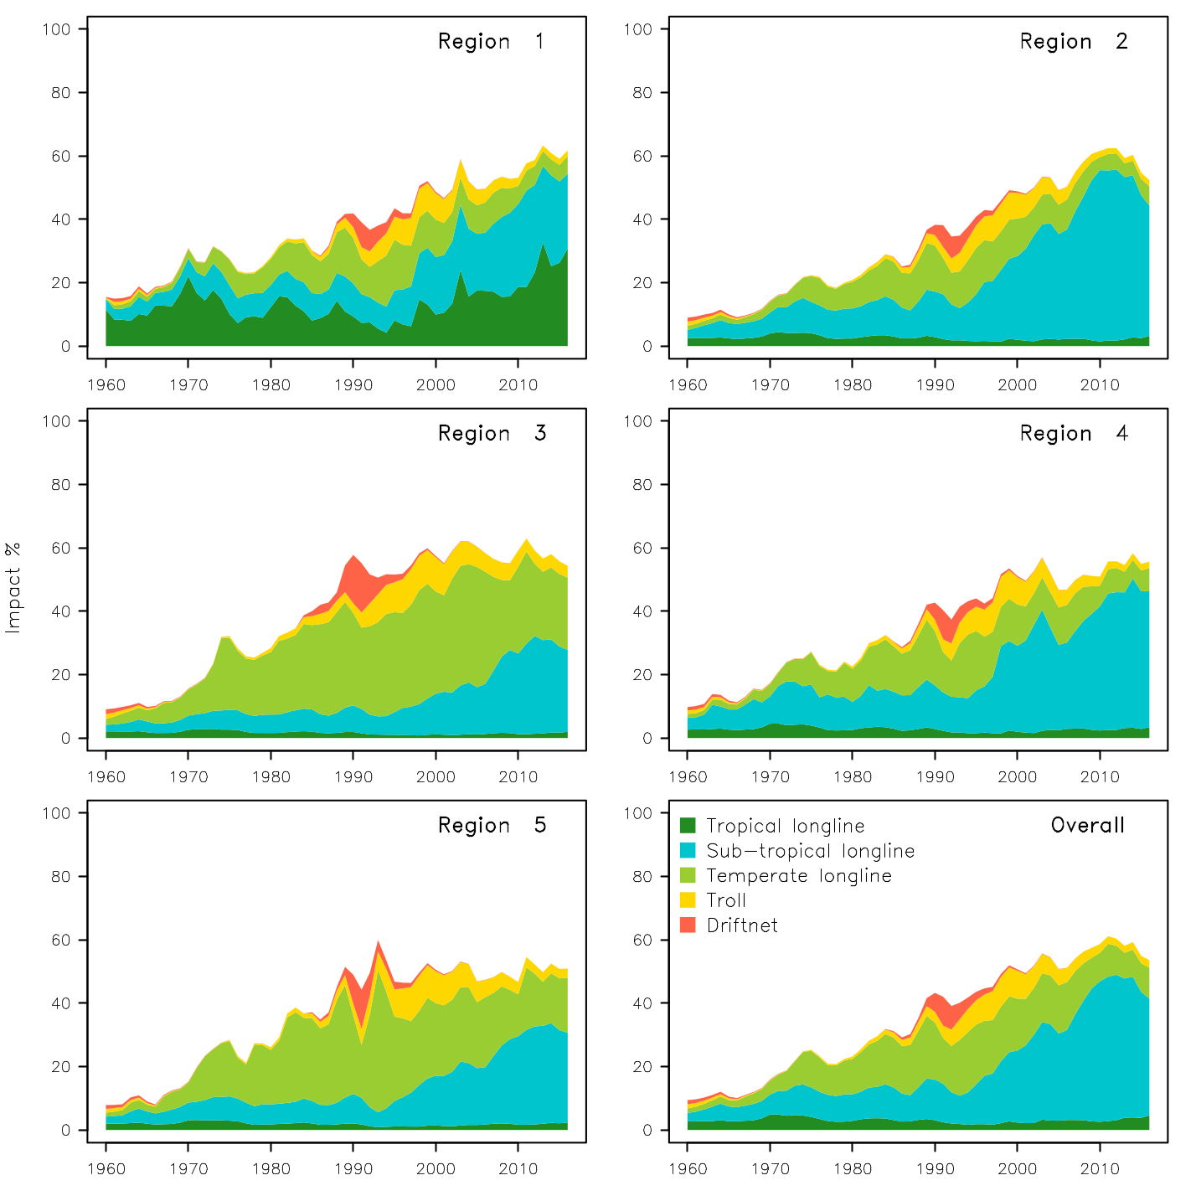
Figure SPA-9 Estimates of reduction in spawning potential due to fishing (fishery impact = 1-SB latest/SB F=0) by region, and over all regions (lower right panel), attributed to various fishery groups for the diagnostic case model.
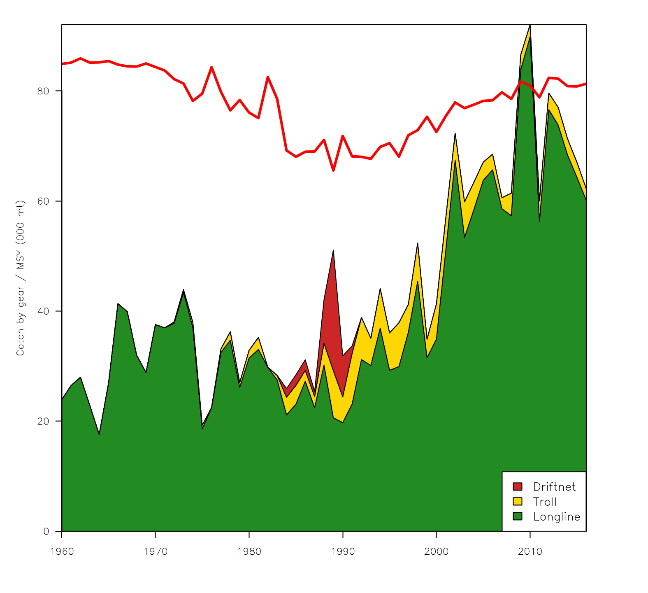
Figure SPA-10: History of the annual estimates of MSY (red line) for the diagnostic case model compared with annual catch by the main gear types.

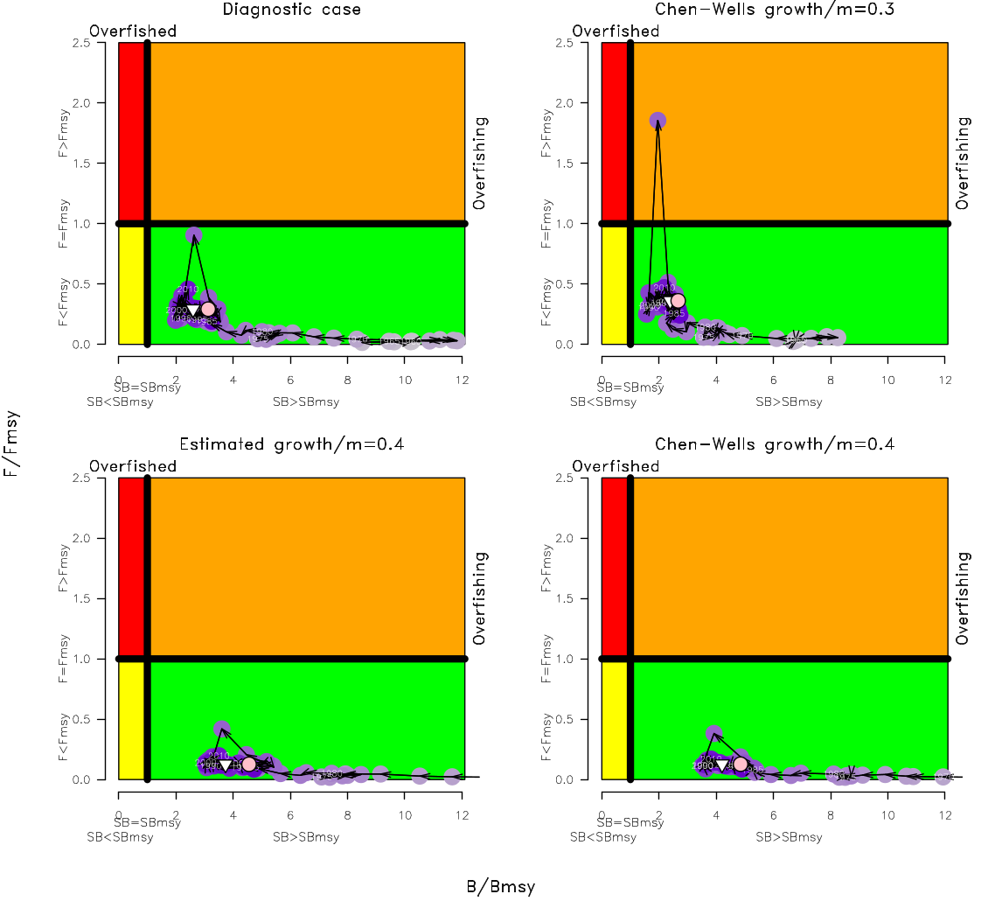
Figure SPA-11 Estimated time-series (or ‘dynamic’) Kobe plots for four example models from the assessment (one from each of the combinations of growth types, and natural mortality M set to 0.3 or 0.4).

Useful References

SC14-SA-WP-05 Stock assessment of South Pacific albacore tuna Rev 2.
https://www.wcpfc.int/node/31182

SC14-SA-WP-02 A compendium of fisheries indicators for tuna stocks. https://www.wcpfc.int/node/30987

SC14-SA-IP-07 Background Analysis for the 2018 stock assessment of South Pacific albacore tuna. https://www.wcpfc.int/node/31260

SC14-SA-IP-08 Trends in the South Pacific Albacore Longline and Troll Fisheries Rev 2. https://www.wcpfc.int/node/30986
And associated excel files
https://www.wcpfc.int/node/30988
https://www.wcpfc.int/node/30989

SC13-WCPFC13-03 Biological and Economic Consequences of Alternative Trajectories to Achieve a Candidate South Pacific Albacore Target Reference Point; Pilling G [1]., M. Skirtun [2], C. Reid [2] and J. Hampton [1] – ([1] SPC-OFP & [2] FFA).
https://www.wcpfc.int/node/29429

SC13-WCPFC13-04 Performance Indicators and Monitoring Strategies for Skipjack and South Pacific Albacore Commensurate with Candidate Management Objectives for the Tropical Purse Seine and Southern Longline Fisheries; Scott R., G. Pilling and J. Hampton (SPC-OFP).
https://www.wcpfc.int/node/29430

SC13-MI-WP-01 Implications of a range of Target Reference Points for the south Pacific albacore stock; FFA.
https://www.wcpfc.int/node/29544

SC13-MI-WP-02 Performance indicators and monitoring strategies for South Pacific Albacore compatible with candidate management objectives for the Southern Longline Fishery; Scott R., G. Pilling and J. Hampton. (SPC-OFP).
https://www.wcpfc.int/node/29545

SC7-SA-WP-05 Regional study of South Pacific albacore population biology: Year 3 – Biological sampling and analysis. https://wcpfc.int/node/2788

Previous Assessments

SC11-SA-WP-06 Stock assessment for south Pacific albacore tuna. Rev 1 (4 August 2015). Harley, S. J[1], N. Davies[2], L Tremblay-Boyer[1], John Hampton[1], and S McKechnie [1] ([1] SPC-OFP & [2] Te Takina Ltd).
https://www.wcpfc.int/node/21776

SC8-SA-WP-04 Stock Assessment of Albacore in the south Pacific Ocean Rev 1 (29 July 2012) https://wcpfc.int/node/3233

SC7-SA-WP-06 Stock assessment of albacore tuna in the South Pacific Ocean. https://wcpfc.int/node/2813

SC5-SA-WP-06 Stock assessment of albacore tuna in the south Pacific Ocean. https://wcpfc.int/node/2177

SC4-SA-WP-08 Stock assessment of Albacore tuna in the south Pacific Ocean. https://wcpfc.int/node/1225

SC2-SA-WP-04 An update of the stock assessment for South Pacific albacore tuna, including an investigation of the sensitivity to key biological parameters included in the model. https://wcpfc.int/node/1749

SC1-SA-WP-03 Stock assessment of albacore tuna in the South Pacific Ocean. https://wcpfc.int/node/1885

