The Commission for the Conservation and Management of
Highly Migratory Fish Stocks in the Western and Central Pacific Ocean

Scientific Committee

North Pacific Albacore Tuna (Thunnus alalunga)

Stock Status and Management Advice

Contents
SC16 2020 (STOCK ASSESSMENT CONDUCTED) 2
SC15 2019 (FISHERY INDICATORS UPDATED) 7
SC14 2018 (FISHERY INDICATORS UPDATED) 7
SC13 2017 (STOCK ASSESSMENT CONDUCTED) 7
References 11

SC16 2020 (STOCK ASSESSMENT CONDUCTED)

    - Review of the 2020 North Pacific albacore tock assessment

- S. Teo (USA)presented SC16-SA-WP-05 Stock Assessment of Albacore Tuna in the North Pacific Ocean in 2020, which detailed the data, biological parameters, model, model diagnostics and sensitivities, and results of the North Pacific albacore stock assessment conducted by ISC’s Albacore Working Group in 2020.

- All available fishery data for North Pacific albacore for the 1994-2018 period were used in the stock assessment. Catch and size composition data were compiled and assigned to 35 fisheries defined for this assessment (based on flag, gear, area, and season). The same abundance index as the 2017 assessment was fitted in the base case model. The North Pacific albacore stock was assessed using a length-based, age-, and sex-structured Stock Synthesis (SS Version 3.30.14.08) model over the 1994-2018 period and it was assumed that there is instantaneous mixing of albacore on a quarterly basis. Biological parameters like growth, natural morality (M) and stock-recruitment steepness, were the same as for the 2017 assessment. All fisheries were assumed to have dome-shaped length selectivity curves, and age-based selectivity for ages 1-5 were also estimated for surface fisheries (troll and pole-and-line) to address age-based changes in juvenile albacore availability and movement. Selectivity curves were also assumed to vary over time for several fleets.

- Maximum likelihood estimates of model parameters, derived outputs, and their uncertainties from the base case model were used to characterize stock status. Based on model diagnostics, the ALBWG concluded that the base case model was able to estimate the stock production function and the effect of fishing on the abundance of the north Pacific albacore stock. Due to the moderate exploitation levels relative to stock productivity, the production function was weakly informative about north Pacific albacore stock size, resulting in asymmetric uncertainty in the stock’s absolute scale, with more uncertainty in the upper limit of the stock than the lower limit. It is important to note that the primary aim of estimating the female SSB in this assessment was to determine whether the estimated SSB was lower than the limit reference point (i.e., determine whether the stock is in an overfished condition). Since the lower bound is better defined, it adds confidence to the evaluation of stock condition relative to the limit reference point.Several sensitivity analyses were conducted to evaluate model performance or the range of uncertainty resulting from changes in model parameters, including natural mortality, stock-recruitment steepness, growth, starting year, selectivity patterns, and weighting of size composition data.

    - Stock status and trends

- SC16 noted that the ISC provided the following conclusions on the stock status of North Pacific albacore:

The Northern Committee (NC) of the Western and Central Pacific Fisheries Commission (WCPFC), which manages this stock together with the Inter American Tropical Tuna Commission (IATTC), adopted a biomass-based limit reference point (LRP) in 2014 (https://www.wcpfc.int/harvest-strategy) of 20% of the current spawning stock biomass when F=0 (20%SSB_{current, F=0}). The 20%SSB_{current, F=0} LRP is based on dynamic biomass and fluctuates depending on changes in recruitment. For north Pacific albacore tuna, this LRP is calculated as 20% of the unfished dynamic female spawning biomass in the terminal year of this assessment (i.e., 2018) (https://www.wcpfc.int/meetings/nc13). However, neither the IATTC nor the WCFPC have adopted F-based limit reference points for the north Pacific albacore stock.

Stock status is depicted in relation to the limit reference point (LRP; 20%SSB_{current, F=0}) for the stock and the equivalent fishing intensity (F_{20%}; calculated as 1-SPR_{20%}) (Figure NPALB-1). Fishing intensity (F, calculated as 1-SPR) is a measure of fishing mortality expressed as the decline in the proportion of the spawning biomass produced by each recruit relative to the unfished state. For example, a fishing intensity of 0.8 will result in a SSB of approximately 20% of SSB₀ over the long run. Fishing intensity is considered a proxy of fishing mortality.

The Kobe plot shows that the estimated female SSB has never fallen below the LRP since 1994, albeit with large uncertainty in the terminal year (2018) estimates. Even when alternative hypotheses about key model uncertainties such as growth were evaluated, the point estimate of female SSB in 2018 (SSB₂₀₁₈) did not fall below the LRP, although the risk increases with this more extreme assumption (Figure NPALB-1). The SSB₂₀₁₈ was estimated to be 58,858 t (95% CI: 27,751 – 89,966 t) and 2.30 (95% CI: 1.49 – 3.11) times greater than the estimated LRP threshold of 25,573 t (95% CI: 19,150 – 31,997 t) (Table NPALB-1). Current fishing intensity, F₂₀₁₅₋₂₀₁₇ (0.50; 95% CI: 0.36 – 0.64; calculated as 1- SPR₂₀₁₅₋₂₀₁₇) , was at or lower than all seven potential F-based reference points identified for the north Pacific albacore stock (Table NPALB-1).

- SC16 noted the following stock status from ISC:

Based on these findings, the following information on the status of the north Pacific albacore stock is provided:

- The stock is likely not overfished relative to the limit reference point adopted by the Western and Central Pacific Fisheries Commission (20%SSB_{current, F=0}), and

- No F-based reference points have been adopted to evaluate overfishing. Stock status was evaluated against seven potential reference points. Current fishing intensity (F₂₀₁₅₋₂₀₁₇) is likely at or below all seven potential reference points (see ratios in Table NPALB-1).

- Management advice and implications

- SC16 noted the following conservation information from ISC:

Two harvest scenarios were projected to evaluate impacts on future female SSB: F constant at the 2015-2017 rate over 10 years (F₂₀₁₅₋₂₀₁₇) and constant catch (average of 2013-2017 = 69,354 t) over 10 years. Median female SSB is expected to increase to 62,873 t (95% CI: 45,123 - 80,622 t) by 2028, with a low probability of being below the LRP by 2028, if fishing intensity remains at the 2015-2017 level (Figure NPALB-2). If future catch is held constant at 69,354 t, the female SSB is expected to increase to 66,313 t (95% CI: 33,463 - 99,164 t) by 2028 and the probability that female SSB will be below the LRP by 2028 is slightly higher than the constant F scenario (Figure NPALB-3). Although the projections appear to underestimate the future uncertainty in female SSB trends, the probability of breaching the LRP in the future is likely small if the future fishing intensity is around current levels.

Based on these findings, the following information is provided:

- If a constant fishing intensity (F₂₀₁₅₋₂₀₁₇) is applied to the stock, then median female spawning biomass is expected to increase to 62,873 t and there will be a low probability of falling below the limit reference point established by the WCPFC by 2028.

- If a constant average catch (C₂₀₁₃₋₂₀₁₇ = 69,354 t) is removed from the stock in the future, then the median female spawning biomass is also expected to increase to 66,313 t and the probability that SSB falls below the LRP by 2028 will be slightly higher than the constant fishing intensity scenario.

Table NPALB-1. Estimates of maximum sustainable yield (MSY), female spawning biomass (SSB), and fishing intensity (F) based reference point ratios for north Pacific albacore tuna for: 1) the base case model; 2) an important sensitivity model due to uncertainty in growth parameters; and 3) a model representing an update of the 2017 base case model to 2020 data. SSB₀ and SSB_{MSY} are the unfished biomass of mature female fish and at MSY, respectively. The Fs in this table are indicators of fishing intensity based on SPR and calculated as 1-SPR so that the Fs reflect changes in fishing mortality. SPR is the equilibrium SSB per recruit that would result from the current year’s pattern and intensity of fishing mortality. Current fishing intensity is based on the average fishing intensity during 2015-2017 (F₂₀₁₅₋₂₀₁₇). 20%SSB_{current, F=0} is 20% of the current unfished dynamic female spawning biomass, where current refers to the terminal year of this assessment (i.e., 2018). The model representing an update of the 2017 base case model is highly similar to but not identical to the 2017 base case model due to changes in data preparation and model structure.
Quantity | Base Case | Growth  CV = 0.06 for L_{inf} | Update of 2017 base case model to 2020 data
MSY (t) ^{A} | 102,236 | 84,385 | 113,522
SSB_{MSY} (t)^{B} | 19,535 | 16,404 | 21,431
SSB₀ (t)^{B} | 136,833 | 113,331 | 152,301
SSB₂₀₁₈ (t) ^{B} | 58,858 | 34,872 | 77,077
SSB₂₀₁₈/20%SSB_{current, F=0} ^{B} | 2.30 | 1.63 | 2.63
F₂₀₁₅₋₂₀₁₇ | 0.50 | 0.64 | 0.43
F₂₀₁₅₋₂₀₁₇/F_{MSY} | 0.60 | 0.77 | 0.52
F₂₀₁₅₋₂₀₁₇/F_{0.1} | 0.57 | 0.75 | 0.49
F₂₀₁₅₋₂₀₁₇/F_{10%} | 0.55 | 0.71 | 0.48
F₂₀₁₅₋₂₀₁₇/F_{20%} | 0.62 | 0.80 | 0.54
F₂₀₁₅₋₂₀₁₇/F_{30%} | 0.71 | 0.91 | 0.62
F₂₀₁₅₋₂₀₁₇/F_{40%} | 0.83 | 1.06 | 0.72
F₂₀₁₅₋₂₀₁₇/F_{50%} | 1.00 | 1.27 | 0.86
A – MSY includes male and female juvenile and adult fish
B – Spawning stock biomass (SSB) in this assessment refers to mature female biomass only.

A | B
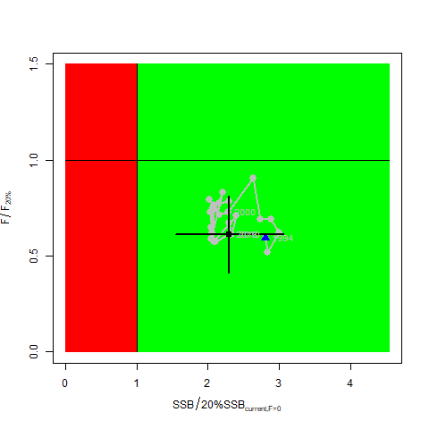 | 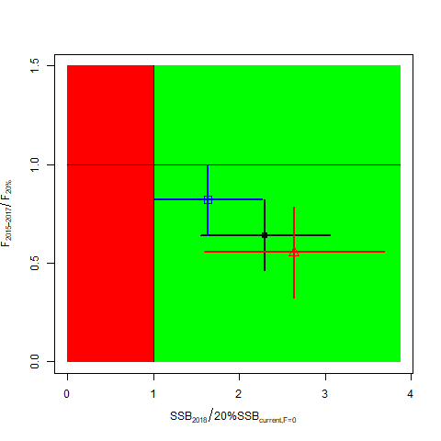
Figure NPALB-1. (A)Kobe plot showing the status of the north Pacific albacore (Thunnus alalunga) stock relative to the 20%SSB_{current, F=0} biomass-based limit reference point, and equivalent fishing intensity (F_{20%}; calculated as 1-SPR_{20%}) over the base case modeling period (1994-2018). Blue triangle indicates the start year (1994) and black circle with 95% confidence intervals indicates the terminal year (2018). (B) Kobe plot showing current stock status and 95% confidence intervals of the base case model (black; closed circle), an important sensitivity run of CV = 0.06 for L_{inf} in the growth model (blue; open square), and a model representing an update of the 2017 base case model to 2020 data (red; open triangle). The coefficients of variation of the SSB/20%SSB_{current, F=0} ratios are assumed to be the same as for the SSB/20%SSB₀ ratios. Fs in this figure is not based on instantaneous fishing mortality. Instead, the Fs are indicators of fishing intensity based on SPR and calculated as 1-SPR so that the Fs reflects changes in fishing mortality. SPR is the equilibrium SSB per recruit that would result from the current year’s pattern and intensity of fishing mortality. Current fishing intensity is calculated as the average fishing intensity during 2015-2017 (F₂₀₁₅₋₂₀₁₇), while current female spawning biomass refers to the terminal year of this assessment (i.e., 2018). The model representing an update of the 2017 base case model is highly similar to but not identical to the 2017 base case model due to changes in data preparation and model structure.

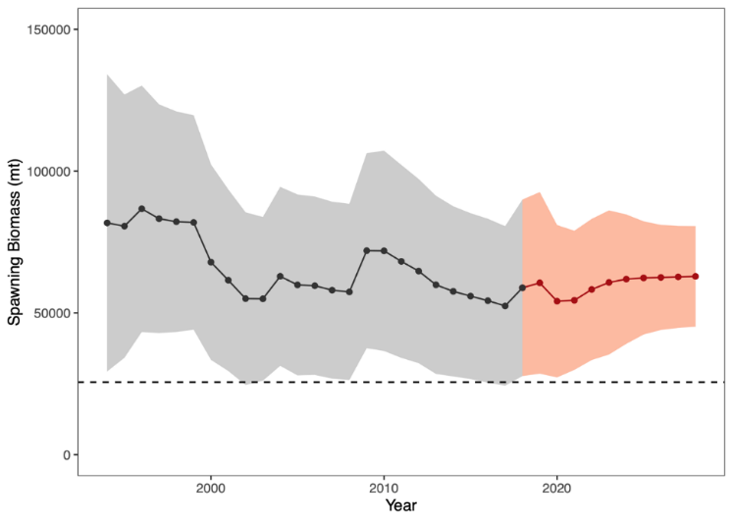
Figure NPALB-2. Historical and future trajectory of north Pacific albacore (Thunnus alalunga) female spawning biomass (SSB) under a constant fishing intensity (F₂₀₁₅₋₂₀₁₇) harvest scenario. Future recruitment is based on the expected recruitment variability. Black line and gray area indicates maximum likelihood estimates and 95% confidence intervals (CI), respectively, of historical female SSB, which includes parameter uncertainty. Red line and red area indicates mean value and 95% CI of projected female SSB, which only includes future recruitment variability and SSB uncertainty in the terminal year. Dashed black line indicates the 20%SSB_{current F=0} limit reference point for 2018 (25,573 t).

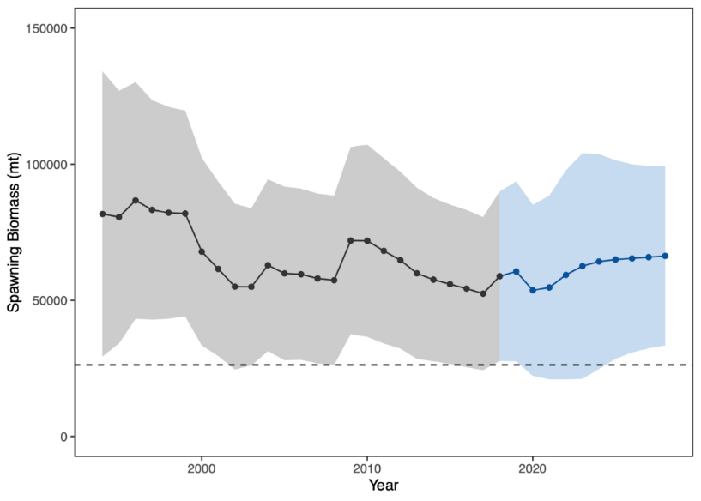
Figure NPALB-3. Historical and future trajectory of north Pacific albacore (Thunnus alalunga) female spawning biomass (SSB) under a constant catch (average 2013-2017 = 69,354 t) harvest scenario. Future recruitment is based on the expected recruitment variability. Black line and blue area indicates maximum likelihood estimates and 95% confidence intervals (CI), respectively, of historical female SSB, which includes parameter uncertainty. Blue line and blue area indicates mean value and 95% CI of projected female SSB, which only includes future recruitment variability and SSB uncertainty in the terminal year. Dashed black line indicates the 20%SSB_{current F=0} limit reference point for 2018 (25,573 t).

SC15 2019 (FISHERY INDICATORS UPDATED)

  - Stock status and trends

- SC15 noted that no stock assessments were conducted for North Pacific albacore in 2019. Therefore, the stock status descriptions from SC13 are still current for North Pacific albacore. For further information on the stock status and trends from SC13, please see https://www.wcpfc.int/node/29904. Updated information on catches was not compiled for and reviewed by SC15.

- SC15 noted that the provisional total NPALB catch by Canada, Japan, USA, Korea, Mexico and Chinese Taipei in 2018 was 49,300 mt, a 9% decrease from 2017 and a 24% decrease from the 2013-2017 average. The detailed catch information by fishery is available in ISC 2019 report (SC15-GN-IP-02). North Pacific albacore is caught by various fishing gears including longline, troll, and pole-and-line.

  - Management Advice and implications

- SC15 noted that no management advice has been provided since SC13 for North Pacific albacore. Therefore, the advice from SC13 should be maintained, pending a new assessment or other new information. For further information on the management advice and implications from SC13, please see https://www.wcpfc.int/node/29904

SC14 2018 (FISHERY INDICATORS UPDATED)

- Stock Status and trends

      - SC14 noted that no stock assessments were conducted for North Pacific albacore in 2018. Therefore, the stock status descriptions from SC13 are still current for North Pacific albacore. Updated information on catches was not compiled for and reviewed by SC14.

- Management advice and implications

      - SC14 noted that no management advice has been provided since SC13 for North Pacific albacore. Therefore, the advice from SC13 should be maintained, pending a new assessment or other new information. For further information on the management advice and implications from SC13, please see below.

SC13 2017 (STOCK ASSESSMENT CONDUCTED)

- ISC presented working paper SC13-SA-WP-09 Stock assessment of albacore tuna in the North Pacific Ocean in 2017.

- Stock status and trends

- SC13 noted that the ISC provided the following conclusions on the stock status of North Pacific albacore.

- Stock status is depicted in relation to the limit reference point (LRP; 20%SSBcurrent, F=0) for the stock and the equivalent fishing intensity (F20%; calculated as 1-SPR20%) (Fig. NPALB-1). Fishing intensity (F, calculated as 1-SPR) is a measure of fishing mortality expressed as the decline in the proportion of the spawning biomass produced by each recruit relative to the unfished state. For example, a fishing intensity of 0.8 will result in a SSB of approximately 20% of SSB0 over the long run. Fishing intensity is considered a proxy of fishing mortality.

- The Kobe plot shows that the estimated female SSB has never fallen below the LRP since 1993, albeit with large uncertainty in the terminal year (2015) estimates. Even when alternative hypotheses about key model uncertainties such as natural mortality and growth were evaluated, the point estimate of female SSB in 2015 (SSB2015) did not fall below the LRP, although the risk increases with these more extreme assumptions (Figure NPALB-1). The SSB2015 was estimated to be 80,618 t and was 2.47 times greater than the LRP threshold of 32,614 t (Table ES1). Current fishing intensity, F2012-2014 (calculated as 1- SPR2012-2014), was lower than potential F-based reference points identified for the north Pacific albacore stock, except F50% (calculated as 1-SPR50%) (Table NPALB-1). Based on these findings, the following information on the status of the north Pacific albacore stock is provided:
- The stock is likely not overfished relative to the limit reference point adopted by the Western and Central Pacific Fisheries Commission (20%SSBcurrent F=0), and
- No F-based reference points have been adopted to evaluate overfishing. Stock status was evaluated against seven potential reference points. Current fishing intensity (F2012-2014) is below six of the seven reference points (see ratios in Table ES-1), except F50%.

- Management advice and implications

- SC13 noted the following conservation information from the ISC.

- The current exploitation level (F2010–2012) is estimated to be below that of F2002–2004, which led to the implementation of conservation and management measures (CMMs) for the North Pacific albacore stock in the EPO (IATTC Resolution C-05-02 supplemented by Resolution C-13-03) and the WCNPO (WCPFC CMM 2005-03). Assuming average historical recruitment and fishing at a constant current F, median female SSB is expected to remain relatively stable between the 25th and median historical percentiles over both the short- and long-term, with a 13% probability that female SSB falls below the SSB-ATHL threshold during a 25-year projection period. In contrast, if a low recruitment scenario is assumed, then median female SSB declines under both harvest scenarios (constant F2010–2012, constant F2002–2004) and the probability that it falls below the SSB-ATHL threshold in the 25-year projection period increases to 65% as calculated by the ALBWG and noted above. The high recruitment scenario is more optimistic, with median future SSB increasing above the historical median SSB and the estimated probability of falling below the SSB-ATHL threshold is correspondingly low at 3%.

Table NPALB-1. Estimates of maximum sustainable yield (MSY), female spawning biomass (SSB) quantities, and fishing intensity (F) based reference point ratios for north Pacific albacore tuna for the base case assessment and important sensitivity analyses. SSB0 and SSBMSY are the unfished biomass of mature female fish and at MSY, respectively. The Fs in this table are not based on instantaneous fishing mortality. Instead, the Fs are indicators of fishing intensity based on SPR and calculated as 1-SPR so that the Fs reflects changes in fishing mortality. SPR is the equilibrium SSB per recruit that would result from the current year’s pattern and intensity of fishing mortality. Current fishing intensity is based on the average fishing intensity during 2012-2014 (F2012-2014).
Quantity | Base Case | M = 0.3 y⁻¹ | Growth  CV = 0.06 for L_{inf}
MSY (t) ^{A} | 132,072 | 92,027 | 118,836
SSB_{MSY} (t) ^{B} | 24,770 | 42,098 | 22,351
SSB₀ (t) ^{B} | 171,869 | 270,879 | 156,336
SSB₂₀₁₅ (t) ^{B} | 80,618 | 68,169 | 63,719
SSB₂₀₁₅/20%SSB_{current, F=0} ^{B} | 2.47 | 1.31 | 2.15
F₂₀₁₂₋₂₀₁₄ | 0.51 | 0.74 | 0.57
F₂₀₁₂₋₂₀₁₄/F_{MSY} | 0.61 | 0.89 | 0.68
F₂₀₁₂₋₂₀₁₄/F_{0.1} | 0.58 | 0.90 | 0.65
F₂₀₁₂₋₂₀₁₄/F_{10%} | 0.56 | 0.81 | 0.63
F₂₀₁₂₋₂₀₁₄/F_{20%} | 0.63 | 0.91 | 0.71
F₂₀₁₂₋₂₀₁₄/F_{30%} | 0.72 | 1.04 | 0.81
F₂₀₁₂₋₂₀₁₄/F_{40%} | 0.85 | 1.21 | 0.96
F₂₀₁₂₋₂₀₁₄/F_{50%} | 1.01 | 1.47 | 1.16
A – MSY includes male and female juvenile and adult fish
B – Spawning stock biomass (SSB) in this assessment refers to mature female biomass only.

A | B
Figure NPALB-1. (A) Kobe plot showing the status of the north Pacific albacore (Thunnus alalunga) stock relative to the 20%SSBcurrent_{, F=0} biomass-based limit reference point, and equivalent fishing intensity (F20%; calculated as 1-SPR20%) over the base case modelling period (1993-2015). Blue triangle indicates the start year (1993) and black circle with 95% confidence intervals indicates the terminal year (2015). (B) Kobe plot showing stock status and 95% confidence intervals in the terminal year (2015) of the base case model (black; closed circle) and important sensitivity runs with M = 0.3 y⁻¹ for both sexes (blue; open square), and CV = 0.06 for Linf in the growth model (white; open triangle). Fs in this figure are not based on instantaneous fishing mortality. Instead, the Fs are indicators of fishing intensity based on SPR and calculated as 1-SPR so that the Fs reflects changes in fishing mortality. SPR is the equilibrium SSB per recruit that would result from the current year’s pattern and intensity of fishing mortality.

References

SC16-SA-WP-05 Stock Assessment of Albacore Tuna in the North Pacific Ocean in 2020 https://www.wcpfc.int/node/46613

For current information related to Northern Stocks Working Group Reports and the ISC Plenary Report:
http://isc.fra.go.jp/reports/isc/isc20_reports.html

SC13-SA-WP-09 Stock Assessment of Albacore in the North Pacific Ocean in 2017 Rev 2(approved version) (29 July 2017). Report of the Albacore Working Group (ISC).
https://www.wcpfc.int/node/29522

SC10-SA-WP-12 Stock Assessment of Albacore Tuna in the North Pacific Ocean in 2014. https://wcpfc.int/node/19202

SC7-SA-WP-10 Stock assessment of albacore tuna in the North Pacific Ocean in 2011. https://wcpfc.int/node/2860

It should be noted that the constant catch scenario is inconsistent with current management approaches for north Pacific albacore tuna adopted by the Inter-American Tropical Tuna Commission (IATTC) and the Western and Central Pacific Fisheries Commission (WCPFC).

