North Pacific Albacore Tuna (Thunnus alalonga)
Stock Status & Trends plus Management Advice and Implications

Contents
SC14 2018 1
SC13 2017 (STOCK ASSESSMENT CONDUCTED) 2
Useful References 4
Previous Assessments 4

SC14 2018

Stock Status
SC14 noted that no stock assessments were conducted for North Pacific albacore in 2018. Therefore, the stock status descriptions from SC13 are still current for North Pacific albacore. Updated information on catches was not compiled for and reviewed by SC14.

Management Advice
SC14 noted that no management advice has been provided since SC13 for North Pacific albacore. Therefore, the advice from SC13 should be maintained, pending a new assessment or other new information. For further information on the management advice and implications from SC13, please see below.

SC13 2017 (STOCK ASSESSMENT CONDUCTED)

- ISC presented working paper SC13-SA-WP-09 Stock assessment of albacore tuna in the North Pacific Ocean in 2017.
- Status and trends

- SC13 noted that the ISC provided the following conclusions on the stock status of North Pacific albacore.

- Stock status is depicted in relation to the limit reference point (LRP; 20%SSBcurrent, F=0) for the stock and the equivalent fishing intensity (F20%; calculated as 1-SPR20%) (Fig. NPALB-1). Fishing intensity (F, calculated as 1-SPR) is a measure of fishing mortality expressed as the decline in the proportion of the spawning biomass produced by each recruit relative to the unfished state. For example, a fishing intensity of 0.8 will result in a SSB of approximately 20% of SSB0 over the long run. Fishing intensity is considered a proxy of fishing mortality.

- The Kobe plot shows that the estimated female SSB has never fallen below the LRP since 1993, albeit with large uncertainty in the terminal year (2015) estimates. Even when alternative hypotheses about key model uncertainties such as natural mortality and growth were evaluated, the point estimate of female SSB in 2015 (SSB2015) did not fall below the LRP, although the risk increases with these more extreme assumptions (Figure NPALB-1). The SSB2015 was estimated to be 80,618 t and was 2.47 times greater than the LRP threshold of 32,614 t (Table ES1). Current fishing intensity, F2012-2014 (calculated as 1- SPR2012-2014), was lower than potential F-based reference points identified for the north Pacific albacore stock, except F50% (calculated as 1-SPR50%) (Table NPALB-1). Based on these findings, the following information on the status of the north Pacific albacore stock is provided:
- The stock is likely not overfished relative to the limit reference point adopted by the Western and Central Pacific Fisheries Commission (20%SSBcurrent F=0), and
- No F-based reference points have been adopted to evaluate overfishing. Stock status was evaluated against seven potential reference points. Current fishing intensity (F2012-2014) is below six of the seven reference points (see ratios in Table ES-1), except F50%.

- Management advice and implications

- SC13 noted the following conservation information from the ISC.

- The current exploitation level (F2010–2012) is estimated to be below that of F2002–2004, which led to the implementation of conservation and management measures (CMMs) for the North Pacific albacore stock in the EPO (IATTC Resolution C-05-02 supplemented by Resolution C-13-03) and the WCNPO (WCPFC CMM 2005-03). Assuming average historical recruitment and fishing at a constant current F, median female SSB is expected to remain relatively stable between the 25th and median historical percentiles over both the short- and long-term, with a 13% probability that female SSB falls below the SSB-ATHL threshold during a 25-year projection period. In contrast, if a low recruitment scenario is assumed, then median female SSB declines under both harvest scenarios (constant F2010–2012, constant F2002–2004) and the probability that it falls below the SSB-ATHL threshold in the 25-year projection period increases to 65% as calculated by the ALBWG and noted above. The high recruitment scenario is more optimistic, with median future SSB increasing above the historical median SSB and the estimated probability of falling below the SSB-ATHL threshold is correspondingly low at 3%.

Table NPALB-1. Estimates of maximum sustainable yield (MSY), female spawning biomass (SSB) quantities, and fishing intensity (F) based reference point ratios for north Pacific albacore tuna for the base case assessment and important sensitivity analyses. SSB0 and SSBMSY are the unfished biomass of mature female fish and at MSY, respectively. The Fs in this table are not based on instantaneous fishing mortality. Instead, the Fs are indicators of fishing intensity based on SPR and calculated as 1-SPR so that the Fs reflects changes in fishing mortality. SPR is the equilibrium SSB per recruit that would result from the current year’s pattern and intensity of fishing mortality. Current fishing intensity is based on the average fishing intensity during 2012-2014 (F2012-2014).
Quantity | Base Case | M = 0.3 y⁻¹ | Growth  CV = 0.06 for L_{inf}
MSY (t) ^{A} | 132,072 | 92,027 | 118,836
SSB_{MSY} (t) ^{B} | 24,770 | 42,098 | 22,351
SSB₀ (t) ^{B} | 171,869 | 270,879 | 156,336
SSB₂₀₁₅ (t) ^{B} | 80,618 | 68,169 | 63,719
SSB₂₀₁₅/20%SSB_{current, F=0} ^{B} | 2.47 | 1.31 | 2.15
F₂₀₁₂₋₂₀₁₄ | 0.51 | 0.74 | 0.57
F₂₀₁₂₋₂₀₁₄/F_{MSY} | 0.61 | 0.89 | 0.68
F₂₀₁₂₋₂₀₁₄/F_{0.1} | 0.58 | 0.90 | 0.65
F₂₀₁₂₋₂₀₁₄/F_{10%} | 0.56 | 0.81 | 0.63
F₂₀₁₂₋₂₀₁₄/F_{20%} | 0.63 | 0.91 | 0.71
F₂₀₁₂₋₂₀₁₄/F_{30%} | 0.72 | 1.04 | 0.81
F₂₀₁₂₋₂₀₁₄/F_{40%} | 0.85 | 1.21 | 0.96
F₂₀₁₂₋₂₀₁₄/F_{50%} | 1.01 | 1.47 | 1.16
A – MSY includes male and female juvenile and adult fish
B – Spawning stock biomass (SSB) in this assessment refers to mature female biomass only.

A 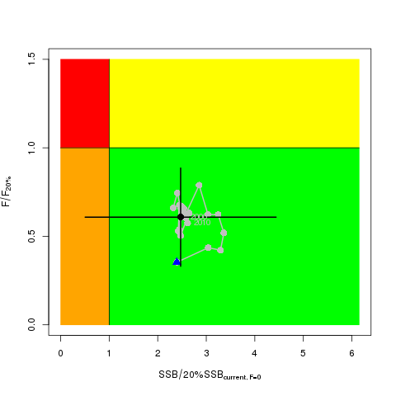 | B 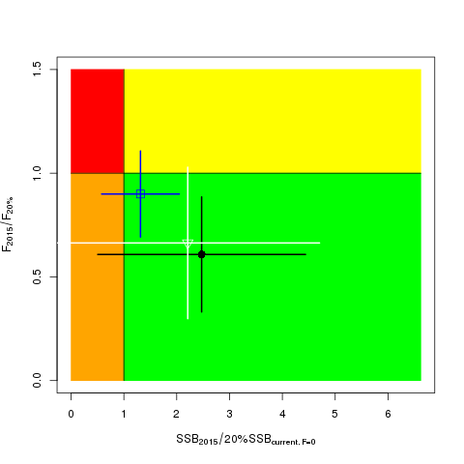
Figure NPALB-1. (A) Kobe plot showing the status of the north Pacific albacore (Thunnus alalunga) stock relative to the 20%SSBcurrent_{, F=0} biomass-based limit reference point, and equivalent fishing intensity (F20%; calculated as 1-SPR20%) over the base case modelling period (1993-2015). Blue triangle indicates the start year (1993) and black circle with 95% confidence intervals indicates the terminal year (2015). (B) Kobe plot showing stock status and 95% confidence intervals in the terminal year (2015) of the base case model (black; closed circle) and important sensitivity runs with M = 0.3 y⁻¹ for both sexes (blue; open square), and CV = 0.06 for Linf in the growth model (white; open triangle). Fs in this figure are not based on instantaneous fishing mortality. Instead, the Fs are indicators of fishing intensity based on SPR and calculated as 1-SPR so that the Fs reflects changes in fishing mortality. SPR is the equilibrium SSB per recruit that would result from the current year’s pattern and intensity of fishing mortality.

Useful References

SC13-SA-WP-09 Stock Assessment of Albacore in the North Pacific Ocean in 2017 Rev 2(approved version) (29 July 2017). Report of the Albacore Working Group (ISC).
https://www.wcpfc.int/node/29522

For current information related to Northern Stocks Working Group Reports and the ISC Plenary Report:
http://isc.fra.go.jp/reports/isc/isc18_reports.html

Previous Assessments

SC10-SA-WP-12 Stock Assessment of Albacore Tuna in the North Pacific Ocean in 2014. https://wcpfc.int/node/19202

SC7-SA-WP-10 Stock assessment of albacore tuna in the North Pacific Ocean in 2011. https://wcpfc.int/node/2860

