

**The Commission for the Conservation and Management of**

**Highly Migratory Fish Stocks in the Western and Central Pacific Ocean**

**Scientific Committee**

**PACIFIC BLUEFIN TUNA (*Thunnus orientalis*)**

Stock Status AND Management Advice

Contents

[**SC16 2020 (BENCHMARK ASSESSMENT)** 2](#_Toc64450096)

[**SC15 2019 (FISHERY INDICATORS UPDATED)** 15](#_Toc64450097)

[**SC14 2018 (STOCK ASSESSMENT CONDUCTED)** 18](#_Toc64450098)

[**SC13 2017 (FISHERY INDICATORS UPDATED)** 24](#_Toc64450099)

[**References** 25](#_Toc64450100)

# **SC16 2020 (BENCHMARK ASSESSMENT)**

* + 1. **Review of 2020 Pacific bluefin tuna stock assessment**

1. H. Fukuda, lead modelerfor the ISC Bluefin Tuna Working Group (PBFWG) made a detailed report on the benchmark stock assessment for PBF conducted by the ISC PBFWG in March 2020 (SC16-SA-WP-06). Several modifications — such as the spatio-temporal modeling for CPUE standardization, more detailed modeling of fisheries, inclusions of newly available size data and discard information, and bias correction for the projection results —were made to improve the assessment.
2. Population dynamics during 1952-2018 were modelled using quarterly observations of catch and size compositions, when available, as well as the annual estimates of standardized CPUE based abundance indices. The assessment model was fitted to those input data in a likelihood-based statistical framework. Based on the diagnostic analysis, the PBFWG concluded that the new base-case model represents the data sufficiently and there is an internal consistency among the assumptions of the assessment model and input data. The new base-case model also showed consistent results with the 2016 and 2018 assessments. The ISC plenary 20 considered the 2020 assessment results as the best available scientific information on Pacific bluefin tuna.
3. The stock projections were developed based on the bootstrap replicates of the base-case model and the future harvesting scenarios, which were requested by the WCPFC and IATTC. For the sake of precautionarily in the light of current low level of the SSB and the possible future low recruitment produced thereby, the future recruitments until the stock recovered to the initial rebuilding target were resampled from relatively low recruitment period (1980-1989). For the following years, future recruitments were randomly resampled from whole stock assessment period.
   * 1. **Stock status and trends**
4. SC16 noted that the ISC provided the following conclusions on the stock status of Pacific bluefin tuna.

The base-case model results show that: (1) spawning stock biomass (SSB) fluctuated throughout the assessment period (fishing years 1952-2018); (2) the SSB steadily declined from 1996 to 2010; (3) there has been a slow increase of the stock biomass continues since 2011; (4) total biomass in 2018 exceeded the historical median with an increase in immature fish; and (5) fishing mortality (F%SPR) declined from a level producing about 1% of SPR[[1]](#footnote-1) in 2004-2009 to a level producing 14% of SPR in 2016- 2018 (Table PBF1). Based on the model diagnostics, the estimated biomass trend for the last 30 years is considered robust although SSB prior to the 1980s is uncertain due to data limitations. The SSB in 2018 was estimated to be around 28,000 t (Table PBF1 and Figure PBF-1), which is a 3,000 t increase from 2016 according to the base-case model. An increase of young fish (0-2 years old) is observed in 2016-2018 (Figure PBF-2), likely resulting from low fishing mortality on those fish (Figure PBF-3) and is expected to accelerate the recovery of SSB in the future.

Historical recruitment estimates have fluctuated since 1952 without an apparent trend. Relatively low recruitment levels estimated in 2010-2014 were of concern in the 2016 assessment. The 2015 recruitment estimate is lower than the historical average while the 2016 recruitment estimate (about 17 million fish) is higher than the historical average (Table PBF-1 and Figure PBF-1). The recruitment estimates for 2017 and 2018, which are based on fewer observations and more uncertain, are below the historical average.

Estimated age-specific fishing mortalities (F) on the stock during the periods of 2011-2013 and 2016-2018 compared with 2002-2004 estimates (the reference period for the WCPFC Conservation and Management Measure) are presented in Figure PBF-3. A substantial decrease in estimated F is observed in ages 0-2 in 2016-2018 relative to the previous years. Note that stricter management measures in the WCPFC and IATTC have been in place since 2015.

Figure PBF-5 depicts the historical impacts of the fleets on the PBF stock, showing the estimated biomass when fishing mortality from the respective fleets is zero. Historically, the WPO coastal fisheries group has had the greatest impact on the PBF stock, but since about the early 1990s the WPO purse seine fishery group targeting small fish (ages 0-1) has had a greater impact and the effect of this group in 2018 was greater than any of the other fishery groups. The impact of the EPO fisheries group was large before the mid-1980s, decreasing significantly thereafter. The WPO longline fisheries group has had a limited effect on the stock throughout the analysis period because the impact of a fishery on a stock depends on both the number and size of the fish caught by each fleet; i.e., catching a high number of smaller juvenile fish can have a greater impact on future spawning stock biomass than catching the same weight of larger mature fish. There is greater uncertainty regarding discards than other fishery impacts because the impact of discarding is not based on observed data.

1. SC16 noted the following stock status from ISC:

The WCPFC and IATTC adopted an initial rebuilding biomass target (the median SSB estimated for the period from 1952 through 2014) and a second rebuilding biomass target (20%SSBF=0 under average recruitment), without specifying a fishing mortality reference level. The 2020 assessment estimated the initial rebuilding biomass target (SSBMED1952-2014) to be 6.4%SSBF=0 and the corresponding fishing mortality expressed as F6.4%SPR. The Kobe plot shows that the point estimate of the SSB2018 was 4.5%SSBF=0 and the recent (2016-2018) fishing mortality corresponds to F14%SPR (Table PBF-1 and Figure PBF-4). Although no reference points have been adopted to evaluate the status of PBF, an evaluation of stock status against some common reference points (Table PBF-2) shows that the stock is overfished relative to biomass-based limit reference points adopted for other species in WCPFC (20%SSBF=0) and fishing mortality has declined but not reached the level corresponding to that reference point (F20%SPR).

The PBF spawning stock biomass (SSB) has gradually increased in the last 8 years (2011-2018). Young fish (age 0-2) shows a more rapid increase in recent years (Figure PBF-1 and PBF2). These changes in biomass coincide with a decline in fishing mortality over the last decade (Figure PBF-3). Based on these findings, the following information on the status of the Pacific bluefin tuna stock is provided:

1. The latest (2018) SSB is estimated to be 4.5% of SSBF=0 which is increased from 4.0% in 2016 (Figure PBF-4 and Table PBF1). No biomass-based limit or target reference points have been adopted for PBF. However, the PBF stock is overfished relative to the potential biomass-based reference points (SSBMED and 20%SSBF=0) adopted for other tuna species by the IATTC and WCPFC.
2. The recent (2016-2018) F%SPRis estimated to produce 14%SPR (Figure PBF-4 and Table PBF2). Although no fishing mortality-based limit or target reference points have been adopted for PBF by the IATTC and WCPFC, recent fishing mortality is above the level producing 20%SPR. However, the stock is subject to rebuilding measures including catch limits and the capacity of the stock to rebuild is not compromised, as shown by the projection results.
3. In addition, SC16 noted that, although the WCPFC has not established any reference points for PBF, recent fishing mortality is above the level producing 20%SPR, which is the second rebuilding target established by the WCPFC indicating that overfishing is taking place relative to the possible reference point of 20%SPR and some of the other commonly used F-related reference points. SC16 also noted that the projection results, while projected from a single base case model, estimate that the stock may continue to rebuild.
4. SC16 noted that regarding the probability of meeting the rebuilding targets, the approach taken in this assessment is not based on the structural uncertainty grid approach used to characterize uncertainty in the assessment of other stocks in the WCPO. The majority of CCMs recommend that such an approach is adopted in future, especially when using these models to drive management action.
5. However, ISC currently does not see the need for structural uncertainty grid because of internal consistency of the assessment model of PBF.
   * 1. **Management advice and implications**
6. SC16 noted that the improved recruitment in 2016, relative to recent years, noted by SC14 in the previous assessment has now been followed by two much lower recruitments. Apart from the low recruitment in 2014 these estimated recruitments for 2017 and 2018 are the lowest since the early 1990s, while noting that the recruitment in these years is uncertain. The majority of CCMs noted that, given ongoing uncertainty in the stock-recruitment relationship and the very low levels of current spawning biomass estimated by this assessment (4.5%), future recruitments may remain low until there is sufficient recovery in spawning biomass. Indeed, the increase seen in young fish in recent years may be transient unless followed up with a series of higher recruitments.
7. While SC16 recognized the existence of an interim Harvest Strategy for this stock, noting ongoing concerns of low stock size, the current level of overfishing relative to the possible reference point of 20%SPR and some of the other commonly used F-related reference points, and uncertain future recruitments, the majority of CCMs reiterate their advice from SC14 and urge the Commission to take a precautionary approach to the management of Pacific Bluefin tuna, especially in relation to the timing of increasing catch levels, until the rebuilding of the stock to higher biomass levels is achieved.
8. SC16 also noted the following conservation information from ISC:

After the steady decline in SSB from 1995 to the historically low level in 2010, the PBF stock has started recovering slowly, consistent with the management measures implemented in 2014-2015. The spawning stock biomass in 2018 was below the two biomass rebuilding targets adopted by the WCPFC while the 2016-18 fishing mortality (F%SPR) has reduced to a level producing 14%SPR.

The projection results based on the base-case model under several harvest and recruitment scenarios and time schedules requested by the RFMOs are shown in Tables PBF3 and PBF4. The projection results show that PBF SSB recovers to the biomass-based rebuilding targets due to reduced fishing mortality by applying catch limits as the stock increases (Figure PBF-6). In most of the scenarios, the SSB biomass is projected to recover to the initial rebuilding target (SSBMED) in the fishing year 2020 (April of 2021) with a probability above the 60% level prescribed in the WCPFC CMM 2019-02 (Table PBF4).

A Kobe chart and impacts by fleets estimated from future projections under the current management scheme are provided for information, (Figures PBF6 and PBF7, respectively). Because the projections include catch limits, fishing mortality (Fx%SPR) is expected to decline, i.e., SPR will increase, as biomass increases. Further stratification of future impacts is possible if the allocation of increased catch limits among fleets/countries is specified.

Based on these findings, the following conservation information is provided:

1. Under all examined scenarios the initial goal of WCPFC and IATTC, rebuilding to SSBMED by 2024 with at least 60% probability, is reached and the risk of SSB falling below historical lowest observed SSB at least once in 10 years is negligible.
2. The projection results assume that the CMMs are fully implemented and are based on certain biological and other assumptions. For example, these future projection results do not contain assumptions about discard mortality. Although the impact of discards on SSB is small compared to other fisheries (Figure PBF-7), discards should be considered in the harvest scenarios.
3. Given the low SSB, the uncertainty in future recruitment, and the influence of recruitment has on stock biomass, monitoring recruitment and SSB should continue so that the recruitment level can be understood in a timely manner.

**Table PBF-1.** Total biomass, spawning stock biomass, recruitment, and spawning potential ratio of Pacific bluefin tuna (*Thunnus orientalis*) estimated by the base-case model, 1952-2018.



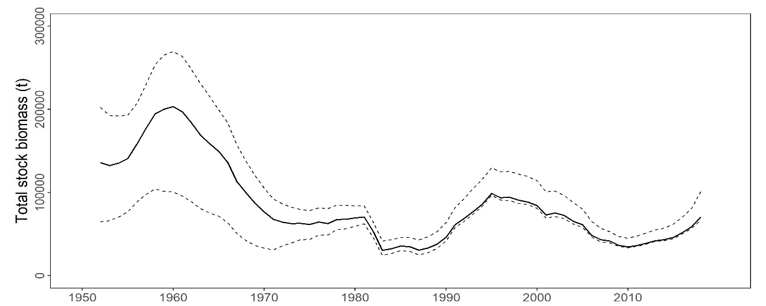

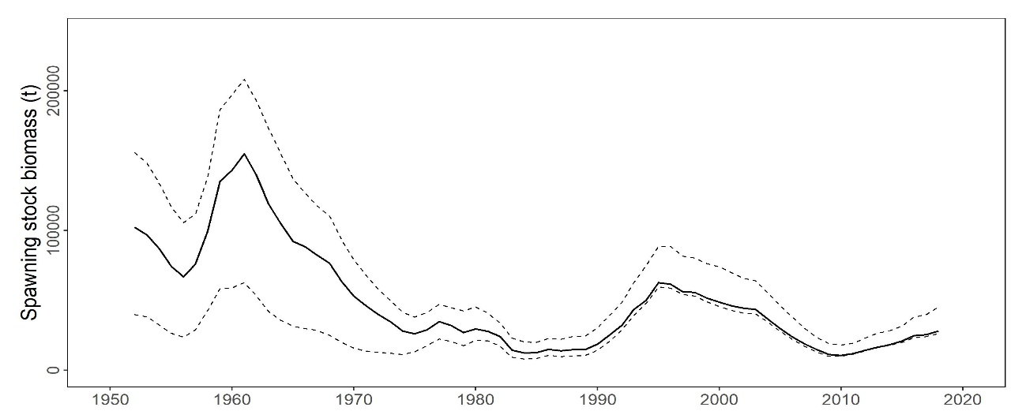

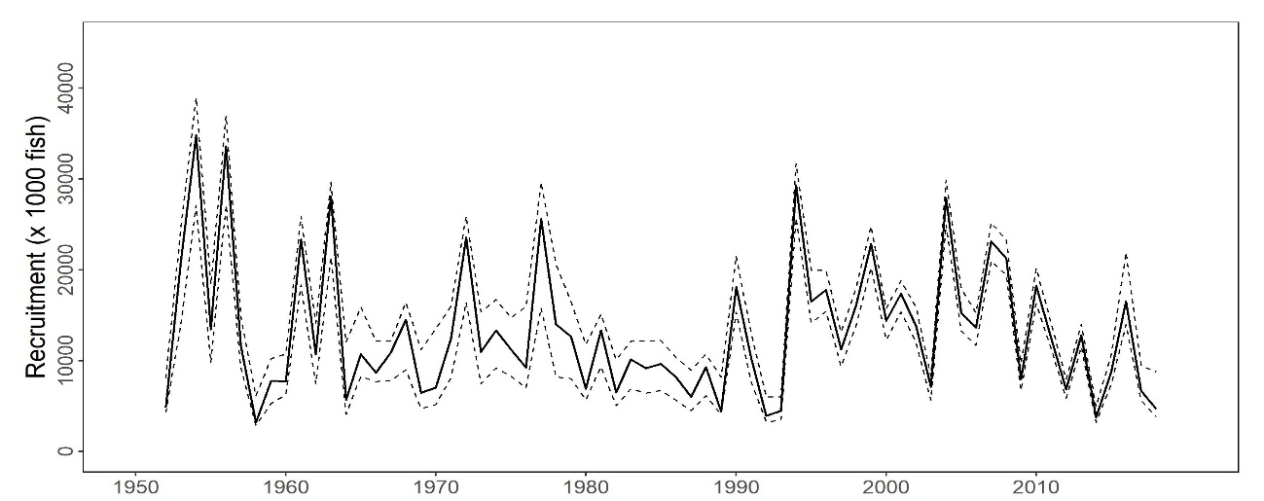

**Figure PBF-1.** Total stock biomass (top), spawning stock biomass (middle), and recruitment (bottom) of Pacific bluefin tuna (*Thunnus orientalis*) (1952-2018) estimated from the base-case model. The solid line is the point estimate and dashed lines delineate the 90% confidence interval.

**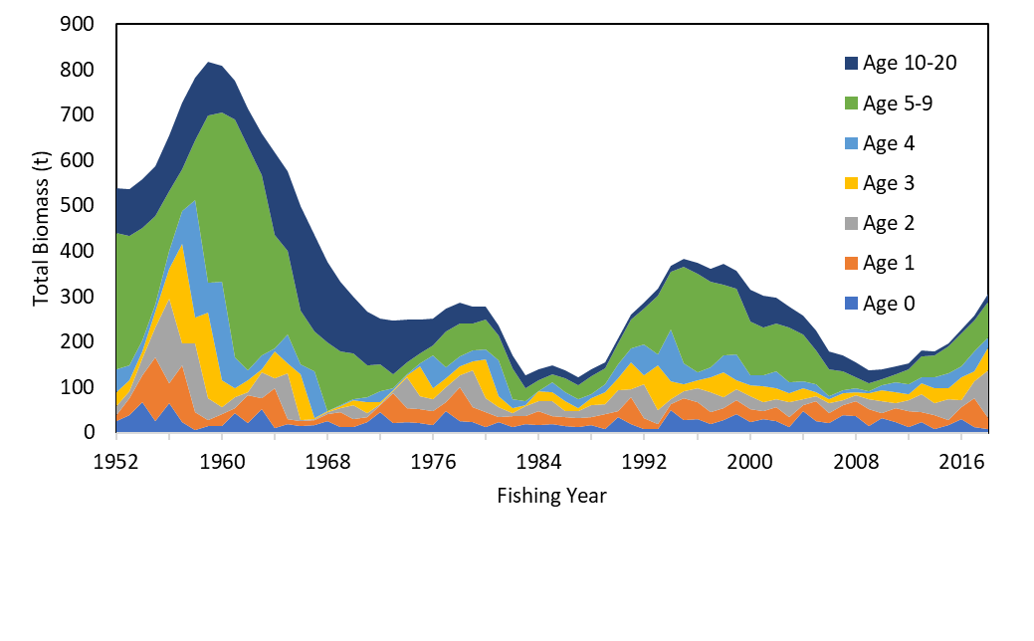**

**Figure PBF-2.** Total biomass (tonnes) by age of Pacific bluefin tuna (*Thunnus orientalis*) estimated from the base-case model (1952-2018).

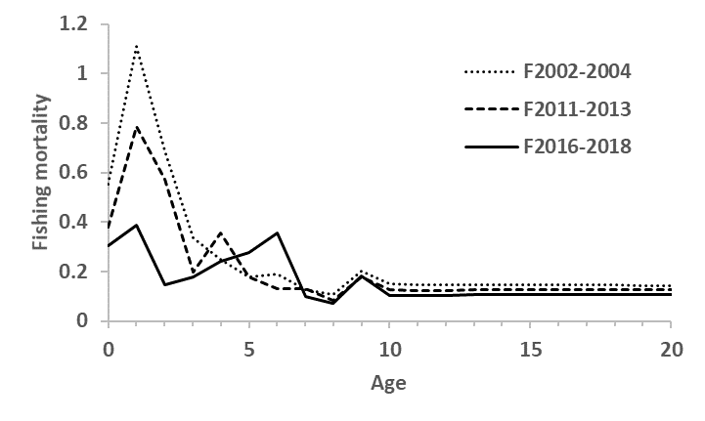

**Figure PBF-3.**Geometric means of annual age-specificfishing mortalities (F) of Pacific bluefin tuna (*Thunnus orientalis*) for 2002-2004 (dotted line), 2011-2013 (broken line) and 2016-2018 (solid line).

**Table PBF-2.** Ratios of the estimated fishing mortalities (Fs and 1-SPRs for 2002-04, 2011-13, 2016-18) relative to potential fishing mortality-based reference points, and terminal year SSB (t) for each reference period, and depletion ratios for the terminal year of the reference period for Pacific bluefin tuna (*Thunnus orientalis*) from the base-case model**.** Fmax: Fishing mortality (F) that maximizes equilibrium yield per recruit (Y/R). F0.1: F at which the slope of the Y/R curve is 10% of the value at its origin. Fmed: F corresponding to the inverse of the median of the observed R/SSB ratio. Fxx%SPR: F that produces given % of the unfished spawning potential (biomass) under equilibrium condition.



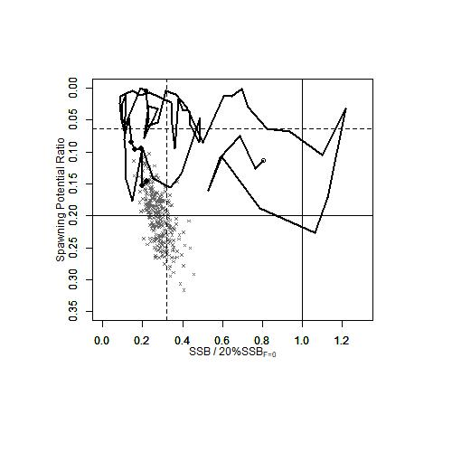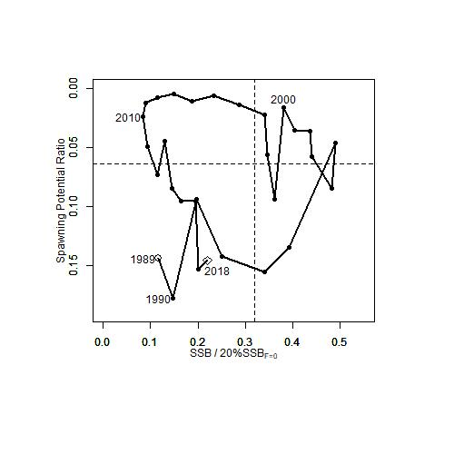

**Figure PBF-4.** Kobe plots for Pacific bluefin tuna (*Thunnus orientalis*) estimated from the base-case model. The X-axis shows the annual SSB relative to 20%SSBF=0 and the Y-axis shows the spawning potential ratio (SPR) as a measure of fishing mortality. Vertical and horizontal solid lines in the left figure show 20%SSBF=0 (which corresponds to the second biomass rebuilding target) and the corresponding fishing mortality that produces SPR, respectively. Vertical and horizontal broken lines in both figures show the initial biomass rebuilding target (SSBMED = 6.4%SSBF=0) and the corresponding fishing mortality that produces SPR, respectively. SSBMED is calculated as the median of estimated SSB over 1952-2014. The left figure shows the historical trajectory, where the open circle indicates the first year of the assessment (1952), solid circles indicate the last five years of the assessment (2014-2018), and grey crosses indicate the uncertainty of the terminal year estimated by bootstrapping. The right figure shows the trajectory of the last 30 years.

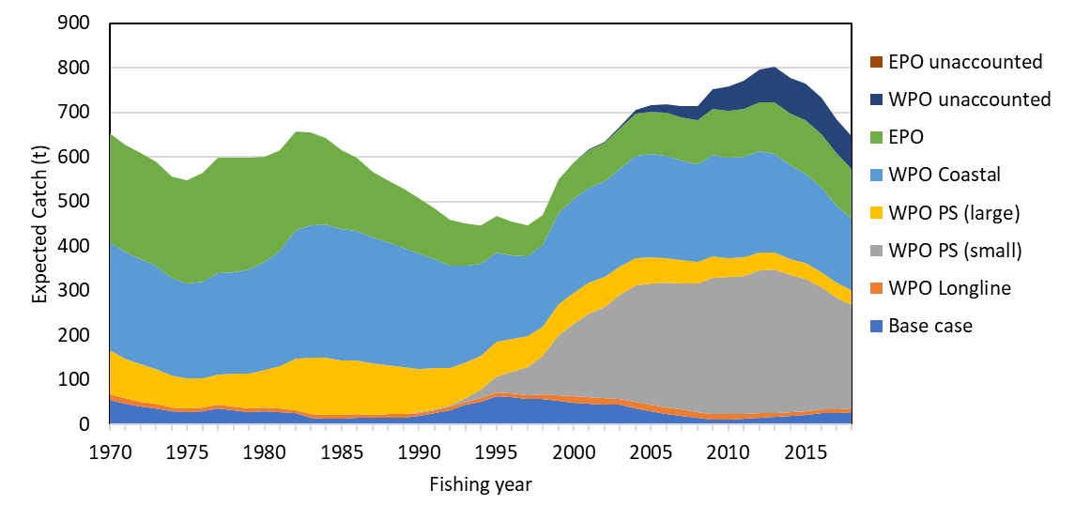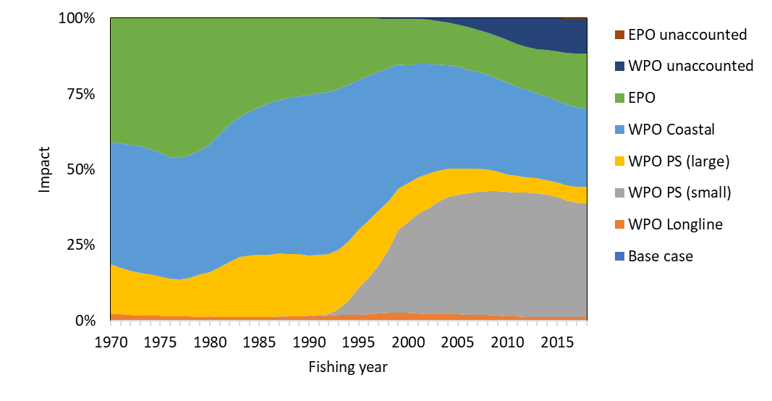

**Figure PBF-5.** The trajectory of the spawning stock biomass of a simulated population of Pacific bluefin tuna (*Thunnus orientalis*) when zero fishing mortality is assumed, estimated by the base-case model. (top: absolute SSB, bottom: relative SSB). Fisheries group definition; WPO longline fisheries: F1, F12, F17, 23. WPO purse seine fisheries for small fish: F2, F3, F18, F20. WPO purse seine fisheries for large fish: F4, F5. WPO coastal fisheries: F6-11, F16, F19. EPO fisheries: F13, F14, F15, F24. WPO unaccounted fisheries: F21, 22. EPO unaccounted fisheries: F25. For exact fleet definitions, please see the 2020 PBF stock assessment report on the ISC website.

**Table PBF-3.** Future projection scenarios for Pacific bluefin tuna (*Thunnus orientalis*) and their probability of achieving various target levels by various time schedules based on the base-case model.



\* The numbering of Scenarios is different from those given by the IATTC-WCPFC NC Joint WG meeting and same as Table 3.

\* Recruitment is switched from low recruitment during 1980-1989 to average recruitment over the whole assessment period in the following year of achieving the initial rebuilding target.

**Table PBF-4.** Expected yield for Pacific bluefin tuna (*Thunnus orientalis*) under various harvesting scenarios based on the base-case model.



\* Catch limits for EPO commercial fisheries are applied for the catch of both small and large fish made by the fleets.

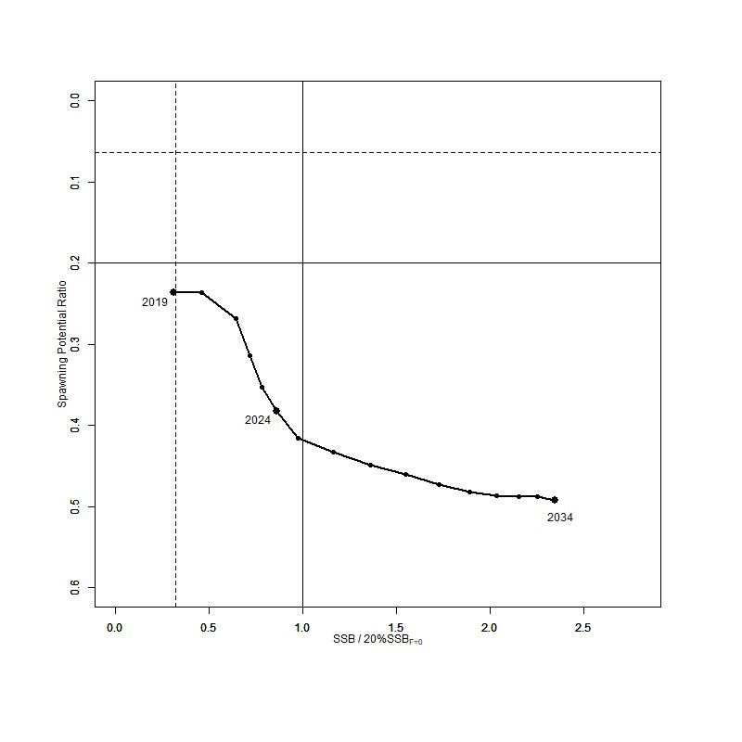

**Figure PBF-6**. “Future Kobe Plot” of projection results for Pacific bluefin tuna (*Thunnus orientalis*) from Scenario 1 from Table PBF3.

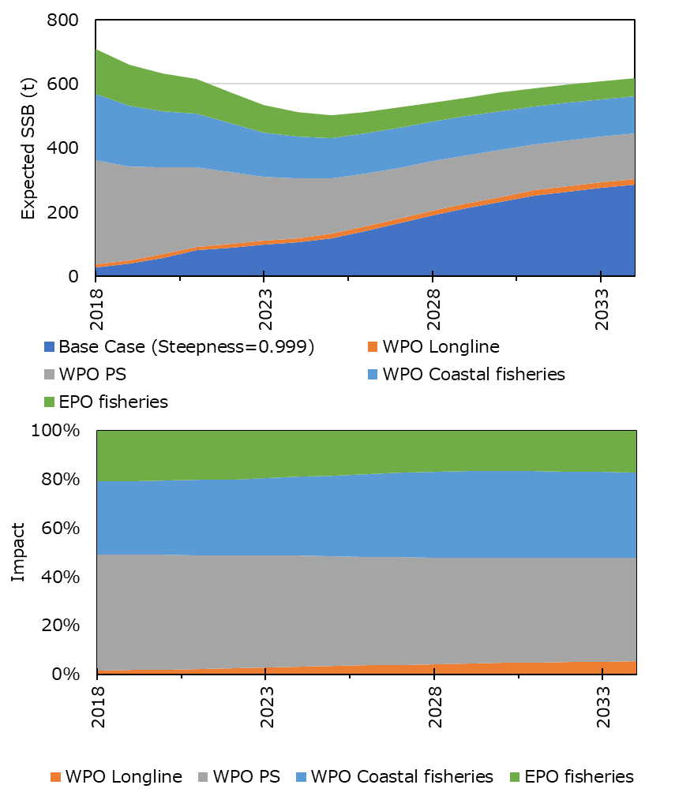

**Figure PBF-7**. “Future impact plot” from projection results for Pacific bluefin tuna (*Thunnus orientalis*) from Scenario 1 of Table S-3. The impact is calculated based on the expected increase of SSB in the absence of the respective group of fisheries.

# **SC15 2019 (FISHERY INDICATORS UPDATED)**

* 1. **Stock Status and trends**

1. SC15 noted that no stock assessment was conducted for Pacific bluefin tuna in 2019. Therefore, the stock status description from SC14 is still current. For further information on the stock status and trends from SC14, please see <https://www.wcpfc.int/node/32155>
2. SC15 noted that the total Pacific bluefin tuna catch by ISC members in 2018 was 10,148 mt, a 31% decrease from 2017 and a 25% decrease from the 2013-2017 average. Pacific bluefin tuna is caught by various fishing gears including purse seine, longline, set net, troll, pole-and-line, handline and recreational fisheries. The detailed catch information by fishery is available in the ISC19 Plenary Report (SC15-GN-IP-02).
   1. **Management advice and implications**
3. SC15 advises the Commission to note the current very low level of spawning biomass (3.3%B0), the current level of overfishing, and that the projections are strongly influenced by the inclusion of a relatively high but uncertain recruitment in 2016. While noting that additional positive signs of Pacific bluefin tuna stock were observed after the last assessment, and while noting that the agreed Harvest Control Rule could allow for catch limit increases, some of CCMs recommended a precautionary approach to the management of Pacific bluefin tuna until the rebuilding of the stock to higher biomass levels is achieved.
4. One CCM recommended that ISC consider a grid approach for taking into account the structural uncertainty for the provision of stock status and management advice.
5. SC15 also noted the following management advice of ISC19:

“The following requests were made to ISC by the IATTC-WCPFC NC Joint Working Group meeting in September 2018 at NC14 (see Attachment E of NC14 Summary Report (<https://www.wcpfc.int/node/31946>)). Responses from ISC PBFWG are provided below the requests.

**Request 1**: review the updated abundance indices, including recruitment index, up to 2017 to evaluate the need to change its scientific advice in 2018.

**Response from ISC**

The WG noted that some positive signs for the PBF stock were observed after the last assessment. In the 2018 assessment, the projections were considered optimistic because they were influenced by a high but uncertain recruitment in the terminal year (2016). The WG notes that the Japanese troll recruitment index value estimated for 2017 is similar to its historical average (1980-2017), that Japanese recruitment monitoring indices in 2017 and 2018 are higher than the 2016 value and that there is anecdotal evidence that larger fish are becoming more abundant in the EPO, although this information needs to be confirmed for the next stock assessment expected in 2020.

After reviewing the updated CPUE indices as well as the Japanese recruitment monitoring results, the PBFWG recommends maintaining the conservation advice from ISC18 (in 2018) that the projection mimicking the current management measures under the low recruitment scenario resulted in an estimated 98% probability of achieving the initial rebuilding target (6.7%SSBF=0) by 2024 and that of achieving the second rebuilding target (20%SSBF=0) 10 years after the achievement of the initial rebuilding target or by 2034, whichever is earlier, is 96%.

In the projections reported here, the projected future SSBs are the medians of the 6,000 individual SSB calculated for each 300 bootstrap replicates (i.e. catch, CPUE and size) to capture the uncertainty of parameter estimations followed by 20 stochastic simulations based on the different future recruitment time series. The projection assumes that each harvesting scenario is fully implemented and is based on certain biological or other assumptions of base case assessment model. If conditions change, the projection results would be more uncertain.

**Request 2**: Conduct projections of harvest scenarios shown below based on 2018 assessment and provide probability of achieving initial and 2nd rebuilding targets in accordance with paragraph 2.1 of HS2017-02.

Scenarios for catch increase

|  |  |  |
| --- | --- | --- |
| West Pacific | | East Pacific |
| Small fish | Large fish |  |
| 0 | 600t | 400t |
| 5% | 1300t | 700t |
| 10% | 1300t | 700t |
| 5% | 1000t | 500t |
| 0 | 1650t | 660t |
| 5% | | 5% |
| 10% | | 10% |
| 15% | | 15% |

\* 250t transfer of catch limit from small fish to large fish by Japan is assumed to continue until 2020.

**Response from ISC**

PBFWG conducted projections in the same manner as in the 2018 assessment. The recruitment scenario followed paragraph 2.1 of WCPFC Harvest Strategy 2017-02; and was kept at a low level (re-sampling from 1980-1989) until the initial rebuilding target is achieved and then changed to the historical average level.

The projection results are shown in Table PBF-02 and Figure PBF-01. The results show that increasing the catch limit of small PBF (<30 kg) in the WPO has the largest impact on the probability of achieving the interim and 2nd rebuilding targets. In addition, an overall increase in catch from the current limits, particularly a 15% increase, has the largest impact on achieving rebuilding targets.

**Table PBF-01.** Future projection scenarios for Pacific bluefin tuna (*Thunnus orientalis*).



**Table PBF-02**. Probability of achieving targets under projection scenarios for Pacific bluefin tuna. Future projection scenarios for Pacific bluefin tuna and their probability of achieving various target levels by various time schedules based on the 2018 base-case model.



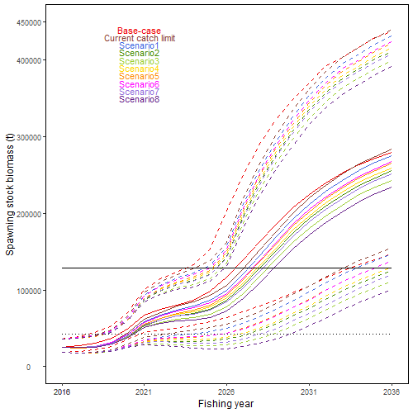

**Figure PBF-01**. Time series of the projected spawning stock biomass by various harvest scenarios listed on the Table PBF-01. Each colored solid and broken lines indicate the median spawning stock biomass and its 95% confidence intervals, respectively. The black dotted and solid lines are corresponded to the spawning stock biomasses of the initial and second rebuilding targets of Pacific bluefin tuna, respectively.

# **SC14 2018 (STOCK ASSESSMENT CONDUCTED)**

Stock status and trends

1. SC14 noted that ISC provided the following conclusions on the stock status of Pacific bluefin tuna:

The base-case model results show that: (1) SSB fluctuated throughout the assessment period, (2) SSB steadily declined from 1996 to 2010; and (3) the slow increase of the stock continues since 2011 including the most recent two years (2015-2016). Based on the model diagnostics, the estimated biomass trend for the last 30 years is considered robust although SSB prior to the 1980s is uncertain due to data limitations. Using the base-case model, the 2016 SSB (terminal year) was estimated to be around 21,000 t in the 2018 assessment, which is an increase from 19,000 t in 2014 (Table PBF‑1 and Figure PBF-11).

Historical recruitment estimates have fluctuated since 1952 without an apparent trend. The low recruitment levels estimated in 2010-2014 were a concern in the 2016 assessment. The 2015 recruitment estimate is lower than the historical average while the 2016 recruitment estimate (15.988 million fish) is higher than the historical average (13.402 million fish) (**Figure PBF-4**, Table PBF‑1-1). The uncertainty of the 2016 recruitment estimate is higher than in previous years because it occurs in the terminal year of the assessment and is mainly informed by one observation from the troll age-0 CPUE index. The troll CPUE series has been shown to be a good predictor of recruitment, with no apparent retrospective error in the recruitment estimates of the terminal year given the current model construction. As the 2016 recruits grow and are observed by other fleets, the magnitude of this year class will be more precisely estimated in the next stock assessment. The above average recruitment estimated in 2016 had a positive impact on the projection results.

Estimated age-specific fishing mortalities (F) on the stock during the periods 2012-2014 and 2015‑2016 compared with 2002-2004 estimates (the base period for the WCPFC Conservation and Management Measure) are presented in Figure PBF-2. A substantial decrease in estimated F is observed in ages 0-2 in 2015-2016 from the previous years. Note that stricter management measures in the WCPFC and IATTC have been in place since 2015.

The WCPFC adopted an initial rebuilding biomass target (the median SSB estimated for the period 1952 through 2014) and a second rebuilding biomass target (20%SSBF=0 under average recruitment), without specifying a fishing mortality reference level.[[2]](#footnote-2) The 2018 assessment estimated the initial rebuilding biomass target to be 6.7%SSBF=0 and the corresponding fishing mortality expressed as SPR of F6.7%SPR (Table PBF-2). SPR is the ratio of the cumulative spawning biomass that an average recruit is expected to produce over its lifetime when the stock is fished at the current intensity to the cumulative spawning biomass that could be produced by an average recruit over its lifetime if the stock was unfished. Because the projections include catch limits, fishing mortality is expected to decline, i.e., Fx%SPR will increase, as biomass increases. The Kobe plot shows that the point estimate of the SSB2016 was 3.3%SSBF=0 and the 2016 fishing mortality corresponds to F6.7%SPR (Figure PBF-3).

**Table PBF-3** provides an evaluation of stock status against some common reference points. It shows that the PBF stock is overfished relative to biomass-based limit reference points adopted for other species in WCPFC (20%SSBF=0) and is subject to overfishing relative to most of the common fishing intensity-based reference points.

**Figure PBF-4** depicts the historical impacts of the fleets on the PBF stock, showing the estimated biomass when fishing mortality from respective fleets is zero. Historically, the WPO coastal fisheries group has had the greatest impact on the PBF stock, but since about the early 1990s the WPO purse seine fleets, in particular those targeting small fish (ages 0-1), have had a greater impact, and the effect of these fleets in 2016 was greater than any of the other fishery groups. The impact of the EPO fishery was large before the mid-1980s, decreasing significantly thereafter. The WPO longline fleet has had a limited effect on the stock throughout the analysis period, because the impact of a fishery on a stock depends on both the number and size of the fish caught by each fleet; i.e., catching a high number of smaller juvenile fish can have a greater impact on future spawning stock biomass than catching the same weight of larger mature fish.

1. SC14 noted the following stock status from ISC:

Based on these findings, the following information on the status of the Pacific bluefin tuna stock is provided:

1. No biomass-based limit or target reference points have been adopted to evaluate the overfished status for PBF. However, the PBF stock is overfished relative to the potential biomass-based reference points evaluated (SSBMED and 20%SSBF=0, Table PBF-3 and Figure PBF-3).
2. No fishing intensity-based limit or target reference points have been adopted to evaluate overfishing for PBF. However, the PBF stock is subject to overfishing relative to most of potential fishing intensity-based reference points evaluated (Table PBF-3 and Figure PBF-3).
3. SC14 noted that the total PBF catch in 2017 was 14,707 mt, 11% increase from 2016 and 9% increase from the average 2012-2016. PBF is caught by various fishing gears including purse seine, longline, set net, troll, pole-and-line, handline and recreational fisheries. The detailed catch information by fishery is available in ISC 2018 stock assessment (SC14-SA-WP-06).

b. Management advice and implications

1. SC14 advises the Commission to note the current very low level of spawning biomass (3.3% B0), the current level of overfishing, and that the projections are strongly influenced by the inclusion of a relatively high but uncertain recruitment in 2016. The majority of CCMs recommended a precautionary approach to the management of Pacific Bluefin tuna, especially in relation to the timing of increasing catch levels, until the rebuilding of the stock to higher biomass levels is achieved.
2. SC14 noted the following conservation advice from ISC:

After the steady decline in SSB from 1995 to the historical low level in 2010, the PBF stock appears to have started recovering slowly. The 2016 stock biomass is below the two biomass rebuilding targets adopted by the WCPFC while the 2015-2016 fishing intensity (spawning potential ratio) is at a level corresponding to the initial rebuilding target.

The 2018 base case assessment results are consistent with the 2016 model results. However, the 2018 projection results are more optimistic than the 2016 projections, mainly due to the inclusion of the relatively good recruitment in 2016, which is above the historical average level (119%) and twice as high as the median of the low recruitment scenario (which occurred 1980-1989).

Based on these results, the following conservation information is provided:

The projection based on the base-case model mimicking the current management measures by the WCPFC (CMM 2017-08) and IATTC (C-16-08) under the low recruitment scenario resulted in an estimated 98% probability of achieving the initial biomass rebuilding target (6.7%SSBF=0) by 2024. This estimated probability is above the threshold (75% or above in 2024) prescribed by the WCPFC Harvest Strategy (Harvest Strategy 2017-02) (scenario 0 of Table PBF-4; see also Figure PBF-5 and Figure PBF-6). The low recruitment scenario is more precautionary than the recent 10 years recruitment scenario.

The Harvest Strategy specifies that recruitment switches from the low recruitment scenario to the average recruitment scenario beginning in the year after achieving the initial rebuilding target. The estimated probability of achieving the second biomass rebuilding target (20%SSBF=0) 10 years after the achievement of the initial rebuilding target or by 2034, whichever is earlier, is 96% (scenario 1 of Table PBF-3, Table PBF-4, and Table PBF-5; Figure PBF-5 and Figure PBF-6). This estimate is above the threshold (60% or above in 2034) prescribed by the WCPFC Harvest Strategy. However, it should be recognized that these projection results are strongly influenced by the inclusion of the relatively high, but uncertain recruitment estimate for 2016.

The Harvest Strategy adopted by WCPFC (Harvest Strategy 2017-02) guided projections conducted by ISC to provide catch reduction options if the projection results indicate that the initial rebuilding target will not be achieved or to provide relevant information for potential increase in catch if the probability of achieving the initial rebuilding target exceeds 75%. The projection results showed that the probability of achieving the initial rebuilding target was above the level (75% or above in 2024) prescribed in the WCPFC Harvest Strategy. Accordingly, the ISC examined some optional scenarios with higher catch limits, which can be found in Appendix 1 of the PBF 2018 stock assessment report (SC14-SA-WP-06).

Research needs

Given the low SSB, the uncertainty in future recruitment, and the influence of recruitment on stock biomass, monitoring of recruitment and SSB should be strengthened so that the recruitment trends can be understood in a timely manner.

**Table PBF‑1**. Total biomass, spawning stock biomass and recruitment of Pacific bluefin tuna (*Thunnus orientalis*) estimated by the base-case model, where coefficient of variation (CV) measures relative variability defined as the ratio of the standard deviation to the mean.



**Table PBF-2.** Spawning stock biomass and fishing intensity of Pacific bluefin tuna (*Thunnus orientalis*) in 1995 (recent high biomass), 2002-2004 (WCPFC reference year biomass), 2011 (biomass 5 years ago), and 2016 (latest) to those of the adopted WCPFC biomass rebuilding targets. SPR is used as a measure of fishing intensity; the lower the number the higher the fishing intensity that year.

|  |  |  |  |  |  |  |
| --- | --- | --- | --- | --- | --- | --- |
|  | Initial rebuilding target | Second rebuilding target | 1995  (recent high) | 2002-2004 (reference year) | 2011  (5 years ago) | 2016  (latest) |
| Biomass (%SSBF=0) | SSB median1952-2014 = 6.7% | 20% | 10.4% | 7.1% | 2.1% | 3.3% |
| SPR | 6.7% | 20% | 5.1% | 3.4% | 4.9% | 6.7% |

**Table PBF-3.** Ratios of the estimated fishing intensities mortalities (Fs and 1-SPRs for 2002-04, 2012-14, 2015-16) relative to potential fishing intensity-based reference points, and terminal year SSB (t) for each reference period, and depletion ratios for the terminal year of the reference period for Pacific bluefin tuna (*Thunnus orientalis*).

****

**Table PBF-4.** Future projection scenarios for Pacific bluefin tuna (*Thunnus orientalis*).

****

\*1 F indicates the geometric mean values of quarterly age-specific fishing mortality during 2002-2004.

\*2 The Japanese unilateral measure (transferring 250 mt of catch upper limit from that for small PBF to that for large PBF during 2017-2020) would be reflected.

\*3 Fishing mortality for the EPO commercial fishery was assumed to be high enough to fulfill its catch upper limit (F multiplied by two). The fishing mortality for the EPO recreational fishery was assumed to be the F2009-11 average level.

\*4 In scenario 0, the future recruitments were assumed to be the low recruitment (1980-1989) level forever. In other scenarios, recruitment was switched from low recruitment to average recruitment from the next year of achieving the initial rebuilding target.

**Table PBF-5**. Future projection scenarios for Pacific bluefin tuna (*Thunnus orientalis*) and their probability of achieving various target levels by various time schedules based on the base-case model.

****

\*1 In scenario 0, the future recruitments were assumed to be the low recruitment (1980-1989) level forever. In other scenarios, recruitment was switched from low recruitment to average recruitment from the next year of achieving the initial rebuilding target.

**Table PBF-6.** Expected yield for Pacific bluefin tuna (*Thunnus orientalis*) under various harvesting scenarios based on the base-case model.



|  |  |
| --- | --- |
|  | C:\Users\Shuya Nakatsuka\AppData\Local\Microsoft\Windows\INetCache\Content.Word\FAA_new_2018 (3).png |
| **Figure PBF-1.** Total stock biomass (top), spawning stock biomass (middle) and recruitment (bottom) ofPacific bluefin tuna (*Thunnus orientalis*) from the base-case model. The solid lines indicate point estimates and the dashed lines indicate the 90% confidence intervals. | **Figure PBF-2.** Geometric means of annual age-specificfishing mortalities of Pacific bluefin tuna (*Thunnus orientalis*) in 2002-2004 (dotted line), 2012-2014 (dashed line), and 2015-2016 (solid line). |

|  |  |
| --- | --- |
| **Figure PBF-3.** Kobe plots for Pacific bluefin tuna (*Thunnus orientalis*). X axis shows the annual SSB relative to 20%SSBF=0 and the Y axis shows the spawning potential ratio as a measure of fishing intensity. Solid vertical and horizontal lines in the left figure show 20%SSBF=0 (which corresponds to the second biomass rebuilding target) and the corresponding fishing intensity, respectively. Dashed vertical and horizontal lines in both figures show the initial biomass rebuilding target (SSBMED = 6.7%SSBF=0) and the corresponding fishing intensity, respectively. SSBMED is calculated as the median of estimated SSB over 1952-2014. The left figure shows the historical trajectory, where the open circle indicates the first year of the assessment (1952) while solid circles indicate the last five years of the assessment (2012-2016). The right figure shows the trajectory of the last 30 years, where grey dots indicate the uncertainty of the terminal year. |  |
| **Figure PBF-4.** Trajectory of the spawning stock biomass of a simulated population of Pacific bluefin tuna (*Thunnus orientalis*) when zero fishing mortality is assumed, estimated by the base-case model (top: absolute impact, bottom: relative impact). Fleet definition; WPO longline: F1, F12, F17. WPO purse seine for small fish: F2, F3, F18. WPO purse seine: F4, F5. WPO coastal fisheries: F6-11, F16, F19. EPO fisheries: F13, F14, F15. |

|  |  |
| --- | --- |
|  | **C:\Users\Shuya Nakatsuka\AppData\Local\Microsoft\Windows\INetCache\Content.Word\scenario1 (2).png** |
| **Figure PBF-5.** Comparison of future SSB of Pacific bluefin tuna (*Thunnus orientalis*) under the current management measures assuming low recruitment using the 2016 assessment (scenario 2016 lowR), assuming low recruitment using the 2018 assessment (scenario 0), and assuming a shift of the recruitment scenario from low to average after achieving the initial rebuilding target using the 2018 assessment (scenario 1). | **Figure PBF-6**. A projection result (scenario 1 from Table PBF-4) for Pacific bluefin tuna (*Thunnus orientalis*) in a form of Kobe plot. The X axis shows the SSB value relative to 20%SSBF=0 (second rebuilding target) and the Y axis shows the spawning potential ratio as a measure of fishing intensity. Vertical and horizontal solid lines indicate the second rebuilding target (20%SSBF=0) and the corresponding fishing intensity, respectively, while vertical and horizontal dashed lines indicate the initial rebuilding target (SSBMED = 6.7%SSBF=0) and the corresponding fishing intensity, respectively. |

# **SC13 2017 (FISHERY INDICATORS UPDATED)**

1. **Stock status and trends**
2. SC13 noted that no stock assessments were conducted for Pacific bluefin tuna in 2017. Therefore, the stock status descriptions from SC12 are still current. For further information on the stock status and trends from SC12, please see <https://www.wcpfc.int/node/27769>
3. **Management advice and implications**
4. SC13 noted that no management advice has been provided since SC12. Therefore, the advice from SC12 should be maintained, pending a new assessment or other new information. For further information on the management advice and implications from SC12, please see <https://www.wcpfc.int/node/27769>

# **References**

SC16-SA-WP-06 Stock Assessment of Pacific Bluefin Tuna in the Pacific Ocean in 2020 <https://www.wcpfc.int/node/46614>

For current information related to Northern Stocks Working Group Reports and the ISC Plenary Report:

<http://isc.fra.go.jp/reports/isc/isc20_reports.html>

SC15-SA-IP-20 Report of the Pacific Bluefin Tuna Working Group Intersessional Workshop (ISC19 – ANNEX 08). <https://www.wcpfc.int/node/43327>

SC14-SA-WP-06 Stock Assessment of Pacific Bluefin Tuna (*Thunnus orientalis*) in the Pacific Ocean in 2018. <https://www.wcpfc.int/node/31024>

SC12-SA-WP-07 Pacific Bluefin Stock Assessment. <https://www.wcpfc.int/node/27559>

SC10-SA-WP-11 Stock Assessment of Bluefin Tuna in the Pacific Ocean in 2014. <https://wcpfc.int/node/19201>

SC9-SA-WP-10 Stock assessment of Pacific bluefin tuna in 2012 (Rev 1). <https://wcpfc.int/node/4731>

1. SPR (spawning potential ratio) is the ratio of the cumulative spawning biomass that an averagerecruit is expected to produce over its lifetime when the stock is fished at the current fishing level to thecumulative spawning biomass that could be produced by an average recruit over its lifetime if the stock was unfished. F%SPR: F that produces % of the spawning potential ratio. [↑](#footnote-ref-1)
2. The IATTC has adopted the first rebuilding target, the second target is to be discussed at a future IATTC meeting. [↑](#footnote-ref-2)