Pacific Bluefin Tuna (Thunnus orientalis)
Stock Status &Trends plus Management Advice and Implications

Contents
SC13 2017 1
SC12 2016 (STOCK ASSESSMENT CONDUCTED) 2
Useful References 12
Previous Assessments 12

SC13 2017

- The last stock assessment was conducted in 2016. No updated information was presented on the status of Pacific bluefin tuna.
- New Zealand noted that FFA members remained extremely concerned about the status of the Pacific bluefin tuna stock, noting the 2016 assessment concluded the spawning biomass was at just 2.6% of unfished levels, and that no updated information has been tabled at SC13. Given the very low status of the stock, there was a pressing need to formally implement a long-term rebuilding strategy. New Zealand noted that WCPFC 13 had requested that the Northern Committee develop a conservation and management measure for adoption at WCPFC 14 to rebuild the stock to 20% of unfished levels at the latest by 2034. It would be appropriate for the SC to provide advice to WCPFC on whether a proposed CMM was likely to achieve the necessary rebuilding of the stock, but in the absence of any updated information or an outline of the draft rebuilding plan, the SC would be unable to provide such advice. As such, FFA members asked that the scientific committee be provided with a report on the current status of the stock by a representative of the Northern committee such that updated scientific advice could be provided to the Commission under this agenda item. WCPFC13 had also requested the ISC to define the meaning of a “drastic drop in recruitment” and the associated risks. FFA members wondered if this definition was available yet, and how it might inform discussion of the emergency rule at NC13 later this month. More broadly FFA members noted their concern that the Northern Committee had not provided updated information about this critically overfished stock to the SC. While ISC was the scientific provider to the NC, the WCPFC Scientific committee was responsible for providing scientific advice to the Commission on all of the stocks that were managed by the Commission. To support the functions of the SC, FFA members suggested that the Northern Committee should contract ISC to provide a brief annual indicator report to SC for all species it conducts assessments for. It would be valuable if this was presented in a similar format to the indicators report provided by SPC in SC13-SA-WP-02.

- EU also expressed its regrets that SC13 had not received any information about Pacific bluefin tuna given the extensive discussion at SC12 and the work undertaken since then, and expressed its hope that a progress report from ISC would be available for discussion at SC14.

- Japan clarified that ISC did not conduct an assessment of PBF in 2017 but reviewed indicators. Adult abundance indices by Japanese and Taiwanese longline showed slow but continuous increasing trend while juvenile abundance index by Japanese troll showed a slight increase from 2014, which was one of the lowest. In addition, recruit monitoring by Japan suggested a further increase in recruitment in 2016, which indicated that recruitment collapse was not occurring. ISC also discussed the definition of "drastic drop of recruitment" as requested by the Commission but did not come up with any good scientific advice. Furthermore, ISC considered that the emergency rule might not be critical given that assessment was planned to be conducted every two years, incorporating good recruitment index. However, ISC could consider a framework of emergency rule if requested by the Commission. Those results, including the results of ISC PBF stakeholder meeting in April would be reported to NC13 for discussion.

- EU also requested that the comprehensive report to Northern Committee provided by Japan on their PBFT work could be made available to SC14.

- USA noted that SC13-GEN-IP-32 provided a draft report from ISC.

- The Pew Charitable Trusts encouraged SC13 to make a clear statement on the status of these stocks. Despite the reassurances by Japan, they noted there was no evidence yet of the promised recovery. They noted that both Japan and Mexico overran their quotas in 2016, making it even more important that clear action be taken. Pew stated that it was critical that that WCPFC make it clear that it is committed to a 20% recovery target by 2034 at the upcoming meeting of the IATTC and prior to the Northern Committee meeting Pew supported the statements made by the EU and by New Zealand on behalf of FFA on this matter.

- Stock status and trends

- SC13 noted that no stock assessments were conducted for Pacific bluefin tuna in 2017. Therefore, the stock status descriptions from SC12 are still current.

- Management advice and implications

- SC13 noted that no management advice has been provided since SC12. Therefore, the advice from SC12 should be maintained, pending a new assessment or other new information.

SC12 2016 (STOCK ASSESSMENT CONDUCTED)

Stock status and trends
- SC12 noted that ISC provided the following conclusions on the stock status of Pacific bluefin tuna in the Pacific Ocean in 2016 presented in SC12-SA-WP-07 (2016 Pacific Bluefin Tuna Stock Assessment):
The PBFWG conducted a benchmark assessment (base-case model) using the best available fisheries and biological information. The base-case model fits well the data that were considered to be more reliable and is internally consistent among most of the sources of data. The 2016 base-case model is a substantial improvement compared to the 2014 assessment and fits all reliable data well. The base-case model indicates: (1) spawning stock biomass (SSB) fluctuated throughout the assessment period (fishing years 1952-2014) and (2) the SSB steadily declined from 1996 to 2010; and (3) the decline appears to have ceased since 2010, although the stock remains near the historic low. The model diagnostics suggest that the estimated biomass trend for the last 30 years is considered robust although SSB prior to the 1980s is uncertain due to data limitations.
Using the base-case model, the 2014 (terminal year) SSB was estimated to be around 17,000 t (Figure 7-4), which is about 9,000 t below the terminal year estimated in the 2014 assessment (26,000 in 2012). This is because of improvements to the input data and refinements to the assessment model scaled down the estimated value of SSB and not because the SSB declined from 2012 to 2014.
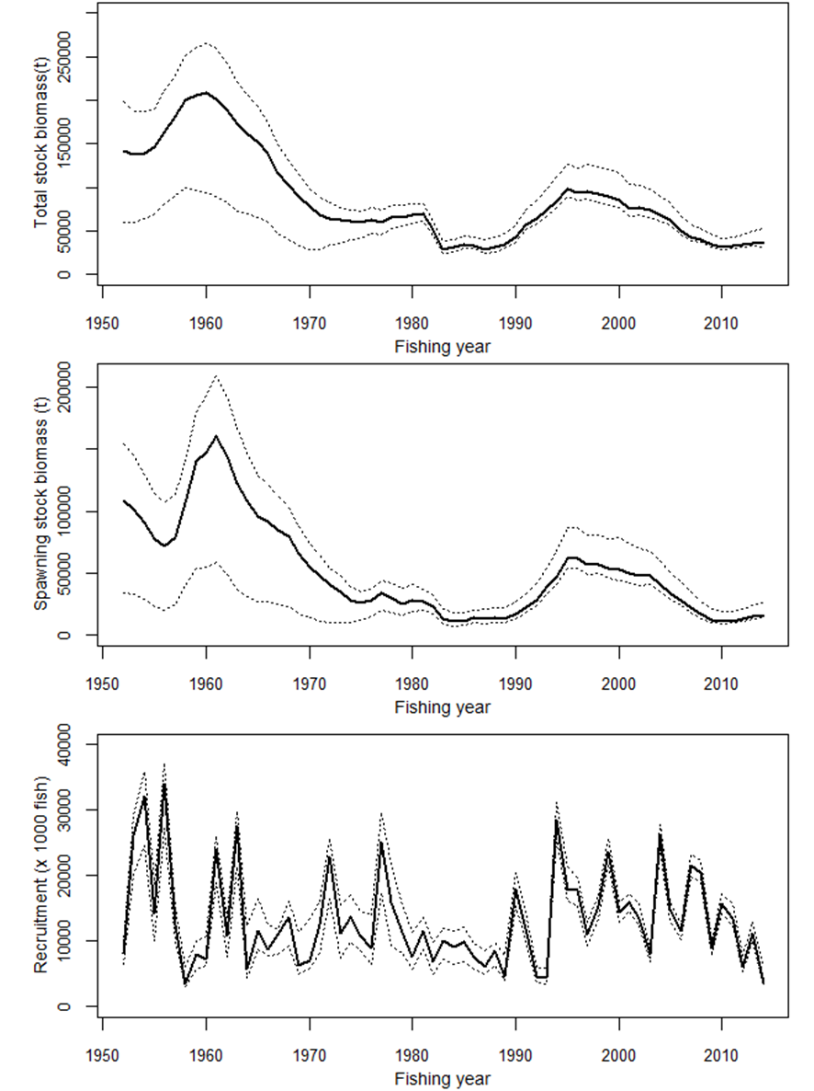
Figure 7-4. Total stock biomass (top), spawning stock biomass (middle) and recruitment (bottom) of PBF from the base-case model. The solid line indicates point estimate and dashed lines indicate the 90% confidence interval.

Recruitment estimates fluctuate widely without an apparent trend. The 2014 recruitment was relatively low, and the average recruitment for the last five years may have been below the historical average level (Figure 7-4). Note that recruitments in terminal years in an assessment are highly uncertain due to limited information on the cohorts. However, two of the last three data points from the Japanese troll CPUE-based index of recruitment, which was consistent with other data in the model, are at their lowest level since the start of the index (1980). Estimated age-specific fishing mortalities on the stock during 2011-2013 and 2002-2004 (the base period for WCPFC CMM 2015-04) are presented in Figure 7-5. Most age-specific fishing mortalities (F) for intermediate ages (2-10 years) are substantially above F2002-2004 while those for age 0 as well as ages 11 and above are lower (Table 7-1).
Table 7-1. Percent change of estimated age-specific fishing mortalities of PBF from 2002-2004 to 2011-2013.
Age | 0 | 1 | 2 | 3 | 4 | 5 | 6 | 7 | 8 | 9 | 10 | 11 | 12 | 13 | 14 | 15 | 16 | 17 | 18 | 19 | 20
change from F2002-2004 to F2011-2013 | -28% | -1% | +96% | +4% | +86% | +43% | -9% | +81% | +21% | +23% | +5% | -5% | -7% | -8% | -9% | -10% | -10% | -10% | -11% | -11% | -11%

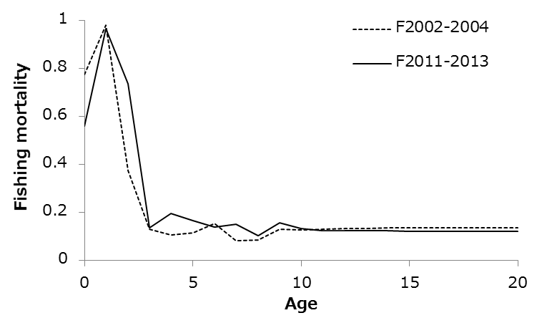
Figure 7-5. Geometric means of annual age-specific (years) fishing mortalities of PBF for 2002-2004 (dashed line) and 2011-2013 (solid line).

Although no limit reference points have been established for the PBF stock under the auspices of the WCPFC and IATTC, the _{F2011-2013} exceeds all calculated biological reference points except for FMED and FLOSS despite slight reductions to F in recent years (Table 7-2). The ratio of SSB in 2014 relative to the theoretical unfished SSB (SSB2014/SSBF=0, the depletion ratio) is 2.6% and SSB2012/SSBF=0 is 2.1% indicating a slight increase from 2012 to 2014. Although the SSB2014/SSBF=0 for this assessment (2.6%) is lower than SSB2012/SSBF=0 from the 2014 assessment (4.2%), this difference is due to improvements to the input data and model structure (Figure 7-4) rather than a decline in SSB from 2012 to 2014. Note that potential effects on Fs as a result of the measures of the WCPFC and IATTC starting in 2015 or by other voluntary measures are not yet reflected in the data used in this assessment.
Since reference points for PBF have yet to be identified, two examples of Kobe plots (Figure 7-6: plot A based on SSBMED and FMED, plot B based on SSB20% and SPR20%) are presented. These versions of the Kobe plot represent two interpretations of stock status in an effort to prompt further discussion. In summary, if these were the reference points, overfishing would be occurring or just at the threshold in the case of FMED; and the stock would be considered overfished. Plot B shows that the stock has remained in an overfished and overfishing status for the vast majority of the assessment period if F_{20%} and SSB_{20%} are the reference points. The ISC notes that the SSB estimates before 1980 are more uncertain and that the reason why the fishing mortality is estimated to be so high right after the WWII is not well understood. The low biomass level at the beginning of the assessment period (1952) could potentially be the result of relatively high catches prior to the assessment period of PBF.
Table 7-2. Ratios of the estimated fishing mortalities F2002-2004, F2009-2011 and F2011-2013 relative to computed F- based biological reference points and SSB (t) and depletion ratio for the terminal year of the reference period for PBF.

 | Fmax | F0.1 | Fmed | Floss | F10% | F20% | F30% | F40% | Estimated SSB for terminal year of each | Depletion ratio for terminal year of each
 |  |  |  |  |  |  |  |  | reference period | reference period
2002-2004 | 1.86 | 2.59 | 1.09 | 0.80 | 1.31 | 1.89 | 2.54 | 3.34 | 41,069 | 0.064
2009-2011 | 1.99 | 2.78 | 1.17 | 0.85 | 1.41 | 2.03 | 2.72 | 3.58 | 11,860 | 0.018
2011-2013 | 1.63 | 2.28 | 0.96 | 0.70 | 1.15 | 1.66 | 2.23 | 2.94 | 15,703 | 0.024

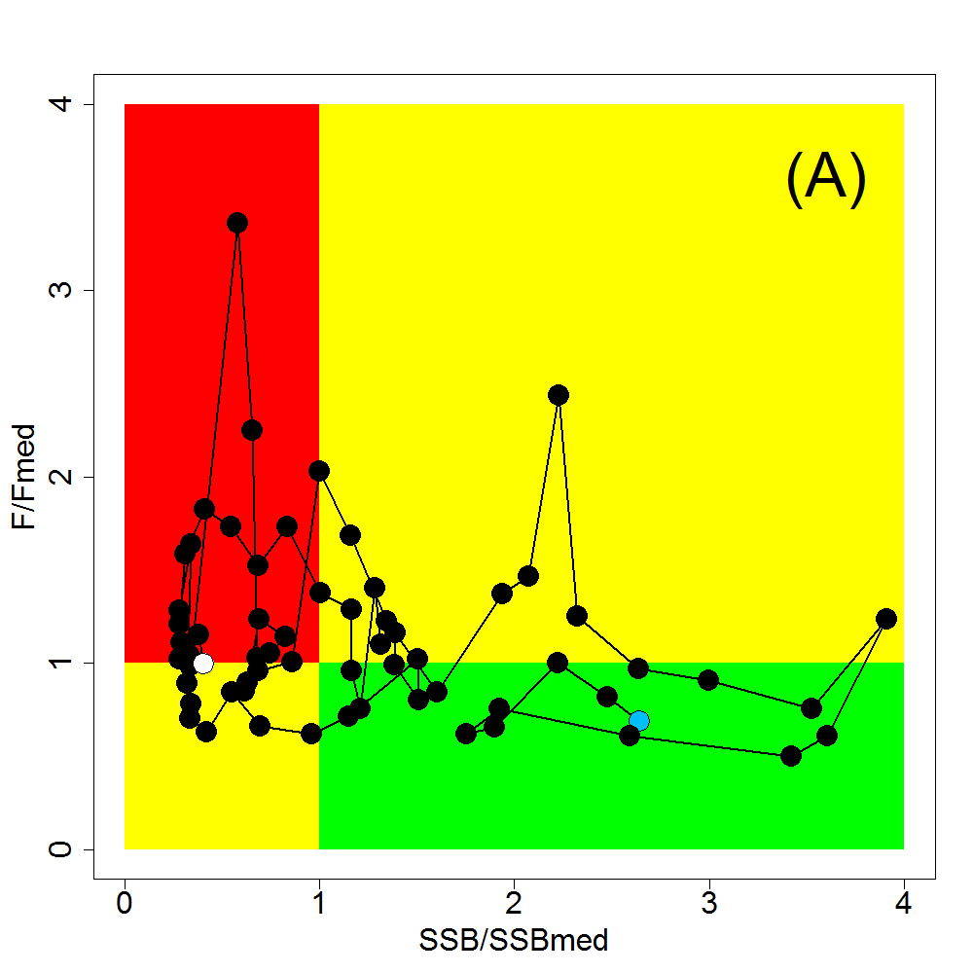 | 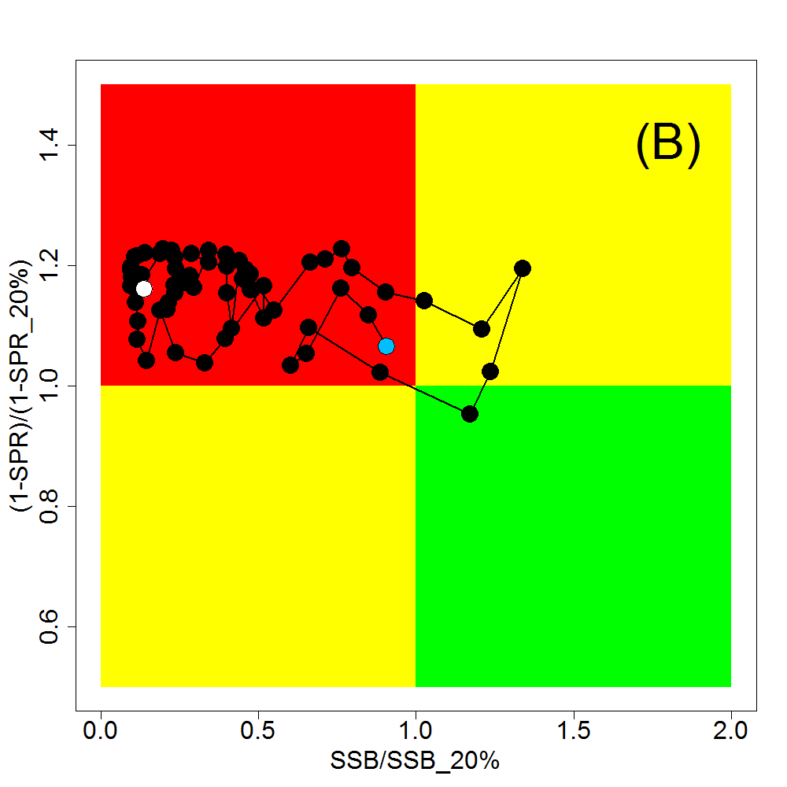
Figure 7-6. Kobe plots for PBF. (A) SSBMED and FMED; (B) SSB20% and SPR20% based. Note that SSBMED is estimated as the median of estimated SSB over whole assessment period (40,944 t) and FMED is calculated as an F to provide SSBMED in long-term, while the plots are points of estimates. The blue and white points on the plot show the start (1952) and end (2014) year of the period modelled in the stock assessment, respectively.

Historically, the WPO coastal fisheries group has had the greatest impact on the PBF stock, but since about the early 1990s the WPO purse seine fleets, in particular those targeting small fish (age 0-1), have had a greater impact, and the effect of these fleets in 2014 was greater than any of the other fishery groups. The impact of the EPO fishery was large before the mid-1980s, decreasing significantly thereafter. The WPO longline fleet has had a limited effect on the stock throughout the analysis period (Figure 7-7). This is because the impact of a fishery on a stock depends on both the number and size of the fish caught by each fleet; i.e., catching a high number of smaller juvenile fish can have a greater impact on future spawning stock biomass than catching the same weight of larger mature fish.

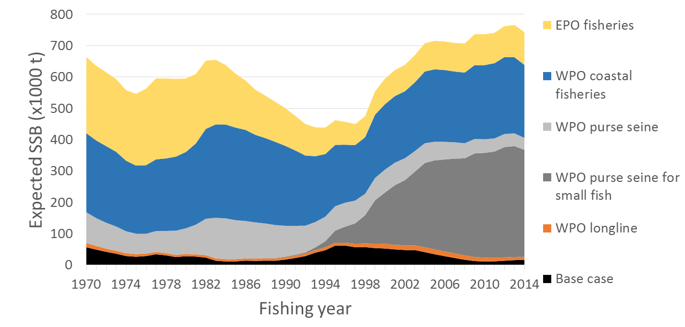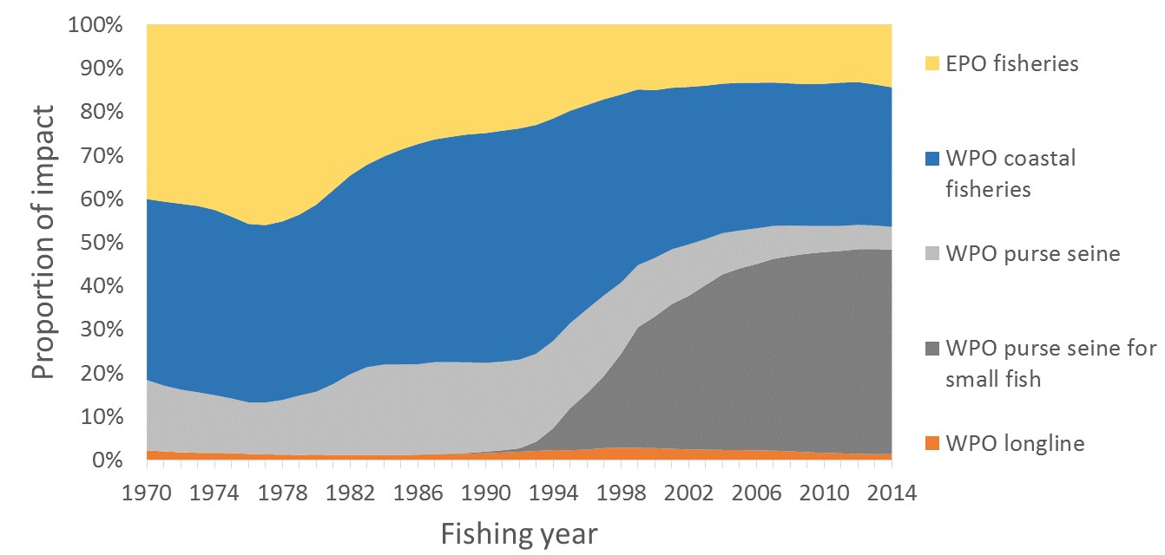
Figure 7-7. Trajectory of the spawning stock biomass of a simulated population of PBF when zero fishing mortality (F=0) is assumed and the STET at F=0 is the same as estimated in the base-case assessment model, estimated by the base-case model. (Top: absolute impact, bottom: relative impact). Fleet definition; WPO longline: F1, F12, F17. WPO purse seine for small fish: F2, F3, F18. WPO purse seine: F4, F5. WPO coastal fisheries: F6-11, F16, F19. EPO fisheries: F13, F14, F15.
- In the absence of any agreed definition of a drastic drop in stock recruitment referred to in CMM 2015-04, SC12 notes with concern that the 2012 and 2014 recruitments are at the lowest levels observed since 1980, noting that ISC noted that recruitment in the terminal years of any assessment is highly uncertain. SC12 also noted a comment from Japan that some indices of 2015 recruitment are above the 2014 level and early anecdotal information regarding the 2016 recruitment suggests it is not particularly low.
- The provisional total Pacific Bluefin tuna catch in 2015 was 11,020 mt in the North Pacific Ocean, which was a 36% decrease over 2014 and a 30% decrease over the average for 2010-2014.
- SC12 noted that, based on the latest stock assessment carried out by ISC in 2016, SC12 noted that the Pacific bluefin tuna spawning stock biomass is depleted to 2.6% of the estimated unfished spawning stock biomass (SBF=0). SC12 emphasized that this depletion level is considerably below the biomass depletion-based Limit Reference Point of 20% of SBF=0 set by the Commission for all other WCPFC key tuna stocks (skipjack, yellowfin, bigeye, south Pacific albacore and north Pacific albacore). However, SC12 also notes that the Pacific bluefin tuna stock remained below 20% of SBF=0 for most of the time of assessment. SC12 also noted that the initial rebuilding target currently defined by the CMM 2015-04, the median of the SSB of the stock assessment period (42,582 mt) corresponds to a spawning biomass of around 7% of estimated unfished spawning stock biomass.
Management advice and implications
- SC12 noted the following conservation advice from ISC:
The steady decline in SSB from 1996 to 2010 appears to have ceased, although SSB2014 is near the historic low and the stock is experiencing exploitation rates above all calculated biological reference points except for FMED and FLOSS.
The projection results based on the base-case model under several harvest and recruitment scenarios and time schedules are shown in Table 7-3 and Figure 7-8. Under all examined scenarios the initial goal of WCPFC, rebuilding to SSBMED by 2024 with at least 60% probability, is reached and the risk of SSB falling below SSBLOSS at least once in 10 years was low.
The projection results indicate that the probability of SSB recovering to the initial WCPFC target (SSBMED by 2024, 38,000 t, calculated in the same manner as the previous assessment) is 69% or above the level prescribed in the WCPFC CMM if low recruitment scenario is assumed and WCPFC CMM 2015-04 and IATTC Resolution C-14-06 continue in force and are fully implemented (Table 4: Scenario 2 with low recruitment).
The ISC notes there are technical inconsistencies in the calculation of SSBMED in the assessment and projection. The ISC also notes the current calculation of SSBMED in the projection includes the most recent estimates of SSB and unless a fixed period of years is specified to calculate SSBMED, the calculation of SSBMED could be influenced by future trends in spawning biomass. The ISC therefore recommends defining SSBMED as the median point estimate for a fixed period of time, either, 1952-2012 or 1952-2014. If 1952-2012 is chosen, then SSBMED is estimated to be 41,069 t, and if 1952-2014 is chosen, SSBMED is 40,994 t. The probabilities of achieving 41,000 t under various scenarios are provided in Table 7-3. The probabilities of achieving 43,000 t, where WCPFC CMM 2015-04’s initial rebuilding target is specified as 42,592 t, are also provided in Table 7-3, although this value is derived from the previous assessment and is higher than the SSBMED calculated in the current assessment. The ISC recommends that in the future absolute values should not be used for the initial rebuilding target, as the calculated values of reference points would change from assessment to assessment.
Scenario 2 with low recruitment has the lowest prospect of recovery among the examined harvest scenarios. The probability of achieving the WCPFC’s initial target (SSBMED by 2024) would increase if more conservative management measures were implemented as shown in Table 7-3 and Figure 7-8. The projection results indicate that a 10% reduction in the catch limit for fish smaller than the weight threshold in CMM 2015-04 would have a larger effect on recovery than a 10% reduction in the catch limit for fish larger than the weight threshold. (Figure 7-8 (D)). The ISC notes that the current assessment model uses a maturity ogive that assumes 20%, 50% and 100% maturity in age 3 (weight on July 1: 34kg), 4 (weight on July 1: 58kg) and 5 (weight on July 1: 85kg), respectively, while the WCPFC CMM 2015-04 specifies that catches of fish smaller than 30kg should be reduced. The weight threshold in the CMM needs to be increased to 85kg (weight of age 5) if the intent is to reduce catches on all juveniles according to the maturity ogive in the assessment.
The projections results assuming a stronger stock-recruitment relationship (where h=0.9) than in the assessment model are not necessarily more pessimistic than the low recruitment scenario. The projection results assume that the CMMs are fully implemented and are based on certain biological or other assumptions. In particular, the ISC noted the implementation of size based management measures need to be monitored carefully. If conditions change, the projection results would be more uncertain. Given the low SSB, the uncertainty in future recruitment, and the influence of recruitment has on stock biomass, monitoring recruitment and SSB should be strengthened so that the recruitment trends can be understood in a timely manner.
Table 7-3. Future projection scenarios for PBF and their probability of achieving various target levels by various time schedules based on the base-case model.
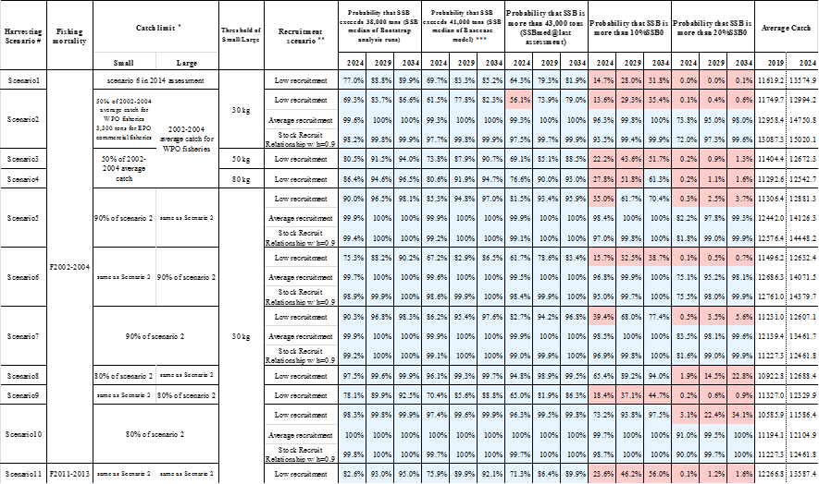
* Catch limits for EPO commercial fisheries is applied for all the catch (small and large fish) made by the Fleets.
** Average recruitment refers to the recruitment for the whole assessment period while low recruitment refers to that of 1980-1989.
*** Probability that SSB exceeds 41,000 tons (SSB median of Base case model) developed by PBFWG at ISC16 Plenary.

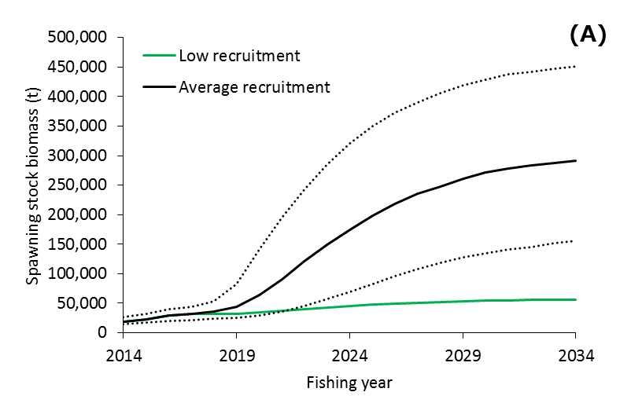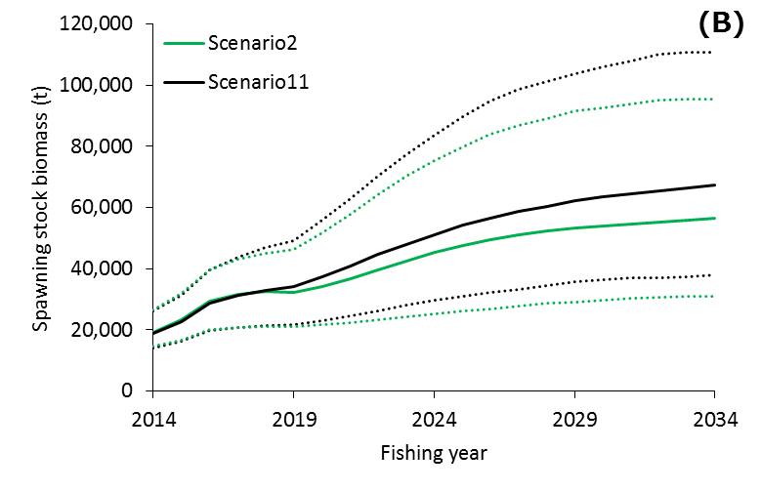
Figure 7-8. Comparisons of various projection results for PBF. (A) Low recruitment vs. historical average recruitment (Scenario 2). (B) Current CMMs (Scenario 2) vs. current F (Scenario 11) (low recruitment). The solid lines indicate median of bootstrapped projection results and dotted lines indicate 90% confidence interval.

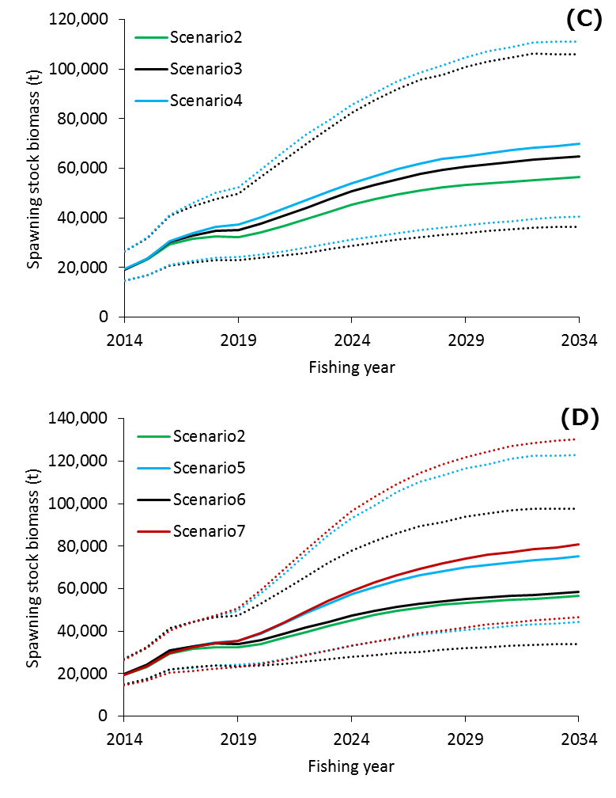
Figure 7-8 (cont.) Comparisons of various projection results for PBF. (C) Different definition of small fish (30kg (Scenario 2) vs. 50kg (Scenario 3) vs. 80kg (Scenario 4)) (low recruitment). (D) Current CMMs (Scenario 2) vs. additional 10% catch limit reduction for small fish (Scenario 5), for large fish (Scenario 6) and for all fish (Scenario 7) (low recruitment). The solid lines indicate median of bootstrapped projection results and dotted lines indicate 90% confidence interval.”

- SC12 advised WCPFC13 that FFA members expressed concern that the substantial depletion of the Pacific bluefin stock due to excess fishing in the northern WCPFC region has probably resulted in range contraction, thus greatly reducing the availability of bluefin tuna (Thunnus orientalis) in the south Pacific. This is of particular significance to Pacific island CCMs because it limits their future opportunities for the participation in fisheries for this stock. SC12 also noted no statistical demonstration is provided to support the range contraction of Pacific Bluefin tuna. SC12 noted the need for additional information.
- In view of the upcoming IATTC-WCPFC joint meeting on Pacific bluefin tuna management, SC12 expressed the need of urgent coordinated actions between WCPFC and IATTC in reviewing the current rebuilding plan, establishing the emergency rule as well as considering and developing reference points and HCRs for the long-term management of PBF.

Useful References

SC13-GN-IP-02 Report of the 17th Meeting of the International Scientific Committee for Tuna and Tuna-like Species in the North Pacific Ocean. (4Aug2017). https://www.wcpfc.int/node/29642

SC12-SA-WP-07 Pacific Bluefin Stock Assessment. https://www.wcpfc.int/node/27559

For current information related to Northern Stocks Working Group Reports and the ISC Plenary Report:
http://isc.fra.go.jp/reports/isc/isc17_reports.html

Previous Assessments

SC10-SA-WP-11 Stock Assessment of Bluefin Tuna in the Pacific Ocean in 2014. https://wcpfc.int/node/19201

SC9-SA-WP-10 Stock assessment of Pacific bluefin tuna in 2012 (Rev 1) 30 July 2013. https://wcpfc.int/node/4731

“Unfished” refers to what SSB would be had there been no fishing.
The unfished SSB is estimated based upon equilibrium assumptions of no environmental or density-dependent effects.
It was noted that the term small fish is not used in CMM 2015-04; however, the measure states “Further substantial reductions in fishing mortality and juvenile catch over the whole range of juvenile ages should be considered…”

