**North Pacific Swordfish (*Xiphias gladius*)**

**Stock Status &Trends plus Management Advice and Implications**

Contents

SC13 2017 1

SC12 2016 1

SC11 2015 2

SC10 2014 (Stock Assessment Conducted) 2

Useful References 11

# SC13 2017

1. **Stock status and trends**
2. **SC13 noted that no stock assessments were conducted for these species in 2017. Therefore, the stock status descriptions from SC10 are still current. Updated information on North Pacific swordfish catches is available in the ISC Plenary Report but was not compiled for and reviewed by SC13.**
3. **Management advice and implications**
4. **SC13 noted that no management advice has been provided since SC10. Therefore, the advice from SC10 should be maintained, pending a new assessment or other new information.**

# SC12 2016

1. **Stock status and trends**

**401. SC12 noted that no stock assessments were conducted for these species in 2016. Therefore, the stock status descriptions from SC10 are still current. Updated information on North Pacific swordfish catches is available in the ISC Plenary Report (SC12-GN-WP-02) but was not compiled for and reviewed by SC12. For further information on the stock status and trends from SC10, please see** <http://www.wcpfc.int/node/19472>

1. **Management advice and implications**

**402. SC12 noted that no management advice has been provided since SC10. Therefore, the advice from SC10 should be maintained, pending a new assessment or other new information. For further information on the management advice and implications from SC10, please see** <http://www.wcpfc.int/node/19472>

# SC11 2015

**a. Status and trends**

1. **SC11 noted that no stock assessments were conducted for these species in 2015. Therefore, the stock status descriptions from SC10 are still current.**

**b. Management advice and implications**

1. **SC11 noted that no management advice has been provided since SC10. Therefore, the advice from SC10 should be maintained, pending a new assessment or other new information.**

# SC10 2014 (Stock Assessment Conducted)

**a. Stock status and trends**

**390. SC10 noted that ISC provided the following conclusions on the stock status of North Pacific swordfish.**

**Exploitable biomass of WCNPO swordfish fluctuated at or above *BMSY* throughout the assessment time horizon and has remained high in recent years and harvest rate fluctuated at or below *HMSY*. Trends in exploitable biomass and harvest rate from the current assessment are very similar to those from the 2009 assessment. In recent years, catches and harvest rates of WCNPO swordfish have had a declining trend, with exploitable biomass fluctuating around 70,000 mt, since 2007. The Kobe plot showed that the WCNPO swordfish stock does not appear to have been overfished or to have experienced overfishing throughout most of the assessment time horizon of 1951–2012. For the current status, results indicated it was very unlikely that the WCNPO swordfish population biomass was below BMSY in 2012 (Pr(*B2012 < BMSY*)=14%). Similarly, it was extremely unlikely that the swordfish population was being fished in excess of *HMSY* in 2012 (Pr(*H2012 > HMSY*) < 1%). Retrospective analyses indicated that there was no retrospective pattern in the estimates of exploitable biomass and harvest rate.**

**For the EPO stock, time series of estimates of exploitable biomass and harvest rate over the assessment time horizon differed from the previous assessment in recent years but have remained high in recent years (Table S2 and Figure S4). Exploitable biomass had a declining trend during 1969–1995 and has increased from 31,000 mt in 1995 to over 60,000 mt in 2010, generally remaining above *BMSY*. Harvest rates were initially low, have had a long-term increasing trend, and likely exceeded *HMSY* in 1998, 2002, 2003, and also the most recent year, 2012 (Figure S4). The Kobe plot showed that overfishing likely occurred in only a few years, but may be occurring in recent years (Figure S5). In 2012, there was a 55% probability that overfishing was occurring in 2012, but there was a less than 1% probability that the stock was overfished. Retrospective analyses indicated that there was a clear retrospective pattern of underestimating exploitable biomass and overestimating harvest rate.**

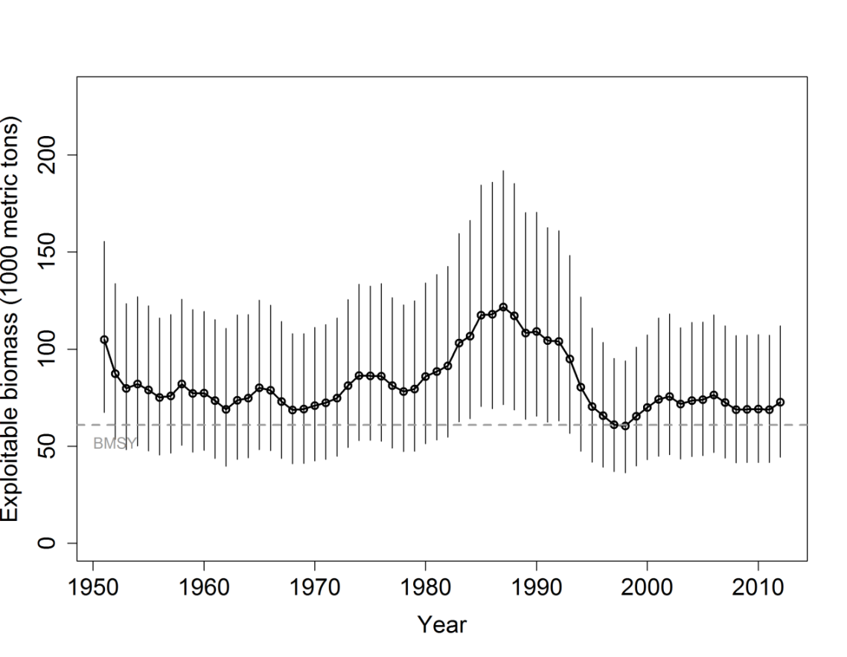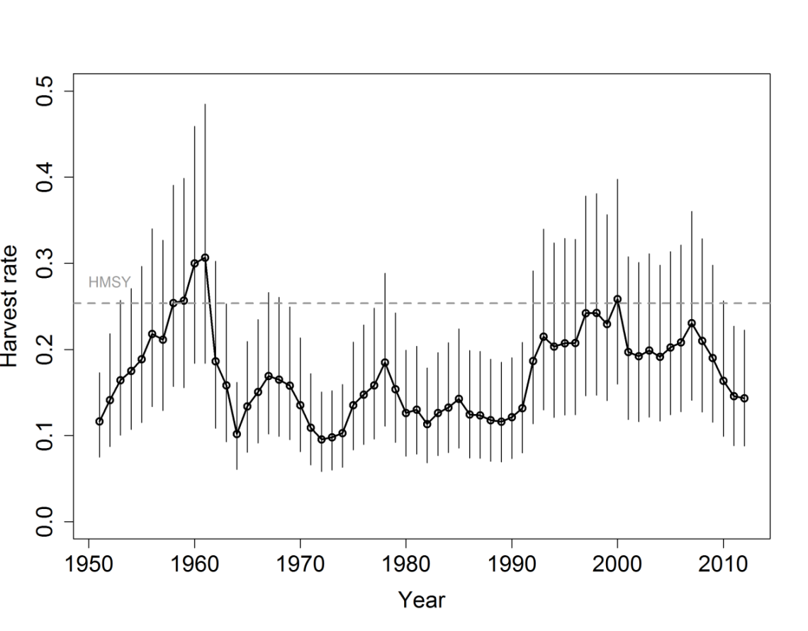

**Figure S2:** Trends in exploitable biomass (top) and harvest rate (bottom) of swordfish (*Xiphias gladius*) in the Western and Central North Pacific Ocean stock area. Estimated mean values from the posterior distribution (black circles and solid line), 95% confidence interval bars (solid vertical lines), and estimated biological reference points (*BMSY* and *HMSY*, horizontal dashed lines) are presented.

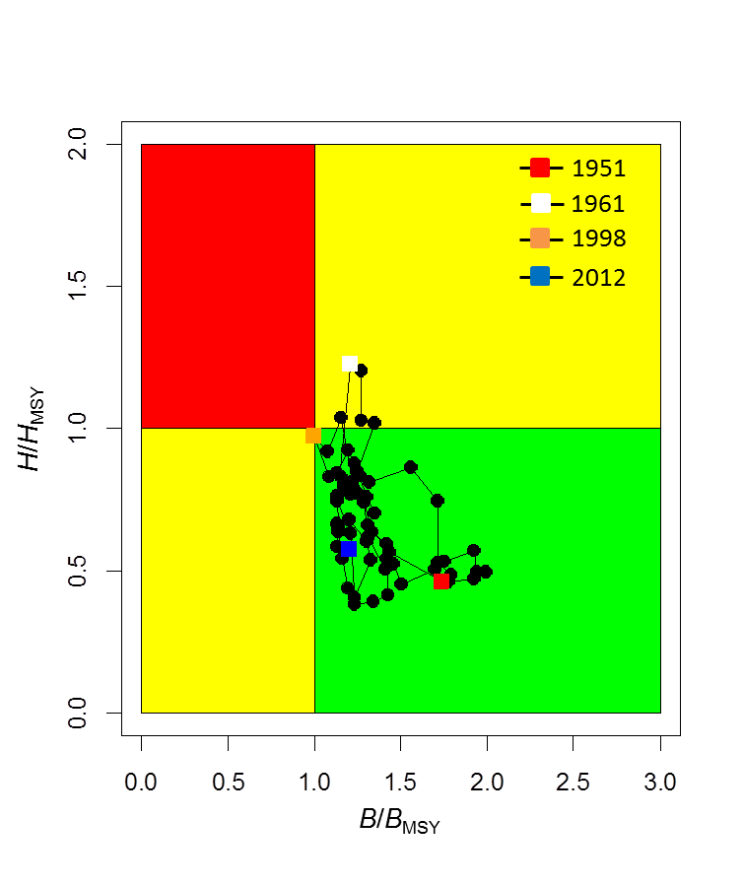

**Figure S3:** Kobe diagram showing the estimated trajectories of relative exploitable biomass (*B/BMSY*) and relative harvest rate (*H/HMSY*) for swordfish (*Xiphias gladius*) in the WCNPO stock area during 1951–2012.

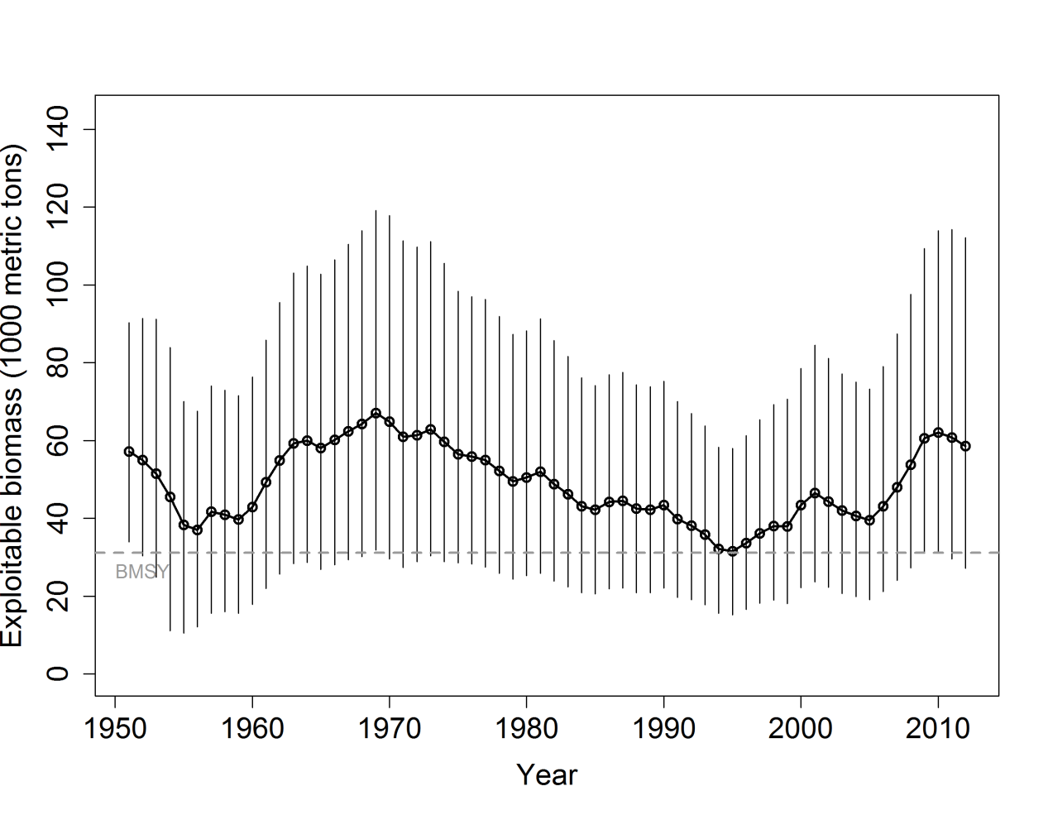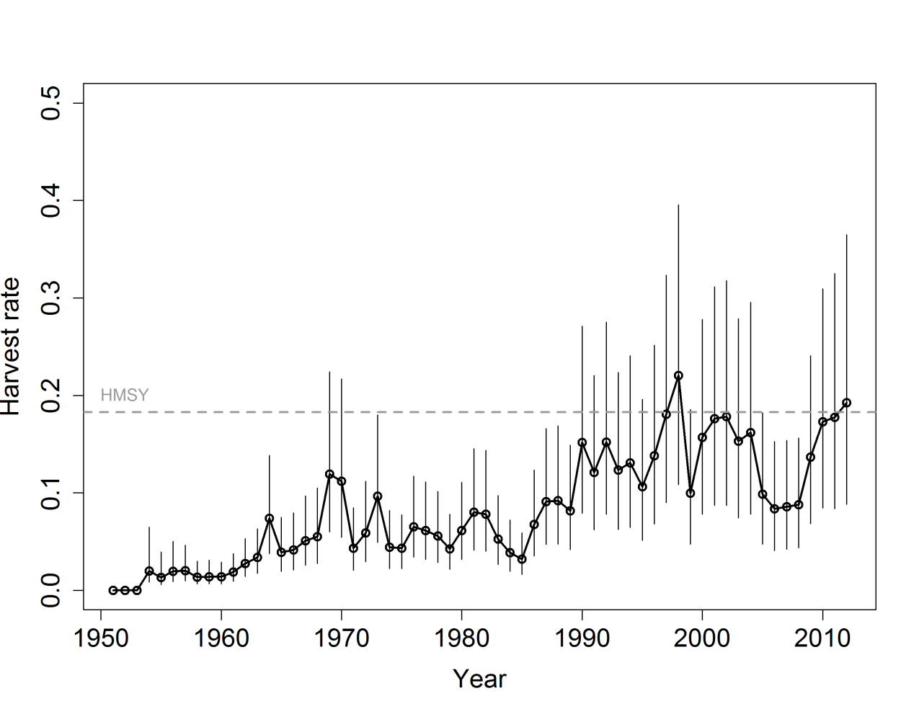

**Figure S4:** Trends in exploitable biomass (top) and harvest rate (bottom) of swordfish (*Xiphias gladius*) in the EPO stock area. Estimated mean values from the posterior distribution (black circles and solid line), 95% confidence interval bars (solid vertical lines), and estimated biological reference points (*BMSY* and *HMSY*, horizontal dashed lines) are presented.

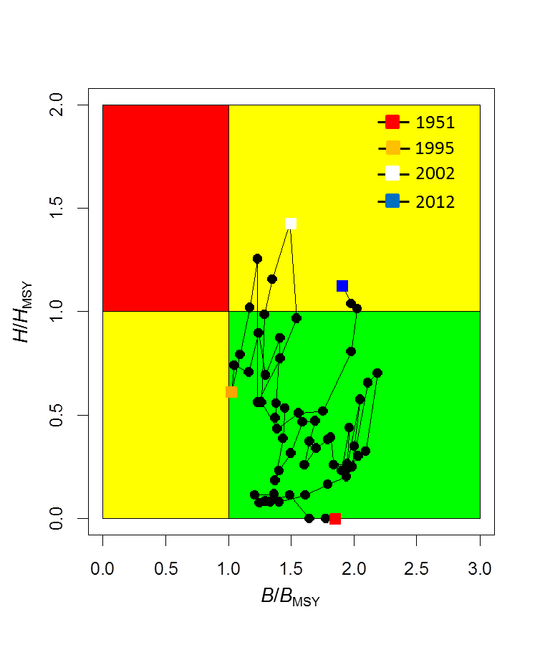

**Figure S5:** Kobe diagram showing the estimated trajectories of relative exploitable biomass (*B/BMSY*) and relative harvest rate (*H/HMSY*) for swordfish (*Xiphias gladius*) in the EPO stock area during 1951–2012.

**b. Stock projections and risk analyses**

**391. SC10 noted that ISC provided the following conclusions on the stock projections and risk analysis of North Pacific swordfish.**

**For the WCNPO stock, stochastic projections for eight harvest scenarios were conducted through 2016 (Figure S6). Results relative to MSY-based reference points indicated that exploitable biomass would likely remain above *BMSY* through 2016 under the status quo catch or status quo harvest rate scenarios (Figure S6). For the high harvest rate scenarios (i.e. maximum observed harvest rate, 150% of *HMSY*, 125% of *HMSY*), exploitable biomass was projected to decline below *BMSY* by 2016 (Figure S6) with harvest rates exceeding *HMSY*. In comparison, the stock would not be expected to experience any overfishing during 2014–2016 under the status quo catch and status quo harvest rate scenarios (Figure S6).**

**For the EPO stock, stochastic projections showed that exploitable biomass will likely have a decreasing trajectory during 2014–2016 under all eight of the harvest scenarios examined (Figure S7). Under the high harvest rate scenarios (status quo catch, maximum observed harvest rate, 150% of *HMSY*), exploitable biomass was projected to decline to be roughly equal to *BMSY* in 2016 (Figure S7) and maintain harvest rates above *HMSY*. In comparison, under the status quo harvest rate scenario, exploitable biomass was projected to decline to only 40,000 mt by 2016, well above the *BMSY* level. Overall, the projections showed that if recent high catch levels persist, exploitable biomass will very likely decrease and a moderate risk of overfishing will likely continue to occur.**

**The risk analyses of harvesting a constant annual catch of WCNPO swordfish during 2014–2016 showed that there would be virtually no chance of the stock being overfished or experiencing overfishing in 2016 (Figure S8) if current annual catches of about 10,000 mt were maintained.**

**The risk analyses for harvesting a constant catch of EPO swordfish during 2014–2016 showed that the probabilities of overfishing and becoming overfished increased as projected catch increased in the future (Figure S8). Maintaining the current catch of EPO swordfish of approximately 9,700 mt would lead to a moderate risk of overfishing in 2016 but would lead to less than 1% probability of the stock being overfished in 2016.**



**Figure S6:** Stochastic projections of expected exploitable biomass (1000 metric tons) of swordfish (*Xiphias gladius*) in the WCPO stock area during 2013–2016 under alternative harvest rates. Upper panel shows projection results of applying a harvest rate set to be 50%, 75%, 100%, 125%, and 150% of the value of estimate of *HMSY* (denoted as *F*MSY in the figure). Lower panel shows projection results of applying a status quo harvest rate based on the 2010–2012 average estimates, a status quo catch based on the 2010–2012 average catch, and the maximum observed harvest rate in the 1951–2012 time series.



**Figure S7:** Stochastic projections of expected exploitable biomass (1000 metric tons) of swordfish (*Xiphias gladius*) in the EPO stock area during 2013–2016 under alternative harvest rates. Upper panel shows projection results of applying a harvest rate set to be 50%, 75%, 100%, 125%, and 150% of the value of estimate of *HMSY* (denoted as *FMSY* in the figure). Lower panel shows projection results of applying a status quo harvest rate based on the 2010–2012 average estimates, a status quo catch based on the 2010–2012 average catch, and the maximum observed harvest rate in the 1951–2012 time series.

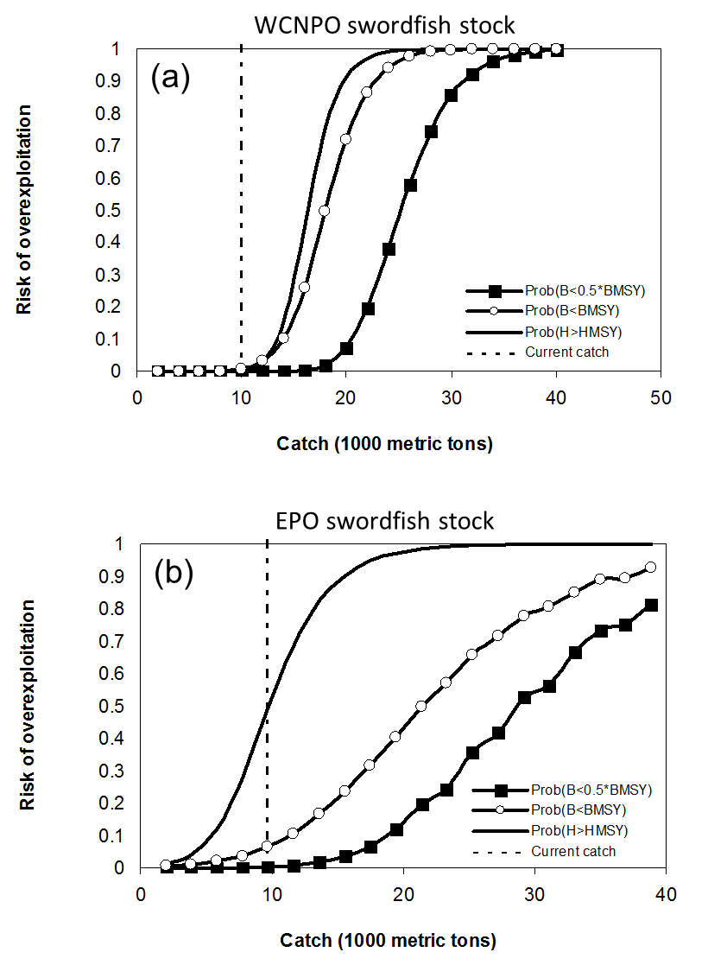

**Figure S8:** Probabilities of experiencing overfishing (*H > HMSY*, solid line), of exploitable biomass falling below *BMSY* (*B < 0.5*BMSY*, open circles), and of being overfished relative to a reference level of ½*BMSY* (*B < 0.5*BMSY*, solid squares) in 2016 for swordfish in the WCPO stock area (a) and EPO stock area (b) based on applying a constant catch biomass (x-axis, thousand mt) in the stock projections.

**c. Management advice and implications**

**392. SC10 noted the following conservation advice from the ISC.**

**Based on the assessment update, the WCNPO stock is not currently overfished and is not experiencing overfishing. The WCNPO stock is not fully exploited.**

**For the EPO swordfish stock, overfishing may be occurring in recent years. The recent average yield of roughly 10,000 mt, or almost two times higher than the estimated MSY, is not likely to be sustainable in the long term. While biomass of the EPO stock appears to be nearly twice *BMSY*, any increases in catch above recent levels should consider the uncertainty in stock structure and unreported catch**

# 

# Useful References

SC10-SA-WP13 North Pacific Swordfish (Xipiaus gladius) Stock Assessment in 2014. ISC Billfish Working Group (International Scientific Committee for Tuna and Tuna-like Species in the North Pacific Ocean).

<https://www.wcpfc.int/node/19203>

For current information related to Northern Stocks Working Group Reports and the ISC Plenary Report:

<http://isc.fra.go.jp/reports/isc/isc17_reports.html>