**South Pacific Swordfish (*Xiphias gladius*)**

**Stock Status &Trends plus Management Advice and Implications**

Contents

[SC14 2018 1](#_Toc522784951)

[SC13 2017 (Stock Assessment Conducted) 1](#_Toc522784952)

[Useful References 12](#_Toc522784953)

[Previous Assessments 13](#_Toc522784954)

# SC14 2018

**Stock Status**

**SC14 noted that no stock assessments were conducted for south Pacific swordfish in 2018. Therefore, the stock status descriptions from SC13 are still current for south Pacific swordfish. Updated information on catches was compiled but not reviewed by SC14.**

**South Pacific Swordfish Management Advice**

**SC14 noted that no management advice has been provided since SC13 for south Pacific swordfish. Therefore, previous advice should be maintained, pending a new assessment or other new information. For further information on the management advice and implications from SC13, please see below.**

# SC13 2017 (Stock Assessment Conducted)

1. Y. Takeuchi (SPC) presented **SC13-SA-WP-13** *Stock Assessment of Swordfish (Xiphias gladius) in the southwest Pacific Ocean*. The stock assessment was based on a structural uncertainty grid comprised of 72 models, each of which was considered to be a plausible representation of South Pacific swordfish (SWO) stock dynamics. The four structural uncertainties represented in the grid were: the three stock-recruitment steepnesses, the two weightings of the size data, the three weightings of the diffusion rate and the four natural mortality. Each individual model consisted of a unique combination of settings from the uncertainty axes. As a result, the uncertainty grid was comprised of 72 related but different models, each of which made a distinct claim about the dynamics of SWO fishery system to best explain and predict stock status. The major uncertainty related to growth and maturity noted in the previous assessment has now been resolved due to the results of new research which were presented to and endorsed by SC12 (**WCPFC-SC12-2016/SA-WP-11**).
2. **SC13 endorsed the 2017 SWO stock assessment as the best and most up to date scientific information available for this species.**
3. **SC13 also endorsed the use of the SWO assessment model uncertainty grid to characterize stock status and management advice and implications.**
4. SC13 reached consensus on the weighting of assessment models in the uncertainty grid for　SWO. The consensus weighting considered all options within the four axes of uncertainty for steepness, size data, diffusion rate and natural mortality to be equally likely. The resulting uncertainty grid was used to characterize stock status, to summarize reference points as provided in the assessment document **SC13-SA-WP-13**, and to calculate the probability of breaching SB*msy* and the probability of Frecent being greater than F*msy*.
5. **Stock status and trends**
6. **The median values of relative recent (2012-2015) spawning biomass (SBrecent/SBmsy) and relative recent fishing mortality (Frecent/Fmsy) over the uncertainty grid were used to measure the central tendency of stock status. The values of the upper 90th and lower 10th percentiles of the empirical distributions of relative spawning biomass and relative fishing mortality from the uncertainty grid were used to characterize the probable range of stock status.**
7. Description of the updated structural sensitivity grid used to characterize uncertainty in the assessment are provided in **Table SWO-1**. Time trends in estimated catch, recruitment, biomass, fishing mortality and depletion are shown in **Figures SWO-1 – 5**. **Figures SWO-6** and **SWO-7** show Majuro plot summarising the results for each of the models in the structural uncertainty grid retained for management advice. Kobe plots are shown in **Figures SWO-8** and **SOW-9**. Summary of reference points over all 72 individual models in the structural uncertainty grid are shown in **Table SWO-2**.

**Table SWO-1:** Description of the structural sensitivity grid used to characterize uncertainty in the assessment

|  |  |  |
| --- | --- | --- |
| Axis | Levels | Option |
| Steepness | 3 | 0.65, 0.80, 0.95 |
| Diffusion rate | 3 | 0, 0.11, 0.25 |
| Size frequency weighting | 2 | Sample size divided by 20,40 |
| Natural mortality vectors | 4 | M1,M2,M3, M4 |



**Figure SWO-1**. Trend of swordfish catch.

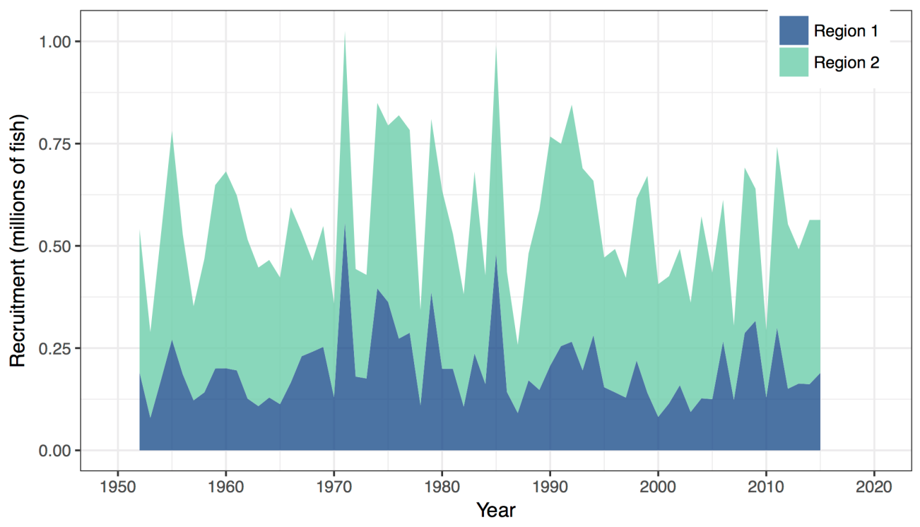

**Figure SWO2.** Estimated annual average recruitment by model region for the diagnostic case model, showing the relative sizes among regions.

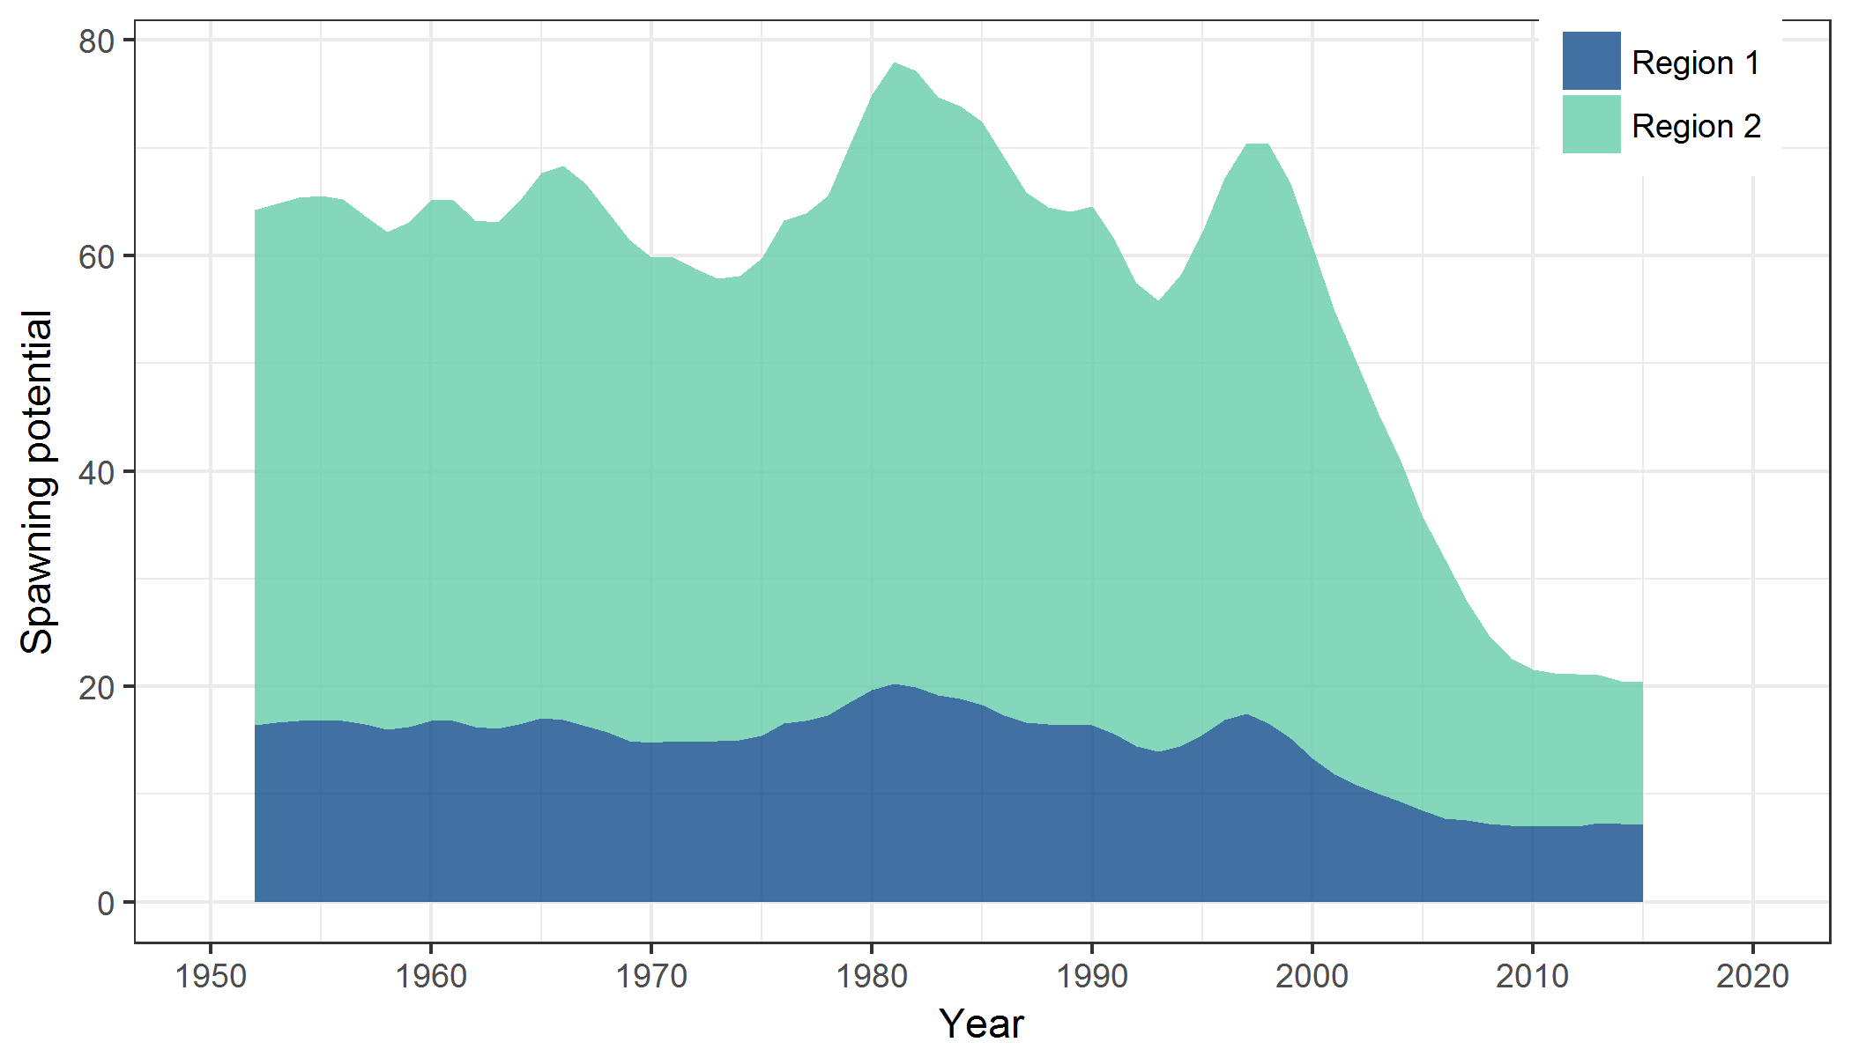

**Figure SWO3.** Estimated annual average spawning potential by model region for the diagnostic case model, showing the relative sizes among regions.

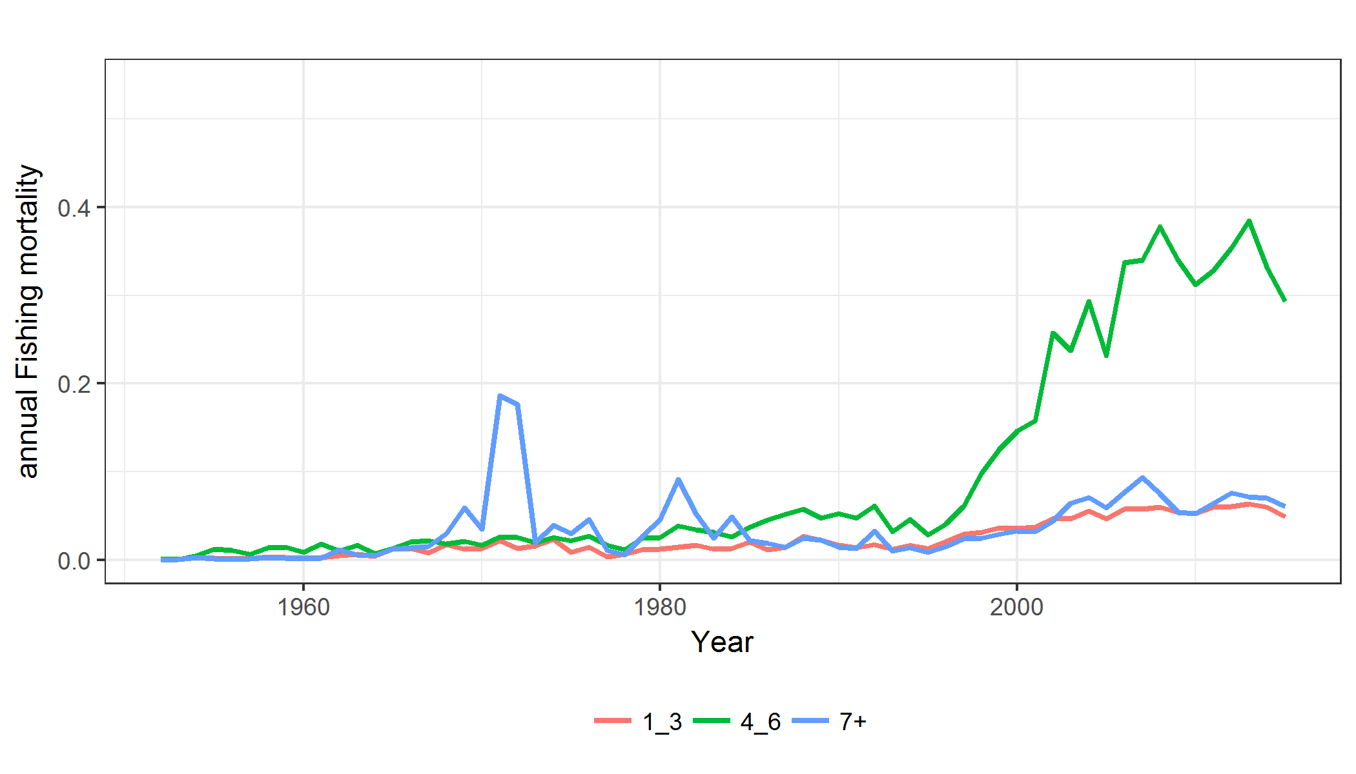

**Figure SWO-4.** Estimated annual average juvenile (age classes 1-3), maturing adult (4-6) and adult (7+) fishing mortality for the diagnostic case model.

**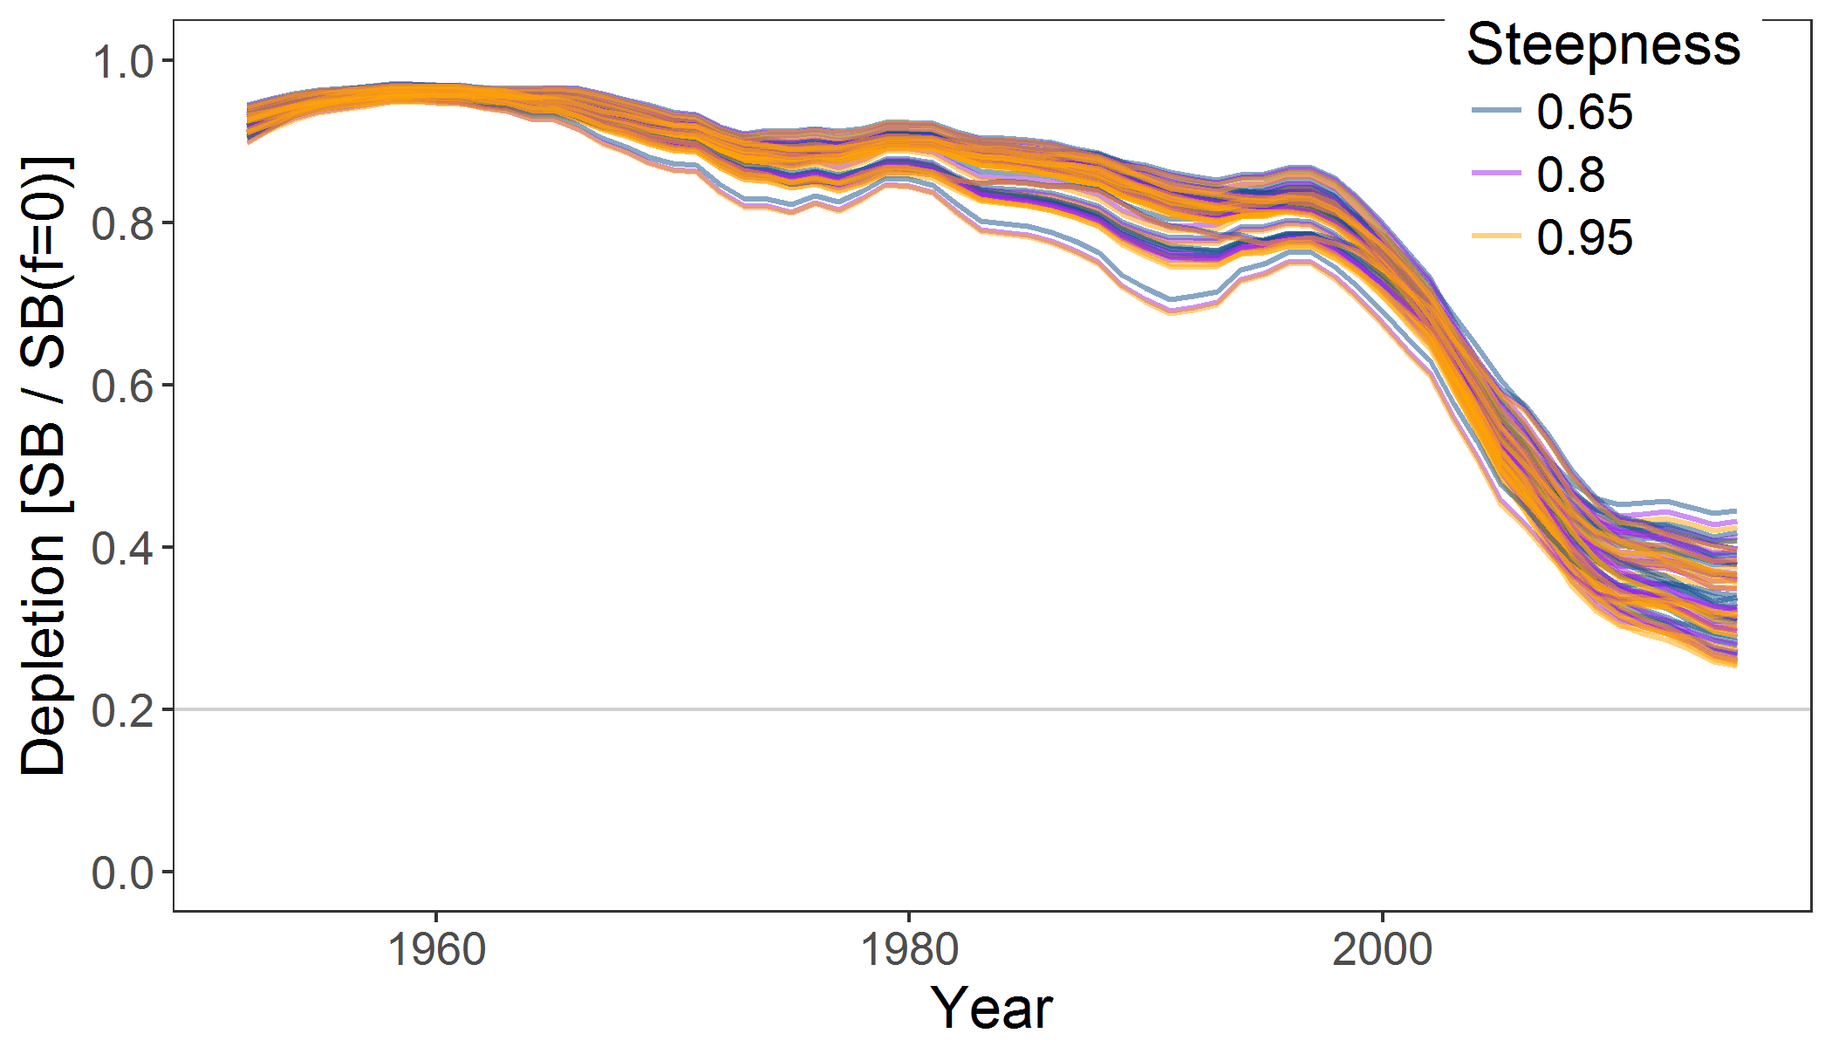**

**Figure SWO-5.** Plot showing the trajectories of fishing depletion (of spawning potential) for the 72 model runs retained for the structural uncertainty grid used for management advice. The colours depict the models in the grid with three levels of steepness (0.65, 0.8 and 0.95).

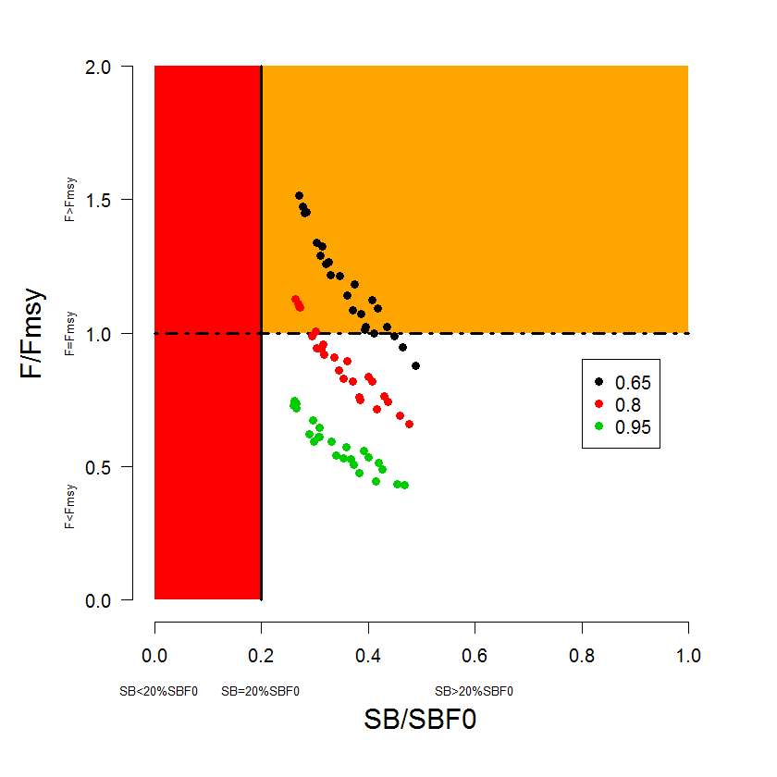

**Figure SWO-6.** Majuro plot summarising the results for each of the models in the structural uncertainty grid retained for management advice. The plots represent estimates of stock status in terms of spawning potential depletion and fishing mortality. The red zone represents spawning potential levels lower than the agreed limit reference point which is marked with the solid black line. The orange region is for fishing mortality greater than F*MSY* (F*MSY* is marked with the black dashed line). The points represent SB*latest*/SB*F=0*, and the colours depict the models in the grid with three levels of steepness (0.65, 0.8 and 0.95).

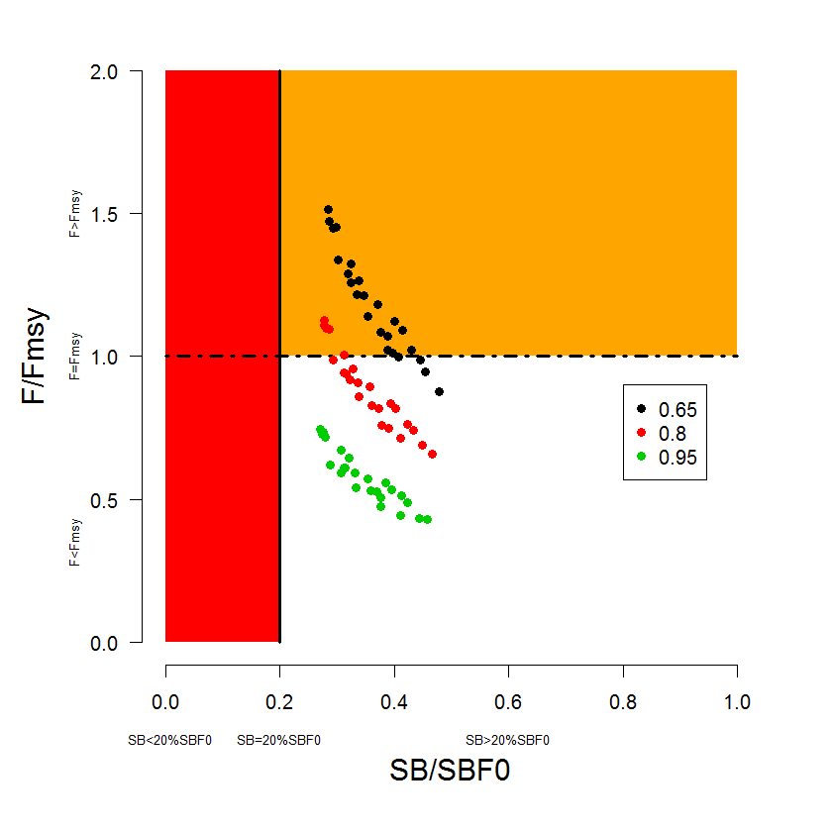

**Figure SWO-7**. Majuro plot summarising the results for each of the models in the structural uncertainty grid retained for management advice. The plots represent estimates of stock status in terms of spawning potential depletion and fishing mortality. The red zone represents spawning potential levels lower than the agreed limit reference point which is marked with the solid black line. The orange region is for fishing mortality greater than FMSY (FMSY is marked with the black dashed line). The points represent SB*recent*/SB*F=0*, and the colours depict the models in the grid with three levels of steepness (0.65, 0.8 and 0.95). Note, SB*recent* is defined as the mean of SB over 2012-2015.

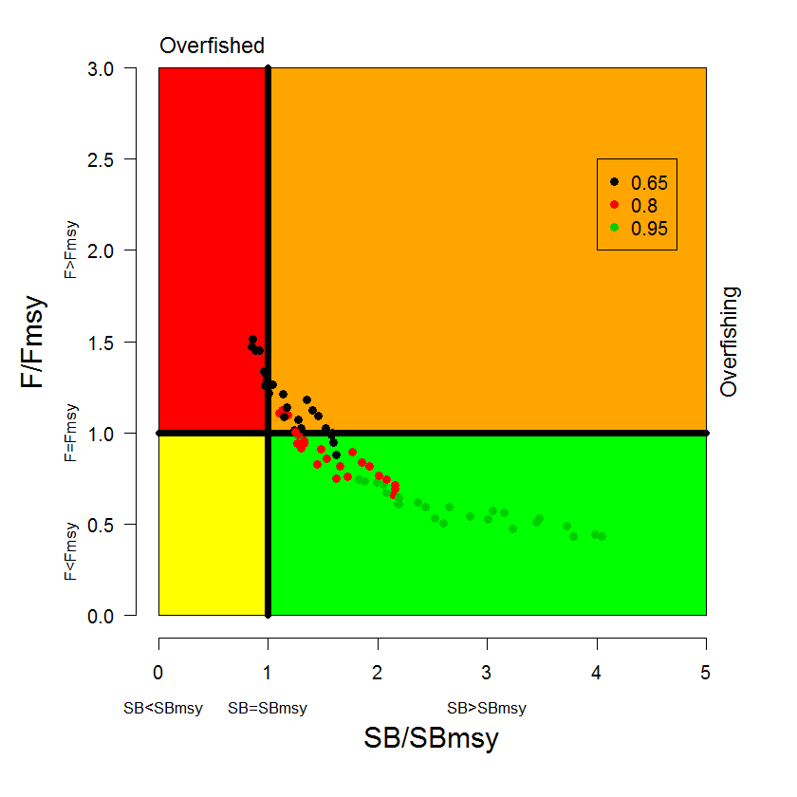

**Figure SWO-8.** Kobe plot summarising the results for each of the models in the structural uncertainty grid, where the x-axis represents SB*latest*/SB*MSY*. The colours depict the models in the grid with three levels of steepness (0.65, 0.8 and 0.95).

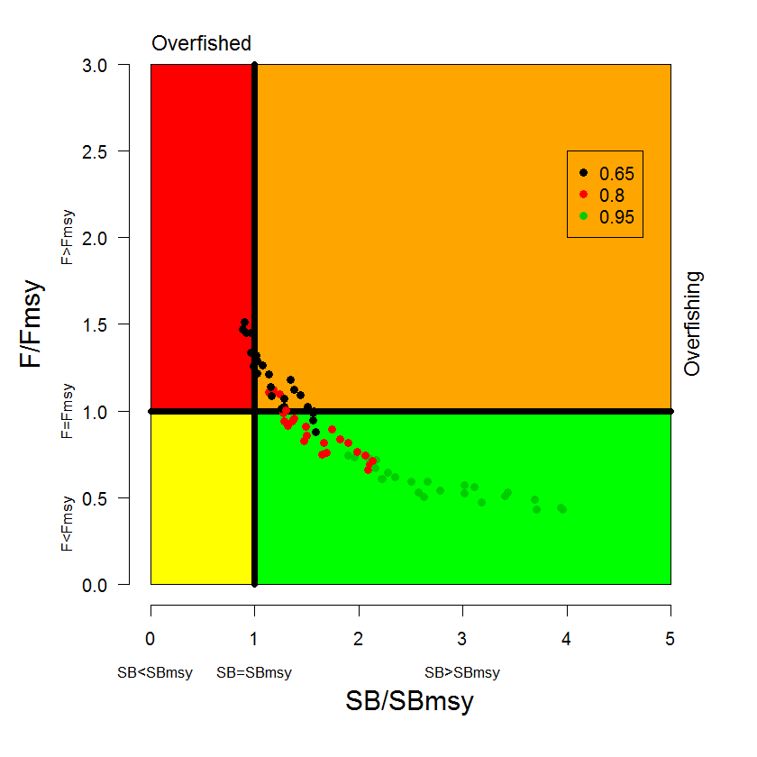

**Figure SWO-9.** Kobe plot summarising the results for each of the models in the structural uncertainty grid. The colours depict the models in the grid with three levels of steepness (0.65, 0.8 and 0.95). As in Figure SWO7, SB*recent* was used instead of SB*latest*.

**/Users/yukiot/Dropbox/MFCL/SC13/SWO/Assessment/plots/Fig36_splotimpactAdult.pdf**

**Figure SWO-10**. Estimates of reduction in spawning potential due to fishing by region, and over all regions (lower left panel), attributed to various fishery groups for the diagnostic case model. Note distant water C includes the **EU** fishery.

**Table SWO-2**. Summary of reference points over the 72 models in the structural uncertainty grid for management advice. Note that SB*recent*/SB*F=0* is calculated where SB*recent* is the mean SB over 2012-2015 instead of 2011-2014 (used in the stock assessment report), at the request of the Scientific Committee.

|  |  |  |  |  |  |  |
| --- | --- | --- | --- | --- | --- | --- |
|  | **Mean** | **Median** | **Min** | **10%** | **90%** | **Max** |
| *Clatest* | 9,884 | 9,884 | 9,318 | 9,343 | 10,157 | 10,287 |
| *MSY* | 8,172 | 7,913 | 5,905 | 6,396 | 10,150 | 11,360 |
| *YFrecent* | 7,628 | 7,775 | 4,998 | 6,062 | 8,948 | 9,684 |
| *fmult* | 1.27 | 1.15 | 0.66 | 0.79 | 1.89 | 2.32 |
| *FMSY* | 0.16 | 0.14 | 0.10 | 0.10 | 0.22 | 0.23 |
| *Frecent/FMSY* | 0.88 | 0.87 | 0.43 | 0.53 | 1.26 | 1.51 |
| *SBMSY* | 17,314 | 17,740 | 7,278 | 8,943 | 26,661 | 30,460 |
| *SB0* | 84,173 | 84,075 | 57,070 | 71,199 | 98,039 | 111,000 |
| *SBMSY/SB0* | 0.20 | 0.21 | 0.11 | 0.12 | 0.28 | 0.28 |
| *SBF=0* | 78,619 | 78,301 | 61,996 | 64,342 | 92,120 | 100,691 |
| *SBMSY/SBF=0* | 0.22 | 0.23 | 0.10 | 0.12 | 0.32 | 0.33 |
| *SBlatest/SB0* | 0.33 | 0.32 | 0.24 | 0.25 | 0.44 | 0.46 |
| *SBlatest/SBF=0* | 0.35 | 0.35 | 0.26 | 0.27 | 0.44 | 0.49 |
| *SBlatest/SBMSY* | 1.85 | 1.61 | 0.85 | 0.99 | 3.14 | 4.05 |
| *SBrecent/SBF=0* | 0.36 | 0.35 | 0.27 | 0.29 | 0.43 | 0.48 |
| *SBrecent/SBMSY* | 1.86 | 1.58 | 0.88 | 1.02 | 3.10 | 3.96 |

1. **SC13 noted that the central tendency of relative recent spawning biomass was median (SBrecent/SBF=0) = 0.35 with a probable range of 0.29 to 0.43 (80% probability interval). The median estimate (0.35) is below that estimated from the 2014 assessment grid((SBcurrent/SBF=0) = 0.49, see SC9-SA-WP-05), noting the differences in grid uncertainty axes used in that assessment, due to the inclusion of two representations of growth and maturity. SC13 also noted that in the previous assessment this central tendency was not considered for the provision of management advice given the uncertainties in growth assumptions. The median estimate for SBrecent/SBmsy is 1.23, that is below that estimated from the 2014 assessment grid ((SBcurrent/SBmsy) = 2.07, see SC9-SA-WP-05).**
2. **SC13 noted that the central tendency of relative recent fishing mortality was median (Frecent/Fmsy) = 0.86 with an 80% probability interval of 0.51 to 1.23. While this suggested that there was likely a buffer between recent fishing mortality and Fmsy, it also showed that there was some probability that recent fishing mortality was above Fmsy.**
3. **SC13 also noted that there was a roughly 32% probability (23 out of 72 models) that the recent fishing mortality was above Fmsy with Prob ((Frecent/Fmsy)>1) = 0.32. The median estimate (0.86) is above that estimated from the 2014 assessment grid (Fcurrent/Fmsy = 0.74, see SC9-SA-WP-05).**
4. **Fishing mortality rate increased notably from the mid-1990s in both model regions, on maturing swordfish aged (4-6) fish in particular.**
5. **Across all models in the uncertainty grid the spawning biomass declines steeply between the late 1990s and 2010 but since then the rate of decline has been less. Those declines are found in both model regions, but are higher in the eastern Region 2 (equator to 50°S, 165°E to 130°W).**
6. **SC13 noted that in comparison with the bigeye and yellowfin assessments, evidence for an increase in recent recruitment for southwest Pacific swordfish was not found in either the CPUE time series or estimates of recruitment. SC13 noted that the longline only nature of the fishery catching mainly larger, older swordfish, is not strongly informative with regards to recruitment dynamics.**
7. **Management advice and implications**
8. **Based on the uncertainty grid adopted by SC13, the south west Pacific swordfish spawning biomass is likely above the 20% SBf=0,biomass LRP adopted for tunas and the SBmsy level noting that the Commission has yet to adopted an LRP for south Pacific swordfish) [and it is highly likely that the stock is not in an overfished condition (0% probability). Recent F is likely below Fmsy, and it appears that the stock is not experiencing overfishing (32% probability).**
9. **SC13 noted that there has been an increase in fishing mortality notably from the mid-1990s, and that the biomass relative to unfished levels is estimated to have declined rapidly during the period late-1990s to 2010 followed by a more gradual but continued decline after 2010, across the uncertainty grid. It was noted the fishing mortality was likely below Fmsy.**
10. **Consistent with its previous advice (from SC9), SC13 recommends that the Commission consider developing appropriate management measures for the area north of 20°S to the equator which is not covered by CMM 2009-03, noting that:**

* **recent catches between the equator and 20°S continue to represent the largest component of the catch in Region 2 (equator to 50°S, 165°E to 130°W) and represent half the total catches from the stock, and,**
* **catches in that area contribute substantially to fishing mortality and spawning biomass depletion levels in eastern Region 2 that are substantially higher than in the western region (Region 1).**

1. **Further, SC13 recommends that current restrictions on catches south of 20°S also be maintained.**

# Useful References

SC13-SA-WP-13 Stock assessment of swordfish in the SW Pacific. Takeuchi Y, G. Pilling and J. Hampton. (SPC-OFP)

<https://www.wcpfc.int/node/29526>

SC12-SA-WP-11 Determination of swordfish growth and maturity relevant to the southwest Pacific stock. Farley J., N. Clear, D. Kolody, K. Krusic-Golub, P. Eveson and J. Young. (AFMA)

<https://www.wcpfc.int/node/27447>

SC9-SA-WP-01 Stock assessment of swordfish (Xiphias gladius) in the southwest Pacific Ocean. Davies, N., G. Pilling, S. Harley, and J. Hampton. (SPC-OFP)

<https://www.wcpfc.int/node/3683>

# Previous Assessments

SC9-SA-WP-05 Stock assessment of swordfish (Xiphias gladius) in the southwest Pacific Ocean. <https://wcpfc.int/node/3683>

SC4-SA-WP-06 Multifan-CL Stock Assessment of Southern Western-Central Pacific Swordfish 1952-2007. <https://wcpfc.int/node/1223>

SC2-SA-WP-07 SW Pacific Swordfish Stock Status Summary from multiple assessment models. <https://wcpfc.int/node/1752>

SC1-SA-WP-07 Southwest Pacific swordfish assessment: 2005-6 objectives and preliminary results. <https://wcpfc.int/node/1891>