Southwest Pacific Striped Marlin (Kajikia audax)
Stock Status &Trends plus Management Advice and Implications

Contents
SC13 2017 1
SC12 2016 1
SC11 2015 2
SC10 2014 2
SC9 2013 2
SC8 2012 (Stock Assessment Conducted) 3
Useful References 8
Previous Assessments 8

SC13 2017

- Stock status and trends

- SC13 noted that no stock assessments were conducted for these species in 2017. Therefore, the stock status descriptions from SC8 for South Pacific striped marlin are still current. Updated information on catches was not compiled for and reviewed by SC13.

- Management advice and implications

- SC13 noted that no management advice has been provided since SC8 for South Pacific striped marlin. Therefore, previous advice should be maintained, pending a new assessment or other new information.

SC12 2016

- Stock status and trends

- SC12 noted that no stock assessments were conducted for these species in 2016. Therefore, the stock status descriptions from SC8 and SC11 for South Pacific striped marlin and North Pacific striped marlin are still current. Updated information on North Pacific striped marlin catches may be available in the ISC Plenary Report (SC12-GN-IP-02), and for South Pacific striped marlin in SC12-ST-IP-01, but was not compiled for and reviewed by SC12.
- Management advice and implications

- SC12 noted that no management advice has been provided since SC8 and SC11 for South Pacific striped marlin and North Pacific striped marlin, respectively. Therefore, previous advice should be maintained, pending a new assessment or other new information.

SC11 2015

- Status and trends

- SC11 noted that no stock assessment was conducted for southwest Pacific striped marlin in 2015. Therefore, the stock status description from SC8 is still current.

- Management advice and implications

- SC11 noted that no management advice had been provided since SC10. Therefore, the advice from SC8 should be maintained.

SC10 2014

a. Status and trends
- SC10 noted that no stock assessment was conducted for southwest Pacific striped marlin in 2014. Therefore, the stock status description from SC9 is still current.
b. Management advice and implications
- SC10 noted that no management advice had been provided since SC9. Therefore, the advice from SC9 should be maintained.

SC9 2013

- Status and trends

- SC9 noted that no stock assessment was conducted for southwest Pacific striped marlin in 2013. Therefore, the stock status description from SC8 is still current.

- Management advice and implications

- SC9 noted that no management advice was provided since SC8. Therefore, the advice from SC8 should be maintained, pending a new assessment or other new information.

SC8 2012 (Stock Assessment Conducted)
a. Status and trends

- SC selected the reference case model from the assessment to characterize stock status and selected several key sensitivity runs to characterize uncertainty in trends in abundance and stock status (Figs. MLS1-MLS5 and Tables MLS1 and MLS 2). It was noted that the use of the reference case and key sensitivities selected by SC8 (see Table MLS1) leads to slightly different conclusions in terms of stock status compared with that based on the uncertainty grid used in the assessment. The reference case and five of the six other key sensitivity runs estimated F_{current}/F_{MSY} to be less than one, indicating that overfishing is unlikely to be occurring. However, when considering SB_{current}/SB_{MSY}, the reference case and four of the six other key sensitivity runs are estimated to be less than one, indicating evidence that the stock may be overfished.

Table MLS1: Estimates of management quantities for selected stock assessment models from the 2012 Ref.case model and the six plausible key model runs. For the purpose of this assessment, “current” is the average over the period 2007–2010 and “latest” is 2011.
 | Ref.case | sel_JP_AU_3log | CP_JP2_AU_2_3 | h=0.65 | h=0.95 | Growth_est | Sz_data_wt
$$C_{current}$$ | 1758 | 1753 | 1785 | 1759 | 1759 | 1707 | 1764
$$C_{latest}$$ | 1522 | 1523 | 1512 | 1522 | 1522 | 1476 | 1521
$$MSY$$ | 2081 | 2017 | 2256 | 1914 | 2276 | 2182 | 2179
$$C_{current}/MSY$$ | 0.85 | 0.87 | 0.79 | 0.92 | 0.77 | 0.78 | 0.81
$$C_{latest}/MSY$$ | 0.73 | 0.76 | 0.67 | 0.80 | 0.67 | 0.68 | 0.70
$$F_{mult}$$ | 1.24 | 1.10 | 1.39 | 0.83 | 1.98 | 1.79 | 1.42
$$F_{current}/F_{MSY}$$ | 0.81 | 0.91 | 0.72 | 1.21 | 0.51 | 0.56 | 0.71
$${SB}_{0}$$ | 15,130 | 14,530 | 16,590 | 16,790 | 14,220 | 15,360 | 16,000
$${SB}_{MSY}/{SB}_{0}$$ | 0.27 | 0.27 | 0.27 | 0.32 | 0.22 | 0.28 | 0.26
$${SB}_{current}/{SB}_{0}$$ | 0.24 | 0.22 | 0.25 | 0.21 | 0.25 | 0.31 | 0.25
$${SB}_{latest}/{SB}_{0}$$ | 0.24 | 0.23 | 0.25 | 0.22 | 0.26 | 0.32 | 0.26
$${SB}_{current}/{SB}_{MSY}$$ | 0.87 | 0.81 | 0.92 | 0.67 | 1.14 | 1.11 | 0.95
$${SB}_{latest}/{SB}_{MSY}$$ | 0.90 | 0.84 | 0.92 | 0.70 | 1.19 | 1.14 | 1.00
$${SB}_{curr}/{SB}_{{curr}_{F=0}}$$ | 0.34 | 0.32 | 0.37 | 0.34 | 0.34 | 0.44 | 0.37
$${SB}_{latest}/{SB}_{{latest}_{F=0}}$$ | 0.37 | 0.34 | 0.39 | 0.37 | 0.37 | 0.46 | 0.40
Steepness (h) | 0.80 | 0.80 | 0.80 | 0.65 | 0.95 | 0.80 | 0.80

Table MLS2: Comparison of southwest Pacific Ocean striped marlin reference points from the 2012 reference case model and the range of the seven models in Table MLS1; the 2006 base case model (steepness estimated as 0.51).
Management quantity | 2012 assessment  Ref.case (uncertainty) | 2006 assessment  Base case
Most recent catch | 1,758 mt (2011) | 1,412 mt (2004)
MSY | 2,081 t  (1,914–2,276) | 2,610 t
F_{current}/F_{MSY} | 0.81 (0.51–1.21) | 1.25
B_{current}/B_{MSY} | 0.83 (0.70–0.99) | 0.70
SB_{current}/SB_{MSY} | 0.87 (0.67–1.14) | 0.68
Y_{Fcurrent}/MSY | 0.99 (0.93–1.00) | 0.99
B_{current}/B_{current, F=0} | 0.46 (0.44–0.53) | 0.53
SB_{current}/SB_{current, F=0} | 0.34 (0.32–0.44) | NA
NA = not available
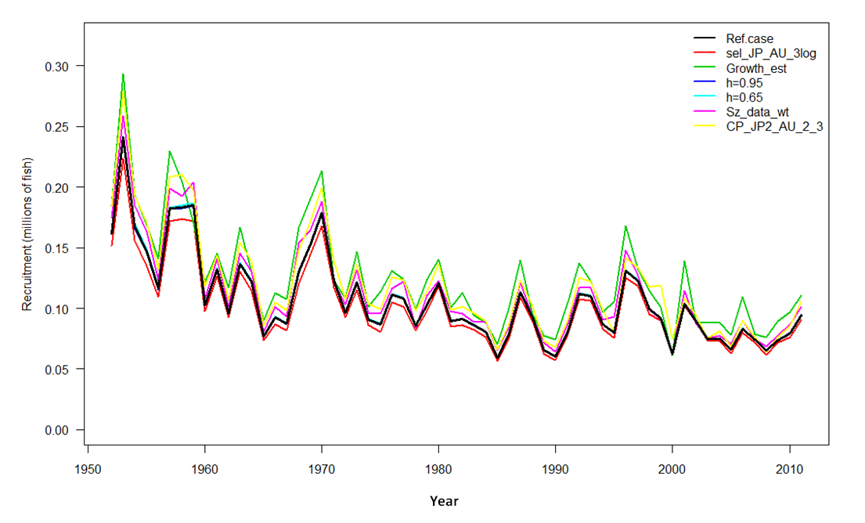
Figure MLS1: Estimated annual recruitment (millions of fish) for southwest Pacific Ocean striped marlin obtained from the Ref.case model (black line) and the six plausible key model runs.
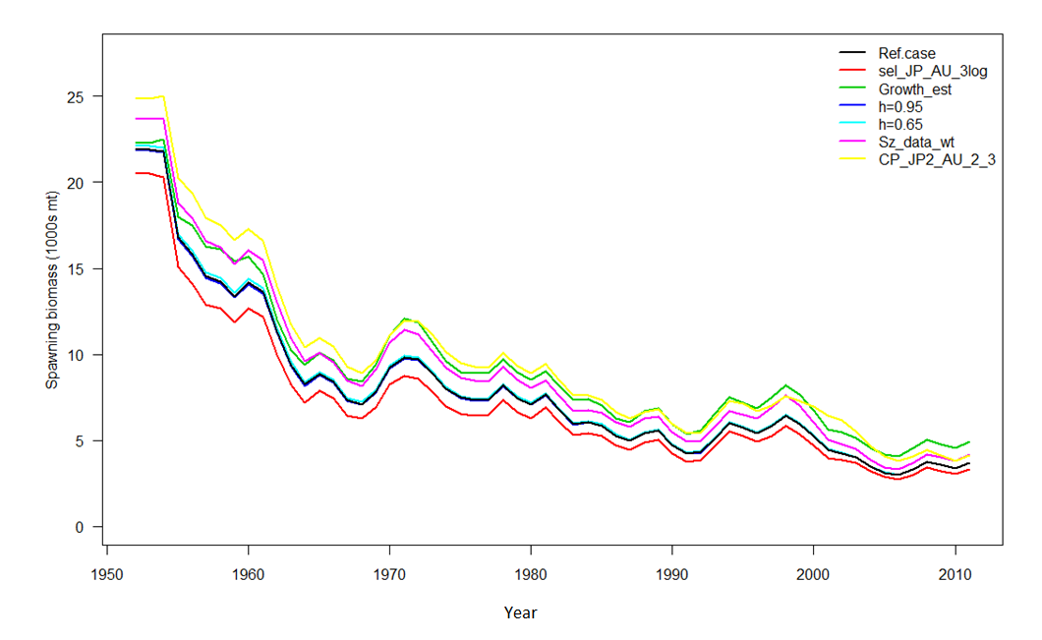
Figure MLS2: Estimated annual average spawning potential for southwest Pacific Ocean striped marlin obtained from the Ref.case model (black line) and the six plausible key model runs.
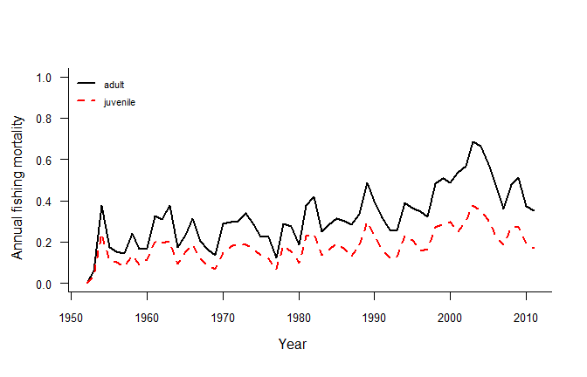
Figure MLS3: Estimated annual average juvenile and adult fishing mortality for southwest Pacific Ocean striped marlin obtained from the Ref.case model.
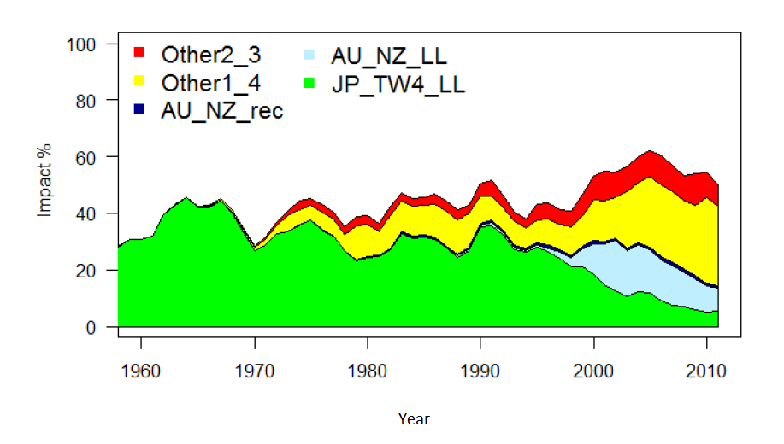
Figure MLS4: Estimates of reduction in spawning potential due to fishing (fishery impact = ${1-SB}_{t}/{SB}_{t_{F=0}}$ ) for southwest Pacific Ocean striped marlin attributed to various fishery groups (Ref.case model). JP_TW4+LL = Japanese longline fisheries in sub-areas 1 to 4 and Taiwanese longline fishery in sub-area 4; AU_NZ_LL = Australian and New Zealand longline fisheries; AU_NZ_rec = Australian and New Zealand recreational fisheries; Other1_4 = all longline fisheries in sub-areas 1 and 4 excluding Taiwanese in sub-area 4 and excluding Japanese; Other2_3 = all longline fisheries in sub-areas 2 and 3 excluding Japanese, Australian and New Zealand.

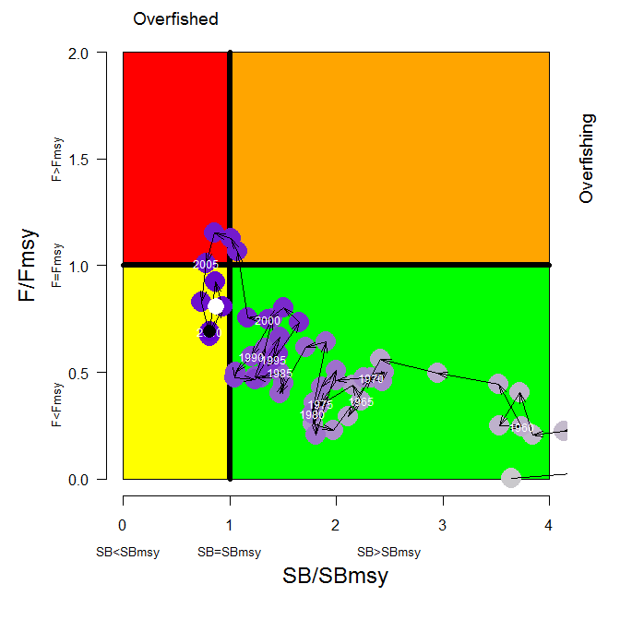
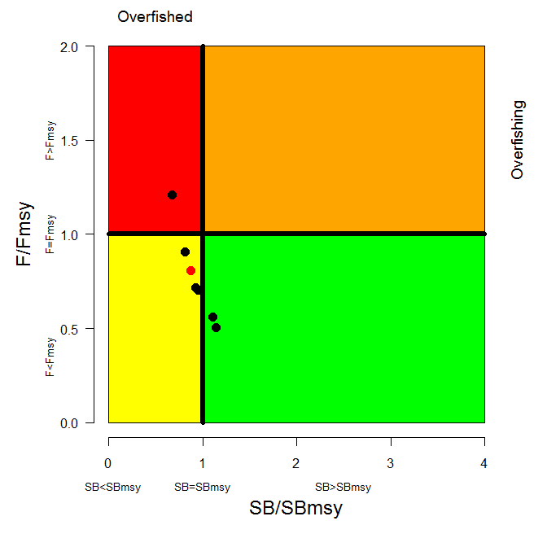
Figure MLS5: Temporal trend in annual stock status, relative to SB_{MSY} (x-axis) and F_{MSY} (y-axis) reference points for the Ref.case (top) and $F_{current}/F_{MSY}$ and ${SB}_{current}/{SB}_{MSY}$ for the Ref.case (red circle) and the six plausible key model runs. See Table MLS1 to determine individual model runs.

b. Management advice and implications

- The southwest Pacific striped marlin assessment results indicate that the stock is fully exploited, is not experiencing overfishing, but may be overfished. SC8 noted that recent catches are close to MSY, and that recent fishing mortality is slightly below F_{MSY}, and that recent spawning biomass is slightly below SB_{MSY}. The recent catch increase is driven in part by increases in catch in the northern area of the stock area that is not subject to the current CMM for this stock.

- SC8 recommended measures to reduce the overall catch of this stock, through the expansion of the geographical scope of CMM 2006-04, in order to cover the distribution range of the stock.

- In designing such a measure to implement this recommendation from SC8, the Commission may need to consider the historic trends in the fishery, including catch declines in the traditional central and southern areas and the recent catch increases in the northern areas.

- SC8 recognized that striped marlin is often caught as a non-target species. SC8, therefore, recommended that data analysis be conducted to identify areas of high catch concentration that could be subject to targeted management.

Useful References

WCPFC-SC9-SA-WP-07 Distribution of longline catches for southwest Pacific striped marlin.
https://www.wcpfc.int/node/3704

WCPFC-SC8-SA-WP-05 Stock Assessment of Striped Marlin (Kajikia audax) in the Southwest Pacific Ocean. https://www.wcpfc.int/node/3234

Previous Assessments

SC2-SA-WP-06 Stock assessment of striped marlin (Tetrapturus audax) in the southwest Pacific Ocean. https://wcpfc.int/meetings/2nd-regular-session

