The Commission for the Conservation and Management of
Highly Migratory Fish Stocks in the Western and Central Pacific Ocean

Scientific Committee

North Pacific Striped Marlin (Kajikia audax)

Stock Status AND Management Advice

Contents
SC15 2019 (STOCK ASSESSMENT CONDUCTED) 2
SC14 2018 (NO STOCK ASSESSMENT) 11
SC13 2017 (NO STOCK ASSESSMENT) 15
Useful References 16
Previous Assessments 16

SC15 2019 (STOCK ASSESSMENT CONDUCTED)

- Stock Status and trends

- SC15 noted that ISC provided the following conclusions on the stock status of Western and Central North Pacific striped marlin:

Estimates of population biomass of the Western and Central North Pacific Ocean (WCNPO) striped marlin fluctuated without trend between 1975 and 1993. The population deceased substantially in 1994 and fluctuated without trend until the present year. Population biomass (age-1 and older) averaged roughly 17,969 mt, or 54% below unfished biomass during the 1975-1993 period and declined to 4,508 mt, or 89% below unfished biomass by 2008. The minimum spawning stock biomass was estimated to be 618 t in 2011 (76% below SSB_{MSY}, the spawning stock biomass to produce MSY, Figure NMLS-1a). In 2017, SSB = 981 t and SSB/SSB_{MSY} = 0.38. Fishing mortality on the stock (average F on ages 3-12) has been around F_{MSY} since 2014 (Figure NMLS-1b). It averaged roughly 0.64 yr-1 during 2015-2017, or 7% above F_{MSY} and in 2017, F=0.80 yr-1 with a relative fishing mortality of F/F_{MSY} = 1.33 (Table NMLS-02). Fishing mortality has been above FMSY in every year except 1984, 1992, and 2016. The predicted value of the spawning potential ratio (SPR, the predicted spawning output at current F as a fraction of unfished spawning output) is estimated to be SPR₂₀₁₅₋₂₀₁₇ = 17% and is approximately equal to the SPR required to produce MSY. Recruitment averaged about 263,000 age-0 recruits between 1994 and 2017, which was 34% below the 1975-2017 average. No target or limit reference points have been established for the WCNPO striped marlin stock under the auspices of the WCPFC. Despite the relatively large L50/Linf ratio for WCNPO striped marlin, the stock is expected to be highly productive due to its rapid growth and high resilience to reductions in spawning potential. Recent recruitments have been lower than expected and have been below the long-term trend since 2005. Although fishing mortality has decreased since 2000, due to the prolonged low recruitment and landings of immature fish, the biomass of the stock has remained below MSY. When the status of WCNPO striped marlin is evaluated relative to MSY-based reference points, the 2017 spawning stock biomass of 981 mt is 62% below SSB_{MSY}(2,604 t) and the 2015-2017 fishing mortality exceeds F_{MSY} by 7%. Therefore, relative to MSY-based reference points, overfishing is occurring and the WCNPO striped marlin stock is overfished (Figure NMLS-02).

Biological reference points were computed for the base case model with Stock Synthesis (Table NMLS-01 and Table NMLS-02). The point estimate of maximum sustainable yield (MSY) was 4,946 t. The point estimate of the spawning biomass to produce MSY (adult female biomass, SSB_{MSY}) was 2,604 t. The point estimate of F_{MSY}, the fishing mortality rate to produce MSY (average fishing mortality on ages 3 – 12) was 0.60 and the corresponding equilibrium value of spawning potential ratio at MSY was SPR_{MSY} = 18%.

Stock projections for WCNPO striped marlin were conducted using the age-structured projection model software AGEPRO. Stochastic projections were conducted using results from the base case model to evaluate the probable impacts of alternative fishing intensities or constant catch quotas on future spawning stock biomass and yield for striped marlin in the WCNPO. For fishing mortality projections, a standard set of F-based projections were conducted. For catch quota projections, the set of rebuilding projection analyses requested by NC14 were conducted. Two future recruitment scenarios were evaluated (Figure 3 and Figure 4): (1) a short-term recruitment scenario based on resampling the empirical cumulative distribution function of recruitment observed during 2012-2016 and (2) a long-term recruitment scenario based on resampling the empirical cumulative distribution function of recruitment observed during 1975- 2016. The short-term recruitment scenario had an average recruitment of 134,020 age-0 fish and the long-term recruitment mean was 306,989 age-0 fish. The stochastic projections employed model estimates of the multi-fleet, multi-season, size- and age-selectivity, and structural complexity in the assessment model to produce consistent results. Fishing mortality-based projections started in 2018 and continued through 2037 under five levels of fishing mortality and the two recruitment scenarios. The five fishing mortality stock projection scenarios were: 1) F status quo (average F during 2015-2017), 2) F_{MSY}, 3) F at 0.2·SSB₀, 4) F_{High} at the highest 3-year average during 1975-2017, and 5) F_{Low} at F_{30%.} For the F-based scenarios, fishing mortality in 2018-2019 was set to be F status quo (0.64) and fishing mortality during 2020-2037 was set to the projected level of F. Catch-based projections also ran from 2018 to 2037 and included seven levels of constant catch for the long-term recruitment scenario and 10 levels of catch for the short-term recruitment scenario. For the catch-based scenarios, catch biomass in 2018-2019 was set to be the status quo catch during 2015-2017 (2,151 t) and annual catches during 2020-2037 were set to the projected catch quota. The ten constant catch stock projection scenarios were: 1) Quota based upon WCPFC CMM10-01, 2) 90% of the quota, 3) 80% of the quota, 4) 70% of the quota, 5) 60% of the quota, 6) 50% of the quota, 7) 40% of the quota, 8) 30% of the quota, 9) 20% of the quota, and 10) 10% of the quota. Results show the projected female spawning stock biomasses and the catch biomasses under each of the scenarios (Table NMLS-03, Figure NMLS-03 and Figure NMLS-04).

- SC15 noted the following stock status from ISC:

Biomass (age 1 and older) for the WCNPO striped marlin stock decreased from 17,000 t in 1975 to 6,000 t in 2017. Estimated fishing mortality averaged F=0.97 yr-1 during the 1975-1994 period with a range of 0.60 to 1.59 yr-1, peaked at F=1.71 year-1 in 2001, and declined sharply to F=0.64 yr-1 in the most recent years (2015-2017). Fishing mortality has fluctuated around F_{MSY} since 2013. Compared to MSY-based reference points, the current spawning biomass (average for 2015- 2017) was 76% below SSB_{MSY} and the current fishing mortality (average for ages 3 – 12 in 2015-2017) was 7% above F_{MSY}.

Based on these findings, the following information on the status of the WCNPO striped marlin stock is provided:
- There are no established reference points for WCNPO striped marlin;
- Results from the base case assessment model show that under current conditions the WCNPO striped marlin stock is overfished and is subject to overfishing relative to MSY- based reference points (Table NMLS-01, Table NMLS-02, and Figure NMLS-01).

- SC15 noted that the assessment results are sensitive to the growth assumption and the ISC billfish working group (hereafter, WG) chair noted that the WG will attempt to revise the growth curve at the next stock assessment.

- SC15 also highlighted the sharp decline in the stock biomass in the mid-1990s and recommends that ISC further investigate the reasons for this decline.

- Management advice and implications

- SC15 noted that some CCMs expressed concerns that based on the new assessment the WCNPO striped marlin stock was overfished and overfishing was occurring relative to MSY-based reference points.

- SC15 noted that while fishing mortality has declined since 2000 fishing mortality has generally remained above F_{MSY} since the introduction of CMM 2010-01 and the stock biomass continues to remain well below SB_{MSY} and the NC target, while noting that the assessment model overestimate biomass in the terminal years. This is despite the phased reduction of the total catch to 80% of the levels caught in 2000-2003 as prescribed in the CMM. SC15 recommends that WCPFC16 note that further reduction in catch will be required to rebuild the stock to MSY levels and the NC target.

- SC15 also noted that this stock does not have agreed upon limit reference points and measures on catch limits and reductions in fishing mortality to allow rebuilding of this stock.

- SC15 recommends that WCPFC16 consider identifying appropriate limit reference points for WCNPO striped marlin.

- SC15 recommends the WCPFC consider appropriate actions to ensure rebuilding this stock to the NC14 rebuilding target. SC15 noted that if lower than average recruitment persists over the near future the probability of rebuilding the stock would be low, noting that there has been a long-term decline in recruitment since the 1990s. Under the F_{MSY} scenario with short-term recruitment assumptions, the probability of achieving 20%SB₀ in 2027 is <0.5%.

- SC15 noted the following conservation advice from ISC:

The status of the WCNPO striped marlin stock shows evidence of substantial depletion of spawning potential (SSB2017 is 62% below SSBMSY), however fishing mortality has fluctuated around F_{MSY} in the last four years. The WCNPO striped marlin stock has produced average annual yields of around 2,100 t per year since 2012, or about 40% of the MSY catch amount. However, the majority of the catch are likely immature fish. All of the projections show an increasing trend in spawning stock biomass during the 2018-2020 period, with the exception of the high F scenario under the short-term recruitment scenario. This increasing trend in SSB is due to the 2017 year class, which is estimated from the stock-recruitment curve and is more than twice as large as recent average recruitment.

Based on these findings, the following conservation information is provided:
- Projection results under the long-term recruitment scenario show that the stock has at least a 60% probability of rebuilding to 20%SSB₀, the rebuilding target specified by NC14, by 2022 for all harvest scenarios, with the exception of the highest F scenario (Average F 1975-1977);
- However, if the stock continues to experience recruitment consistent with the short- term recruitment scenario (2012-2016), catches must be reduced to 60% of the WCPFC catch quota from CMM 2010-01 (3,397 t) to 1,359 t in order to achieve a 60% probability of rebuilding to 20%SSB₀=3,610 t by 2022. This corresponds to a reduction of roughly 37% from the recent average yield of 2,151 t;
- For the constant catch projection scenarios that were tested, it was notable that all of the projections under the long-term recruitment scenario would be expected to achieve the spawning biomass target by 2020 with probabilities ranging from 61% to 73% and corresponding catch quotas ranging from 3,397 to 1,359 t (Table NMLS-03).

It was also noted that retrospective analyses show that the assessment model appears to overestimate spawning potential in recent years, which may mean the projection results are ecologically optimistic.

Special Comments

The WG achieved a base-case model using the best available data and biological information. However, the WG recognized uncertainty in some assessment inputs including drift gillnet catches and initial catch amounts, life history parameters such as maturation and growth, and stock structure.

Overall, the base case model diagnostics and sensitivity runs show that there are some conflicts in the data (ISC/19/ANNEX/11). When developing a conservation and management measure to rebuild the resource, it is recommended that these issues be recognized and carefully considered, because they affect the perceived stock status and the probabilities and time frame for rebuilding of the WCNPO striped marlin stock.

Research Needs

To improve the stock assessment, the WG recommends continuing model development work, to reduce data conflicts and modeling uncertainties, and reevaluating and improving input assessment data.

Existing genetic studies suggest regional spawning subgroups of striped marlin throughout the entire Pacific. More research is needed to improve upon knowledge of regional stock structure and regional mixing for incorporation into the stock assessment.

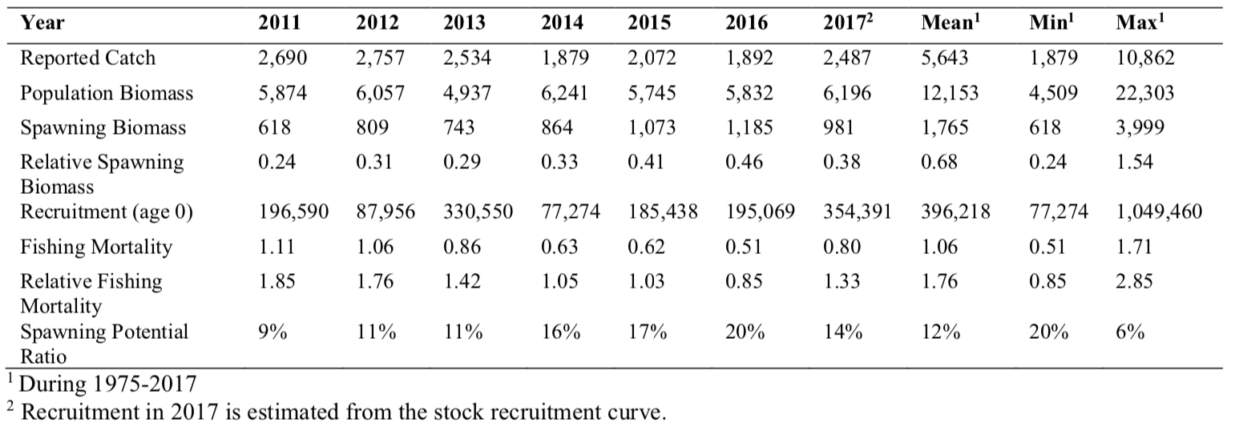
Table NMLS-01. Reported catch (t) used in the stock assessment along with annual estimates of population biomass (age-1 and older, t), female spawning biomass (t), relative female spawning biomass (SSB/SSB_{MSY}), recruitment (thousands of age-0 fish), fishing mortality (average F, ages-3 – 12), relative fishing mortality (F/F_{MSY}), and spawning potential ratio of WCNPO striped marlin.

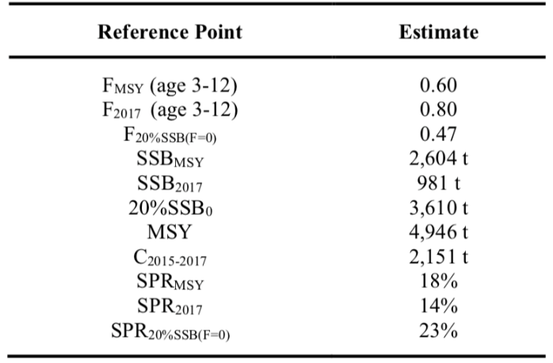
Table NMLS-02. Estimates of biological reference points along with estimates of fishing mortality (F), spawning stock biomass (SSB), recent average yield (C), and spawning potential ratio (SPR) of WCNPO MLS, derived from the base case model assessment model, where “MSY” indicates reference points based on maximum sustainable yield.

Table NMLS-03. Projected median values of WCNPO striped marlin spawning stock biomass (SSB, t), catch (t), and probability of reaching 20%SSB0 under five constant fishing mortality rate (F) and ten constant catch scenarios during 2018-2037. For scenarios which have a 60% probability of reaching the target of 20%SSB_{F=0}, the year in which this occurs is provided; NA indicates projections that did not meet this criterion. Note that 20%SSB_{F=0} is 3,610 t and SSB_{MSY} is 2,604 t.
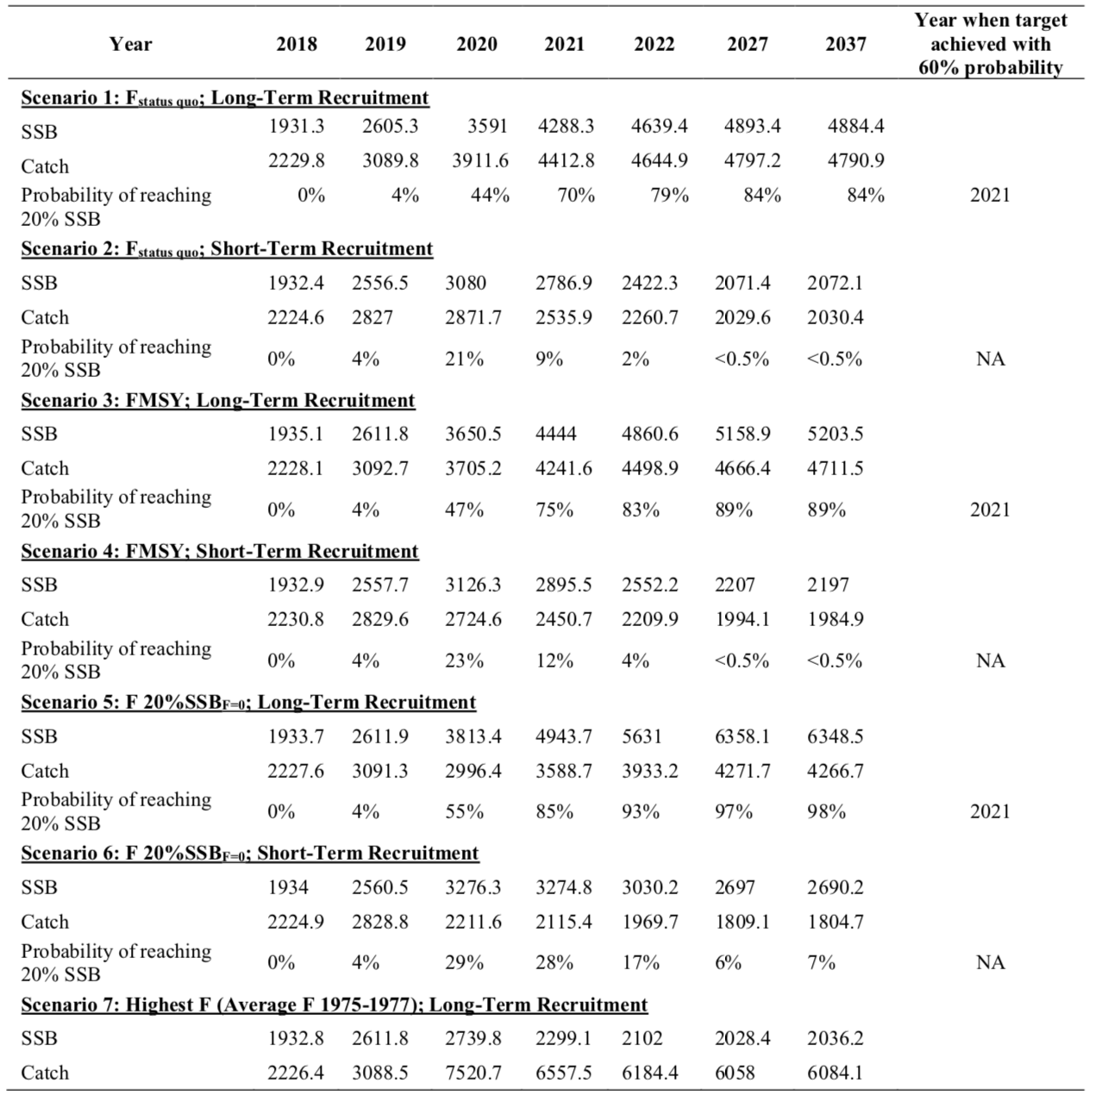
Table NMLS-03. (Continued)
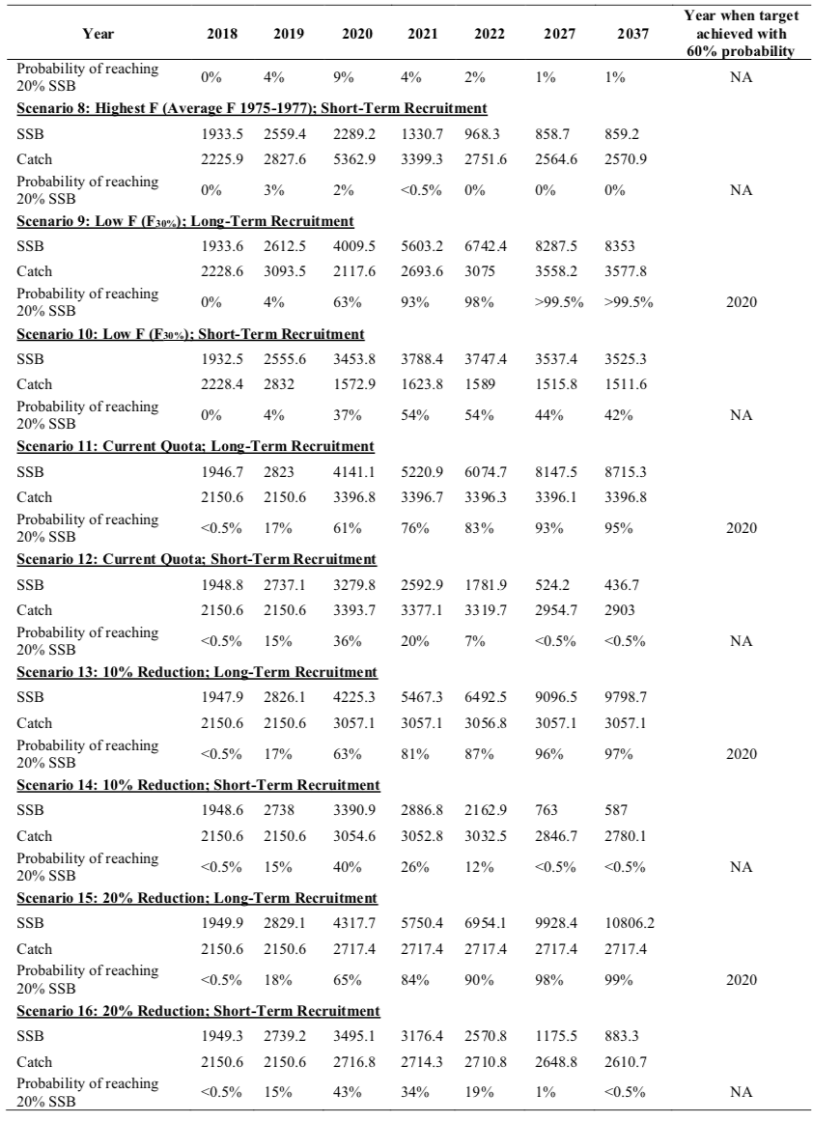

Table NMLS-03. (Continued)
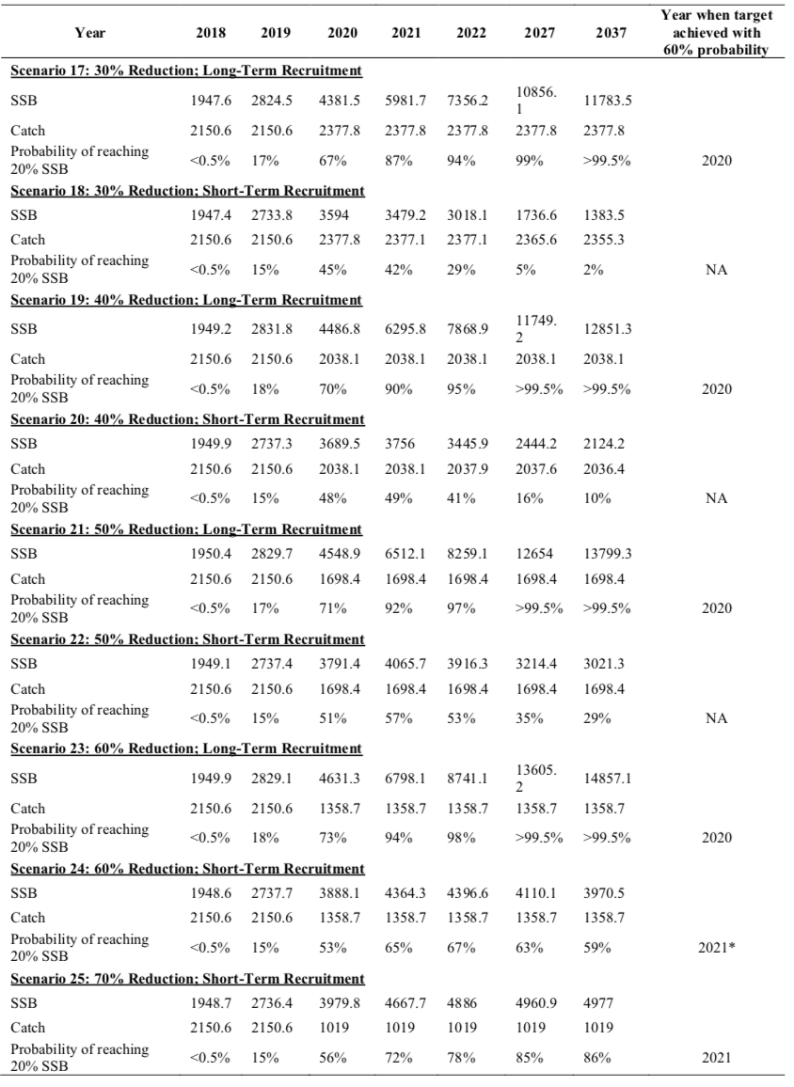

Table NMLS-03. (Continued)
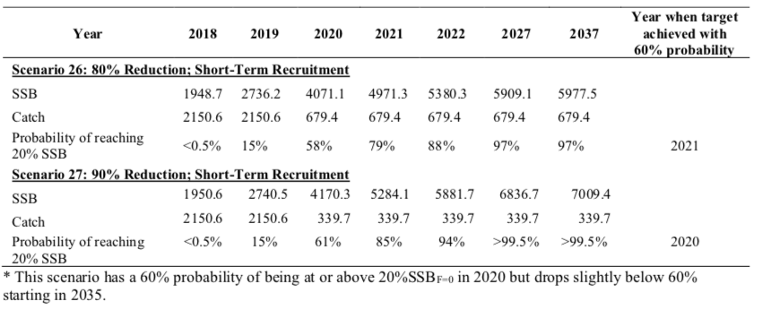

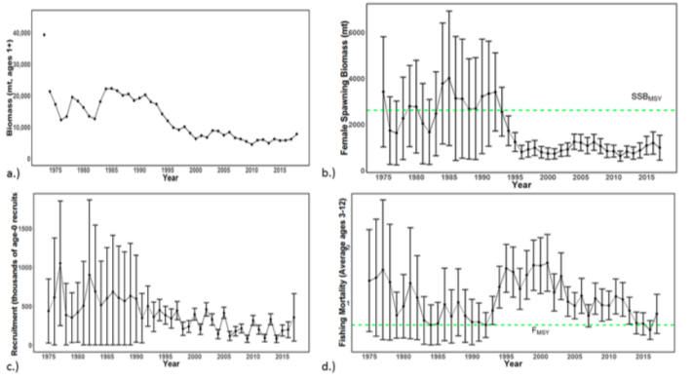 | 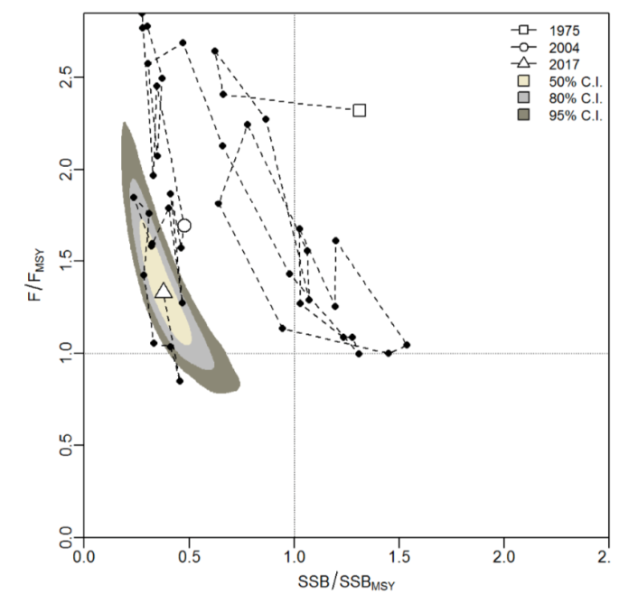
Figure NMLS-01. Time series of estimates of (a) population biomass (age 1+), (b) spawning biomass, (c) recruitment (age-0 fish), and (d) instantaneous fishing mortality (average for age 3-12, year-1) for WCNPO striped marlin (derived from the 2019 stock assessment. The circles represent the maximum likelihood estimates by year for each quantity and the error bars represent the uncertainty of the estimates (95% confidence intervals), green dashed lines indicate SSB_{MSY} and F_{MSY}. | Figure NMLS-02. Kobe plot of the time series of estimates of relative fishing mortality (average of age 3-12) and relative spawning stock biomass of WCNPO striped marlin during 1975-2017. The white square denotes the first year (1975) of the assessment, the white circle denotes 2004, and the white triangle denotes the last year (2017) of the assessment.
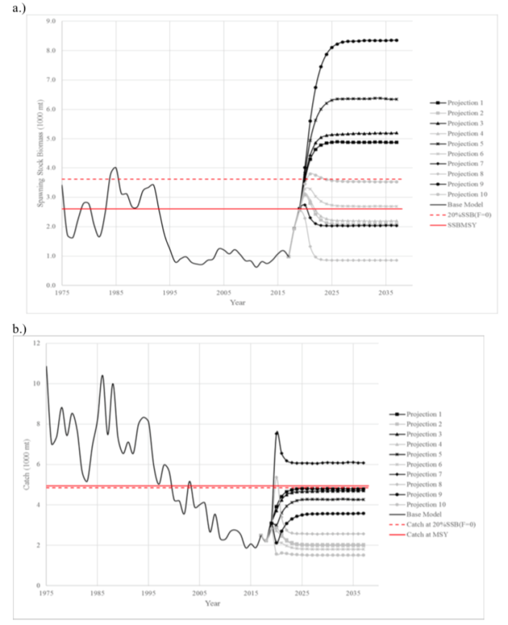 | 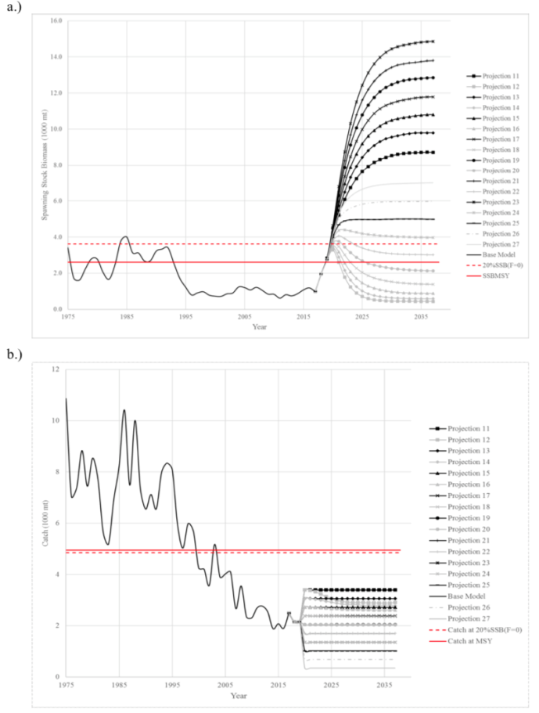
Figure NMLS-03. Historical and projected trajectories of spawning biomass and total catch from the WCNPO striped marlin base case model based upon F scenarios (projection 1-10): (a) projected spawning biomass and (b) projected catch. | Figure NMLS-04. Historical and projected trajectories of spawning biomass and total catch from the WCNPO striped marlin base case model based upon constant catch scenarios (projections 11-15): (a) projected spawning biomass; and (b) projected catch.

Note on Figure NMLS-3 and Figure NMLS-4: Black lines are the long-term recruitment scenario results; grey lines show the short-term recruitment scenario results. The red dashed line shows the catch or spawning stock biomass at 20%SSB_{F=0} and the solid red line is the catch or spawning stock biomass at SSB_{MSY}. The list of projection scenarios can be found in Table NMLS-03.

SC14 2018 (NO STOCK ASSESSMENT)

  - Stock status and trends

- SC14 noted that no stock assessments were conducted for North Pacific striped marlin in 2018. Therefore, the stock status descriptions from SC11 are still current for North Pacific striped marlin. Updated information on catches was not compiled for and reviewed by SC14.

- To emphasize the importance of developing a stock rebuilding plan for North Pacific striped marlin, SC14 reiterated the ISC15 stock status information, excerpted from SC11:

“Estimates of population biomass of the Western and Central North Pacific (WCNPO) striped marlin stock (Kajikia audax) exhibit a long-term decline (Table 1). Population biomass (age-1 and older) averaged roughly 20,513 mt, or 46% of unfished biomass during 1975-1979, the first 5 years of the assessment time frame, and declined to 6,819 mt, or 15% of unfished biomass in 2013. Spawning stock biomass is estimated to be 1,094 mt in 2013 (39% of SSBMSY, the spawning stock biomass to produce MSY). Fishing mortality on the stock (average F on ages 3 and older) is currently high and averaged roughly F =0.94 during 2010-2012, or 49% above FMSY. The predicted value of the spawning potential ratio (SPR, the predicted spawning output at current F as a fraction of unfished spawning output) is currently SPR2010-2012 = 12% which is 33% below the level of SPR required to produce MSY. Recruitment averaged about 308 thousand recruits during 1994-2011, which was 25% below the 1975-2013 average. No target or limit reference points have been established for the WCNPO striped marlin stock under the auspices of the WCPFC.

The WCNPO striped marlin stock is expected to be highly productive due to its rapid growth and high resilience to reductions in spawning potential. The status of the stock is highly dependent on the magnitude of recruitment, which has been below its long-term average since 2007, with the exception of 2010 (Table S1). Changes in recent size composition data in comparison to the previous assessment resulted in changes in fishery selectivity estimates and also affected recruitment estimates. This, in turn, affected the scaling of biomass and fishing mortality to reference levels.

Table S1: Reported annual values of catch (mt), poulation biomass (mt), spawning stock biomass (mt), relative spawning stock biomass SSB/SSBMSY), recruitment (000s), fishing mortality, relative fishing mortality (F/FMSY), exploitation rate, and spawning potential ration for the WCNPO striped marlin stock.
Year | 2007 | 2008 | 2009 | 2010 | 2011 | 2012 | 2013 | Mean1 | Min1 | Max1
Reported Catch | 3084 | 3503 | 2468 | 2852 | 3125 | 3521 | 2984 | 5822 | 2468 | 10594
Population Biomass | 6915 | 6773 | 6409 | 5156 | 7823 | 7349 | 6819 | 12758 | 5156 | 28440
Spawning Stock Biomass | 1192 | 1171 | 970 | 984 | 873 | 1013 | 1094 | 2025 | 815 | 6946
Relative Spawning Biomass | 0.42 | 0.42 | 0.34 | 0.35 | 0.31 | 0.36 | 0.39 | 0.75 | 0.29 | 2.46
Recruitment (age 0) | 240 | 242 | 63 | 496 | 155 | 224 | 352 | 410 | 63 | 1369
Fishing Mortality | 0.82 | 0.99 | 0.80 | 0.96 | 0.89 | 0.97 | 0.76 | 0.95 | 0.47 | 1.54
Relative Fishing Mortality | 1.29 | 1.57 | 1.27 | 1.51 | 1.41 | 1.53 | 1.20 | 1.50 | 0.74 | 2.44
Exploitation Rate | 45% | 52% | 39% | 55% | 40% | 48% | 44% | 48% | 32% | 65%
Spawning Potential Ratio | 15% | 12% | 16% | 13% | 12% | 12% | 14% | 13% | 7% | 24%
1 During 1975-2013

When the status of striped marlin is evaluated relative to MSY-based reference points, the 2013 spawning stock biomass is 61% below SSB_{MSY} (2819 t) and the 2010-2012 fishing mortality exceeds F_{MSY} by 49%. Therefore, overfishing is occurring relative to MSY-based reference points and the WCNPO striped marlin stock is overfished.”

  - Management advice and implications

- SC14 noted that no management advice has been provided since SC11 for North Pacific striped marlin. Therefore, previous advice should be maintained, pending a new assessment or other new information. For further information on the management advice and implications from SC11, please see below.

- To emphasize the importance of developing a stock rebuilding plan for North Pacific striped marlin, SC14 reiterated the following management advice and information, excerpted from SC11.

“SC11 noted the following conservation advice from ISC:
The stock has been in an overfished condition since 1977, with the exception of 1982 and 1983, and fishing appears to be impeding rebuilding especially if recent low recruitment levels persist.

Projection results show that fishing at FMSY could lead to median spawning biomass increases of 25%, 55%, and 95% from 2015 to 2020 under the recent recruitment, medium- term recruitment, and stock recruitment-curve scenarios.

Fishing at a constant catch of 2,850 t could lead to potential increases in spawning biomass of 19% to over 191% by 2020, depending upon the recruitment scenario.

In comparison, fishing at the 2010-2012 fishing mortality rate, which is 49% above FMSY, could lead to changes in spawning stock biomass of -18% to +18% by 2020, while fishing at the average 2001-2003 fishing mortality rate (F2001-2003=1.15), which is 82% above FMSY, could lead to spawning stock biomass decreases of -32% to -9% by 2020, depending upon the recruitment scenario.

SC11 expressed concerns about the updated stock status of WCNPO striped marlin, noting that the stock was overfished (SSB2013 at 61% below SSBMSY) and that overfishing was occurring (F2010-2012 exceeds FMSY by 49%). Although a LRP for billfish species has not been adopted by the WCPFC, SC11 noted that SSBcurrent/SSBcurrent,F=0=0.12 and is below the LRP adopted for tunas. SC11 also noted that projections indicate that Prob(SSB2020>SSB2015)<50% for all constant catch scenarios over 2,850 mt (under the three recruitment hypotheses modelled), which means that in order to allow the spawning biomass to rebuild then catches need to be reduced to less than 2,850mt. SC11 recommends that the Commission develop a rebuilding plan for North Pacific striped marlin with subsequent revision of CMM 2010-01 in order to improve stock status.”

  - Recommendations on the designation of North Pacific striped marlin as a Northern Stock

- Regarding the issue of the designation of North Pacific striped marlin as a Northern Stock (WCPFC14 Report, Para 378), SC14 provides the following recommendations:
- SC14 recommends that the Commission clarify and quantify what is meant by “mostly north of 20 degrees N”.
- In relation to paragraph 1, SC14 recommends that a check-list of benchmark scientific information for North Pacific striped marlin be developed to support the Commission’s deliberations in determining the designation of a northern stock. As such, the following table is forwarded for the Commission’s consideration.
No | Criteria | Response | Comments
1 | What proportion of the total estimated stock biomass occurs on average north of 20N? | *Proportion of biomass above 20 ºN is 2-4 times larger than the proportion of biomass south of 20 ºN in the North Pacific | WCPFC-SC14-2018/ SA-IP-011 This value was estimated by stock assessment result in 2007.
2 | Does all of the breeding/spawning area(s) occur north of 20 ºN? | Unknown
3 | Does all of the nursery area(s) occur north of 20 ºN | Unknown
4 | Do any other important life history stages occur south of 20N? | Unknown
5 | What proportion of the total estimated catch occurs north of 20 ºN? | **Range of annual percentages of 66%-96% above 20 ºN. During the 2000s the average percentage was 73% above 20 ºN | WCPFC-SC14-2018/ SA-IP-011 These values were estimated from stock assessment results in 2007, but were not endorsed by SC3.
6 | Is fishery catch-per-unit-effort demonstrably higher north of 20 ºN for comparable fisheries? | Unknown
7 | Is there sufficient information about fish movement between north and south of 20 ºN? | No
*Proportion of biomass was calculated in 1964 and 1969 that is near the initial condition.
**The average proportion of the total catch in numbers were calculated by decade (1950's-2000's).

SC13 2017 (NO STOCK ASSESSMENT)

- Stock status and trends

- SC13 noted that no stock assessments were conducted for these species in 2017. Therefore, the stock status descriptions from SC11 for North Pacific striped marlin are still current. Updated information on North Pacific striped marlin catches may be available in the ISC Plenary Report, but was not compiled for and reviewed by SC13.

- Management advice and implications

- SC13 noted that no conservation advice has been provided since SC11 for North Pacific striped marlin. Therefore, previous advice should be maintained, pending a new assessment or other new information.

Useful References

SC15-SA-WP-09 Stock Assessment Report for Striped Marlin (Kajikia audax) in the Western and Central North Pacific Ocean through 2017. https://www.wcpfc.int/node/42926

SC11-SA-WP-10 Stock assessment update for striped marlin (Kajikia audax) in the western and central North Pacific Ocean through 2013. ISC Billfish Working Group (International Scientific Committee for Tuna and Tuna-like Species in the North Pacific Ocean)
https://www.wcpfc.int/node/21780

For current information related to Northern Stocks Working Group Reports and the ISC Plenary Report:
http://isc.fra.go.jp/reports/isc/isc17_reports.html

Previous Assessments

SC8-SA-WP-10 Stock Assessment of North Pacific Striped Marlin https://wcpfc.int/node/3281

The rebuilding target, 20% SSB0, is estimated from the stock recruitment curve.

