**North Pacific Striped Marlin (Kajikia audax)**

**Stock Status &Trends plus Management Advice and Implications**

Contents

SC13 2017 1

SC12 2016 1

SC11 2015 (Stock Assessment Update Conducted) 2

Useful References 8

Previous Assessments 8

# SC13 2017

1. **Stock status and trends**
2. **SC13 noted that no stock assessments were conducted for these species in 2017. Therefore, the stock status descriptions from SC11 for North Pacific striped marlin are still current. Updated information on North Pacific striped marlin catches may be available in the ISC Plenary Report, but was not compiled for and reviewed by SC13.**
3. **Management advice and implications**
4. **SC13 noted that no conservation advice has been provided since SC11 for North Pacific striped marlin. Therefore, previous advice should be maintained, pending a new assessment or other new information.**

# SC12 2016

1. **Stock status and trends**
2. **SC12 noted that no stock assessments were conducted for these species in 2016. Therefore, the stock status descriptions from SC8 and SC11 for South Pacific striped marlin and North Pacific striped marlin are still current. Updated information on North Pacific striped marlin catches may be available in the ISC Plenary Report (SC12-GN-IP-02), and for South Pacific striped marlin in SC12-ST-IP-01, but was not compiled for and reviewed by SC12.**
3. **Management advice and implications**
4. **SC12 noted that no management advice has been provided since SC8 and SC11 for South Pacific striped marlin and North Pacific striped marlin, respectively. Therefore, previous advice should be maintained, pending a new assessment or other new information.**

# SC11 2015 (Stock Assessment Update Conducted)

1. J. Brodziak Chair of the ISC Billfish Working Group (BILLWG), presented ISC presented SC11-SA-WP-10 (Stock assessment update for striped marlin (Kajikia audax) in the western and central North Pacific Ocean through 2013). The Western and Central North Pacific striped marlin stock is separated from the Eastern North Pacific stock based on results of population genetic studies and empirical patterns in the spatial distribution of fishery catch-per-unit effort. The boundary of the Western and Central North Pacific stock is defined to be the waters of the Pacific Ocean west of 140°W and north of the equator. (Figure S1).

**Discussion**

1. Australia noted that SPC does a full grid of structural uncertainties and it is disappointing that ISC doesn’t do the same thing; it was hoped ISC can do so in the future. Australia stated that the CPUE indices used in the assessment were discontinuous at two points in the time-series and queried how the assessment scaled the biomass before and after these split years. Australia also stated that fitting 16 different CPUE indices to the model, with each being equally weighted, may compromise the estimated abundance trends because some CPUE indices appear to show a conflict trend.
2. Brodziak explained that CPUE breaks are based on changes in fishing practices and deployments that affect striped marlin. The basic impact of this is a less contiguous time series. The index is scaled based on catchability co-efficient as calculated in the stock synthesis. Each block has its own estimates.
3. Australia noted that the assessment indicated that around 50% of the adult biomass is being caught each year and a lengthy discussion took place about the biological plausibility of this result. Brodziak noted that a number of stocks have experienced 50% catch of the standing stock each year and most of them stayed in an overfished state for a long time. This particular species grows very rapidly, is more long lived and is very fecund; it has a strong “bounceback” potential. The difference between this and the Pacific tunas - which have steepnessess between 0.65-0.95 – whereas the steepness for this stock is 0.87. This difference in steepness is important as this species is quite resilient, however recruitment is a problem: this species is patchily distributed and the number assumes the animals can find mates; it is possible that this is occurring for this species, and chronic overfishing is not good.
4. FFA members expressed concern over the worsening state of this species. In the 2015 assessment, the North Pacific striped marlin stock, being evaluated relative to MSY-based reference points, was overfished and overfishing was occurring. The 2013 spawning stock biomass is 61% below SBMSY and the 2010-2012 fishing mortality exceeds FMSY by 49%. These CCMs stated that CMM 2010-01 appears not to be working to reduce the total catch of striped marlin north of the equator and asked that the SC11 advice reflects these trends. The SC11 advice should include more stringent measures like catch limits and reduction in fishing mortality to allow rehabilitation of the stock.
5. Australia queried the domed-shaped selectivity found for the longline fleets, noting that the assessment undertaken on south Pacific striped marlin in 2012 had estimated asymptotic selectiveness for most longline fleets, and asked what might be causing the differences. Brodziak commented that in the 2011 assessment, logistic curves were used for all fleets but the results were not plausible for the biomass trends. No systematic evaluation was undertaken as this was not a benchmark analysis, it was an update and what was found in the past was propagated into this current evaluation.
6. FFA members expressed grave concern that the stock has been in an overfished condition since 1977, with the exception of 1982 and 1983, and fishing appears to be impeding rebuilding. They noted that the conservation advice states this is especially true if recent (2007-2011) low recruitment levels persist below its long-term average since 2004. FFA members underscored the urgency to recover this stock and stated that this should not be dismissed because the species is resilient. North Pacific striped marlin is caught as bycatch in some of FFA EEZs north of the equator. It also forms an important component of these CCMs’ domestic fisheries and recreational sector. FFA members supported SC11 advice reflecting a requirement to substantially reduce fishing mortality and catch.
7. On the issue of ratio of the catch as a ratio of current biomass, Japan gave the example of skipjack. Its total biomass is about 3.6 million mt and current catch is 2 million mt. Taking note of FFA members’ comments Japan had doubts about the result of the stock assessment. This was an update assessment, but it is very different from the past assessment – fishing mortality was going up and down against FMSY but now looks like it is continuously above FMSY. As this is an update and there is a difference from previous fishing mortality, this CCM suggests there is a change in perception about whether stock would bounce back when at FMSY. Japan suggested a recommendation requesting the Commission to take action based on the stock assessment from ISC. The wording could be SC11 notes the stock status and conclusions for North Pacific striped marlin provided by ISC. SC11 has concerns about the stock status and current catch.

**4.4.3.2 Provision of scientific information**

**a. Status and trends**

1. **SC11 noted the stock status and conclusions for North Pacific striped marlin provided by ISC in SC11-*SA-WP-10*.**

***“Estimates of population biomass of the Western and Central North Pacific (WCNPO) striped marlin stock (Kajikia audax) exhibit a long-term decline (Table S1 and Figure S2). Population biomass (age-1 and older) averaged roughly 20,513 mt, or 46% of unfished biomass during 1975-1979, the first 5 years of the assessment time frame, and declined to 6,819 mt, or 15% of unfished biomass in 2013. Spawning stock biomass is estimated to be 1,094 mt in 2013 (39% of SSBMSY, the spawning stock biomass to produce MSY, Figure S3). Fishing mortality on the stock (average F on ages 3 and older) is currently high (Figure S4) and averaged roughly F = 0.94 during 2010-2012, or 49% above FMSY. The predicted value of the spawning potential ratio (SPR, the predicted spawning output at current F as a fraction of unfished spawning output) is currently SPR2010-2012 = 12% which is 33% below the level of SPR required to produce MSY. Recruitment averaged about 308 thousand recruits during 1994-2011, which was 25% below the 1975-2013 average. No target or limit reference points have been established for the WCNPO striped marlin stock under the auspices of the WCPFC.***

***The WCNPO striped marlin stock is expected to be highly productive due to its rapid growth and high resilience to reductions in spawning potential. The status of the stock is highly dependent on the magnitude of recruitment, which has been below its long-term average since 2007, with the exception of 2010 (Table S1). Changes in recent size composition data in comparison to the previous assessment resulted in changes in fishery selectivity estimates and also affected recruitment estimates. This, in turn, affected the scaling of biomass and fishing mortality to reference levels (Figure S6).***

***When the status of striped marlin is evaluated relative to MSY-based reference points, the 2013 spawning stock biomass is 61% below SSBMSY (2819 t) and the 2010-2012 fishing mortality exceeds FMSY by 49% (Figures S3, S4, and S5). Therefore, overfishing is occurring relative to MSY-based reference points and the WCNPO striped marlin stock is overfished.”***



**Figure S1:** Stock boundary for the stock assessment update of Western and Central North Pacific Ocean striped marlin (WCNPO) as indicated by the blue lines. Red lines indicate the WCPFC convention area.

**Table S1:** Reported annual values of catch (mt) and posterior mean values of exploitable biomass (B, mt), relative biomass (*B/BMSY*), harvest rate (percent of exploitable biomass), relative harvest rate (*H/HMSY*), and probability of annual harvest rate exceeding HMSY for the WCNPO striped marlin stock.

|  |  |  |  |  |  |  |  |  |  |  |
| --- | --- | --- | --- | --- | --- | --- | --- | --- | --- | --- |
| **Year** | **2007** | **2008** | **2009** | **2010** | **2011** | **2012** | **2013** | **Mean1** | **Min1** | **Max1** |
| Reported Catch | 3084 | 3503 | 2468 | 2852 | 3125 | 3521 | 2984 | 5822 | 2468 | 10594 |
| Population Biomass | 6915 | 6773 | 6409 | 5156 | 7823 | 7349 | 6819 | 12758 | 5156 | 28440 |
| Spawning Stock Biomass | 1192 | 1171 | 970 | 984 | 873 | 1013 | 1094 | 2025 | 815 | 6946 |
| Relative Spawning Biomass | 0.42 | 0.42 | 0.34 | 0.35 | 0.31 | 0.36 | 0.39 | 0.75 | 0.29 | 2.46 |
| Recruitment (age 0) | 240 | 242 | 63 | 496 | 155 | 224 | 352 | 410 | 63 | 1369 |
| Fishing Mortality | 0.82 | 0.99 | 0.80 | 0.96 | 0.89 | 0.97 | 0.76 | 0.95 | 0.47 | 1.54 |
| Relative Fishing Mortality | 1.29 | 1.57 | 1.27 | 1.51 | 1.41 | 1.53 | 1.20 | 1.50 | 0.74 | 2.44 |
| Exploitation Rate | 45% | 52% | 39% | 55% | 40% | 48% | 44% | 48% | 32% | 65% |
| Spawning Potential Ratio | 15% | 12% | 16% | 13% | 12% | 12% | 14% | 13% | 7% | 24% |

1 During 1975-2013



**Figure S2**. Trend in population biomass and reported catch biomass of Western and Central North Pacific striped marlin (*Kajikia audax*) during 1975-2013.



**Figure S3**. Trends in estimates of spawning biomass of Western and Central North Pacific striped marlin (*Kajikia audax*) during 1975-2013 along with 80% confidence intervals.



**Figure S4**. Trends in estimates of fishing mortality of Western and Central North Pacific striped marlin (*Kajikia audax*) during 1975-2013 along with 80% confidence intervals.



**Figure S5**. Kobe plot of the trends in estimates of relative fishing mortality and relative spawning biomass of Western and Central North Pacific striped marlin (*Kajikia audax*) during 1975-2013.

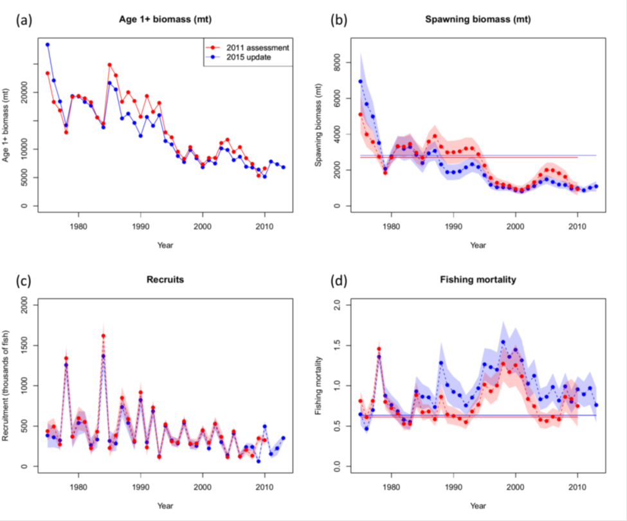

**Figure S6.** Comparison of time series of total biomass (age 1 and older) (a), spawning biomass (b), age-0 recruitment (c), and instantaneous fishing mortality (year-1) (d) for the WCNPO striped marlin between the 2011 stock assessment (red) and the 2015 update (blue). The solid line with circles represents the maximum likelihood estimates for each quantity and the shadowed area represents the 95% asymptotic intervals of the estimates (± 1.96 standard deviations). The solid horizontal lines indicated the MSY-based reference points for 2011 (red) and 2015 (blue).

**b. Management advice and implications**

1. **SC11 noted the following conservation advice from ISC.**

***“The stock has been in an overfished condition since 1977, with the exception of 1982 and 1983, and fishing appears to be impeding rebuilding especially if recent low recruitment levels persist.***

***Projection results show that fishing at FMSY could lead to median spawning biomass increases of 25%, 55%, and 95% from 2015 to 2020 under the recent recruitment, medium-term recruitment, and stock recruitment-curve scenarios.***

***Fishing at a constant catch of 2,850 t could lead to potential increases in spawning biomass of 19% to over 191% by 2020, depending upon the recruitment scenario.***

***In comparison, fishing at the 2010-2012 fishing mortality rate, which is 49% above FMSY, could lead to changes in spawning stock biomass of -18% to +18% by 2020, while fishing at the average 2001-2003 fishing mortality rate (F2001-2003=1.15), which is 82% above FMSY, could lead to spawning stock biomass decreases of -32% to -9% by 2020, depending upon the recruitment scenario.”***

1. **SC11 expressed concerns about the updated stock status of WCNPO striped marlin, noting that the stock was overfished (SSB2013 at 61% below SSBMSY) and that overfishing was occurring (F2010-2012 exceeds FMSY by 49%). Although a LRP for billfish species has not been adopted by the WCPFC, SC11 noted that SSBcurrent/SSBcurrent,F=0=0.12 and is below the LRP adopted for tunas. SC11 also noted that projections indicate that Prob(SSB2020>SSB2015)<50% for all constant catch scenarios over 2,850 mt (under the three recruitment hypotheses modelled), which means that in order to allow the spawning biomass to rebuild then catches need to be reduced to less than 2,850mt.**
2. **SC11 recommends that the Commission develop a rebuilding plan for North Pacific striped marlin with subsequent revision of CMM 2010-01 in order to improve stock status.**

# Useful References

SC11-SA-WP-10 Stock assessment update for striped marlin (Kajikia audax) in the western and central North Pacific Ocean through 2013. ISC Billfish Working Group (International Scientific Committee for Tuna and Tuna-like Species in the North Pacific Ocean)

<https://www.wcpfc.int/node/21780>

For current information related to Northern Stocks Working Group Reports and the ISC Plenary Report:

<http://isc.fra.go.jp/reports/isc/isc17_reports.html>

# Previous Assessments

SC8-SA-WP-10 Stock Assessment of North Pacific Striped Marlin <https://wcpfc.int/node/3281>