The Commission for the Conservation and Management of
Highly Migratory Fish Stocks in the Western and Central Pacific Ocean

Scientific Committee

Pacific Blue Marlin (Makaira nigricans)

Stock Status and Management Advice

Contents
SC13, 2017 – SC15, 2019 (NO STOCK ASSESSMENTS) 2
SC12 2016 (STOCK ASSESSMENT CONDUCTED) 2
Useful References 5
Previous Assessments 5

SC13, 2017 – SC15, 2019 (NO STOCK ASSESSMENTS)

- Stock Status and trends

- SC15 noted that no stock assessments were conducted for Pacific blue marlin in 2019. Therefore, the stock status descriptions from SC12 are still current for Pacific blue marlin. For further information on the stock status and trends from SC12, please see https://www.wcpfc.int/node/27769. Updated information on catches was not compiled for and reviewed by SC15.

- Management Advice and implications

- SC15 noted that no management advice has been provided since SC12 for Pacific blue marlin. Therefore, previous advice should be maintained, pending a new assessment or other new information. For further information on the management advice and implications from SC12, please see https://www.wcpfc.int/node/27769

SC12 2016 (STOCK ASSESSMENT CONDUCTED)

Stock status and trends

- SC12 noted the stock status for Pacific blue marlin provided by ISC in SC12-GN-IP-02 and SC12-SA-WP-12:
Estimates of total BUM stock biomass show a long term decline. Population biomass (age-1 and older) averaged roughly 130,965 t in 1971-1975, the first 5 years of the assessment time frame, and has declined by approximately 40% to 78,082 t in 2014 (Figure 7-11). Female spawning biomass was estimated to be 24,809 t in 2014, or about 25% above SSBMSY (Table 7-3 and Table 7-4). Fishing mortality on the stock (average F, ages 2 and older) averaged roughly F = 0.28 during 2012-2014, or about 12% below FMSY. The estimated spawning potential ratio of the stock (SPR, the predicted spawning output at the current F as a fraction of unfished spawning output) is currently SPR2012-2014 = 21%. Annual recruitment averaged about 897,000 recruits during 2008-2014, and no long-term trend in recruitment was apparent. Overall, the time series of spawning stock biomass and recruitment estimates indicate a long-term decline in spawning stock biomass and suggest a fluctuating pattern without trend for recruitment (Figure 7-11).

Table 7-3. Reported catch (t) used in the stock assessment along with annual estimates of population biomass (age-1 and older, t), female spawning biomass (t), relative female spawning biomass (SSB/SSBMSY), recruitment (thousands of age-0 fish), fishing mortality (average F, ages-2 and older), relative fishing mortality (F/FMSY), and spawning potential ratio of Pacific blue marlin.

Year | 2008 | 2009 | 2010 | 2011 | 2012 | 2013 | 2014 | Mean¹ | Min¹ | Max¹
Reported Catch | 17,828 | 18,282 | 20,086 | 18,165 | 19,407 | 20,727 | 20,356 | 18,232 | 9,160 | 25,589
Population Biomass | 71,768 | 69,720 | 72,696 | 72,995 | 76,697 | 78,761 | 78,082 | 101,149 | 69,720 | 135,623
Spawning Biomass | 22,706 | 23,065 | 22,392 | 23,182 | 23,432 | 24,771 | 24,809 | 41,717 | 20,972 | 71,807
Relative Spawning Biomass | 1.14 | 1.16 | 1.13 | 1.17 | 1.18 | 1.25 | 1.25 | 2.10 | 1.06 | 3.62
Recruitment (age 0) | 687 | 1031 | 702 | 1061 | 763 | 909 | 839 | 897 | 589 | 1181
Fishing Mortality | 0.27 | 0.29 | 0.30 | 0.26 | 0.27 | 0.28 | 0.28 | 0.22 | 0.09 | 0.38
Relative Fishing Mortality | 0.82 | 0.88 | 0.92 | 0.82 | 0.83 | 0.87 | 0.87 | 0.67 | 0.26 | 1.17
Spawning Potential Ratio | 22% | 21% | 20% | 22% | 22% | 21% | 21% | 31% | 15% | 51%
¹ During 1971-2014
Table 7-4. Estimates of biological reference points along with estimates of fishing mortality (F), female spawning stock biomass (SSB), recent average yield (C), and spawning potential ratio (SPR) of BUM, derived from the base case model assessment model, where “MSY” and “20%” indicate reference points based on maximum sustainable yield and a spawning potential ratio of 20%, respectively.
Reference Point | Estimate
F_{MSY} (age 2+) | 0.32
F20% (age 2+) | 0.30
F2012-2014 (age 2+) | 0.28
SSBMSY | 19,853 mt
SSB20% | 22,727 mt
SSB2014 | 24,809 mt
MSY | 19,901 mt
C2012-2014 | 20,163 mt
SPRMSY | 0.18
SPR2012-2014 | 0.21
Note: SSB values represent female spawning biomass only.

The Kobe plot depicts the stock status relative to MSY-based reference points for the base case model (Figure 7-12) and shows that spawning stock biomass decreased to roughly the MSY level in the mid-2000s, and has increased slightly in recent years (Table 7-4 and Figure 7-11).Based on the results of this 2016 stock assessment update, the Pacific blue marlin stock is not currently overfished and is not experiencing overfishing. Because Pacific blue marlin is mainly caught as bycatch, direct control of the annual catch amount through the setting of a total allowable catch may be difficult.”

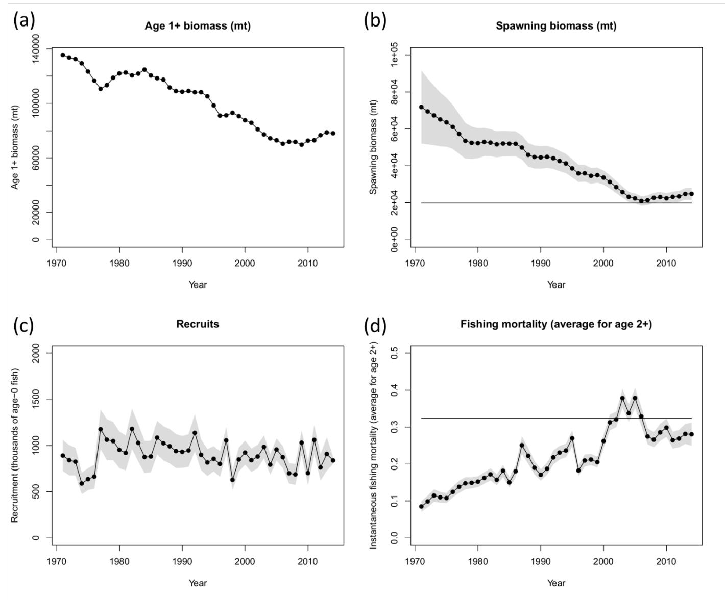
Figure 7-11. Time series of estimates of (a) population biomass (age 1+), (b) female spawning biomass, (c) recruitment (age-0 fish), and (d) instantaneous fishing mortality (average for age 2+, year-1) for BUM derived from the 2016 stock assessment update. The solid circles represents the maximum likelihood estimates by year for each quantity and the shadowed area represents the uncertainty of the estimates (± 1 standard deviation), except for the total biomass time series. The solid horizontal lines indicate the MSY- based reference points for spawning biomass and fishing mortality.

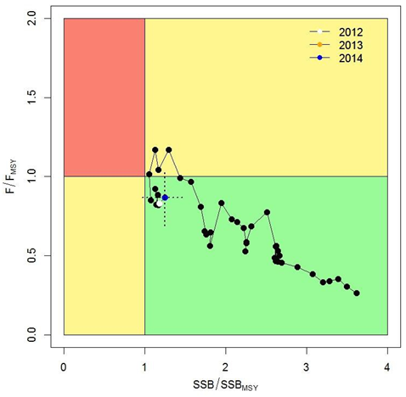 | Figure 7-12. Kobe plot of the time series of estimates of relative fishing mortality (average of age 2+) and relative spawning stock biomass of BUM during 1971-2014. The dashed lines denote the 95% confidence intervals for the estimates in the year 2014.

Management advice and implications

- SC12 noted the conservation advice for Pacific blue marlin provided by ISC in SC12-GN-IP-02 and SC12-SA-WP-12:

Since the stock is nearly full exploited, the ISC recommends that fishing mortality remain at or below current levels (2012-2014).

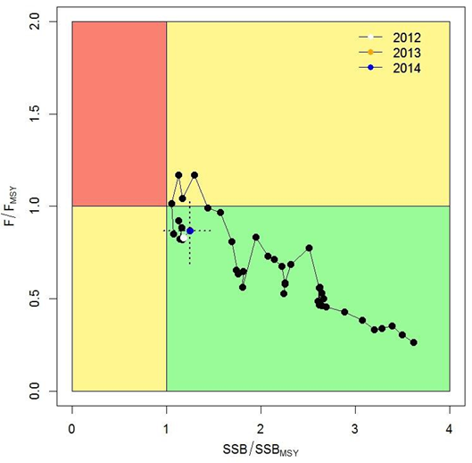 | Figure 7-12. Kobe plot of the time series of estimates of relative fishing mortality (average of age 2+) and relative spawning stock biomass of BUM during 1971-2014. The dashed lines denote the 95% confidence intervals for the estimates in the year 2014.

Useful References

SC12-GN-IP-02 Report of the 16th Meeting of the International Scientific Committee for Tuna and Tuna-like Species in the North Pacific Ocean. ISC (International Scientific Committee for Tuna and Tuna-like Species in the North Pacific Ocean) https://wcpfc.int/node/27556

SC12-SA-WP12 Stock Assessment Update for Blue Marlin (Makaira nigricans) in the Pacific Ocean through 2014. ISC Billfish Working Group. https://wcpfc.int/node/27549

For current information related to Northern Stocks Working Group Reports and the ISC Plenary Report:
http://isc.fra.go.jp/reports/isc/isc18_reports.html

Previous Assessments

SC9-SA-WP-09 Stock Assessment of Blue Marlin in the Pacific Ocean in 2013 (Replacement Document 31 July 2013) https://wcpfc.int/node/4732

