Pacific Blue Marlin (Makaira nigricans)
Stock Status &Trends plus Management Advice and Implications

Contents
SC14 2018 1
SC13 2017 1
SC12 2016 2
SC12 2015 (Benchmark Stock Assessment Update Conducted) 3
Useful References 9
Previous Assessments 9

SC14 2018
Stock Status

SC14 noted that no stock assessments were conducted for Pacific blue marlin in 2018. Therefore, the stock status descriptions from SC12 are still current for Pacific blue marlin. Updated information on catches was compiled but not reviewed by SC14.

Management Advice

SC14 noted that no management advice has been provided since SC12 for Pacific blue marlin. Therefore, previous advice should be maintained, pending a new assessment or other new information. For further information on the management advice and implications from SC12, please see below.

SC13 2017

- Stock status and trends

- SC13 noted that no stock assessment was conducted for this species in 2017. Therefore, the stock status descriptions from SC12 for Pacific blue marlin are still current. Updated information on Pacific blue marlin catches may be available in the ISC Plenary Report, but was not compiled for and reviewed by SC13.

- Management advice and implications

- SC13 noted that no conservation advice has been provided since SC12 for Pacific blue marlin. Therefore, previous advice should be maintained, pending a new assessment or other new information.

SC12 2016

- Stock status and trends

- SC12 noted that no stock assessments were conducted for these species in 2016. Therefore, the stock status descriptions from SC8 and SC11 for South Pacific striped marlin and North Pacific striped marlin are still current. Updated information on North Pacific striped marlin catches may be available in the ISC Plenary Report (SC12-GN-IP-02), and for South Pacific striped marlin in SC12-ST-IP-01, but was not compiled for and reviewed by SC12.
- Management advice and implications

- SC12 noted that no management advice has been provided since SC8 and SC11 for South Pacific striped marlin and North Pacific striped marlin, respectively. Therefore, previous advice should be maintained, pending a new assessment or other new information.

SC12 2015 (Benchmark Stock Assessment Update Conducted)

- J. Brodziak, Chair of the ISC Billfish Working Group (ISC BILLWG) presented SC12-SA-WP-12 an update of the benchmark stock assessment for the Pacific blue marlin (Makaira nigricans) stock conducted in 2013 by the ISC Billfish Working Group (BILLWG). The 2016 assessment update consisted of applying a Stock Synthesis model with newly available catch, abundance index, and length and size composition data for 1971-2014. We used the same model structure and parameters as were used in the base case run from the 2013 stock assessment. The results indicated that biomass (age 1 and older) for the Pacific blue marlin stock fluctuated around 120,000 metric tons from 1971 until 1984, thereafter exhibited a long-term decline to the lowest level of 69,720 metric tons in 2009, and then increased to around 78,000 metric tons during the last three years of the assessment (2012-2014). Estimated fishing mortality gradually increased from the early 1970s to the mid-2000s, peaked at 0.38 year-1 in 2005 in response to higher catches, and declined to 0.28 year-1 in the most recent years (2012-2014). Compared to MSY-based reference points, the current spawning biomass (average for 2012-2014) was 23% above SSBMSY and the current fishing mortality (average for ages 2 and older in 2012-2014) was 14% below FMSY. The base case model indicated that under current conditions the Pacific blue marlin stock was not overfished and was not subject to overfishing relative to MSY-based reference points.

Discussion

- Australia asked why the assessment broke the Japanese fleet time series data into early and late time series, wondering about the quality of data before then and implications for uncertainty.
- The ISC BILLWG Chair explained that there was a change in logbook reporting from 1993 a change in logbook reporting, so the series breaks in 1993/94. The two series have an overall mean square error for each series fitting to the data. Regarding data quality, it was expected that the more recent logbook period would be better, but the previous period was not considered to be poor quality.
- Australia noted that the Hawaiian longline CPUE data was based on observer data and showed a reasonably strong decline over a ten year period and asked about the data quality of the catch series.
- The ISC BILLWG Chair noted that catch data is very good, noting that the Japanese fleet data is collected from all over the distribution areas and the Hawaii observer data is collected from the edge of the distribution areas. From the 1990s to the present fishers were unable to operate in the area efficiently. As the Hawaii had run up against its bigeye tuna quota and was shut down within the year in recent years, it has expanded into the north east Pacific region. The CPUE for the longline in Hawaii excluded the shallow set and only considers the deep-set sector, which has an impact on blue marlin even though it is not the target. There is a strong negative correlation between the Hawaii CPUE and other CPUEs, with one showing a decline and the other flat with some variation. The ISC BILLWG Chair commented that using the Japanese early longline data combined with the Hawaii longline and excluding other series you get an overfished stock, and directed interested CCMs to the sensitivity analyses in the assessment.
- Australia commented that the spawning biomass trend in the last year was 35% of what it was in 1971 and asked what the depletion might have been prior to that, given the fishery was operating in the 1950s.
- The ISC BILLWG Chair confirmed that the estimated unfished biomass is included in the paper and noted that including the large catch time series starting in 1952 gives a similar trajectory, assuming a low catch of around 1000 mt to initialise the model. It was noted that ISC ran this as an alternative model in the previous benchmark analysis. It was reported that there were diverse opinions in the working group about the quality of pre-1971 data around whether it was better to start in 1971 with a stock that had experienced fishing, or start in 1952 noting that the time series catches were not as well determined.
- Australia suggested that for the next assessment it would be useful for the analysis to go back to 1952 using Japanese data as a sensitivity and to provide alternatives.
- SPC (J. Hampton) expressed surprised by how well the size data, even in aggregate form, were fitted by the model and asked whether there was process error in the selectivities.
- The ISC BILLWG Chair emphasised that they are not as good when looking at the individual fits to the standardised residuals, but on an expected value sense, the difference between observed and predicted over the entire time period, they are a good fit with flexible selectivity functions. It was noted that the Japanese longline had data above 100,000 blue marlin fish lengths, which was a huge dataset, and there had been consistency measuring blue marlin. Regarding process error in the model, the ISC BILLWG Chair noted that if there is a good estimate of life history parameters, fitting the size data could be expected.
- FFA members expressed concern that spawning stock biomass estimates declined to their lowest level of 20,972 metric tons in 2006, and only increased slightly in 2014, and the time-series of spawning stock biomass at the beginning of the spawning cycle has continued dropping to now be only 21% of the unfished SSB in 2010−2014. These CCMs considered that the paper’s conclusion that the stock is not overfished could be misleading, given that the spawning biomass is close to the LRP used for tropical tunas, and asked that their concerns over the long-term reduction in spawning biomass be reflected in advice to the Commission. They noted that any assessment of this species should be carried out by SPC as the distribution pattern of this species was Commission-wide. As it was a shared stock also caught in FFA EEZs, these CCMs stated a preference to be involved as it would require FFA members’ operational data.
- Indonesia asked if the ISC BILLWG Chair had any candidate management measures for this species.
- The ISC BILLWG Chair noted that SC had not been asked to develop management measure for this species, but to establish its status. In the table, F20% is very similar to those used for tropical tunas but assumed value of spawning depletion may not be the same for various species. It was explained that blue marlin is a highly evolved animal, designed to grow big, fast, with high potential resilience. The resilience estimated for striped marlin was used for this species in the stock assessment. The ISC BILLWG Chair noted that the spawning potential ratio to produce MSY was 18%, which indicates the spawning biomass can be reduced to 18% of the unfished level and be at the point of best yield. It was noted that this species was not caught much in purse-seine, but is caught as bycatch. It was valuable for recreational fishing and it was important to maintain stock sizes for that. Longline fishing mortality should not be increased and the stock should continue to be monitored.
- Japan noted FFA’s sense of urgency about this species and noted that the Commission differs from other RFMOs using BMSY as the target; WCPFC essentially requires an LRP at BMSY. This CCM agreed that the stock had declined to just above MSY, but was still above MSY; the effort should not be increased.
- Australia reminded the meeting that MSY-based reference points depended on knowing the stock recruitment relation and the value of the steepness parameter which is often highly uncertain. Comments referencing the status of the stock against MSY-based reference points, which correspond to a relatively low level of stock depletion for blue marlin, can also be highly uncertain. The blue marlin stock assessment assumes a value of steepness of 0.87 which is quite high; whether it may be a reasonable value for blue marlin remains uncertain. This CCM noted that if the value of steepness was lower that the value assumed, the corresponding status of the stock may be below the MSY-reference points noted in the table of results for the present assessment.
- The ISC BILLWG Chair noted that the use of steepness had been carefully considered in the assessment and update, noting that steepness is effectively a function of life history parameters, reproductive ecology, and density-dependent patterns in life history parameters that are used for stock assessment. It was also noted that research published in 1999 estimated maximum reproductive rates of some 246 fish stocks using mixed effects analyses and produced an associated estimates of steepness of about h≈0.9 for swordfish, the only billfish analysed (i.e., Myers, R. et. al. 1999. The maximum reproductive rate of fish at low population sizes. Canadian Journal of Fisheries and Aquatic Sciences 56:2404–2419). We took an independent approach based on the simulation of populations comprised of individual fish and the calculation of how many offspring females could produce given a suite of life history parameters. The median estimate of steepness was h=0.87 for North Pacific striped marlin and this value was used for Pacific blue marlin in both the 2013 and 2016 assessments. In comparison, the median estimate for Pacific bluefin tuna was about h≈0.91 (Mangel et al. 2010). There remained uncertainty about the calculation and this was characterised through the sensitivity analysis, all information relating to which is in the assessment.
- EU noted that the current management objective set by this Commission in both the Convention and the tropical tuna CMM are bound by MSY-based management objectives.
- SPC asked whether ISC could make the data available for others to look at, as SPC does for its assessments. The ISC BILLWG Chair suggested contacting the ISC Chair and Secretariat and the question could be considered by ISC plenary. It was noted that observers are also welcome to participate in the ISC meetings and the next ISC BILLWG meeting was set for March 2017.
- FFA members supported the ISC conservation advice for this species, but suggested tightening the language, i.e. ‘To avoid overfishing of this nearly fully exploited stock (F/F_{MSY} = 0.88) fishing mortality and catch rates should not be increased from the current (2012-2014) level.’ These CCMs consider that the new text was consistent with SC9’s advice, and reflects the average SSB from 2010−2014 which was estimated to be at 21% of unfished SSB.

4.4.3.2 Provision of scientific information

a. Status and trends

- SC12 noted the stock status for Pacific blue marlin provided by ISC in
SC12-GN-IP-02 and SC12-SA-WP-12:

Estimates of total BUM stock biomass show a long term decline. Population biomass (age-1 and older) averaged roughly 130,965 t in 1971-1975, the first 5 years of the assessment time frame, and has declined by approximately 40% to 78,082 t in 2014 (Figure 7-11). Female spawning biomass was estimated to be 24,809 t in 2014, or about 25% above SSBMSY (Table 7-3 and Table 7-4). Fishing mortality on the stock (average F, ages 2 and older) averaged roughly F = 0.28 during 2012-2014, or about 12% below FMSY. The estimated spawning potential ratio of the stock (SPR, the predicted spawning output at the current F as a fraction of unfished spawning output) is currently SPR2012-2014 = 21%. Annual recruitment averaged about 897,000 recruits during 2008-2014, and no long-term trend in recruitment was apparent. Overall, the time series of spawning stock biomass and recruitment estimates indicate a long-term decline in spawning stock biomass and suggest a fluctuating pattern without trend for recruitment (Figure 7-11).
Table 7-3. Reported catch (t) used in the stock assessment along with annual estimates of population biomass (age-1 and older, t), female spawning biomass (t), relative female spawning biomass (SSB/SSBMSY), recruitment (thousands of age-0 fish), fishing mortality (average F, ages-2 and older), relative fishing mortality (F/F_{MSY}), and spawning potential ratio of Pacific blue marlin.
Year | 2008 | 2009 | 2010 | 2011 | 2012 | 2013 | 2014 | Mean¹ | Min¹ | Max¹
Reported Catch | 17,828 | 18,282 | 20,086 | 18,165 | 19,407 | 20,727 | 20,356 | 18,232 | 9,160 | 25,589
Population Biomass | 71,768 | 69,720 | 72,696 | 72,995 | 76,697 | 78,761 | 78,082 | 101,149 | 69,720 | 135,623
Spawning Biomass | 22,706 | 23,065 | 22,392 | 23,182 | 23,432 | 24,771 | 24,809 | 41,717 | 20,972 | 71,807
Relative Spawning Biomass | 1.14 | 1.16 | 1.13 | 1.17 | 1.18 | 1.25 | 1.25 | 2.10 | 1.06 | 3.62
Recruitment (age 0) | 687 | 1031 | 702 | 1061 | 763 | 909 | 839 | 897 | 589 | 1181
Fishing Mortality | 0.27 | 0.29 | 0.30 | 0.26 | 0.27 | 0.28 | 0.28 | 0.22 | 0.09 | 0.38
Relative Fishing Mortality | 0.82 | 0.88 | 0.92 | 0.82 | 0.83 | 0.87 | 0.87 | 0.67 | 0.26 | 1.17
Spawning Potential Ratio | 22% | 21% | 20% | 22% | 22% | 21% | 21% | 31% | 15% | 51%
¹ During 1971-2014

Table 7-4. Estimates of biological reference points along with estimates of fishing mortality (F), female spawning stock biomass (SSB), recent average yield (C), and spawning potential ratio (SPR) of BUM, derived from the base case model assessment model, where “MSY” and “20%” indicate reference points based on maximum sustainable yield and a spawning potential ratio of 20%, respectively.

Reference Point | Estimate
FMSY (age 2+) | 0.32
F20% (age 2+) | 0.30
F2012-2014 (age 2+) | 0.28
SSBMSY | 19,853 mt
SSB20% | 22,727 mt
SSB2014 | 24,809 mt
MSY | 19,901 mt
C2012-2014 | 20,163 mt
SPRMSY | 0.18
SPR2012-2014 | 0.21
Note: SSB values represent female spawning biomass only.

The Kobe plot depicts the stock status relative to MSY-based reference points for the base case model (Figure 7-12) and shows that spawning stock biomass decreased to roughly the MSY level in the mid-2000s, and has increased slightly in recent years (Table 7-4 and Figure 7-11). Based on the results of this 2016 stock assessment update, the Pacific blue marlin stock is not currently overfished and is not experiencing overfishing. Because Pacific blue marlin is mainly caught as bycatch, direct control of the annual catch amount through the setting of a total allowable catch may be difficult.”
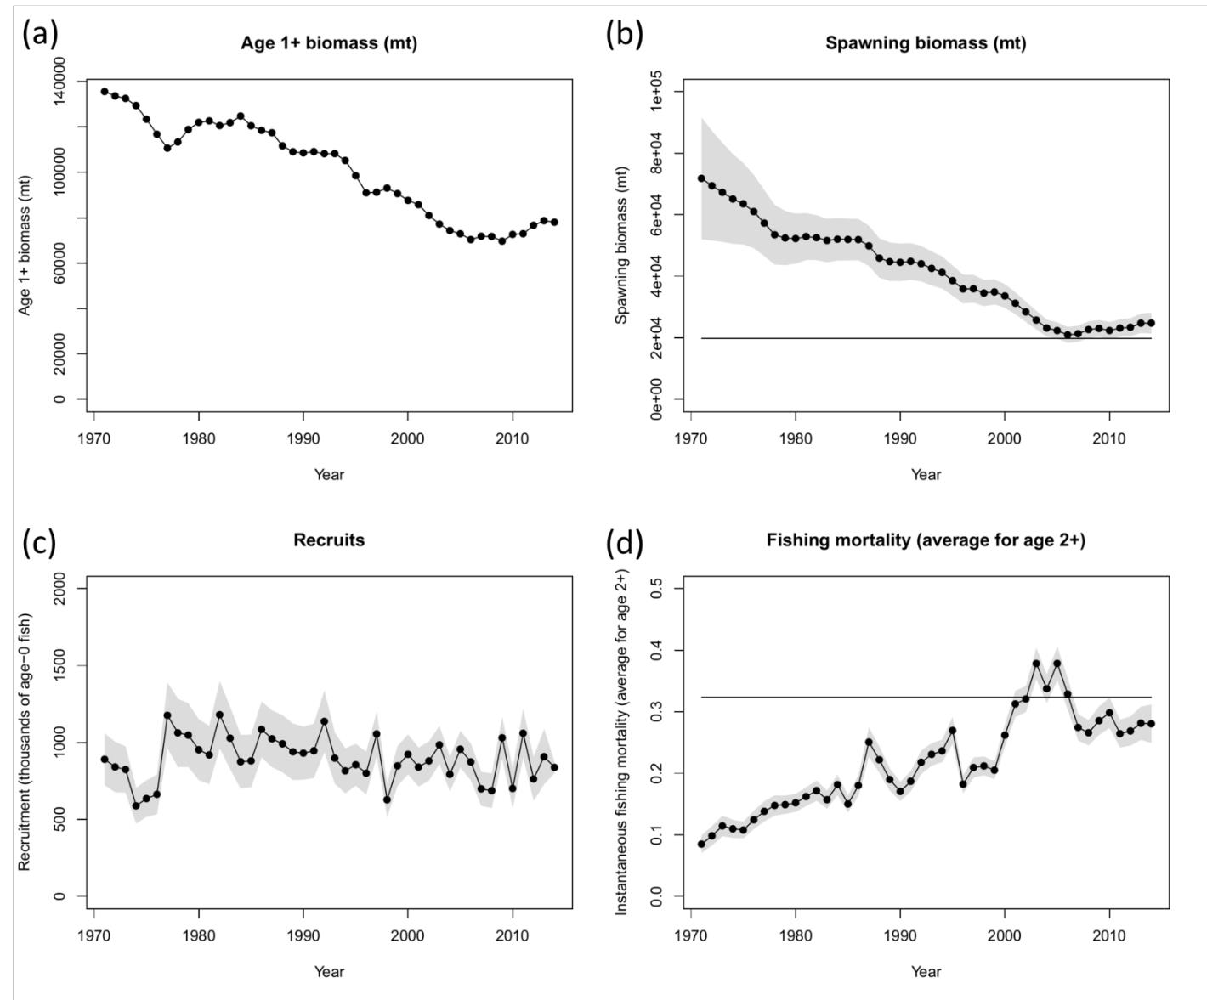
Figure 7-11. Time series of estimates of (a) population biomass (age 1+), (b) female spawning biomass, (c) recruitment (age-0 fish), and (d) instantaneous fishing mortality (average for age 2+, year-1) for BUM derived from the 2016 stock assessment update. The solid circles represents the maximum likelihood estimates by year for each quantity and the shadowed area represents the uncertainty of the estimates (± 1 standard deviation), except for the total biomass time series. The solid horizontal lines indicate the MSY- based reference points for spawning biomass and fishing mortality.

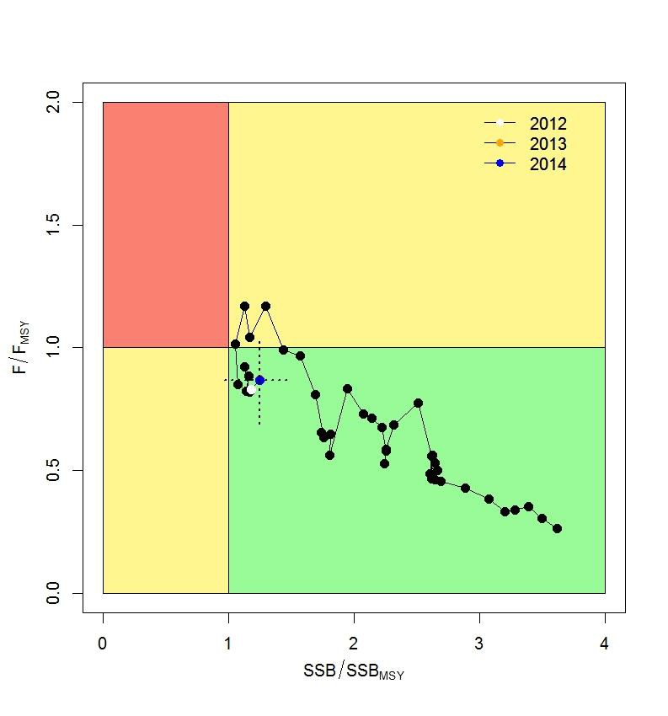

Figure 7-12. Kobe plot of the time series of estimates of relative fishing mortality (average of age 2+) and relative spawning stock biomass of BUM during 1971-2014. The dashed lines denote the 95% confidence intervals for the estimates in the year 2014.

b. Management advice and implications

- SC12 noted the conservation advice for Pacific blue marlin provided by ISC in
SC12-GN-IP-02 and SC12-SA-WP-12:

Since the stock is nearly full exploited, the ISC recommends that fishing mortality remain at or below current levels (2012-2014).

Useful References

SC12-GN-IP-02 Report of the 16th Meeting of the International Scientific Committee for Tuna and Tuna-like Species in the North Pacific Ocean. ISC (International Scientific Committee for Tuna and Tuna-like Species in the North Pacific Ocean) https://wcpfc.int/node/27556

SC12-SA-WP12 Stock Assessment Update for Blue Marlin (Makaira nigricans) in the Pacific Ocean through 2014. ISC Billfish Working Group. https://wcpfc.int/node/27549

For current information related to Northern Stocks Working Group Reports and the ISC Plenary Report:
http://isc.fra.go.jp/reports/isc/isc18_reports.html

Previous Assessments

SC9-SA-WP-09 Stock Assessment of Blue Marlin in the Pacific Ocean in 2013 (Replacement Document 31 July 2013) https://wcpfc.int/node/4732

