**Oceanic Whitetip Shark (Carcharhinus longimanus)**

**Stock Status &Trends plus Management Advice and Implications**

Contents

SC14 2018 1

SC13 2017 1

SC12 2016 2

SC11 2015 2

SC10 2014 2

SC9 2013 3

SC8 2012 (Stock Assessment Conducted) 4

Useful References 9

# SC14 2018

**Stock Status**

**SC14 noted that no stock assessments were conducted for oceanic whitetip shark in 2018. Therefore, the stock status descriptions from SC8 are still current for oceanic whitetip shark. Updated information on catches was not compiled for and reviewed by SC14.**

**Management Advice**

**SC14 noted that no management advice has been provided since SC8 for oceanic whitetip shark. Therefore, previous advice should be maintained, pending a new assessment or other new information. For further information on the management advice and implications from SC8, please see below.**

# SC13 2017

1. **Stock status and trends**
2. **SC13 noted that no stock assessments were conducted for these shark species in 2017. Therefore, the stock status descriptions from SC8 are still current for oceanic whitetip shark respectively. Updated information on catches was not compiled for and reviewed by SC13.**
3. **Management advice and implications**
4. **SC13 noted that no management advice has been provided since SC8 for oceanic whitetip shark. Therefore, previous advice should be maintained, pending a new assessment or other new information.**

# SC12 2016

1. **Stock status and trends**
2. **SC12 noted that no stock assessments were conducted for these shark species in 2016. Therefore, the stock status descriptions from SC8, SC9, and SC10 are still current for oceanic whitetip shark, silky shark, and North Pacific blue shark respectively. Updated information on catches was not compiled for and reviewed by SC12.**
3. **Management advice and implications**
4. **SC12 noted that no management advice has been provided since SC8, SC9, and SC10 for oceanic whitetip shark, silky shark, and North Pacific blue shark, respectively. Therefore, previous advice should be maintained, pending a new assessment or other new information.**

# SC11 2015

**a. Status and trends**

1. **SC11 noted that no stock assessments were conducted for these shark species in 2015. Therefore, the stock status descriptions from SC8 and SC9 are still current for oceanic whitetip shark and silky shark, respectively.**
2. **SC11 noted that no stock assessment has been conducted for South Pacific blue shark.**

**b. Management advice and implications**

1. **SC11 noted that no management advice has been provided since SC8 and SC9 for oceanic whitetip shark and silky shark, respectively. Therefore, previous advice should be maintained, pending a new assessment or other new information.**

# SC10 2014

**a. Status and trends**

1. **SC10 noted that no stock assessment was conducted for this species in 2014.**
2. **Management advice and implications**
3. **Because there was no stock assessment for this species, advice from SC8 should be maintained, pending a new assessment or other new information.**

# SC9 2013

**a. Status and trends**

1. **SC9 noted that no stock assessment was conducted for WCPO oceanic whitetip shark in 2013. Therefore, the stock status description from SC8 is still current.**

**b. Management advice and implications**

1. **SC9 noted that no management advice has been provided since SC8. Therefore, the advice from SC8 should be maintained, pending a new assessment or other new information.**

# SC8 2012 (Stock Assessment Conducted)

**a. Status and trends**

1. Spawning biomass, total biomass and recruitment have all exhibited a declining trend since 1995 (the first year of the assessment) (Fig. OCS 1). Current spawning biomass is low and is estimated to be at 15% of *SBMSY*.
2. Fishing mortality from the non-target longline fishery has been on an increasing trend since 1995, while fishing mortality from the targeted longline fishery and purse-seine fisheries has varied without any trend (Fig. OCS 2). Current fishing mortality is high and is estimated to be more than six times greater than *FMSY*.
3. The key conclusions are that overfishing is occurring and the stock is in an overfished state relative to MSY-based reference points (*SBcurrent/SBMSY* = 0.153 [range: 0.082–0.409]) and depletion-based reference points (*SBcurrent/SB0 = 0.065* [range: 0.034-0.173]) (Tables OCS1 and OSC2). This conclusion is robust to uncertainties in key model assumptions (Figs. OCS 3 and OCS 4).

Table OCS 1: Estimates of management quantities for the reference case and sensitivity runs.





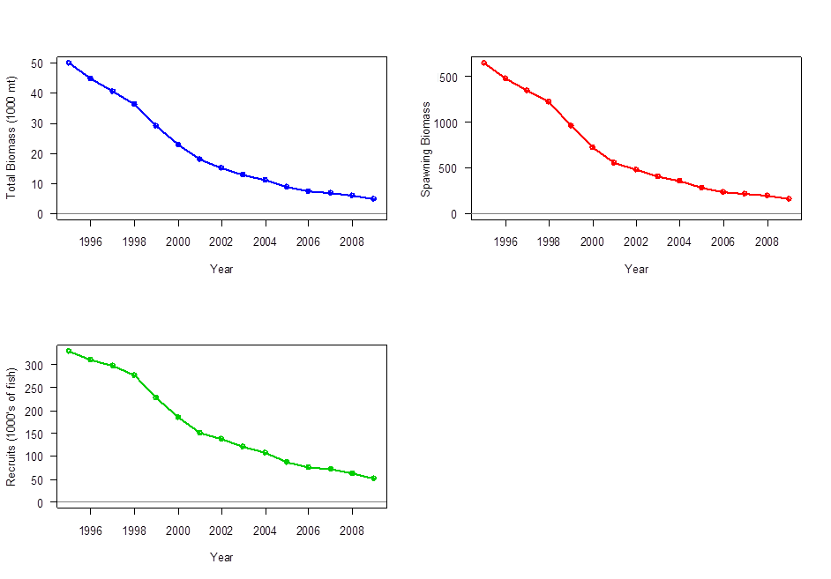

Figure OCS 1: Estimated total biomass (top left, 1,000 mt), estimated spawning biomass (top right) and estimated annual recruitment (1,000s of fish) in the WCPO for the reference case.



Figure OCS 2: Estimated fishing mortality by fleet for the reference case over the model period.



Figure OCS 3: Sensitivity analysis effects on total biomass (top) and recruitment (bottom) of alternate variable levels on the reference case. Figures on the left show the effects of natural mortality, SigmaR (the s.d. on the recruitment devs.) and steepness. Figures on the right show the effects of changing the catch inputs, initial depletion, sample size down weighting, and CPUE inputs.

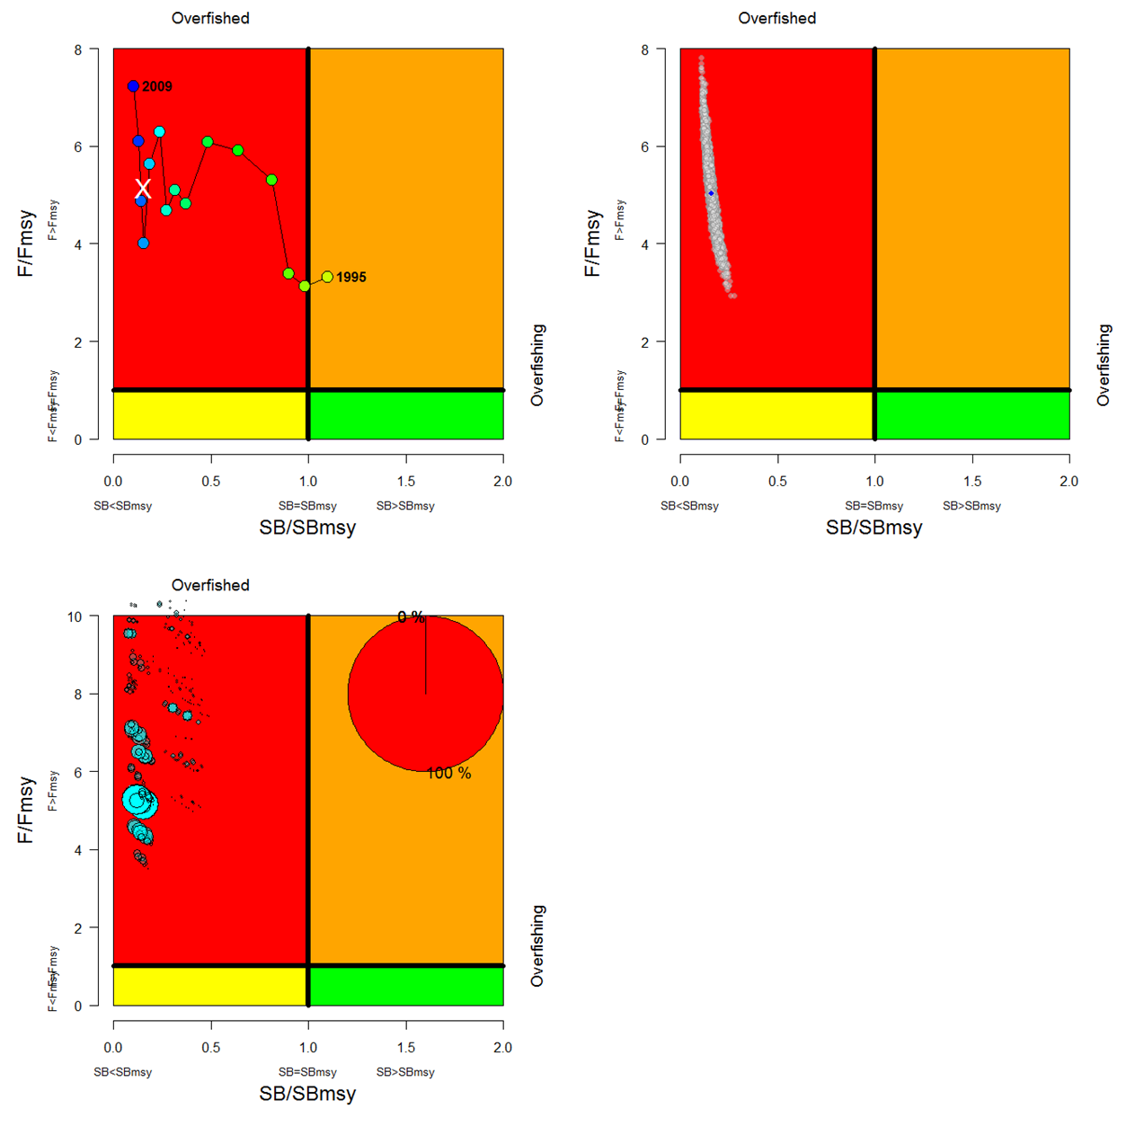

Figure OCS 4: Kobe plots indicating annual stock status, relative to *SBMSY* (x-axis) and *FMSY* (y-axis) reference points. These present the reference model for the period 1995–2009 (top left panel), the statistical uncertainty based on the Markov chain Monte Carlo (MCMC) analysis for the current (average of 2005–2008) status (top right panel, blue dot indicates current estimates), and based on the current (average of 2005–2008) estimates for all 648 models in the grid (bottom panel). In the bottom panel, the size of the blue circles is proportional to the weight (plausibility) of the model run. The pie chart in the top right summarizes the proportion of model weight in each quadrant. Note that the y-axes range differ in the bottom plot.

**b. Management advice and implications**

1. **Despite the data limitations going into the assessment, and the wide range of uncertainties considered, all of the accepted model runs indicate that the WCPO oceanic whitetip shark stock is currently overfished and overfishing is occurring relative to commonly used MSY-based reference points and depletion-based reference points. Management measures to reduce fishing mortality and to rebuild spawning biomass have been agreed to under CMM 2011-04, but mitigation to avoid capture is recommended.**
2. **Given the bycatch nature of most fishery impacts, mitigation measures provide the best opportunity to improve the status of the WCPO oceanic whitetip shark stock.**
3. **Reference points for non-target species, including oceanic whitetip sharks, should be developed as envisaged under Articles 5 and 10 of the WCPF Convention.**

# Useful References

WCPFC-SC8-SA-WP-06 Stock Assessment of Oceanic Whitetip Sharks in the Western and Central Pacific Ocean Rev 1 (3 August 2012). <https://www.wcpfc.int/node/3235>