The Commission for the Conservation and Management of
Highly Migratory Fish Stocks in the Western and Central Pacific Ocean

Scientific Committee

Silky Shark (Carcharhinus falciformis)

Stock Status AND Management Advice

Contents
SC15 2019 (NO STOCK ASSESSMENT) 2
SC14 2018 (STOCK ASSESSMENT CONDUCTED) 2
SC13 2017 (NO STOCK ASSESSMENT) 4
Useful References 5
Previous Assessments 5

SC15 2019 (NO STOCK ASSESSMENT)

- Stock status and trends

- SC15 noted that no stock assessments were conducted for silky shark in 2019. Therefore, the stock status descriptions from SC14 are still current for silky shark. For further information on the stock status and trends from SC14, please see https://www.wcpfc.int/node/32155. Updated information on catches was not compiled for and reviewed by SC15.

- Management advice and implications

- SC15 noted that no management advice has been provided since SC14 for silky shark. Therefore, previous advice should be maintained, pending a new assessment or other new information. For further information on the management advice and implications from SC14, please see https://www.wcpfc.int/node/32155.

SC14 2018 (STOCK ASSESSMENT CONDUCTED)

- The SC accepts the WCPO silky shark stock assessment as best available science for this stock.

a. Stock status and trends

- SC14 noted given the inherent uncertainty in the current assessment the current estimates of stock status should be considered indicative only. Although these estimates are not considered a reliable basis for management decision-making they represent progress since the 2013 assessment and the best available science concerning the status of silky sharks in the WCPO. Therefore, as part of its ongoing review of the established conservation and management measure for silky sharks (CMM 2013-08), the Commission may wish to consider these indicative results until such time as better estimates become available.

- SC14 noted that indications from the 2018 WCPO model show that the stock declined steadily over the model period (1995-2016) (Figure FAL-1). The assessment model estimates spawning biomass in 2016 to have been at 47% of the unexploited level (SB₂₀₁₆/SB₀ = 0.469). Current biomass is estimated to be above the MSY reference biomass level; however, there is considerable uncertainty associated with the estimate of stock status (SB₂₀₁₆/SB_{MSY} = 1.178 95% CI 0.590-1.770) (Table FAL-1). On balance, the stock is not considered to be overfished, i.e. there is a 78% probability that SB₂₀₁₆ is greater than SB_{MSY} (Table FAL-1).

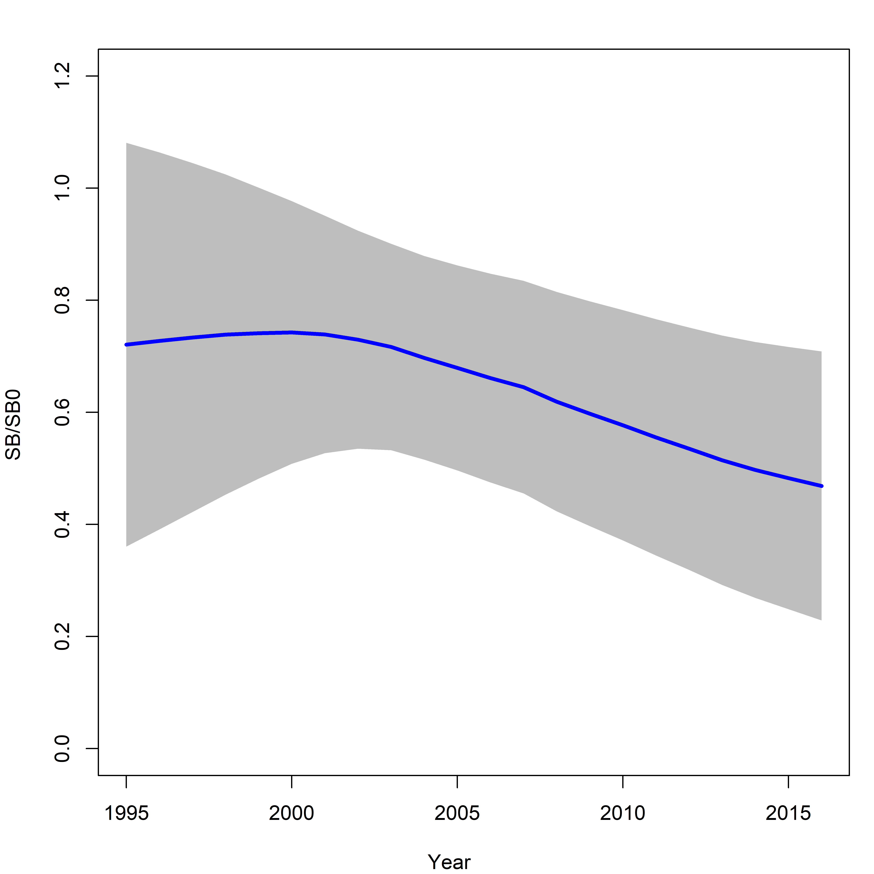 | Figure FAL-1: Estimated spawning biomass relative to unexploited biomass (SB₀) for the WCPO assessment model (CPUEqdev).

Table FAL-1: Management quantities (and 95% confidence intervals) for the WCPO assessment model (CPUEqdev).
Management quantity | Value | Confidence interval (95%)
SB₀ | 11,865 | 6,412-17,318
SB₁₉₉₅ | 8,552 | 2,590-14,513
SB_{MSY} | 4,721 | 2,560-6,882
SB_{MSY}/SB₀ | 0.398 | 0.397-0.399
SB₂₀₁₆ | 5,560 | 301-10,819
SB₂₀₁₆/SB₀ | 0.469 | 0.229-0.729
SB₂₀₁₆/SB_{MSY} | 1.178 | 0.590-1.77
Pr(SB₂₀₁₆ > SB_{MSY}) | 0.78
F₂₀₁₆/F_{MSY} | 1.607 | 0.316-2.810
Pr(F₂₀₁₆ > F_{MSY}) | 0.84
F₂₀₁₆ | 0.313
MSY | 12,162 | 6,711-17,615
Catch 2016 (mt) | 22,503

- Fishing mortality is estimated to be above F_{MSY} (F₂₀₁₆/F_{MSY} = 1.607, Pr(F₂₀₁₆ > F_{MSY}) = 84%). The current level of catch is substantially higher than the MSY. If catches remain at the current level there is a high probability that the biomass will decline to below the SB_{MSY} level in the foreseeable future (~ 5 years).

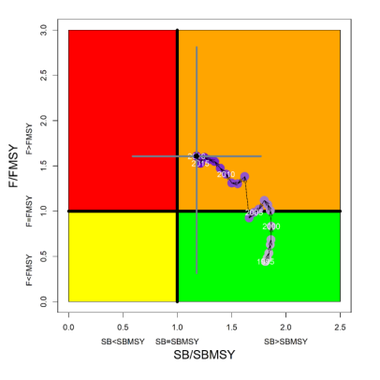 | Figure FAL-2: Kobe plot for the WCPO assessment model (CPUEqdev).

b. Management advice and implications

- SC14 concludes that on the basis of the best available science, and pending the availability of less uncertain stock status indicators, the stock is not overfished, but is subject to overfishing (Figure FAL-2).

- SC14 recommends, given that the WCPO silky shark stock continues to be subject to overfishing, that CMM 2013-08 be maintained as a precautionary measure.

SC13 2017 (NO STOCK ASSESSMENT)

- Stock status and trends

- SC13 noted that no stock assessments were conducted for these shark species in 2017. Therefore, the stock status descriptions from SC9 are still current for silky shark. Updated information on catches was not compiled for and reviewed by SC13.

- Management advice and implications

- SC13 noted that no management advice has been provided since SC9 for silky shark. Therefore, previous advice should be maintained, pending a new assessment or other new information.

Useful References

SC14-SA-WP-08 Pacific-wide Silky Shark (Carcharhinus falciformis) Stock Status Assessment and Addendum. https://www.wcpfc.int/node/31006

Previous Assessments

SC9-SA-WP-03 Updated Stock assessment of silky shark in the western and central Pacific Ocean. https://www.wcpfc.int/node/3685

SC8-SA-WP-07 Stock Assessment of Silky Sharks in the Western and Central Pacific Ocean Rev 1 (3 August 2012) https://wcpfc.int/node/3236

