The Commission for the Conservation and Management of
Highly Migratory Fish Stocks in the Western and Central Pacific Ocean

Scientific Committee

Southwest Pacific Blue Shark (Prionace glauca)

Stock Status AND Management Advice

Contents
SC18 2022 (FURTHER STOCK ASSESSMENT ANALYSIS ) 2
SC17 2021 (STOCK ASSESSMENT CONDUCTED) 8
SC13-2017 – SC16-2020 (NO STOCK ASSESSMENTS) 10
SC12-2016 (STOCK ASSESSMENT CONDUCTED) 11
Useful References 12

SC18 2022 (FURTHER STOCK ASSESSMENT ANALYSIS)

Towards providing scientific advice for Southwest Pacific blue shark (Project 107b)

- SC18 reviewed SC18-SA-WP-03 (Report on WCPFC project 107b: Improved stock assessment and structural uncertainty grid for Southwest Pacific blue shark), which is a response to SC17 recommendations to assess performance of each model and evaluate the plausibility of the uncertainty grid before approving the results for providing management advice using several diagnostic tests.

Provision of scientific information

- Status and trends

- A description of the structural uncertainty grid with associated weighting that was used to define stock status and characterize uncertainty in the Southwest Pacific blue shark (SBSH) assessment is included in Table SBSH-1.

- SC18 noted the improvement of the structural uncertainty grid and the use of 228 models, with a priori weighting, and the reduced grid complexity compared to the 2021 version.

- SC18 noted the stock biomass was low throughout the region through the early 2000s following the expansion of longline fishing effort in the region, but the estimates across the uncertainty grid of 228 models largely indicated that the stock has been recovering since then.

- SC18 noted that the median value of relative recent dynamic spawning biomass depletion for Southwest Pacific blue shark (SB₂₀₁₇₋₂₀₂₀/SB_{F=0}) was 0.71 (90th percentiles 0.37 and 0.82). Alternatively, relative recent equilibrium spawning biomass depletion for South Pacific blue shark (SB₂₀₁₇₋₂₀₂₀/SB₀) was = 0.80 (90th percentiles 0.43 and 0.90).

- SC18 noted that the median value of SB₂₀₁₇₋₂₀₂₀/SB_{MSY} was 1.64 (90th percentiles 0.88 and 1.87; Table SBSH-2) with 87% likelihood (according to the 228 weighted models) that the biomass is above SB_{MSY}.

- SC18 noted that the fishing mortality has declined over the last decade and is currently relatively low with the median F₂₀₁₇₋₂₀₂₀/F_{MSY} = 0.65 (90th percentiles 0.43 and 0.86; Table SBSH-2).

- SC18 noted that there was a 1% likelihood (according to the 228 weighted models) that the recent fishing mortality (F₂₀₁₇₋₂₀₂₀) was above F_{MSY}.

Table SBSH-1. Description of the seven axes for the updated 2022 structural uncertainty grid. Base settings used under the diagnostic case are highlighted in bold. Weights used for alternative values in the weighting of the grid axes are given in parentheses.
Axis | Description
Catch scenario | Base (0.9), high (0.1)
Discard scenario | Low (0.25), base (0.5), high (0.25)
Initial F | base (0.9), high (0.1)
High latitude CPUE | New Zealand (1), low weight (0.5), remove (RM) early New Zealand (0.5)
Low latitude CPUE | Japan (1), Australia (0.5), remove EU CPUE
Survival fraction | Base, low, high
Growth | Manning and Francis (2005), Joung et al. (2018)

Table SBSH-2. Summary of reference points and stock status for the subset of 228 grid model in the structural uncertainty grid, after sub-setting the grid for model runs that showed acceptable retrospective patterns and estimates for natural mortality. Grid axes are weighted by prior input weights. The symbols used in the yield and stock status are described in Table 3 of SC18-SA-WP03.
(catch in mt)
 | Mean | Median | Min | 10% | 90% | Max
C_{latest} | 5,965 | 5671 | 3707 | 3978 | 7593 | 9601
C_{recent} | 6,912 | 6744 | 4322 | 4596 | 8926 | 9577
MSY | 11,413 | 9993 | 8968 | 9313 | 16333 | 25629
SB₀ | 22,772 | 20603 | 15686 | 18524 | 32263 | 53503
SB_{F=0} | 25,894 | 22658 | 17559 | 20161 | 38033 | 66434
SB_{MSY} | 11,104 | 9985 | 7564 | 9008 | 15854 | 26684
SB_{latest} | 18,420 | 17904 | 12973 | 15902 | 20424 | 38004
SB_{recent} | 16,344 | 15907 | 11320 | 14000 | 17670 | 33654
SB_{latest}/SB₀ | 0.85 | 0.90 | 0.42 | 0.49 | 1.01 | 1.19
SB_{recent}/SB₀ | 0.76 | 0.80 | 0.37 | 0.43 | 0.90 | 1.05
SB_{latest}/SB_{F=0} | 0.76 | 0.79 | 0.32 | 0.43 | 0.93 | 1.29
SB_{recent}/SB_{F=0} | 0.67 | 0.71 | 0.29 | 0.37 | 0.82 | 1.15
SB_{latest}/SB_{MSY} | 1.75 | 1.84 | 0.85 | 1.00 | 2.10 | 2.47
SB_{recent}/SB_{MSY} | 1.55 | 1.64 | 0.76 | 0.88 | 1.87 | 2.19
F_{MSY} | 0.144 | 0.142 | 0.134 | 0.136 | 0.158 | 0.181
F_{lim,AS} | 0.228 | 0.225 | 0.211 | 0.214 | 0.248 | 0.291
F_{crash,AS} | 0.325 | 0.320 | 0.299 | 0.304 | 0.351 | 0.419
F_{latest} | 0.073 | 0.072 | 0.039 | 0.051 | 0.093 | 0.120
F_{recent} | 0.094 | 0.094 | 0.048 | 0.065 | 0.117 | 0.160
F_{latest}/F_{MSY} | 0.51 | 0.52 | 0.24 | 0.35 | 0.67 | 0.78
F_{recent}/F_{MSY} | 0.65 | 0.65 | 0.30 | 0.43 | 0.86 | 1.06
F_{latest}/F_{lim,AS} | 0.32 | 0.33 | 0.15 | 0.22 | 0.43 | 0.50
F_{recent}/F_{lim,AS} | 0.41 | 0.41 | 0.19 | 0.27 | 0.55 | 0.68
F_{latest}/F_{crash,AS} | 0.23 | 0.23 | 0.11 | 0.15 | 0.30 | 0.35
F_{recent}/F_{crash,AS} | 0.29 | 0.29 | 0.13 | 0.19 | 0.39 | 0.48

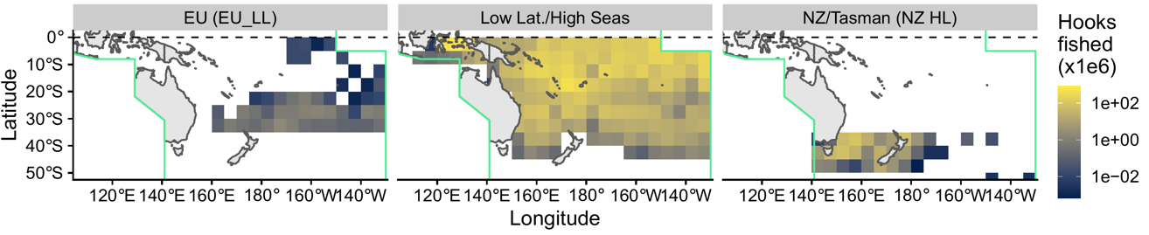
Figure SBSH-1. Spatial structure used in the 2022 stock assessment model.

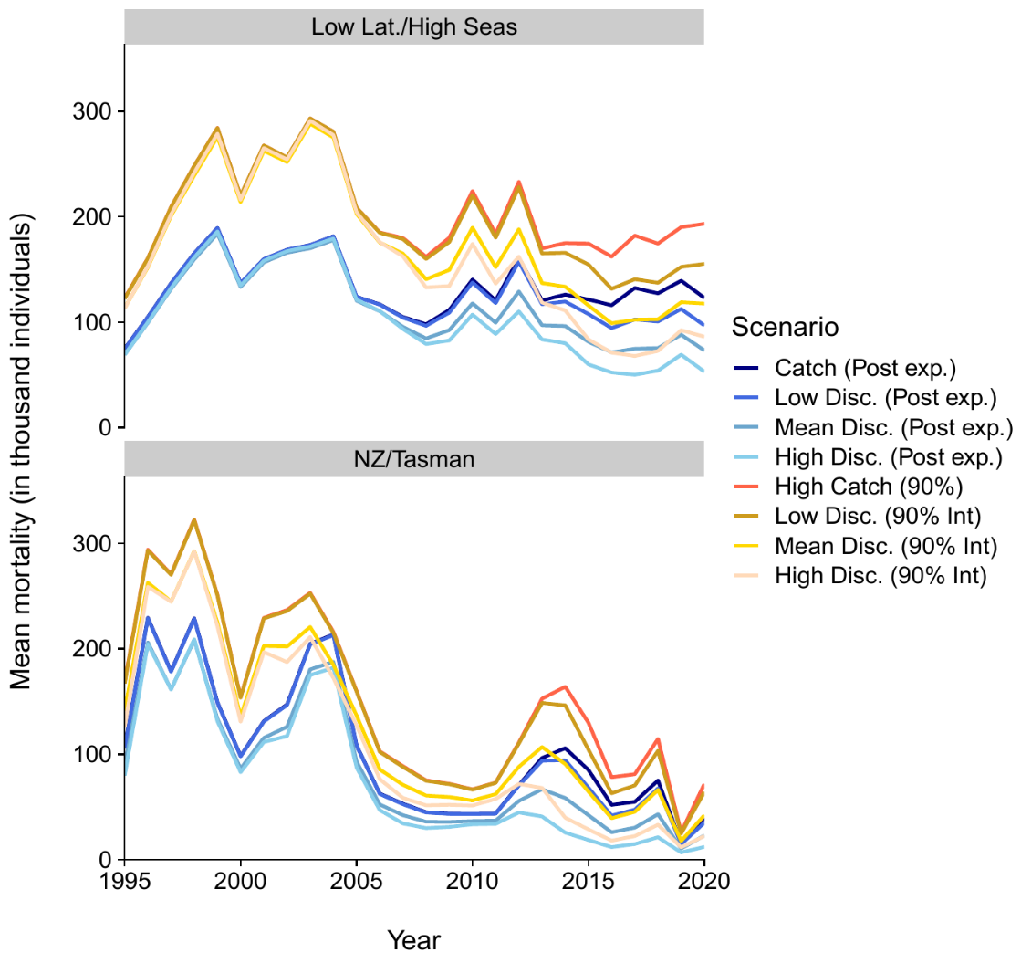
Figure SBSH-2. Top panel: Time series of total reported annual Southwest Pacific BSH catch for the EU-SP fleet (mt), Bottom panels: Predicted total fishing related mortality by latitudinal stratum (high [≥ 35 degree South] and low latitude [< 35 degree South]), including 17% post release mortality for live-discarded blue sharks. Interactions refer to the posterior median (50%) and 90th percentile (90%) of the predicted catch from the observer catch rate model. Low, median and high discard scenarios refer to the 25%, 50% (median) and 75% discard estimates. All discard estimates were applied at flag and latitudinal stratum level to overall interactions.

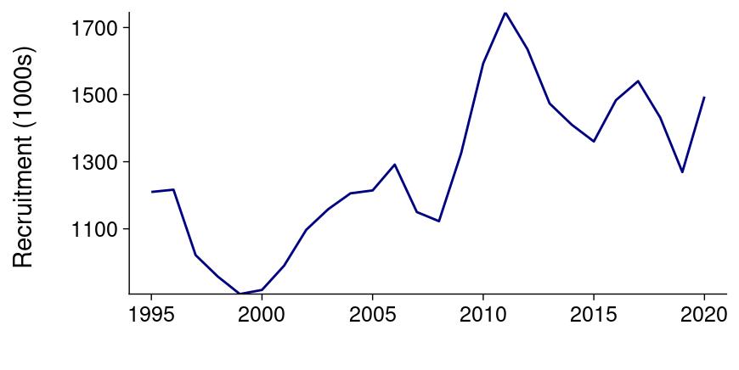
Figure SBSH-3. Estimated annual recruitment for the diagnostic case model

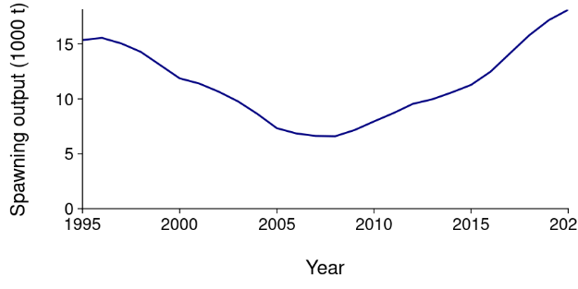
Figure SBSH-4. Estimated annual spawning potential by model region for diagnostic case model

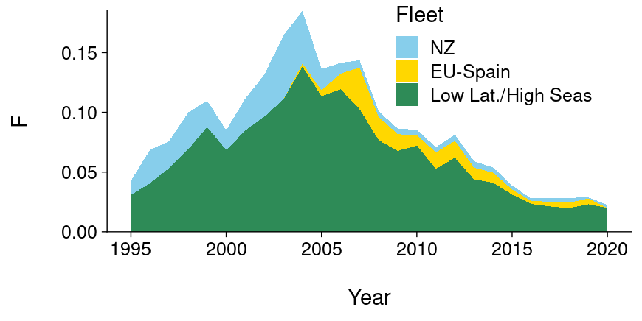
Figure SBSH-5. Estimated annual fishing mortality for the diagnostic case model
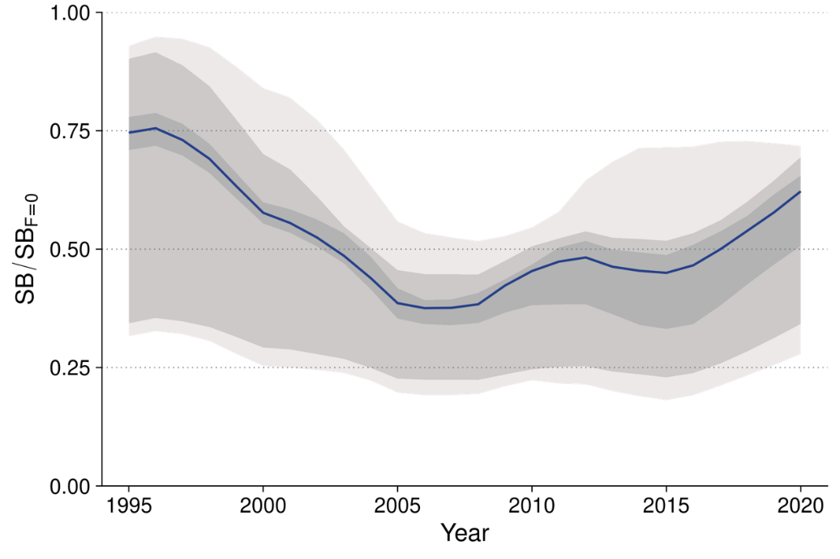
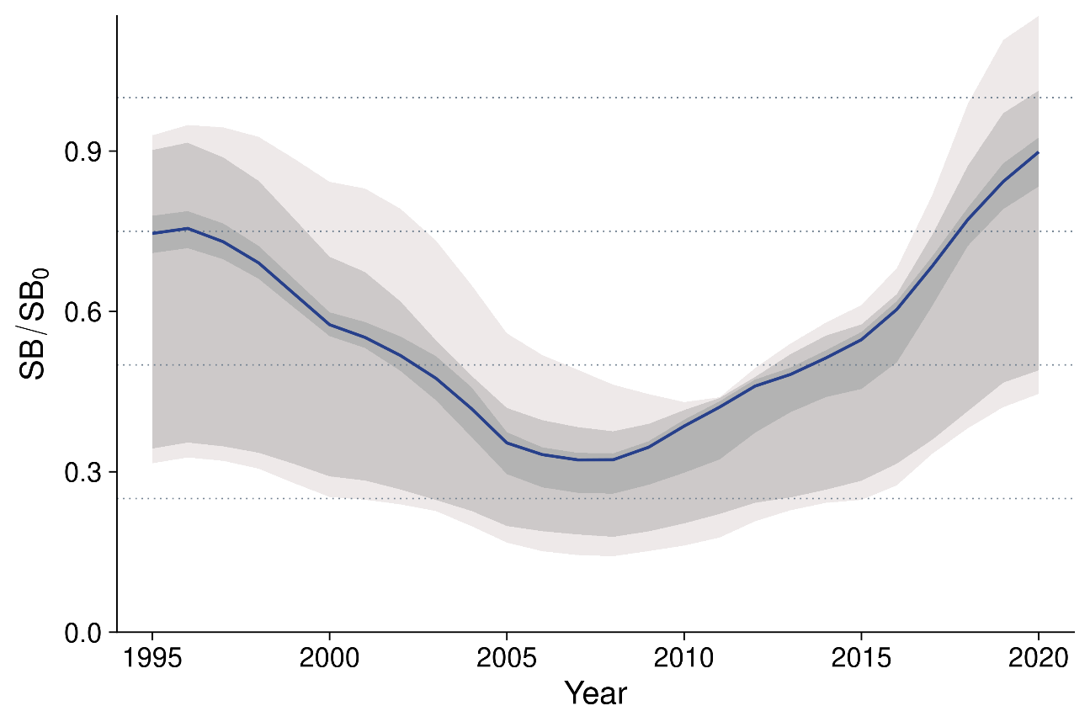
Figure SBSH-6. Plot showing the quantiles of trajectories of fishing depletion (of spawning potential) for the 228 model runs included in the structural uncertainty grid
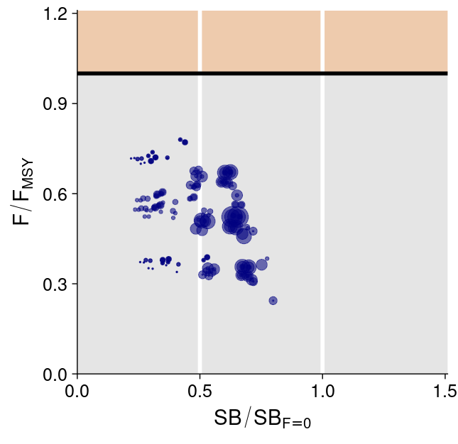
Figure SBSH-7. Majuro plot summarising the results for each of the models in the structural uncertainty grid. Size indicates weight of each model in the grid, darker shading indicates multiple models with similar outcomes.
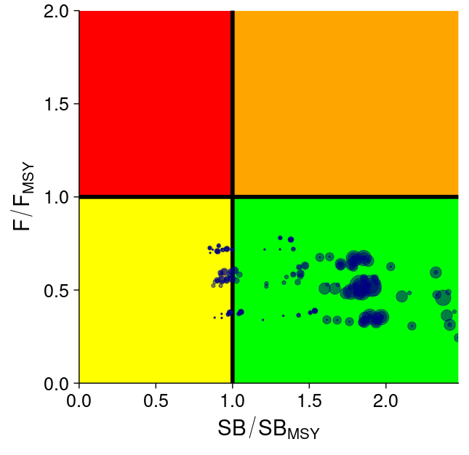
Figure SBSH-8. Kobe plot summarising the results for each of the models in the structural uncertainty grid. Size indicates weight of each model in the grid, darker shading indicates multiple models with similar outcomes.
- Management advice and implications

- SC18 welcomed the reduction and refinement of the grid of models for Southwest Pacific blue shark as well as the approach to the weighting of the model.

- Based on the above information, SC18 advised the Commission that the Southwest Pacific blue shark is unlikely to be overfished and it is unlikely that overfishing is occurring when considered against MSY and depletion-based reference points.

- Future research recommendations

- SC18 noted the following research recommendations to achieve improvement in future shark assessments:

- Providing more time, either as inter-session projects, or by extending time-frames for shark data analyses. This will allow more thorough investigation of input data quality and trends, which shape assessment choices. In addition, it would allow input analyses to be completed in time to be presented to the SPC’s Pre-assessment Workshop prior to the stock assessment. In addition, allowing more time for the assessments themselves will allow a more thorough investigation of alternative model structures, which may include comparisons with low-information methods such as spatial risk assessments.
- Increased effort to reconstruct catch histories for sharks (and other bycatch species) from a range of sources. Our catch reconstruction models showed that model assumptions and formulation can have important implications for reconstructed catches. Additional data sources, such as log-sheet reported captures from reliably reporting vessels, may be incorporated into integrated catch-reconstruction models to fill gaps in observer coverage.
- Additional tagging be carried out using satellite tags in a range of locations, especially known nursery grounds in South-East Australia and New Zealand, as well as high seas areas to the north and east of New Zealand, where catch-rates are high. Such tagging may help to resolve questions about the degree of natal homing and mixing of the stock.
- Tagging may also help to obtain better estimates of natural mortality, if carried out in sufficient numbers. This could be taken up as part of the WCPFC Shark Research Plan to assess the feasibility and scale of such an analysis.
- Additional growth studies from a range of locations could help build a better understanding of typical growth, as well as regional growth differences. Current growth data are conflicting, despite evidence that populations at locations of current tagging studies are likely connected or represent individuals from the same population.
- Genetic/genomic studies could be undertaken to augment the tagging work to help resolve these stock/sub-stock structure patterns. To support this work, a strategic tissue sampling program for sharks is recommended with samples to be stored and curated in the Pacific Marine Specimen Bank.

SC17 2021 (STOCK ASSESSMENT CONDUCTED)

- SC17 reviewed SC17-SA-WP-03 (Stock assessment of Southwest Pacific blue shark).

- Provision of information about indicators

SC17 noted that in 2021, the three major CPUE time series (high-latitude fisheries around New Zealand and South-East Australia; mid-latitude EU-Spain fishery; and the high latitude and high seas Japan fishery) for blue shark in the Southwest Pacific from 1995 to 2020 indicated a consistent trend of increasing CPUE in the recent decade.

SC17 noted that the CPUE of low latitude/high seas Japanese fishery suggested a declining trend in biomass from relatively high values of CPUE in the 1990s, reflecting increasing effort during that time, followed by a steady increase of biomass since around 2010 as effort plateaued and discard rates increased, and returned to biomass levels estimated at the beginning of the assessment period.

SC17 noted that blue sharks are relatively productive with fast growth and high fecundity compared to other sharks. In addition, the population is structured spatially with smaller fish in the higher latitudes.

- Stock status and trends

SC17 noted that WCPFC has not yet agreed on any reference points for Southwest Pacific blue shark.

SC17 noted that Southwest Pacific blue shark assessment was undertaken using the Stock Synthesis model framework and the structural uncertainty grid approach with 9 structural uncertainties (Catch, Discard, Initial-F, Rec. dev., High latitude CPUE, Low latitude CPUE, Natural mortality, survival function, growth) resulting in 3,888 models. In addition, a surplus production model was run. SC17 noted that both assessment methods produced similar results.

SC17 agreed that the assessment was an improvement on the 2016 assessment. In particular, the catch reconstruction, CPUE time series, and re-parameterization of biological parameters using combined information from south and north Pacific assessments.

SC17 noted that 90% of model runs indicated that F₂₀₂₀ was below F_{MSY} and 96% of model runs shows that SB₂₀₂₀ was above SB_{MSY}. However, the model grid was not adopted by SC17 due to the views of some CCMs that a more thorough investigation of diagnostics across the grid of models was required. These CCMs recommended that residual pattern and retrospective analysis, among other approaches, would be informative, and a deeper investigation into the grid model selection and uncertainty was advised.

SC17 noted that fishing mortality has likely declined over the last decade and is currently relatively low due to the fact that most sharks are released upon capture in most longline fleets.

SC17 requested several diagnostics (i.e., CPUE’s residuals, retrospective analysis, jitter analysis, and recruitment deviations) for the diagnostic case.

These diagnostics showed that the model convergence was reasonable for the models in the uncertainty grid with low maximum gradient and positive definite of hessian matrix, but the model fitting of the CPUEs and recruitment deviations were contended by some members of the SC.

- Management advice and implications

SC17 noted, based on the above information, that stock biomass is likely increasing, and fishing pressure has declined through the recent decade. The results indicate that, if assessed against conventional reference points, it is likely that the stock will not be found to be overfished nor would overfishing be occurring.

SC17 recommended improving the manner in which the grid was selected before approving the results for providing management advice and proposed developing objective criteria for evaluating the plausibility of the grid. It was suggested that an attempt be made to use diagnostic tests as criteria for determining the final grid of results to inform management advice and uncertainty in the assessment. The performance of each model would be assessed against the following four criteria.
- Model convergence and stability: the analysis should assess the final gradient (the final gradient should be relatively small; <1e⁴), and check that the Hessian matrix is definite. Apply the jitter procedure to verify the stability of the model to evaluate whether the model has converged to a global solution rather than a local minimum.
- Goodness-of-fit: evaluate whether residuals patterns of the CPUE and length-frequency distributions were normally distributed or/and had temporal trends.
- Model consistency: retrospective analysis to check the consistency of model estimates, for example, the invariance in SB and F as the model is updated with new data in retrospect.
- Prediction skill: hindcasting analysis could be done to evaluate the model prediction skill of the CPUE. When conducting hindcasting, a model is fitted to the first part of a time series and then projected over the period omitted in the original fit. Prediction skill can then be evaluated by comparing the predictions from the projection with the observations.

- Future research recommendations

SC17 recommended that:
- increased effort be made to re-construct catch histories for sharks (and other bycatch species) from a range of sources;
- dynamic/non-equilibrium reference points, such as SB_{F=0} be investigated for shark stock status, as they may be more appropriate for fisheries with uncertain early exploitation history and strong environmental influences;
- additional tagging be carried out using satellite tags in a range of locations, especially known nursery grounds in South-East Australia and New Zealand, as well as high seas areas to the north and east of New Zealand, where catch-rates are high;
- additional growth studies from a range of locations be undertaken to help build a better understanding of typical growth, as well as regional growth differences;
- genetic/genomic studies be undertaken to augment the tagging work to help resolve these stock/sub-stock structure patterns;
- aggregated data for key sharks are submitted as by ocean area not simply as WCPO and, where possible, these data should be retrospectively corrected; and
- observers (or the vessel) should record number of shark lines deployed per set or the number of floats with shark lines.

SC13-2017 – SC16-2020 (NO STOCK ASSESSMENTS)

- There were no stock assessments for southwest Pacific blue shark in 2017 - 2020. This was not discussed at SC16 due to its streamlined agenda and discussions were conducted virtually due to the impacts of COVID-19 pandemic. Therefore, the stock status descriptions and management advice from SC15 are still current for southwest Pacific blue shark.

- Stock status and trends

- SC15 noted that no stock assessments were conducted for South Pacific blue shark in 2019. Therefore, the stock status descriptions from SC13 are still current for South Pacific blue shark. For further information on the stock status and trends from SC13, please see https://www.wcpfc.int/node/29904. Updated information on catches was not compiled for and reviewed by SC15.

- Management advice and implications

- SC15 noted that no management advice has been provided for South Pacific blue shark.

SC12-2016 (STOCK ASSESSMENT CONDUCTED)

- Stock status and trends

- SC12 noted that WCPFC has not yet determined limit biological reference points for South Pacific blue shark.

- SC12 noted that the stock status for shark assessments presented to the Scientific Committee have been traditionally assessed relative to MSY-based reference points. It was also noted that realistic estimates of equilibrium unexploited recruitment and spawning biomass could not be obtained in the 2016 South Pacific blue shark assessment due to the lack of available data, conflicting CPUE time series, and uncertainty in the estimated stock recruitment relationship.

- SC12 noted that the 2015 catch of south Pacific blue shark provided within aggregate 5-degree square catch data was 26% lower than in 2014, and a 34% reduction over the average for 2010-14.

- SC12 noted that the 2016 South Pacific blue shark assessment is preliminary and is considered to be a work in progress. As a result, it cannot be used to determine stock status and form the basis of management advice.

- SC12 noted that there are a number of data uncertainties within the South Pacific blue shark assessment, especially with regard to historical and contemporary longline catch and CPUE estimates. The data-poor nature of the South Pacific blue shark assessment indicates that an improvement in the amount and quality of available biological and fishery information will be required in order to develop a useful integrated stock assessment model.

- SC12 noted the recommendations in the working papers (SC12-SA-WP-08 and SC12-SA-WP-09) for data improvements and other analytical work needed to improve the assessment for South Pacific blue shark, and recommends prioritizing such work.

- Management advice and implications

- SC12 noted that no management advice has been provided for South Pacific blue shark.

Useful References

SC18-SA-WP-03 Report on WCPFC project 107b: Improved stock assessment and structural uncertainty grid for Southwest Pacific blue shark (1Aug) - Rev.01. https://meetings.wcpfc.int/node/16244

SC17-SA-WP-03 Stock Assessment of Southwest Pacific Blue Shark (28July) - Rev.01. Philipp Neubauer, Kath Large and Stephen Brouwer. https://meetings.wcpfc.int/node/12552

SC17-SA-IP-05 Updated draft research plan for ‘key’ tuna species in the WCPO, 2021-2024. SPC-OFP. https://meetings.wcpfc.int/node/12563

SC17-SA-IP-06 Characterisation of the fisheries catching South Pacific blue shark (Prionace glauca) in the Western and Central Pacific Ocean. Stephen Brouwer, Kath Large and Philipp Neubauer. https://meetings.wcpfc.int/node/12564

SC15-SA-IP-14 Data preparation for Southeast Pacific blue and shortfin mako sharks. https://www.wcpfc.int/node/43055

SC13-SA-IP-13 Updated abundance indicators for New Zealand blue, porbeagle and shortfin mako sharks. https://www.wcpfc.int/node/29537

SC12-SA-WP-08 Assessment of blue shark in the southwestern Pacific Rev 1 (22 July 2016). https://www.wcpfc.int/node/27535

SC12-SA-WP-09 Catch and CPUE inputs to the South Pacific blue shark stock assessment Rev 1 (16 July 2016). https://www.wcpfc.int/node/27493

