Pacific Bigeye Thresher Shark (Alopias superciliosus)
Stock Status & Trends plus Management Advice and Implications

Contents
SC13 2017 (Sustainability Risk Assessment) 1
Useful References 3

SC13 2017 (Sustainability Risk Assessment)

- Stock status and trends

- SC13 noted that the results of the assessment indicate that assuming a range of longline post-capture survival rates of 30-70%, which likely reflects current fishing operations, median sustainability risk for the 2000-2014 period ranged between:
- 20% below to 60% above the MIST based on 0.5r,
- 50% below to 10% above the MIST based on 0.75r, and
- 60% to 20% below the MIST based on r.

- SC13 also noted that CPUE increased in the calibration area (the Hawaii-based fleet) in the last year of the assessment. This may suggest an increase in biomass, but the reason for the CPUE increase is not understood.

- Management advice and implications
- SC13 noted that although the stock status of this species is currently unknown, the bigeye thresher assessment showed that, estimating for current fishing operations (with 30-70% post-capture mortality) across a range of scenarios, some of the median F estimates exceeded two of the three indicative reference points (0.5r and 0.75r) (Table BTH-1). Across all 30-70% post-capture scenarios, there is a >50% probability in most years that F > MIST based on 0.5r and a >20% probability in most years that F > MIST based on 0.75r. (Table BTH-2).

TABLE BTH-1. Sustainability risk (ratio of impact to MIST, at three levels of the MIST, with values >1 considered to be unsustainable) (median values and 95% quantile range) for bigeye thresher in the Pacific. Estimates are for the Core Area and the Assessment Area assuming the occurrence of post-capture survival (random occurrence between 30% and 70%) in impact estimation and three initial population status assumptions (low (0.3), medium (0.5), and high (0.7)). Results are contrasted for the fifteen-year period (2000-2014) and the recent period (2011-2014). Fcrash = r, Flim = 0.75r, and Fmsm = r/2.
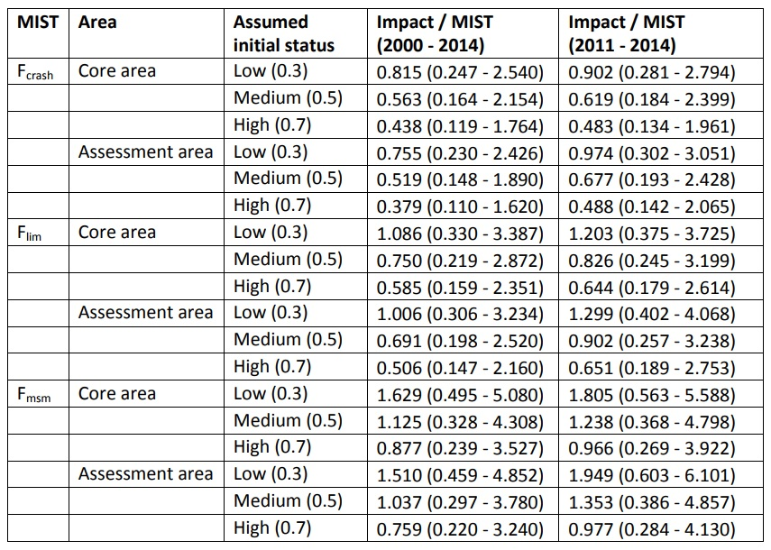

TABLE BTH-2. Sustainability risk probabilities (Pr(Impact > MIST), for 3 levels of MIST: Fcrash, Flim, and Fmsm) for bigeye thresher in the Pacific, 2000-2014, assuming 100% capture mortality (left) and the occurrence of post-capture survival (right) over the Core Area and the Assessment Area (combined values across three initial population status assumptions). Fcrash = r, Flim = 0.75r, and Fmsm = r/2.
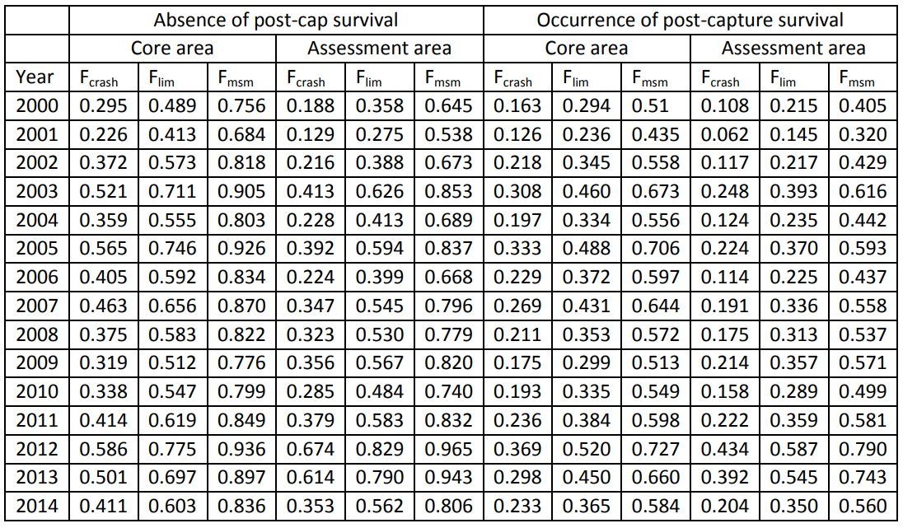

- SC13 noted that the modelled scenario of 30-70% post-capture survival reduced F estimates by approximately one third and reduced the risk that the MIST based on r will be exceeded by 50% compared to the scenario assuming no post-catch survival. A “no-retention” measure was not modelled but would be expected to reduce F even further.

- SC13 noted that the area of highest estimated fishing mortality overlapped with the region of higher relative abundance for the species, corresponding to a narrow band between approximately 10-15°N and 150°E-140°W. Fishing operations targeting bigeye tuna and operating during the April-June period had the highest mortality over the recent period (2011-2014).

- SC13 noted that the Commission needs to further consider appropriate limit reference points and risk tolerances for exceeding LRPs for sharks.

- SC13 recommends that WCPFC14 take the results of this assessment into consideration when framing a management measure for bigeye thresher sharks in the WCPO.

Useful References

WCPFC-SC13-SA-WP-11 Pacific-wide sustainability risk assessment of bigeye thresher shark (Alopias superciliosus) Rev 2 (12 August 2017). https://www.wcpfc.int/node/29524

