Whale Shark (Rhincodon typus)
Stock Status & Trends plus Management Advice and Implications

Contents
SC14 2018 1
Useful References 3

SC14 2018

Provision of scientific information

SC14 reviewed the report Risk to the Indo-Pacific whale shark (Rhincodon typus) population from interactions with Pacific purse seine fisheries (SC14-SA-WP-12). The analysis estimated the risk of overfishing the Indo-Pacific whale sharks by overlaying predicted spatial abundance of whale sharks with Pacific-wide fishing effort to estimate total fishing mortality relative to limit reference points.

Stock status and trends

A nominal trend of high interactions in 2006-2008, followed by lower rates thereafter was not altered by standardization (Figure RHN-1), and is consistent with trends found in the Eastern Pacific Ocean by Román et al. 2018. These decreasing annual trends in interactions do not appear to result from management measures as prohibitions on intentional setting of purse seines on whale sharks were adopted by the PNA in 2010, by the WCPFC in 2012 and by the IATTC in 2015. Furthermore, the trends may have been influenced by low WCPO purse seine observer coverage rates prior to 2010.
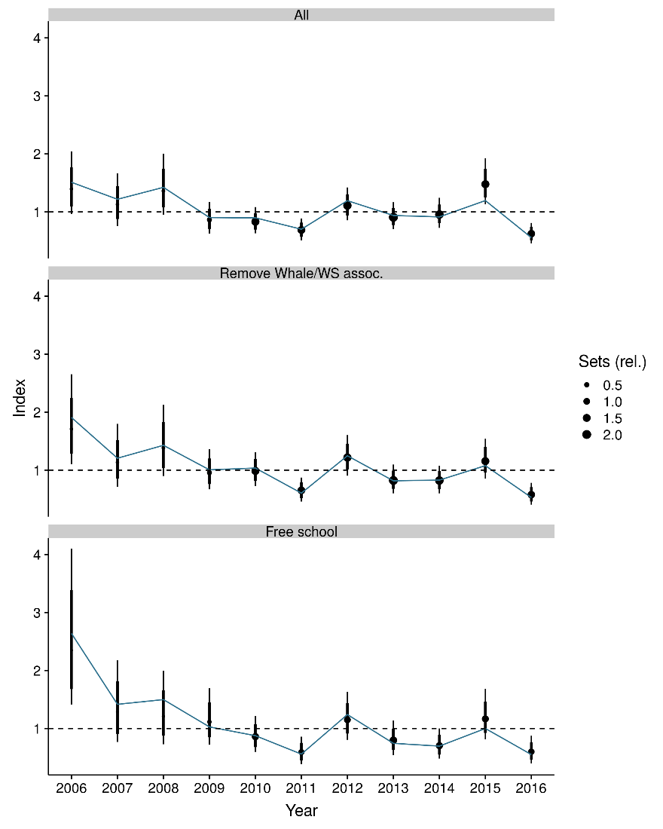
Figure RHN-1: Estimated temporal index of interactions based on a) the full observer dataset, b) the full dataset without whale- and whale shark associated sets, and c) free-school sets only. The rationale behind the different effort subsets is given in section 2.2.2 of WCPFC-2018-SC14/SA-WP-12. The index is centred to have a geometric mean of one and is therefore unit-less.

SC14 noted that over a range of notional reference points, and in accordance with expert-elicited post-mortality rates of ~10%, median sustainability risk from Pacific Ocean fisheries alone for the 2006-2016 period ranged between (Figure RHN-2):

  - 3-12% of the limit risk level based on 0.5r_{max} (F_{msm}),
  - 2-8% of the limit risk level based on 0.75r_{max} (F_{lim}), and
  - 2-6% of the limit risk level based on r_{max} (F_{crash}), where r_{max} is the maximum population growth rate. [adopted]

Figure RHN-2: Risk that mortality exceeds either of three limit reference points (RR_crash (F_{MSM}: 0.5r_{max}), RR_lim (F_{Lim}: 0.75r_{max}), RR_crash (F_{crash}: r_{max})).

SC14 noted the report’s findings that understanding and reducing post-release mortality is recommended as one of most effective approaches to maintaining acceptable risk levels.

SC14 also noted the report’s findings that the total risk to the Indo-Pacific whale shark population may be higher if there are differential impacts to more vulnerable population segments within the Pacific and/or higher fishing mortalities outside of the region (e.g. the Indian Ocean).

SC14 considered the use of precautionary risk assessment model inputs. It was noted that input parameters to the risk assessment were drawn from the best available data, but in some cases where the data were uninformative about the probability distributions of the parameters of interest the methodology put more weight on precautionary values.

Management advice and implications
SC14 considers there is a low probability that the Indo-Pacific whale shark is at risk from Pacific purse seine fisheries (median probability of less than 8% that current risk levels exceed life history-based notional reference points F_{Lim} and F_{crash}).

SC14 recommends that the WCPFC initiate concerted efforts to identify and promote best practice safe release methods for whale sharks.

SC14 recommends that research be undertaken to quantify post-release mortality rates under a variety of release scenarios.

Useful References

SC14-SA-WP-12 Risk to the Indo-Pacific Ocean whale shark population from interactions with Pacific Ocean purse-seine fisheries Rev 1. https://www.wcpfc.int/node/31005

